Безплатно преглеждат пациенти
Владимир СИМЕОНОВ
Стандарт стр. 7

с хематологични заболявания в Благоевград. Д-р Вера Стоева от Националната специализирана болница за хематологични заболявания (НСБАЛХЗ) София ще преглежда и консултира безплатно пациенти със съмнение за хематологично заболяване на 13 юли.
Кампанията се организира от Институт за здравно образование и Българско медицинско сдружение по хематология с подкрепата на водещи университетски хематологични центрове: НСБАЛХЗ София, УМБАЛ "Св. Георги Пловдив", УМБАЛ "Св. Марина Варна" и Община Благоевград.
Целта е изграждане на добра връзка между общопрактикуващите лекари със специалисти хематолози от водещи университетски центрове. Жители на Благоевград, които имат съмнения за своето състояние, неуточнена хематологична диагноза или са лежали с такава диагноза в хематологично или друго отделение, могат да научат от горещия телефон на кампанията 070010126 (на цената на градски разговор) начините за участие в безплатния преглед. Телефонната линия е отворена всеки работен ден от 10 до 17 ч.

МЕДИА МОНИТОРИНГ ХЕМАТОЛОГИЧНИ ЗАБОЛЯВАНИЯ – БЛАГОЕВГРАД
АГЕНЦИЯ:
http://agencia.bg/%D0%BD%D0%BE%D0%B2%D0%B8%D0%BD%D0%B8/item/24551-%D0%BA%D0%B0%D0%BA%D0%B2%D0%BE-%D1%82%D0%B5%D1%87%D0%B5-%D0%B2%D1%8A%D0%B2-%D0%B2%D0%B5%D0%BD%D0%B8%D1%82%D0%B5-%D0%BD%D0%B8http://agencia.bg/%D0%BD%D0%BE%D0%B2%D0%B8%D0%BD%D0%B8/item/24551-%D0%BA%D0%B0%D0%BA%D0%B2%D0%BE-%D1%82%D0%B5%D1%87%D0%B5-%D0%B2%D1%8A%D0%B2-%D0%B2%D0%B5%D0%BD%D0%B8%D1%82%D0%B5-%D0%BD%D0%B8
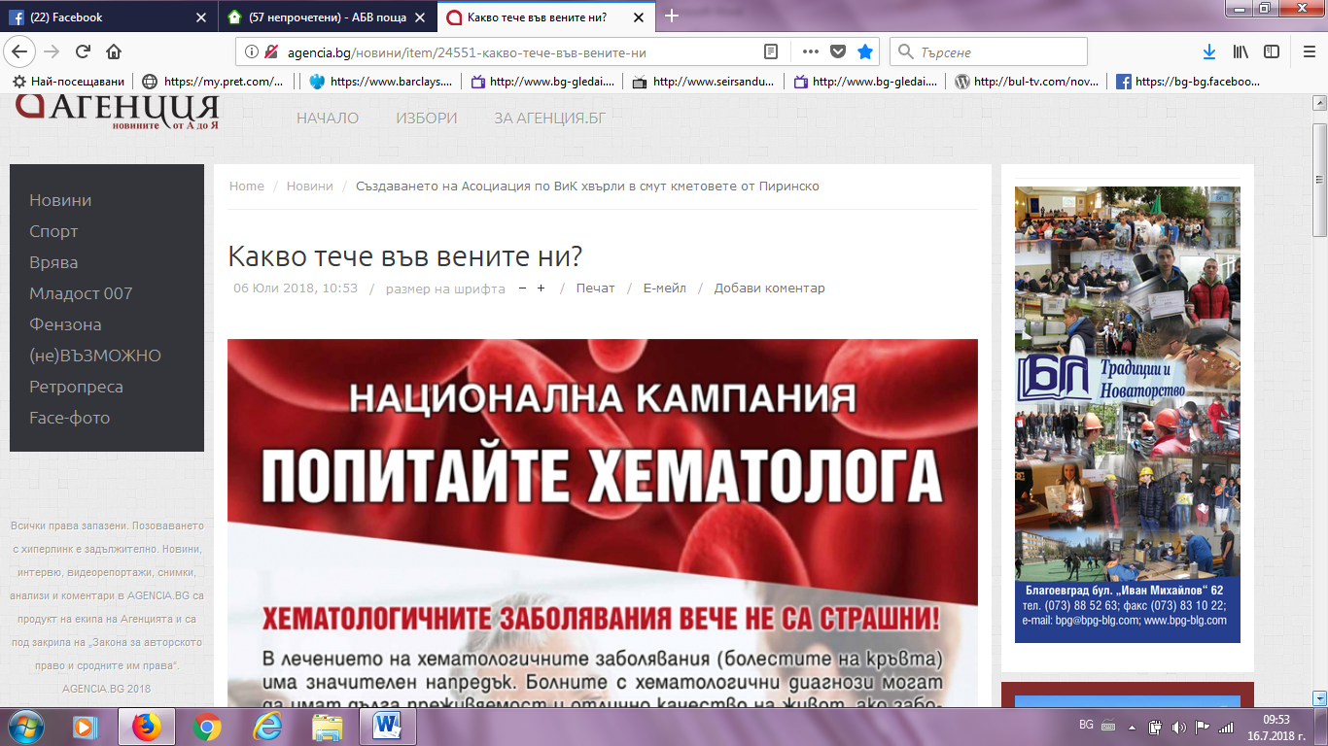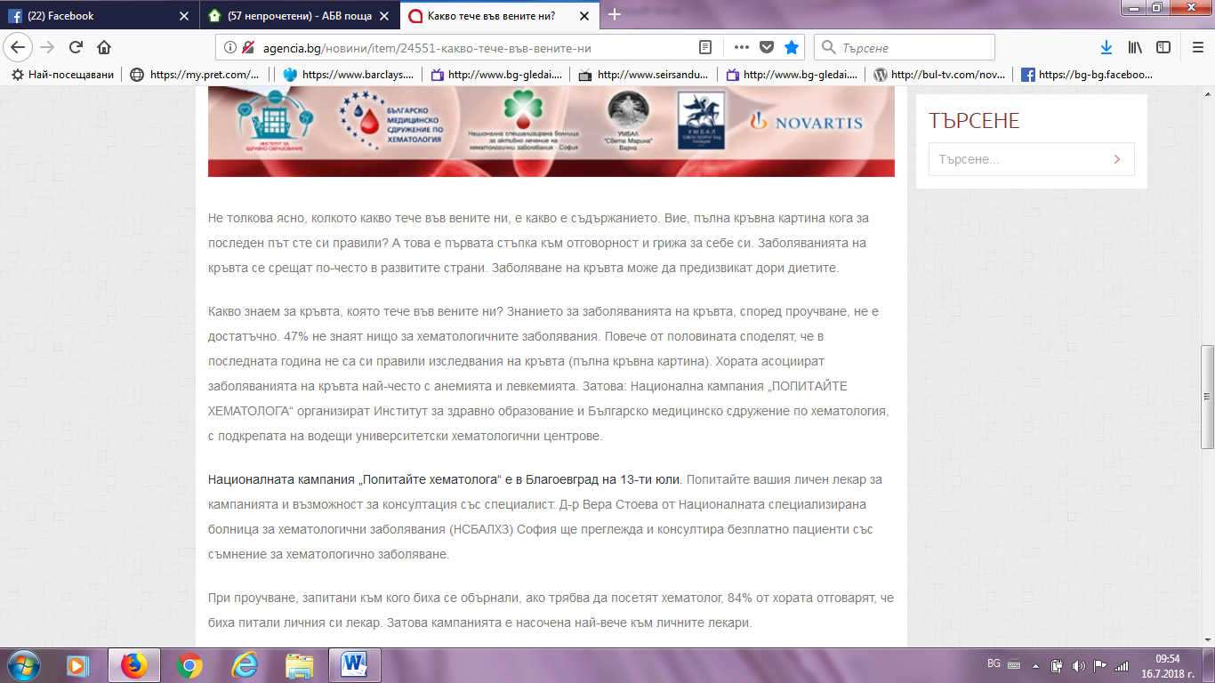

ПОРТАЛЪТ РАЗЛОГ ИНФО:
https://razloginfo.com/news.php?extend.8720https://razloginfo.com/news.php?extend.8720
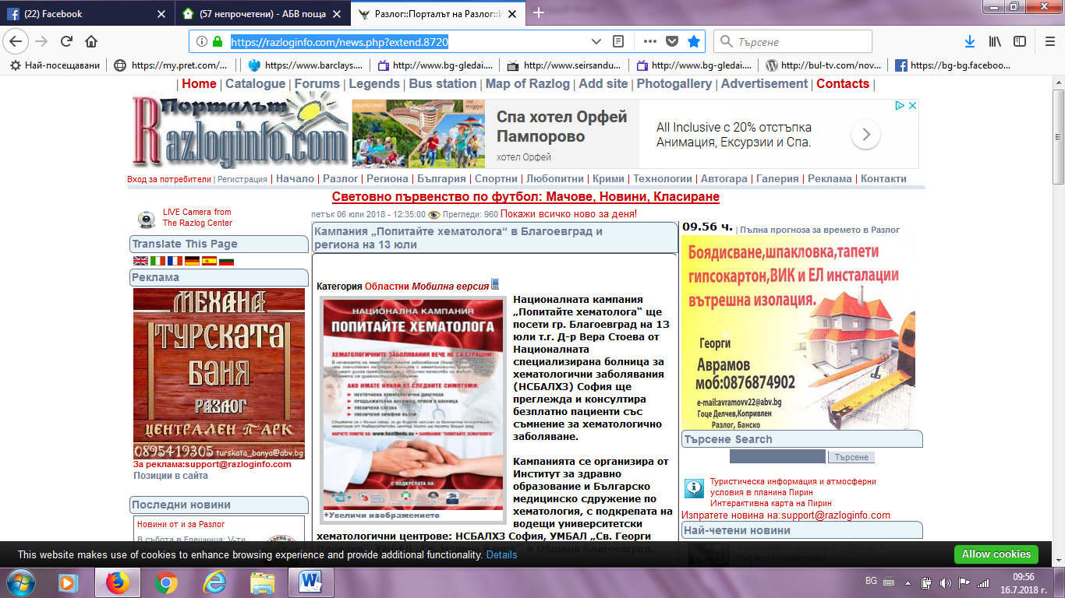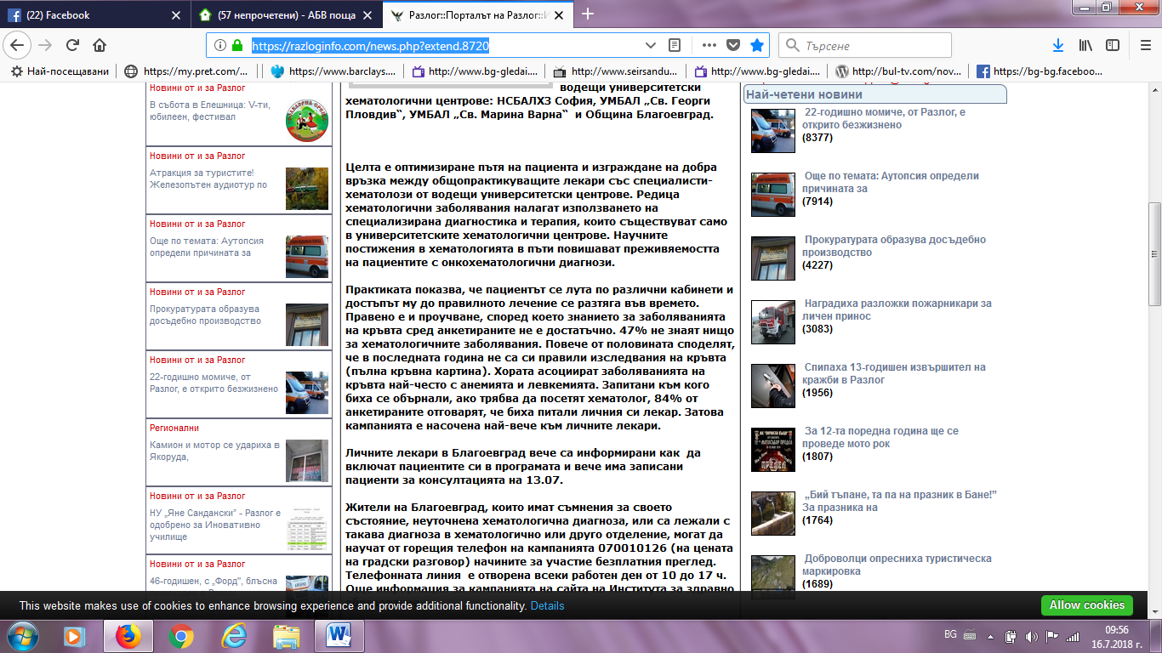

ТВ ДАРТС:
https://tvdarts.com/index.php/home/2016-10-03-21-55-07
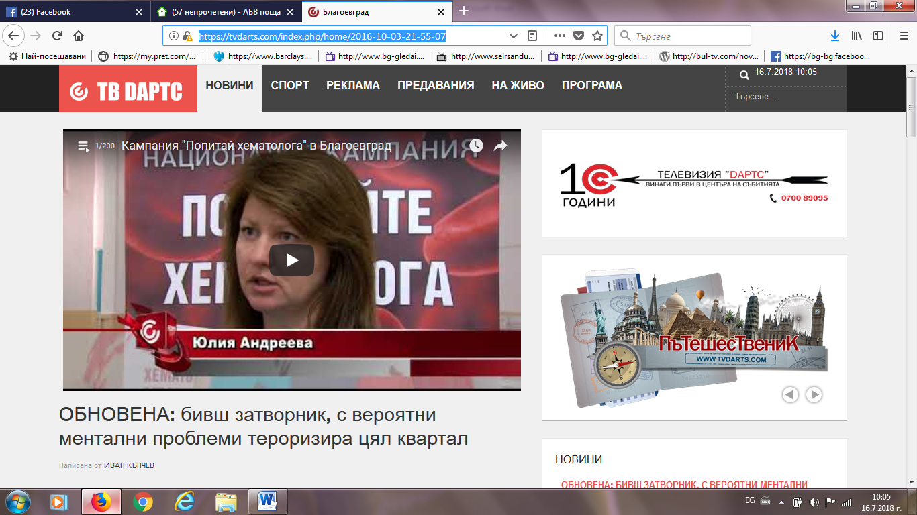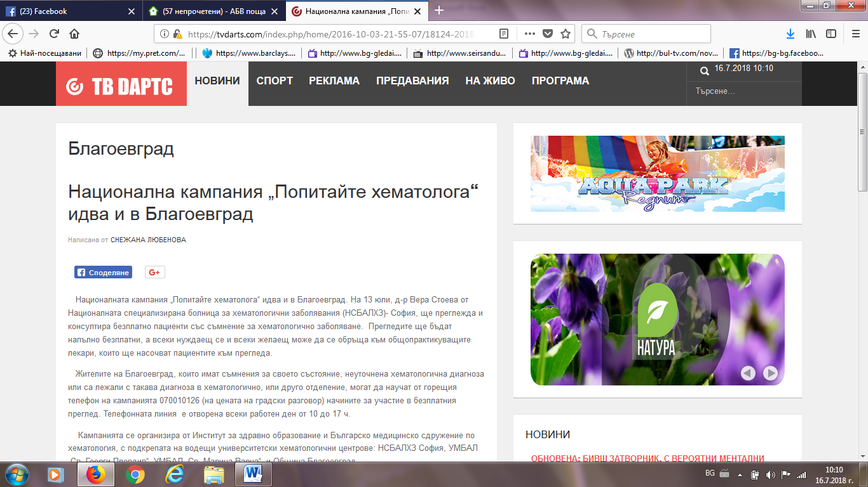

ИНФО МРЕЖА:
http://infomreja.bg/nacionalnata-kampaniq-popitajte-hematologa-shte-poseti-blagoevgrad-54087.html
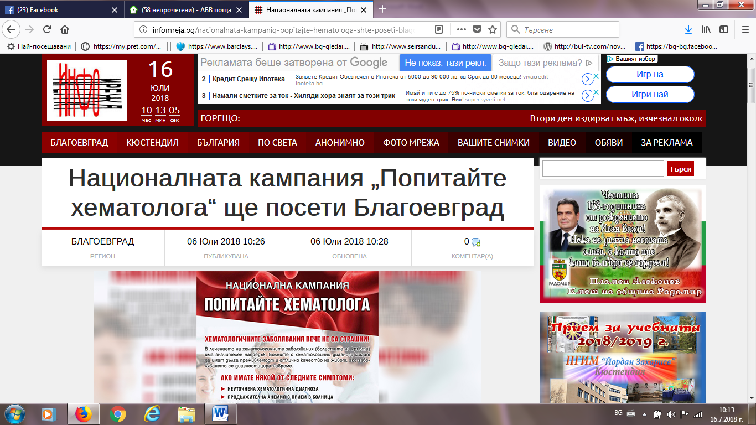
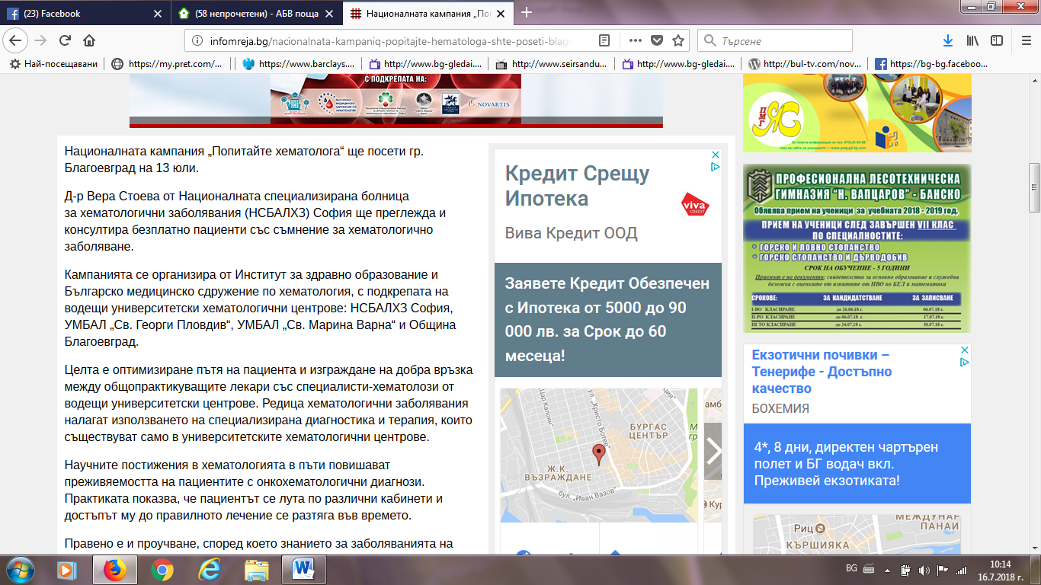

ДАРИК НЮЗ:
https://dariknews.bg/regioni/blagoevgrad/nacionalna-kampaniia-popitajte-hematologa-idva-i-v-blagoevgrad-2108399https://dariknews.bg/regioni/blagoevgrad/nacionalna-kampaniia-popitajte-hematologa-idva-i-v-blagoevgrad-2108399
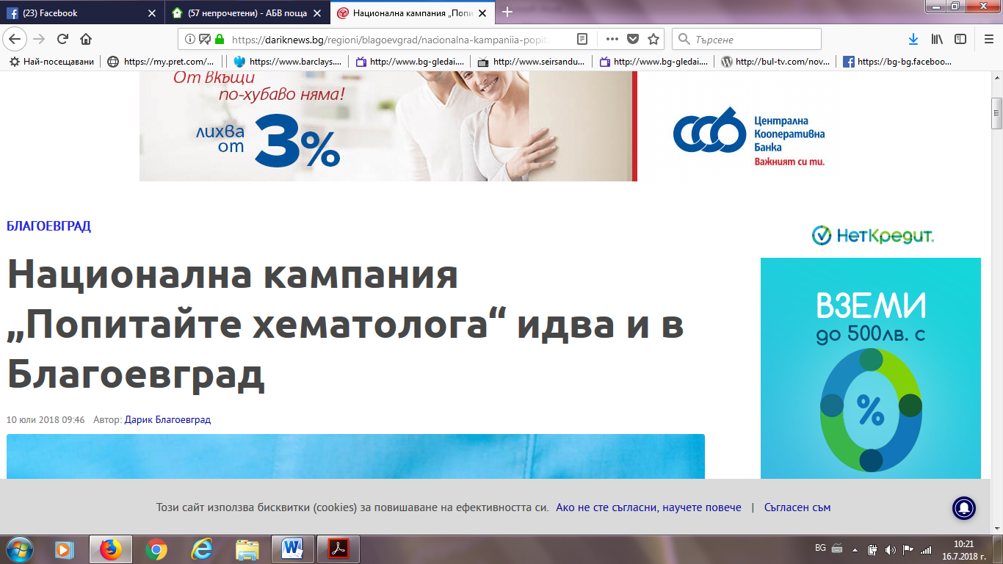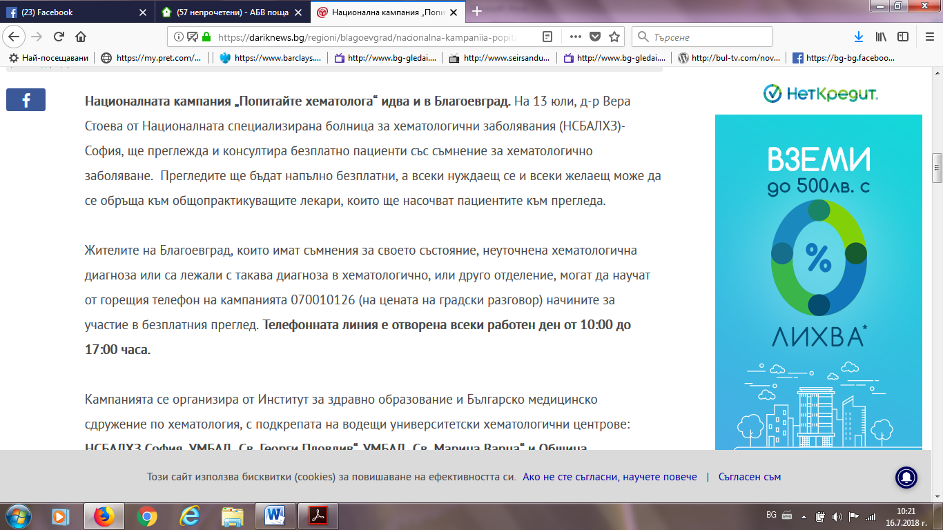

ТОП ПРЕСА:
http://toppresa.bg/148675/%D0%BF%D0%BE%D0%BF%D0%B8%D1%82%D0%B0%D0%B9%D1%82%D0%B5-%D1%85%D0%B5%D0%BC%D0%B0%D1%82%D0%BE%D0%BB%D0%BE%D0%B3%D0%B0-%D0%B1%D0%B5%D0%B7%D0%BF%D0%BB%D0%B0%D1%82%D0%BD%D0%BE-%D0%B2-%D0%B1%D0%BB%D0%B0
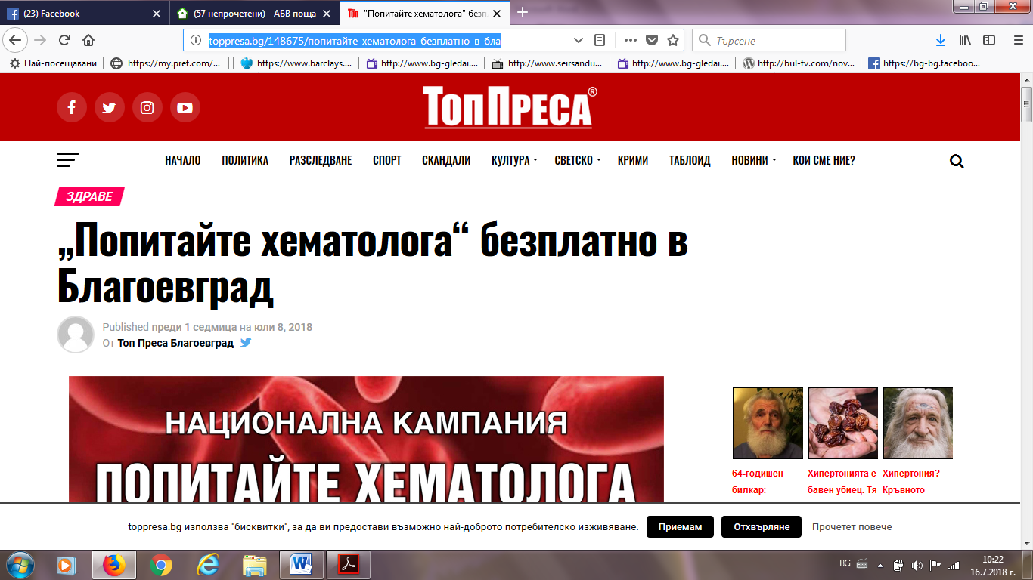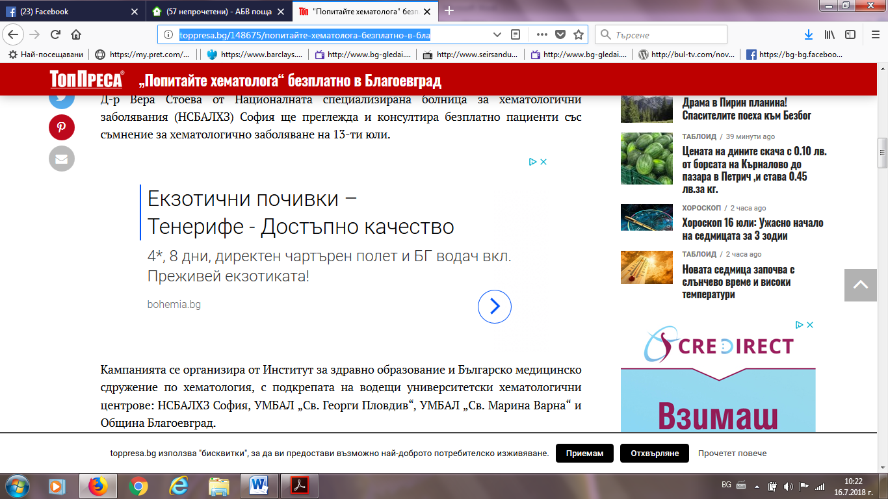

ПИРИН ПРЕС:
http://pirinpress.bg/dir/?p=47883http://pirinpress.bg/dir/?p=47883
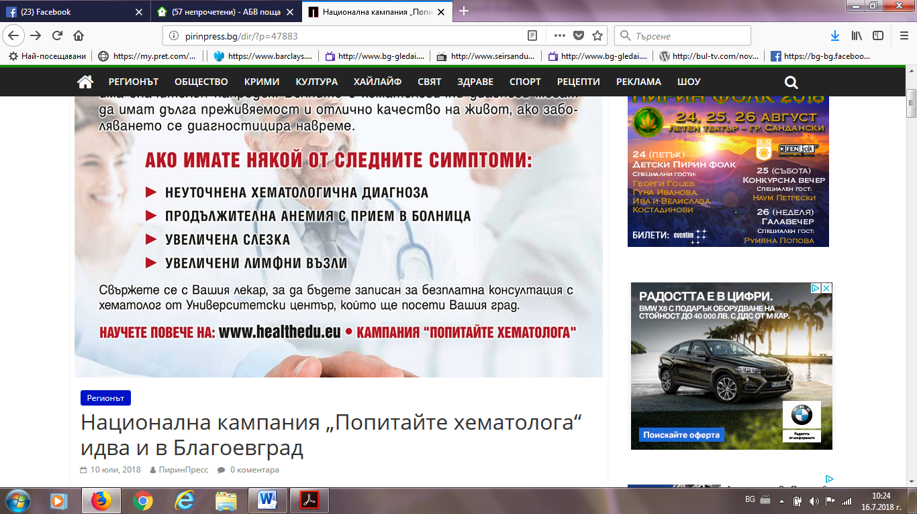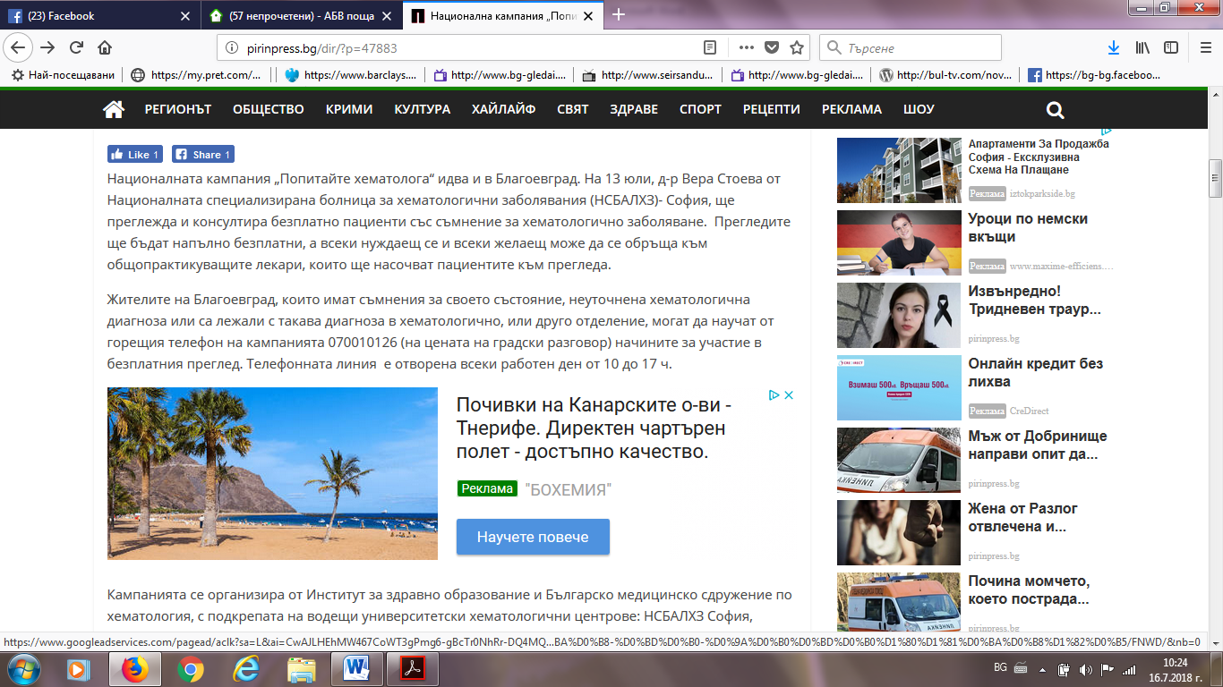

АНТЕН ЕЪР:
https://www.antenneair.eu/%D0%BA%D0%B0%D0%BC%D0%BF%D0%B0%D0%BD%D0%B8%D1%8F%D1%82%D0%B0-%E2%80%9E%D0%BF%D0%BE%D0%BF%D0%B8%D1%82%D0%B0%D0%B9%D1%82%D0%B5-%D1%85%D0%B5%D0%BC%D0%B0%D1%82%D0%BE%D0%BB%D0%BE%D0%B3%D0%B0%E2%80%9D/%D0%B1%D1%8A%D0%BB%D0%B3%D0%B0%D1%80%D0%B8%D1%8F/%D0%B7%D0%B4%D1%80%D0%B0%D0%B2%D0%B5/07/2018/

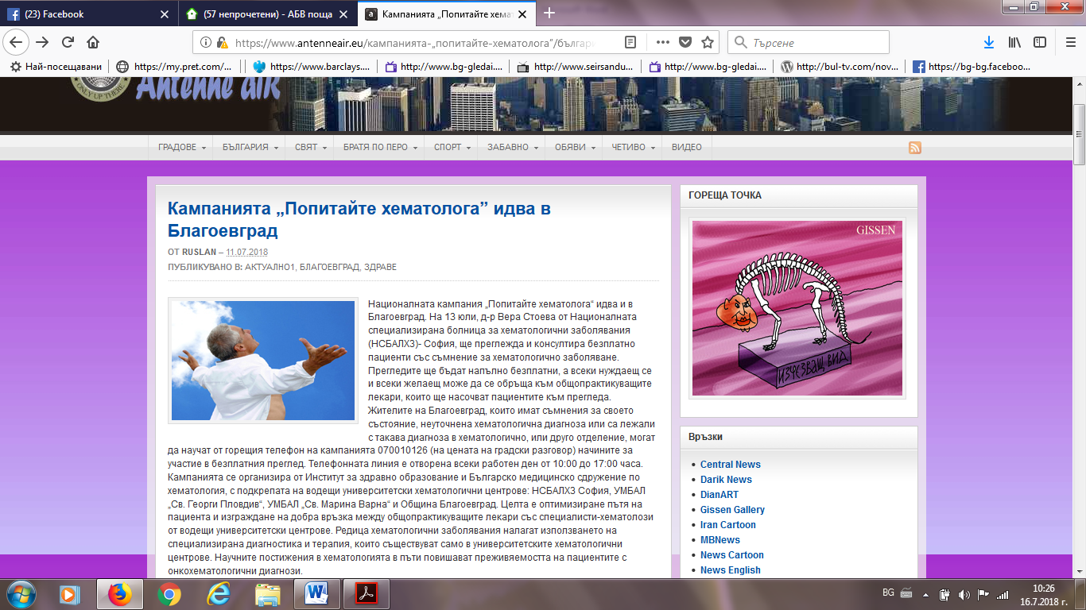

ТРУД БГ:
https://trud.bg/%D0%BD%D0%B0%D1%86%D0%B8%D0%BE%D0%BD%D0%B0%D0%BB%D0%BD%D0%B0-%D0%BA%D0%B0%D0%BC%D0%BF%D0%B0%D0%BD%D0%B8%D1%8F-%D0%BF%D0%BE%D0%BF%D0%B8%D1%82%D0%B0%D0%B9%D1%82%D0%B5-%D1%85%D0%B5%D0%BC%D0%B0/https://trud.bg/%D0%BD%D0%B0%D1%86%D0%B8%D0%BE%D0%BD%D0%B0%D0%BB%D0%BD%D0%B0-%D0%BA%D0%B0%D0%BC%D0%BF%D0%B0%D0%BD%D0%B8%D1%8F-%D0%BF%D0%BE%D0%BF%D0%B8%D1%82%D0%B0%D0%B9%D1%82%D0%B5-%D1%85%D0%B5%D0%BC%D0%B0/
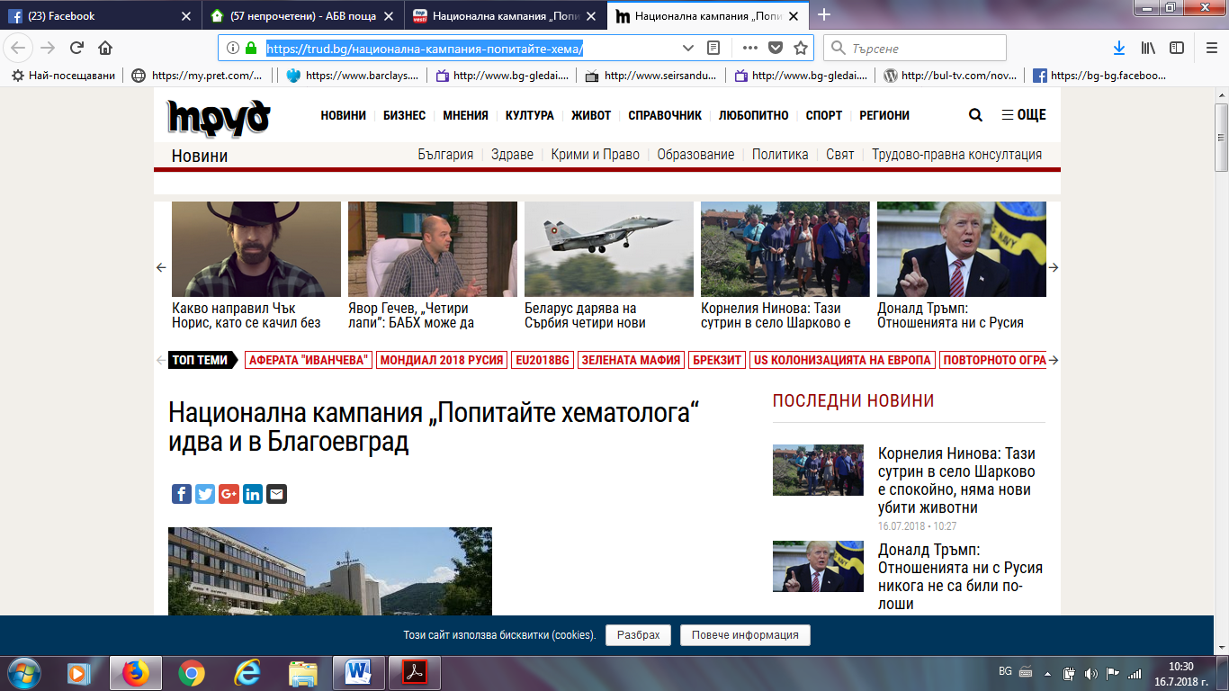
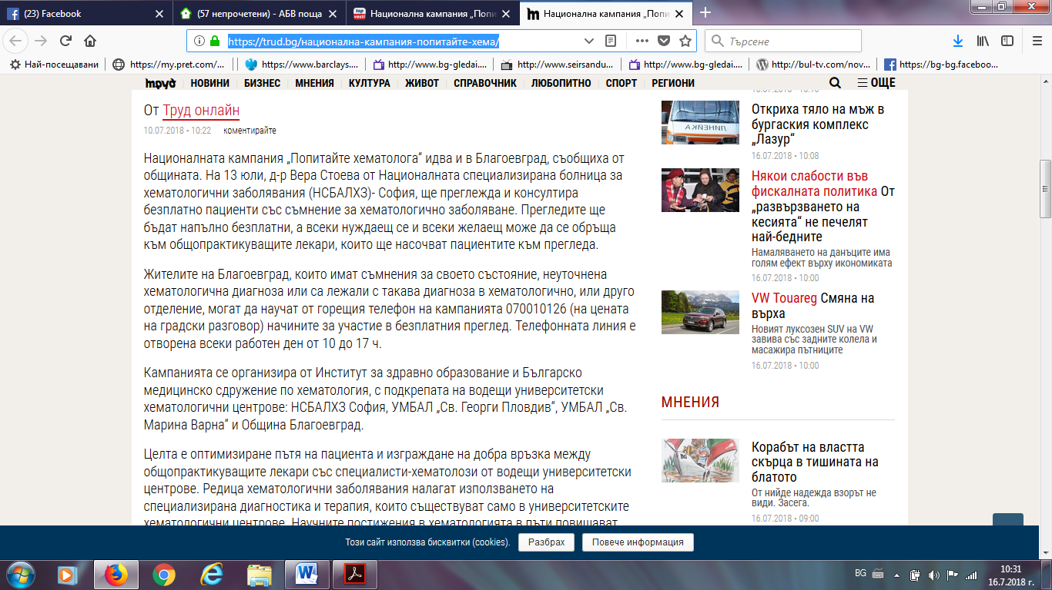
БЛАГОЕВГРАД УТРЕ:
http://www.blagoevgrad.utre.bg/2018/07/10/502742-natsionalnata_kampania_popitayte_hematologa_idva_v_blagoevgradhttp://www.blagoevgrad.utre.bg/2018/07/10/502742-natsionalnata_kampania_popitayte_hematologa_idva_v_blagoevgrad
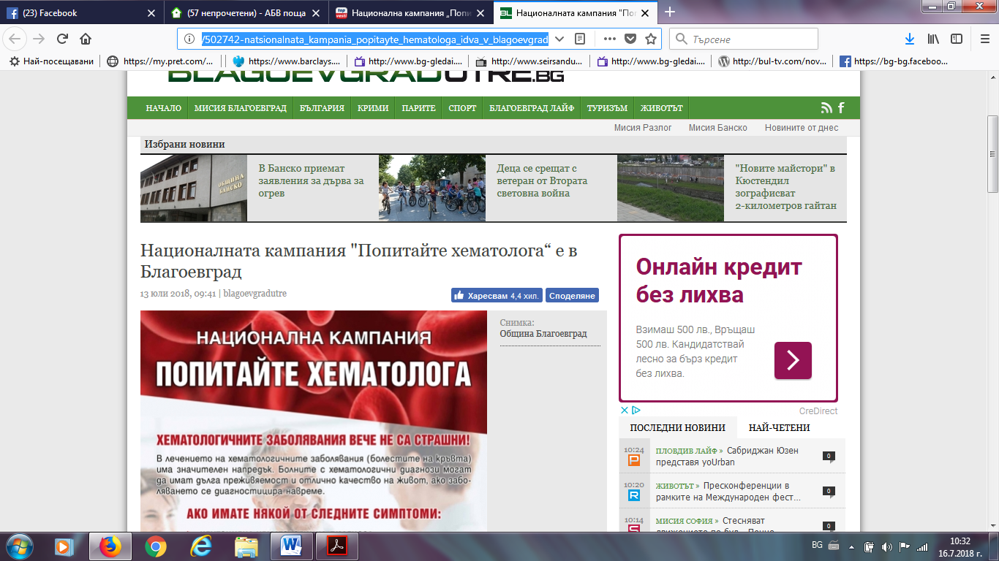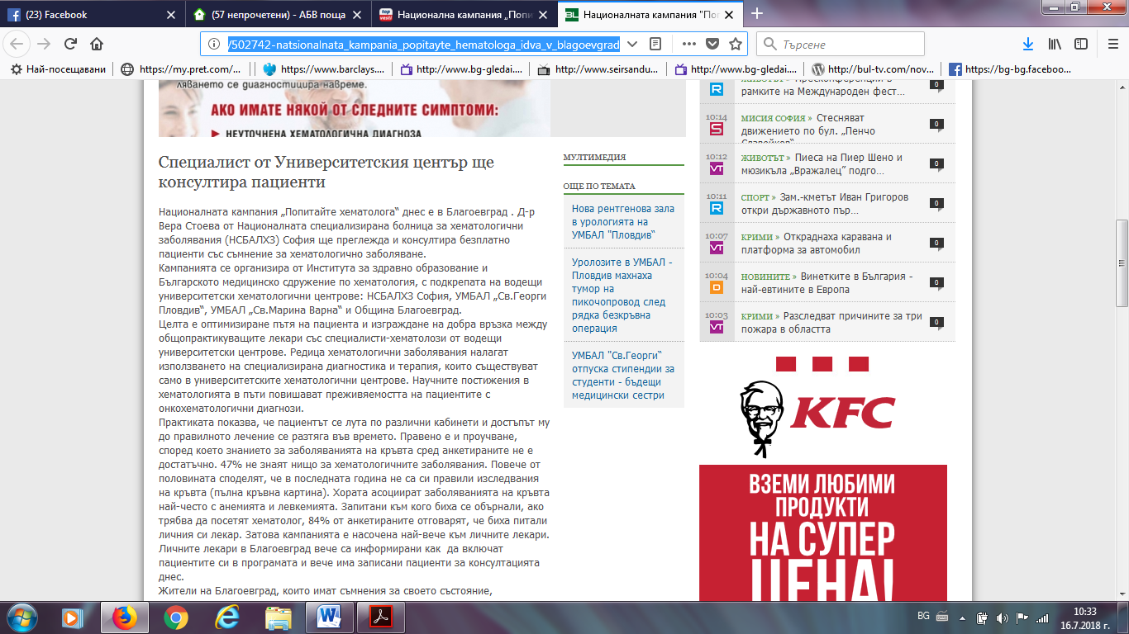

ФОКУС НЮЗ:
http://focus-news.net/news/2018/07/10/2543616/blagoevgrad-natsionalna-kampaniya-popitayte-hematologa-idva-i-v-grada.html
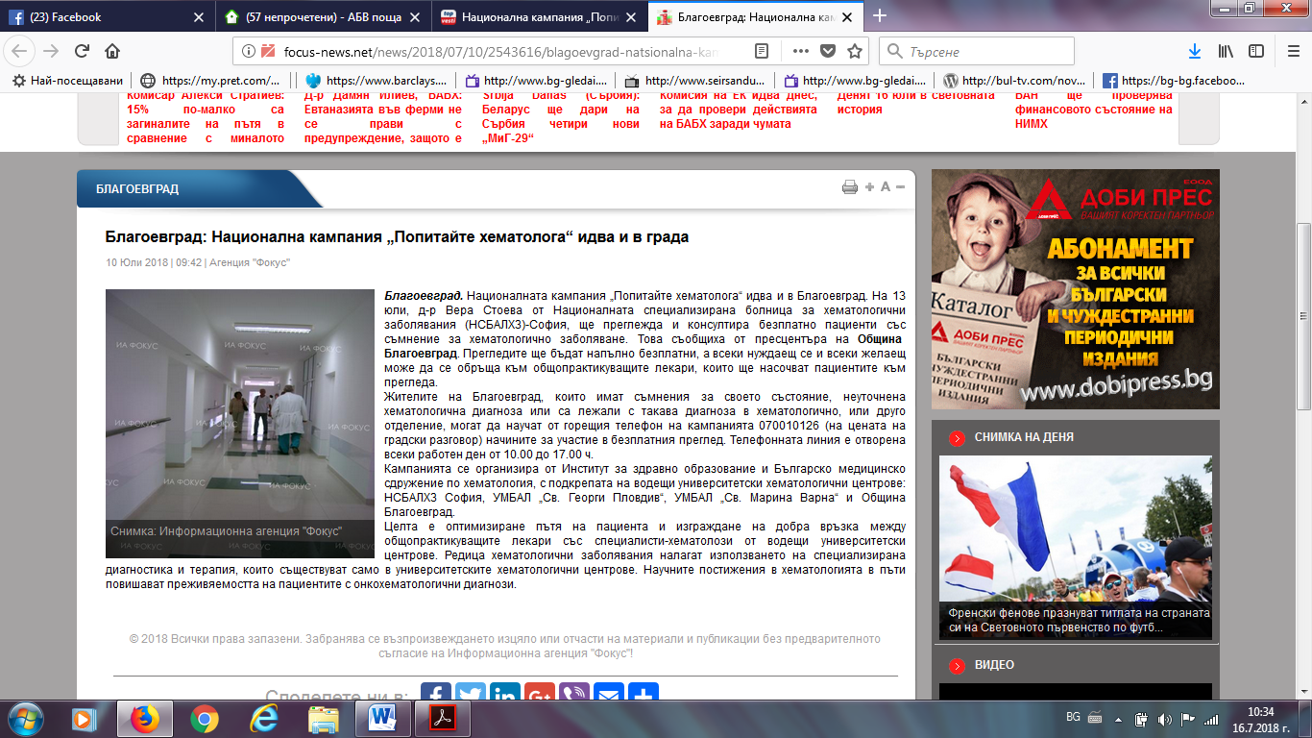
БЛАГОЕВГРАД 24 БГ:
http://www.blagoevgrad24.bg/news/802025.html
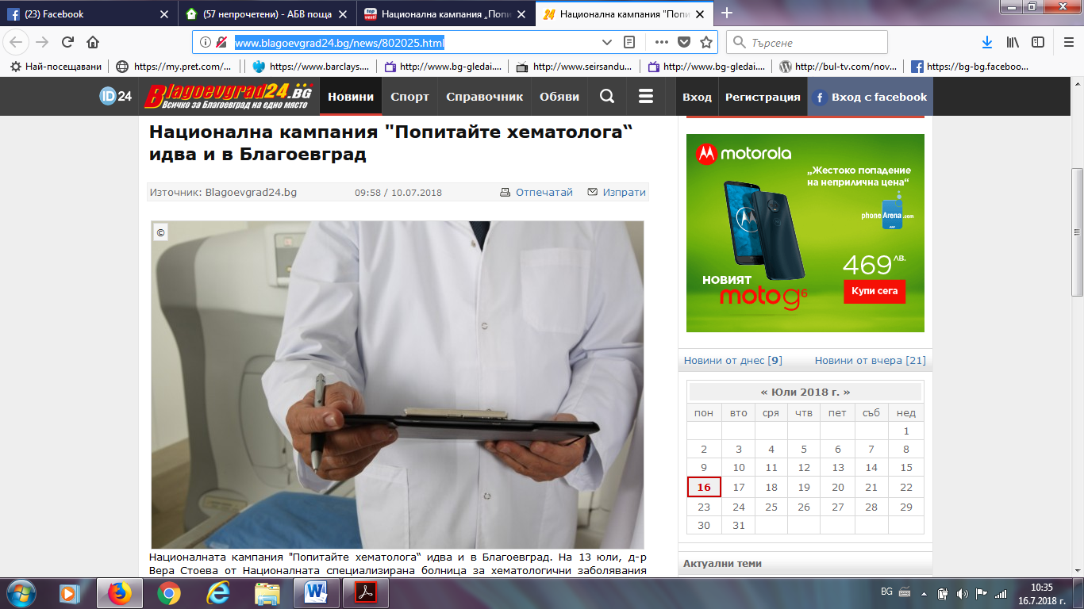

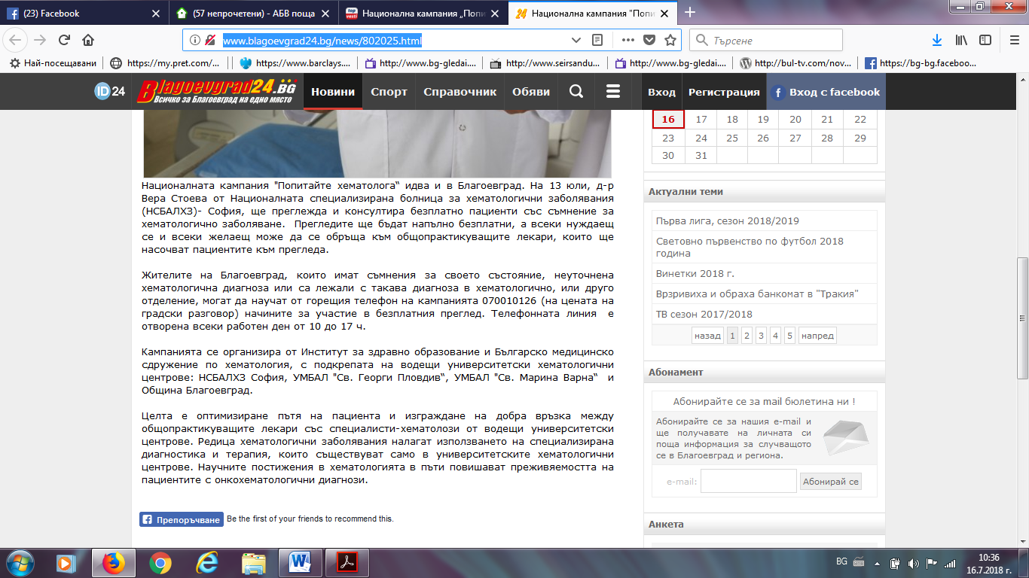
СТРУМА:
https://struma.bg/%D0%B1%D0%B5%D0%B7%D0%BF%D0%BB%D0%B0%D1%82%D0%BD%D0%B8-%D0%BC%D0%B5%D0%B4%D0%B8%D1%86%D0%B8%D0%BD%D1%81%D0%BA%D0%B8-%D0%BF%D1%80%D0%B5%D0%B3%D0%BB%D0%B5%D0%B4%D0%B8-%D0%B2-%D0%B1%D0%BB%D0%B0%D0%B3/
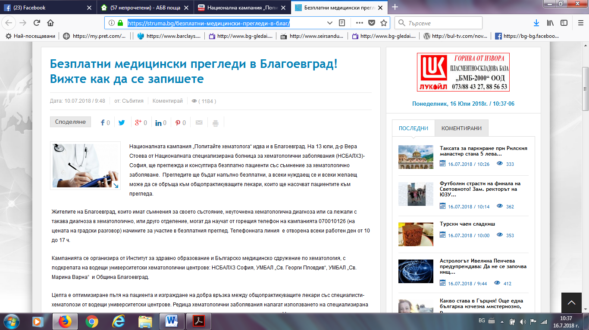

ПАЛО БГ:
http://www.palo.bg/a/%D0%BD%D0%B0%D1%86%D0%B8%D0%BE%D0%BD%D0%B0%D0%BB%D0%BD%D0%B0-%D0%BA%D0%B0%D0%BC%D0%BF%D0%B0%D0%BD%D0%B8%D1%8F-%D0%BF%D0%BE%D0%BF%D0%B8%D1%82%D0%B0%D0%B9%D1%82%D0%B5-%D1%85%D0%B5%D0%BC%D0%B0%D1%82%D0%BE%D0%BB%D0%BE%D0%B3%D0%B0-%D0%B8%D0%B4%D0%B2%D0%B0-%D0%B8-%D0%B2-%D0%B1%D0%BB%D0%B0%D0%B3%D0%BE%D0%B5%D0%B2%D0%B3%D1%80%D0%B0%D0%B4-232742
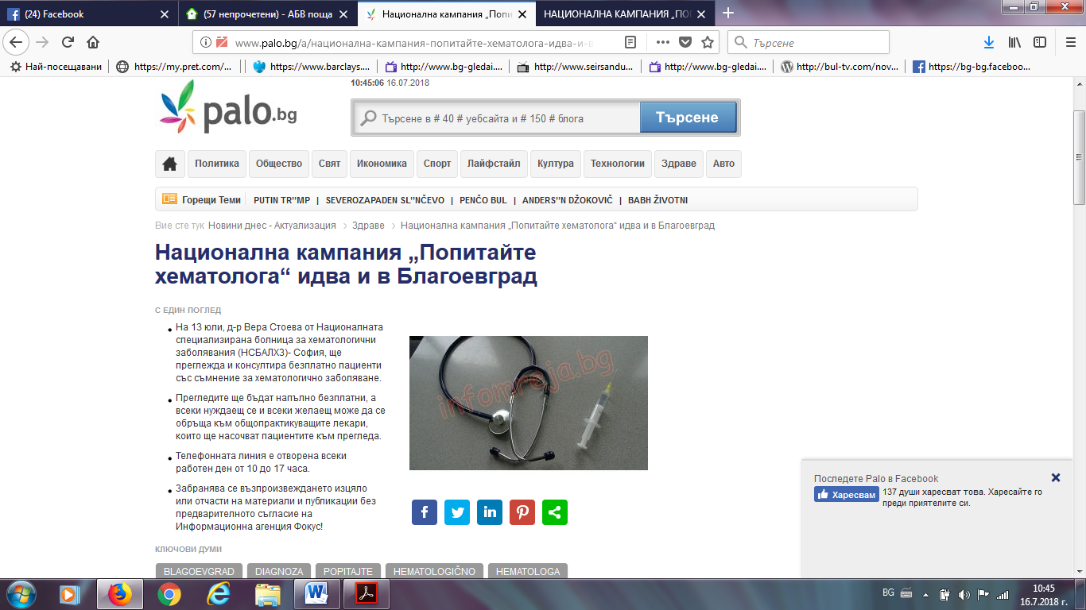
ПИРИНСКО: http://pirinsko.com/nacionalna-kampaniq-popitajte-hematologa-idva-i-v-blagoevgrad-47932.html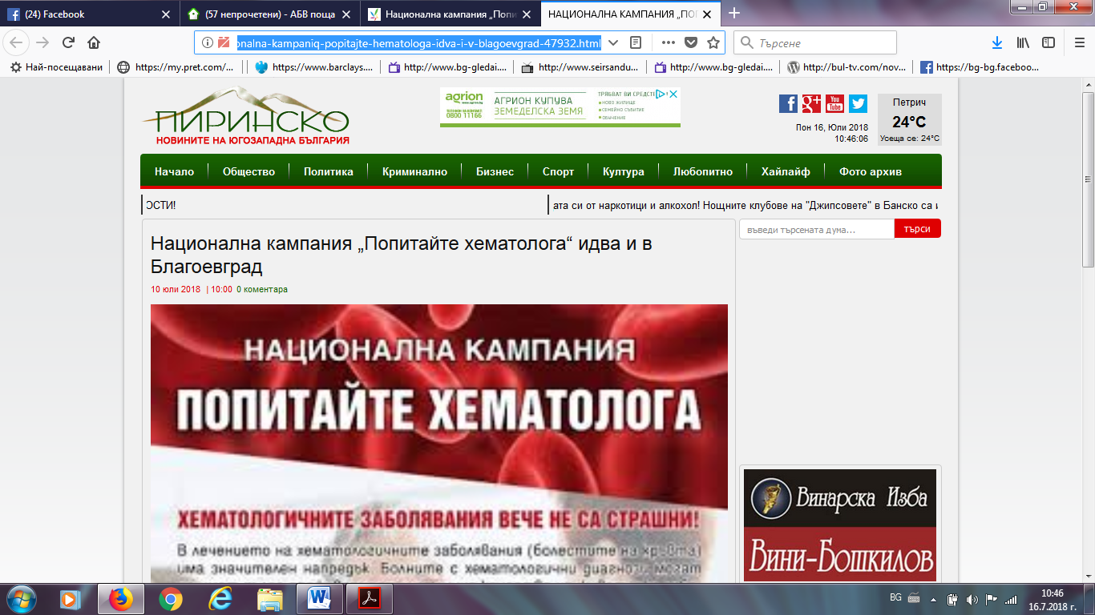
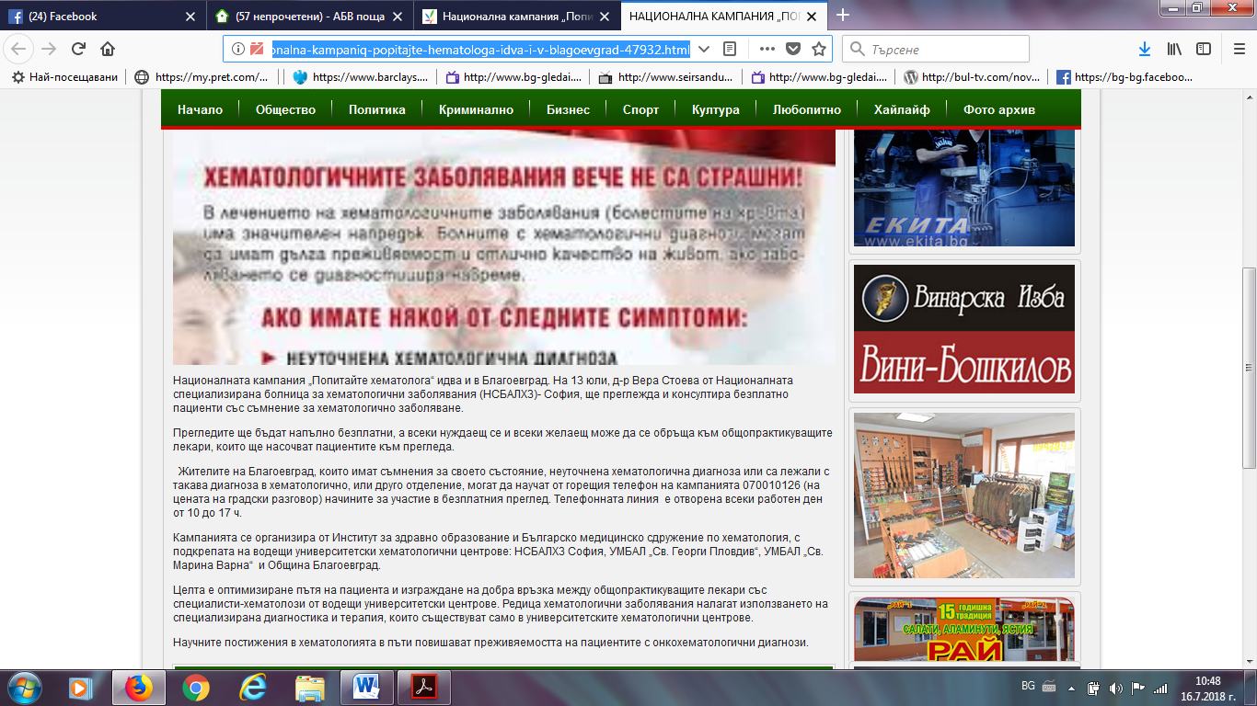
БНР:
http://bnr.bg/blagoevgrad/post/100993815
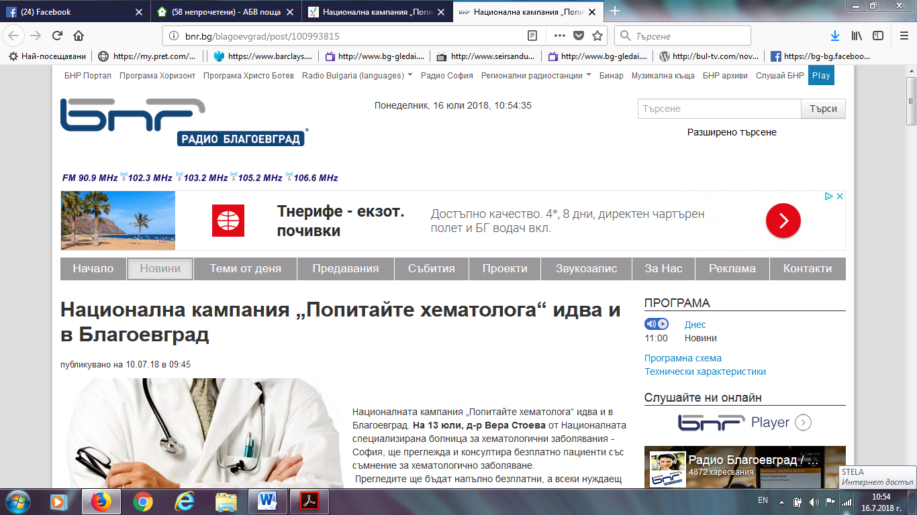

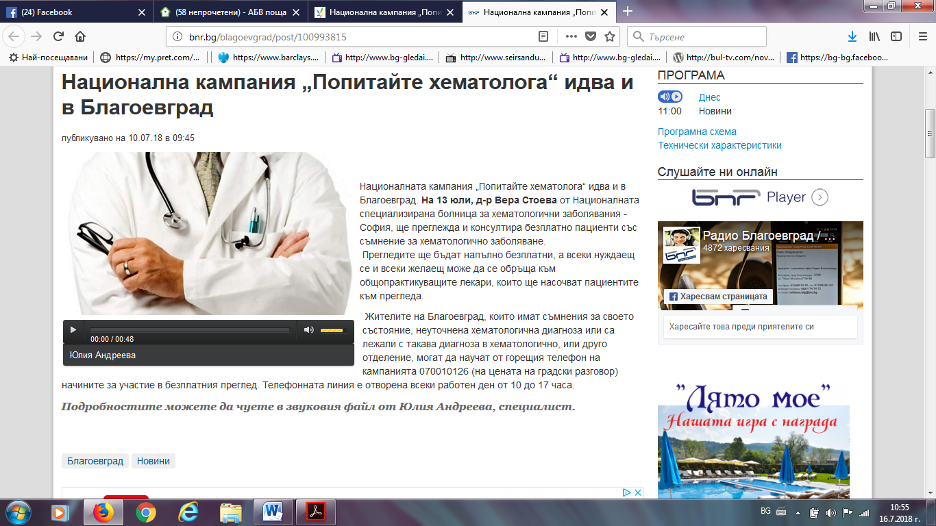
ОБЩИНА БЛАГОЕВГРАД:
http://www.blgmun.com/news4201/nacionalna-kampaniya-popitaite-hematologa-idva-i-v-blagoevgrad.html
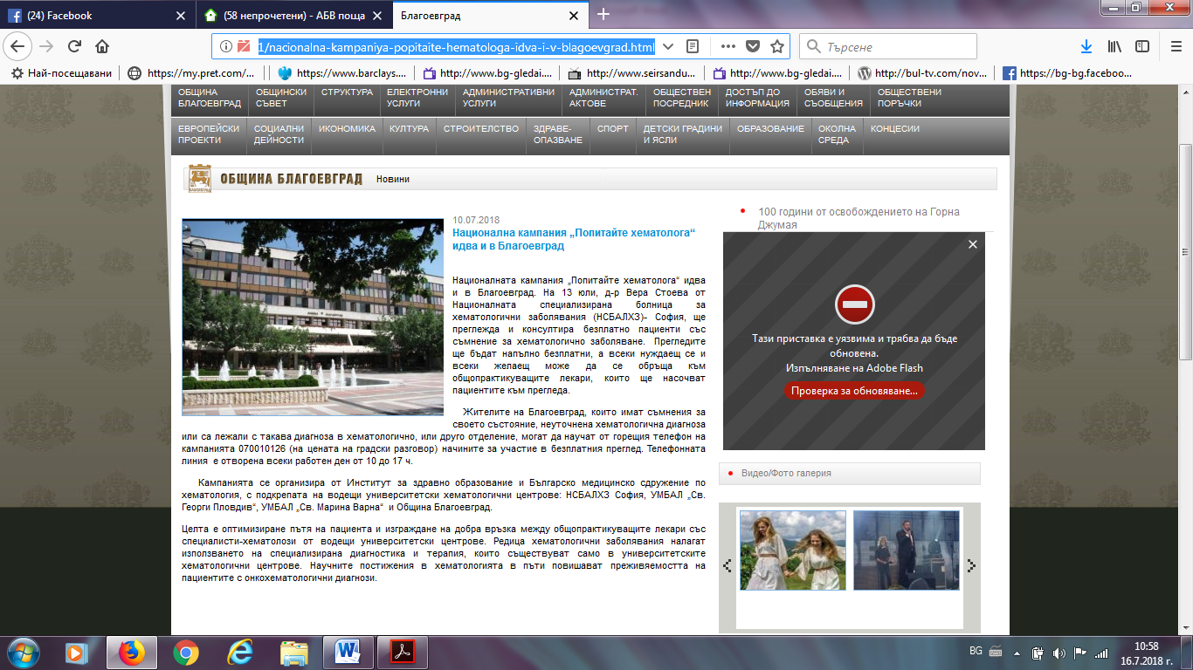

Е-79:
https://e-79.bg/%D0%B1%D1%8A%D0%BB%D0%B3%D0%B0%D1%80%D0%B8%D1%8F/%D0%BE%D0%B1%D1%89%D0%B5%D1%81%D1%82%D0%B2%D0%BE/%D0%B1%D0%B5%D0%B7%D0%BF%D0%BB%D0%B0%D1%82%D0%BD%D0%B8-%D1%85%D0%B5%D0%BC%D0%B0%D1%82%D0%BE%D0%BB%D0%BE%D0%B3%D0%B8%D1%87%D0%BD%D0%B8-%D0%BF%D1%80%D0%B5%D0%B3%D0%BB%D0%B5%D0%B4%D0%B8-%D0%B2-%D0%B1/https://e-79.bg/%D0%B1%D1%8A%D0%BB%D0%B3%D0%B0%D1%80%D0%B8%D1%8F/%D0%BE%D0%B1%D1%89%D0%B5%D1%81%D1%82%D0%B2%D0%BE/%D0%B1%D0%B5%D0%B7%D0%BF%D0%BB%D0%B0%D1%82%D0%BD%D0%B8-%D1%85%D0%B5%D0%BC%D0%B0%D1%82%D0%BE%D0%BB%D0%BE%D0%B3%D0%B8%D1%87%D0%BD%D0%B8-%D0%BF%D1%80%D0%B5%D0%B3%D0%BB%D0%B5%D0%B4%D0%B8-%D0%B2-%D0%B1/

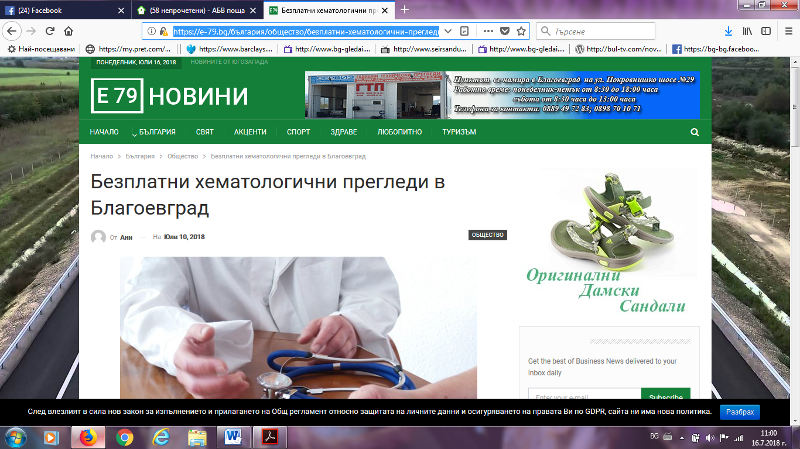

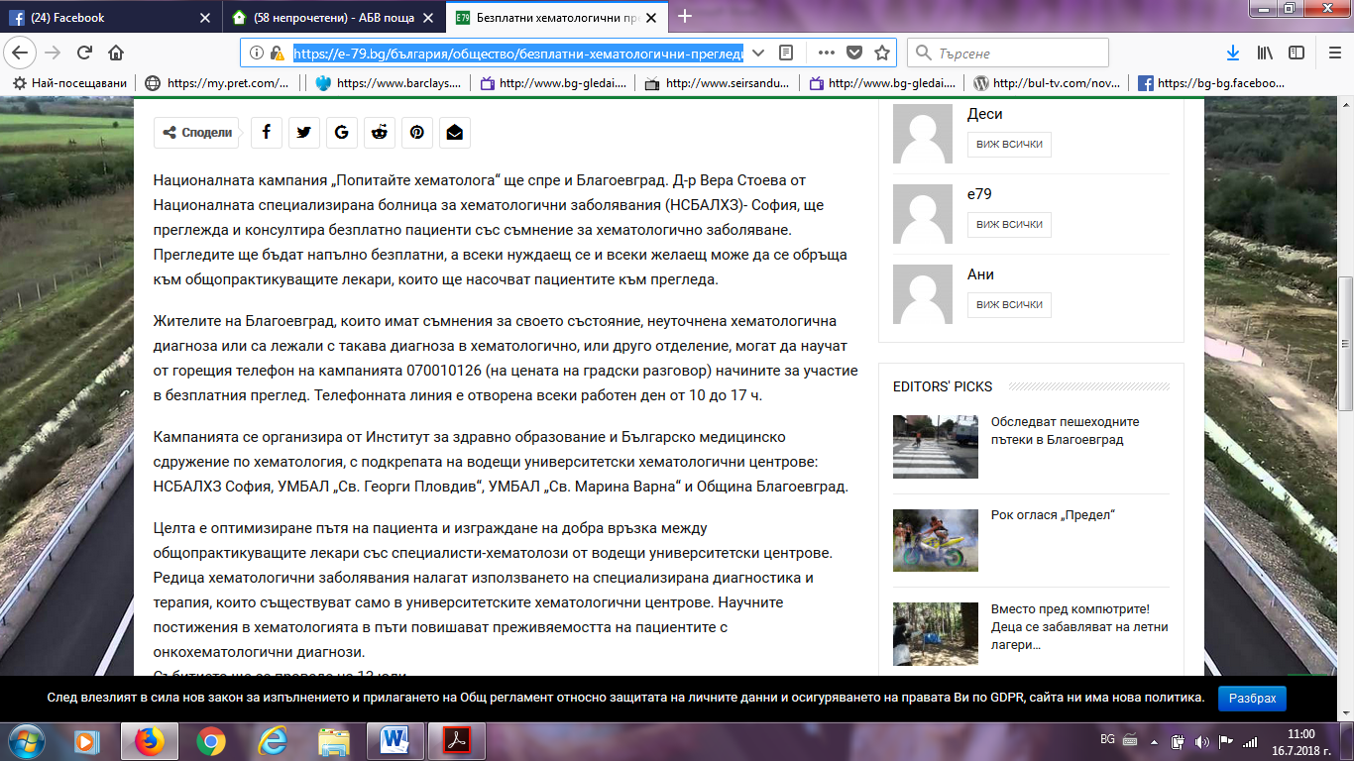
Благоевград нюз:
http://blagoevgrad-news.com/%D0%B1%D0%B5%D0%B7%D0%BF%D0%BB%D0%B0%D1%82%D0%BD%D0%B8-%D0%BC%D0%B5%D0%B4%D0%B8%D1%86%D0%B8%D0%BD%D1%81%D0%BA%D0%B8-%D0%BF%D1%80%D0%B5%D0%B3%D0%BB%D0%B5%D0%B4%D0%B8-%D0%BD%D0%B0-13-%D1%8E%D0%BB%D0%B8/
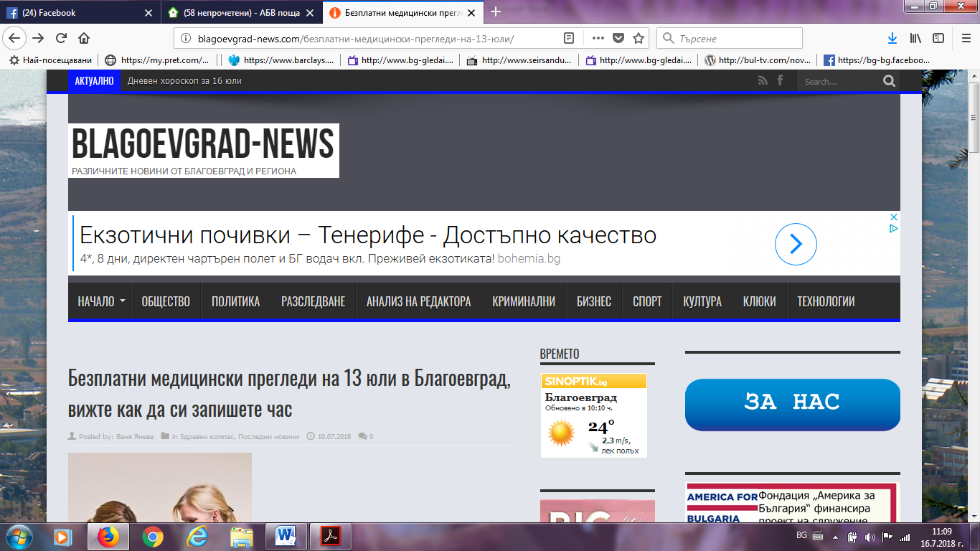

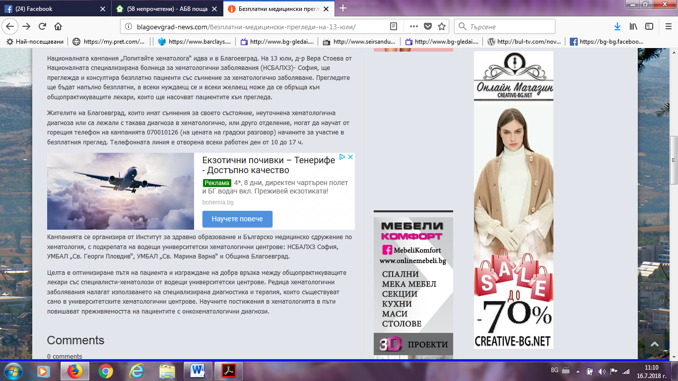
ХЕМАТОЛОГИ. БГ:
https://hematology.bg/2018/07/12/%d0%bd%d0%b0%d1%86%d0%b8%d0%be%d0%bd%d0%b0%d0%bb%d0%bd%d0%b0%d1%82%d0%b0-%d0%ba%d0%b0%d0%bc%d0%bf%d0%b0%d0%bd%d0%b8%d1%8f-%d0%bf%d0%be%d0%bf%d0%b8%d1%82%d0%b0%d0%b9%d1%82%d0%b5-%d1%85%d0%b5/https://hematology.bg/2018/07/12/%d0%bd%d0%b0%d1%86%d0%b8%d0%be%d0%bd%d0%b0%d0%bb%d0%bd%d0%b0%d1%82%d0%b0-%d0%ba%d0%b0%d0%bc%d0%bf%d0%b0%d0%bd%d0%b8%d1%8f-%d0%bf%d0%be%d0%bf%d0%b8%d1%82%d0%b0%d0%b9%d1%82%d0%b5-%d1%85%d0%b5/
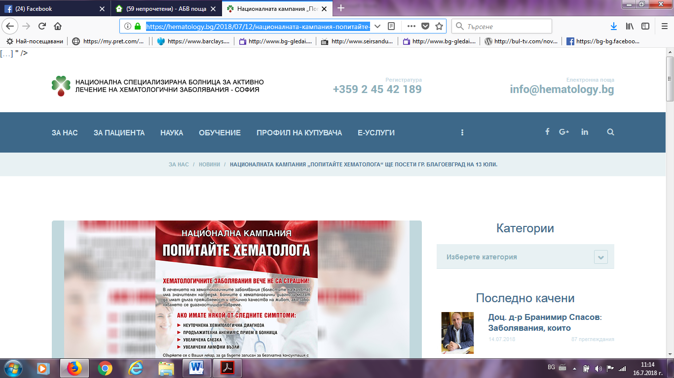
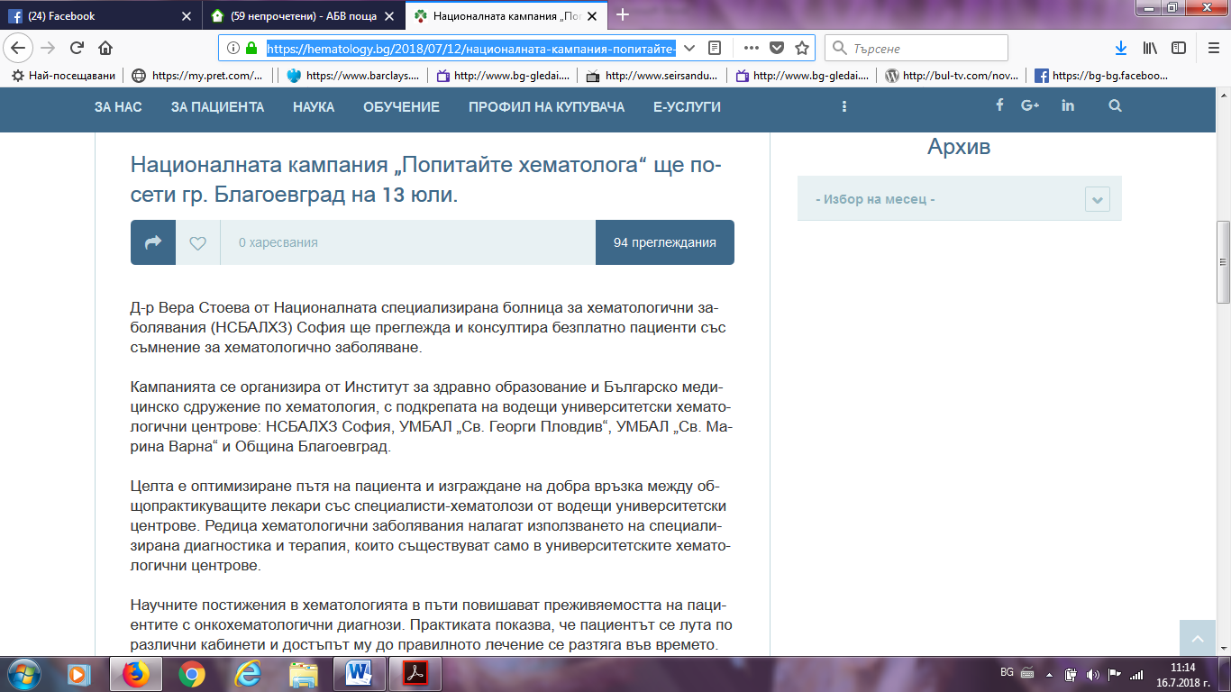
ФЕЙСБУК БЛАГОЕГРАД:
https://www.facebook.com/blgrad/posts/10155564490671981/
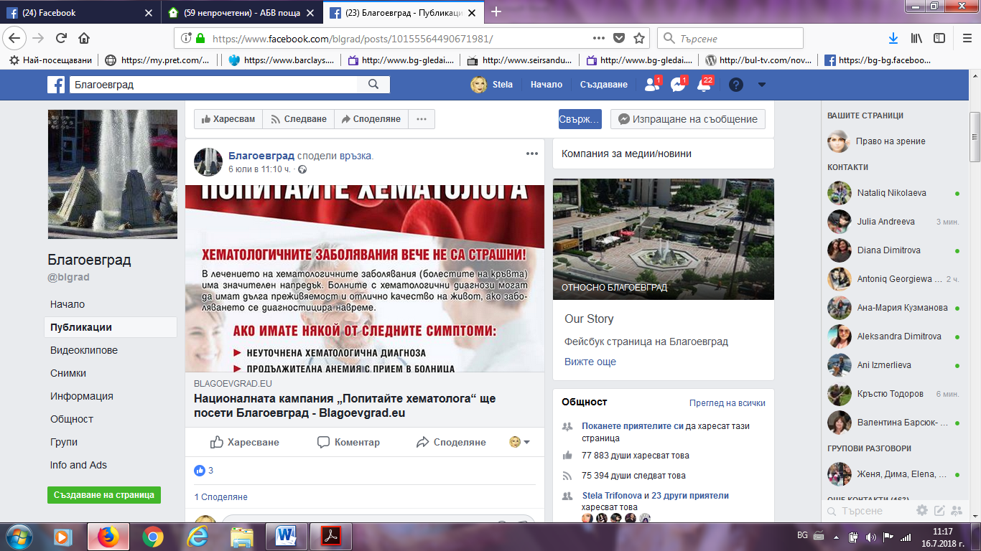

Е НОВИНА.БГ:
http://enovina.bg/novina/bezplatni-pregledi-v-blagoevgrad-4996/http://enovina.bg/novina/bezplatni-pregledi-v-blagoevgrad-4996/
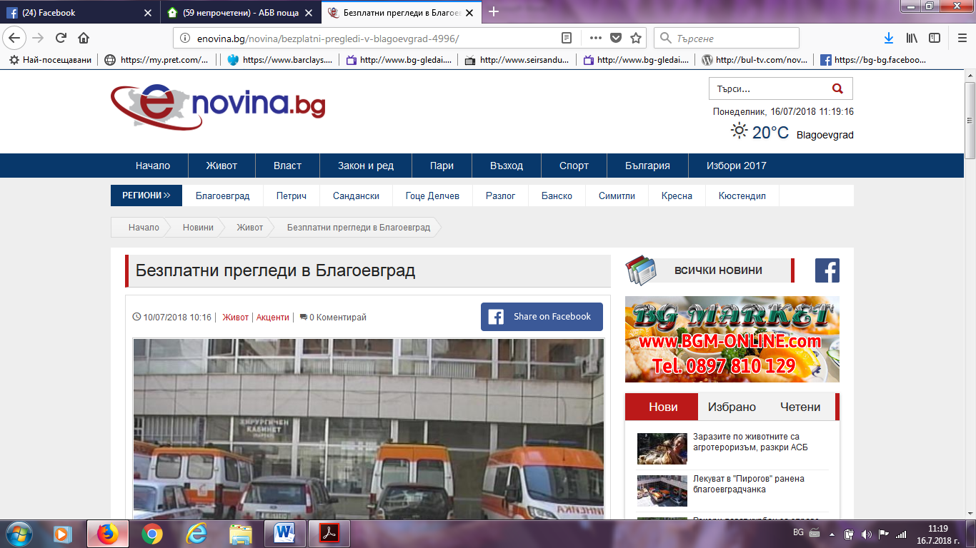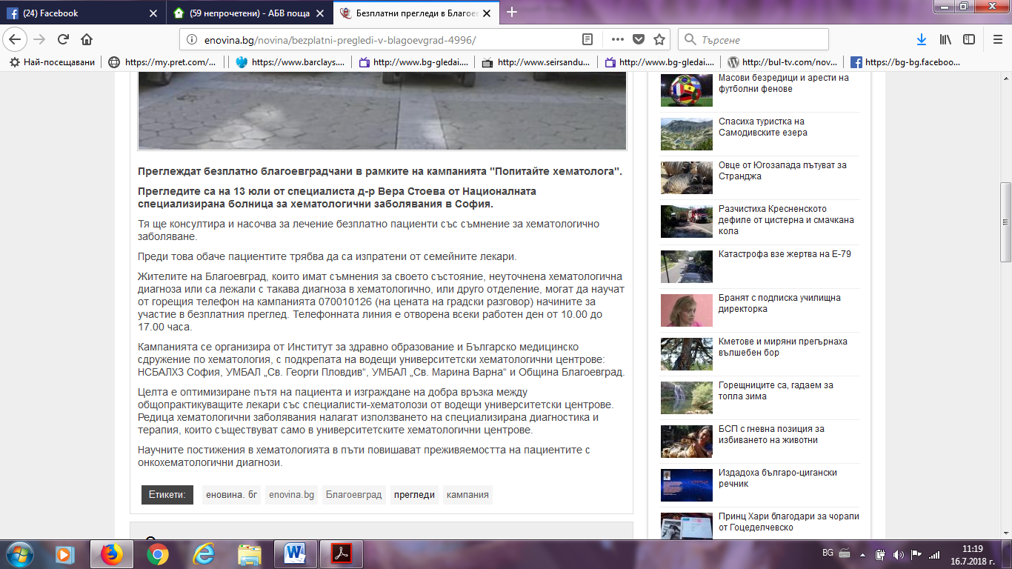

ПИРИН НЮЗ:
http://pirinnews.com/novina/669/nacionalna-kampaniya-popitajte-hematologa-idva-i-v-blagoevgrad/http://pirinnews.com/novina/669/nacionalna-kampaniya-popitajte-hematologa-idva-i-v-blagoevgrad/
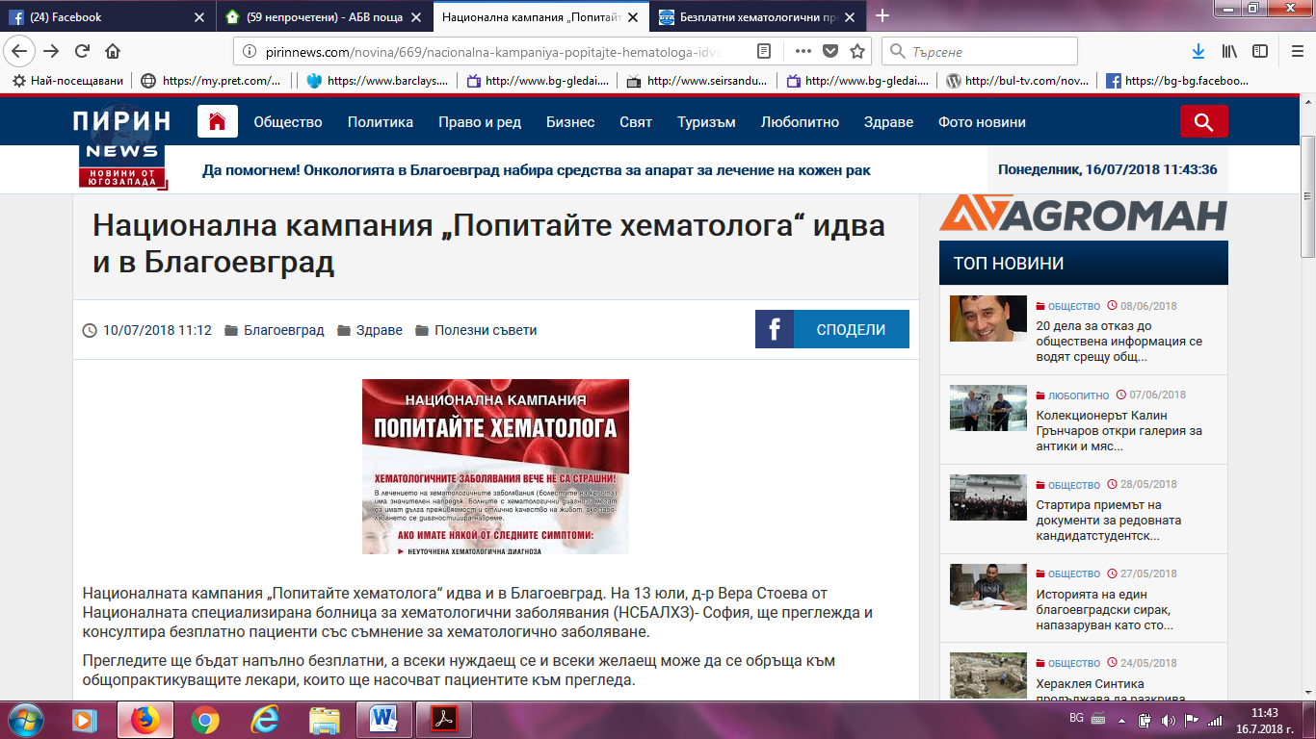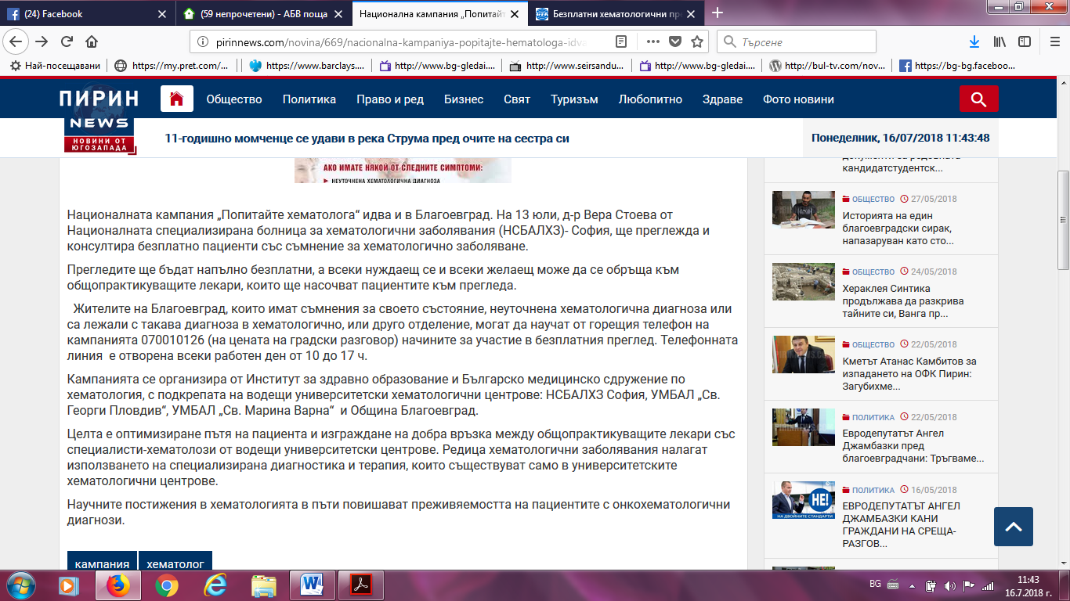

ФОКУС РАДИО:
http://focus-radio.net/%D0%BD%D0%B0%D1%86%D0%B8%D0%BE%D0%BD%D0%B0%D0%BB%D0%BD%D0%B0-%D0%BA%D0%B0%D0%BC%D0%BF%D0%B0%D0%BD%D0%B8%D1%8F-%D0%BF%D0%BE%D0%BF%D0%B8%D1%82%D0%B0%D0%B9%D1%82%D0%B5-%D1%85%D0%B5%D0%BC%D0%B0/
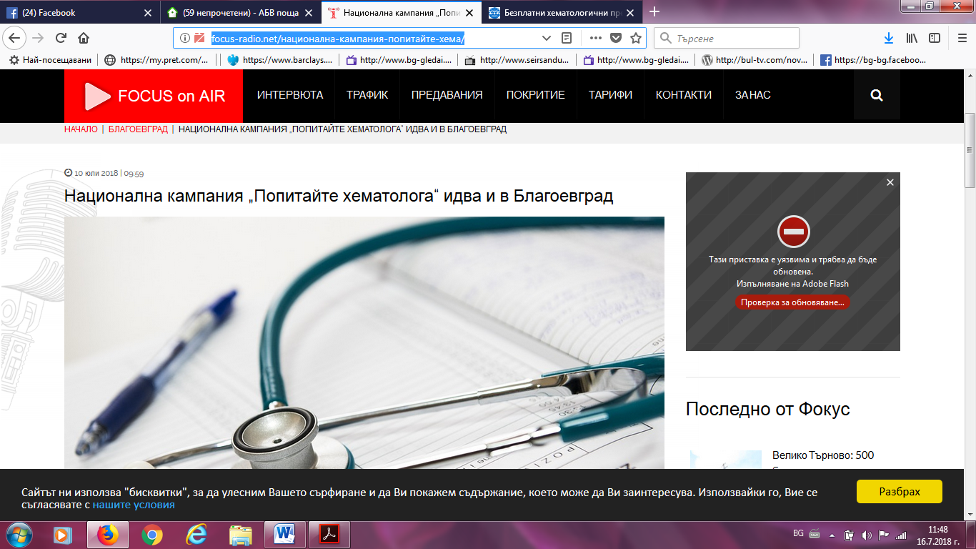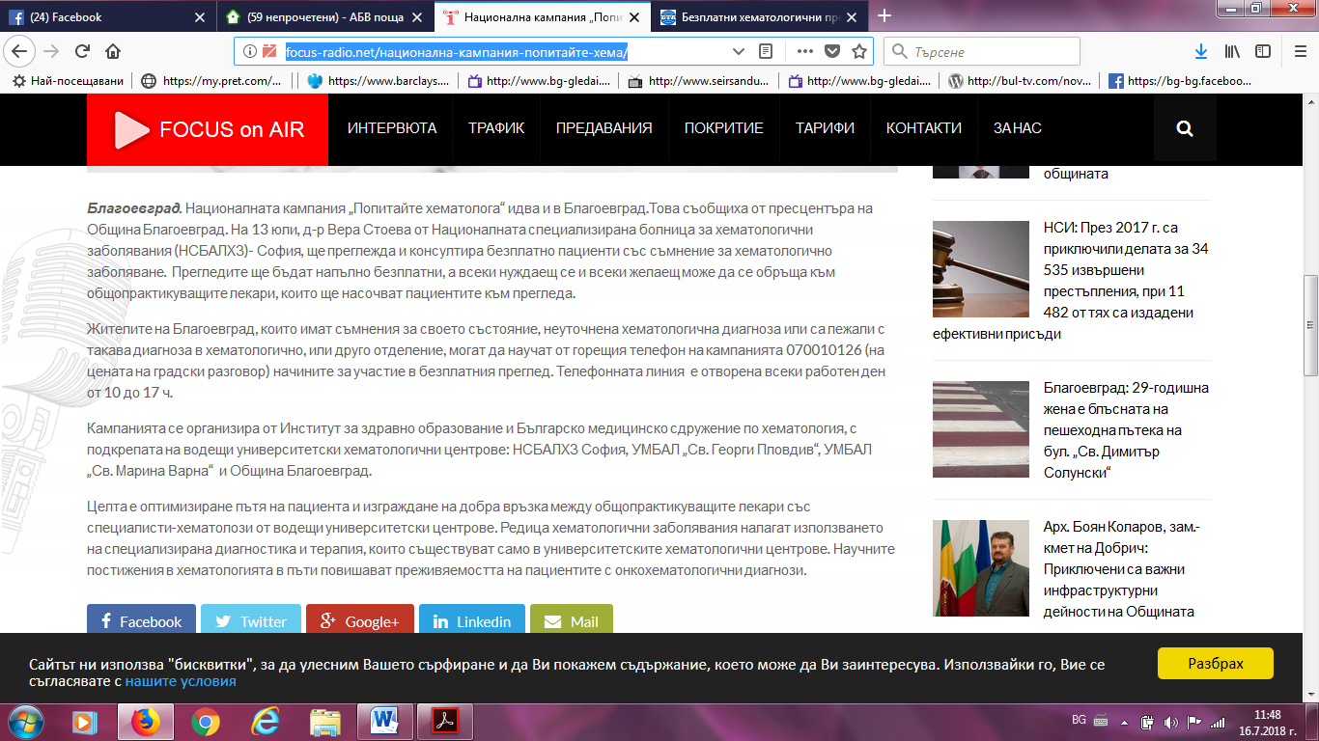

БЛАГОЕВГРАД ИНФО:
http://blagoevgrad.info/article/18/07/10/natsionalnata-kampaniya-%E2%80%9Epopitaite-hematologa%E2%80%9C-shche-poseti-gr-blagoevgrad
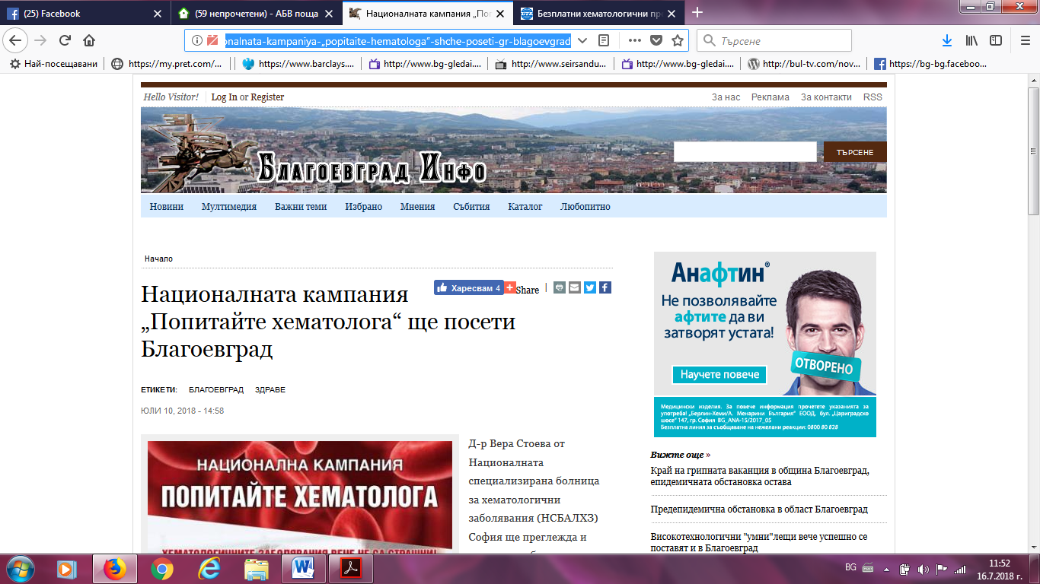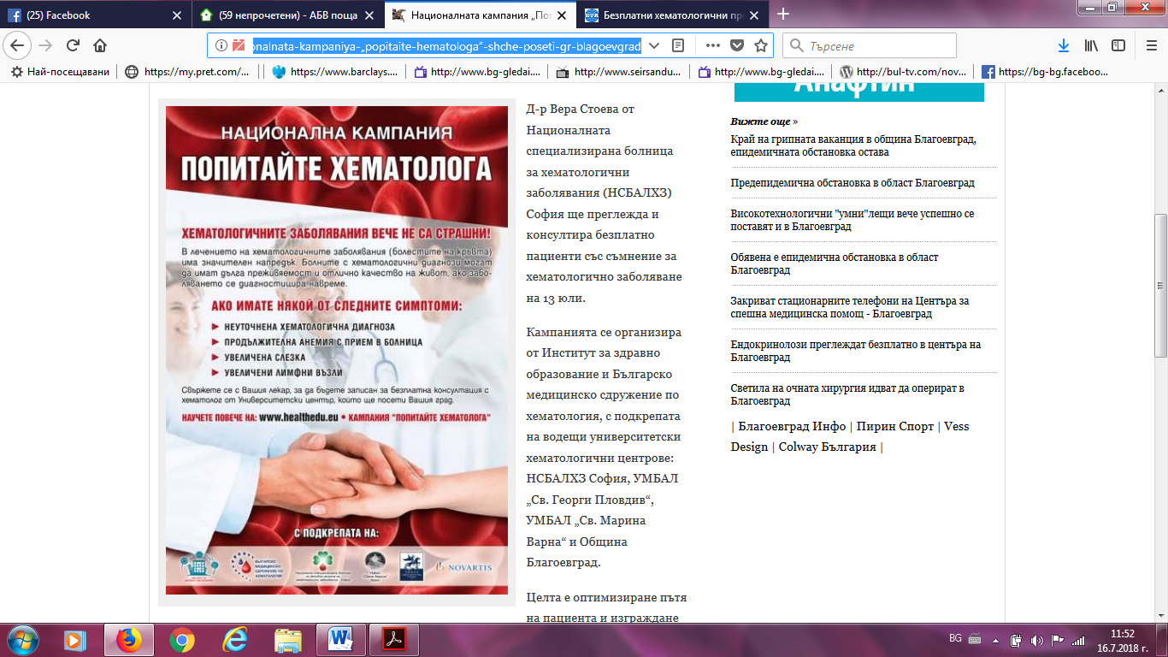

ТОП НОВИНИ:
https://blagoevgrad.topnovini.bg/node/798636https://blagoevgrad.topnovini.bg/node/798636
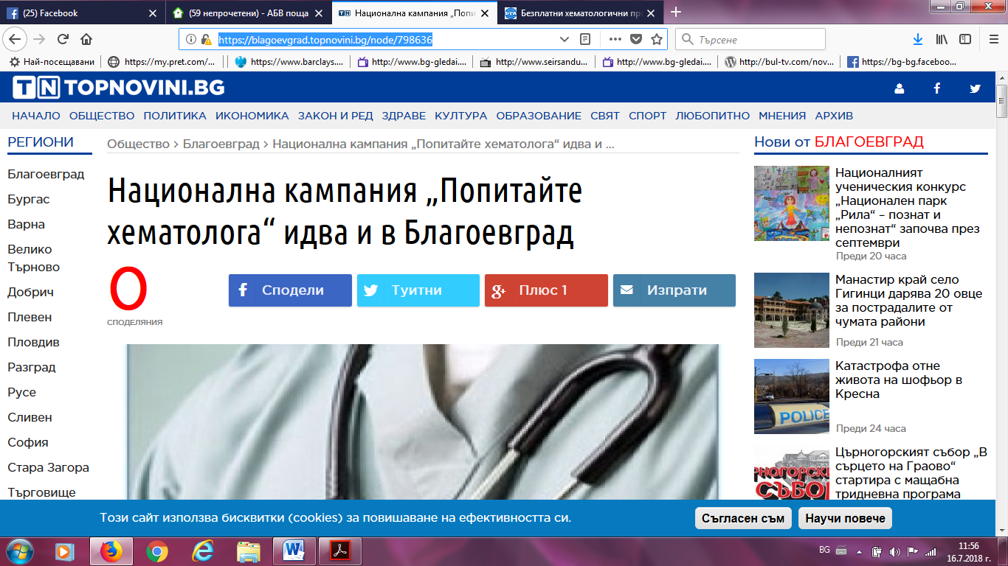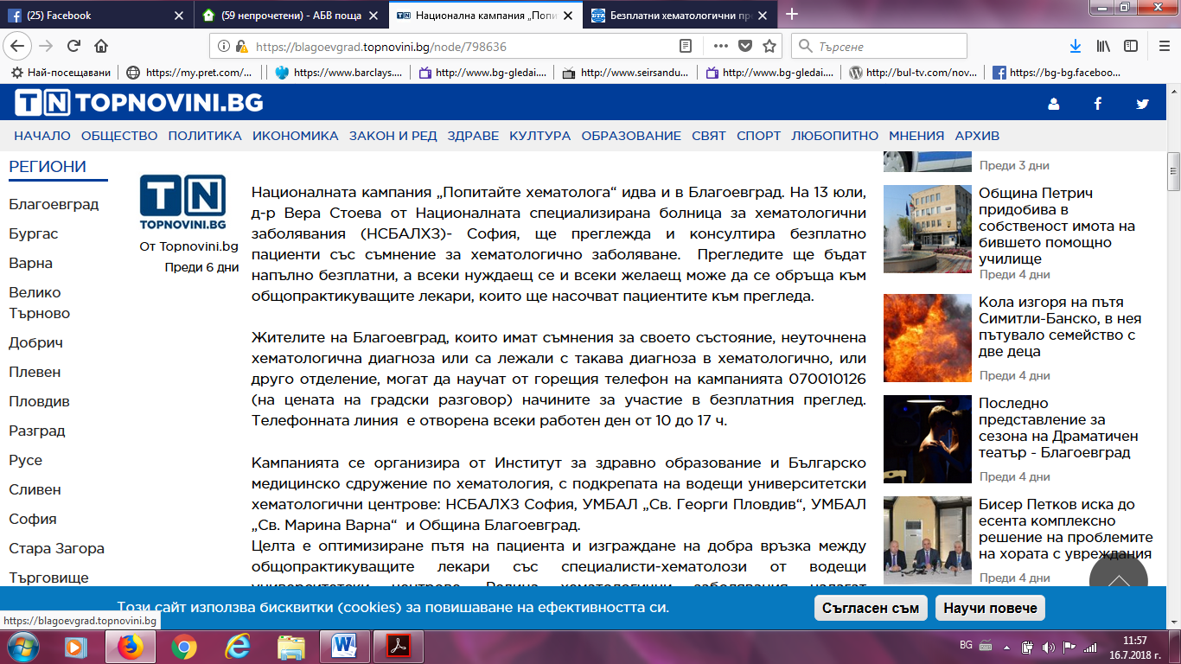

ВЯРА НЮЗ:
http://viaranews.com/?p=271330http://viaranews.com/?p=271330
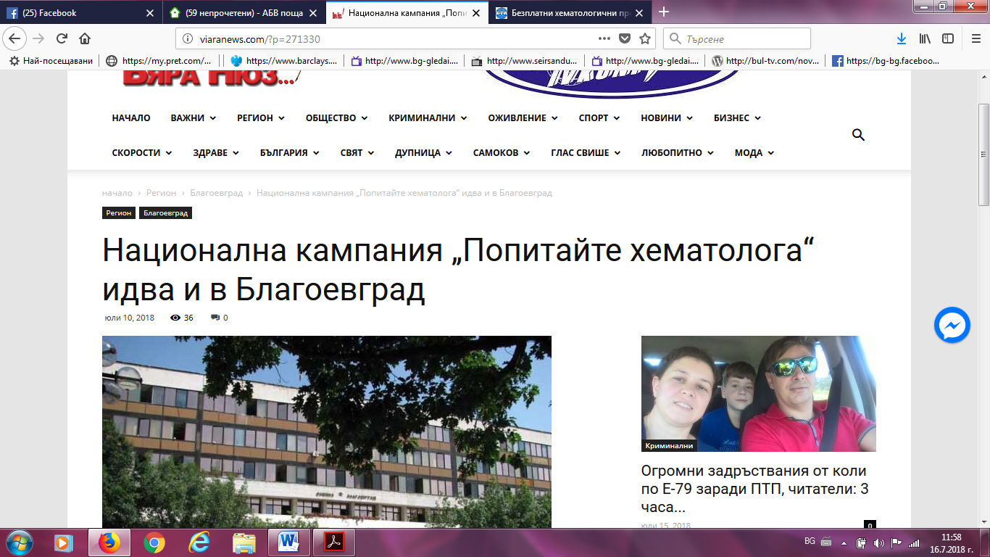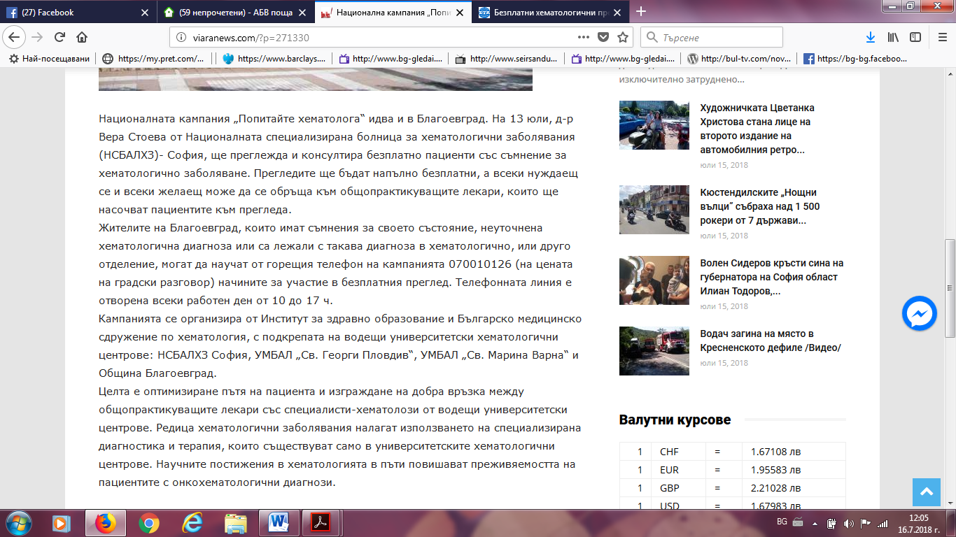

КМЕТА:
http://www.kmeta.bg/popitajte-hematologa-bezplatno-v-blagoevgradhttp://www.kmeta.bg/popitajte-hematologa-bezplatno-v-blagoevgrad
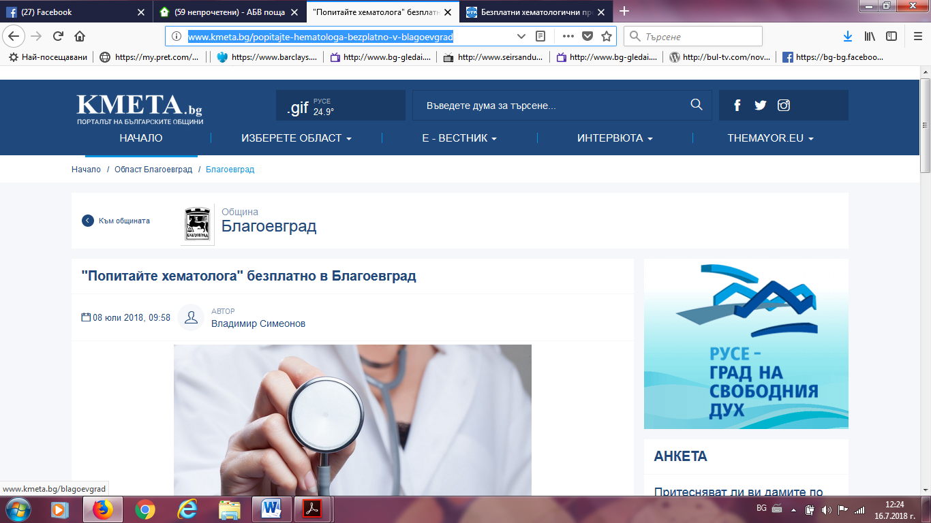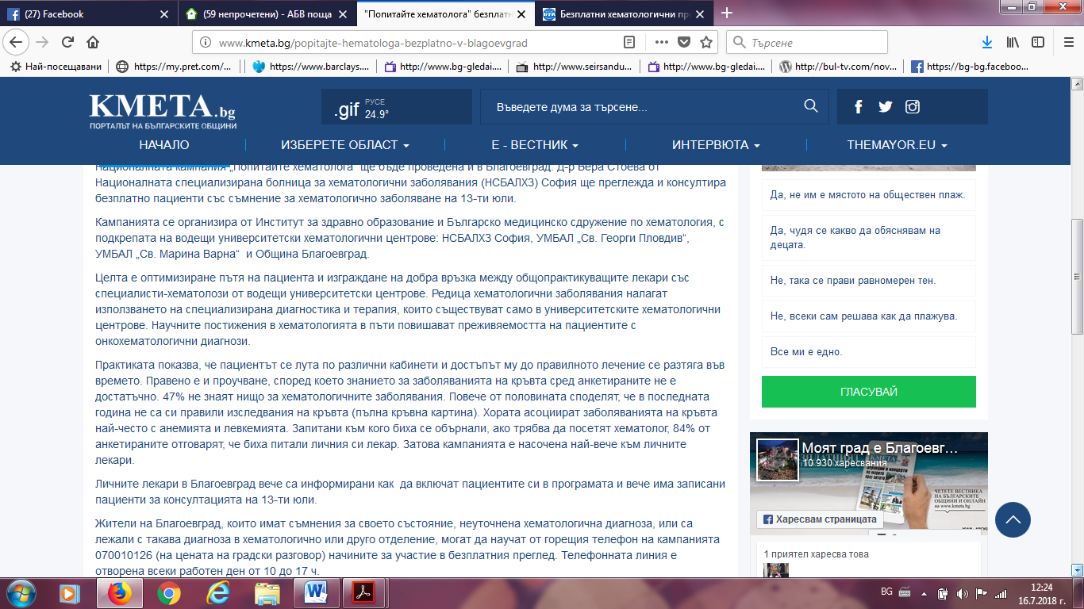

БЛАГОЕВГРАД. ЕИ:
https://www.blagoevgrad.eu/bezplatni-pregledi-ot-spetsialist-hematolog-v-blagoevgrad.html
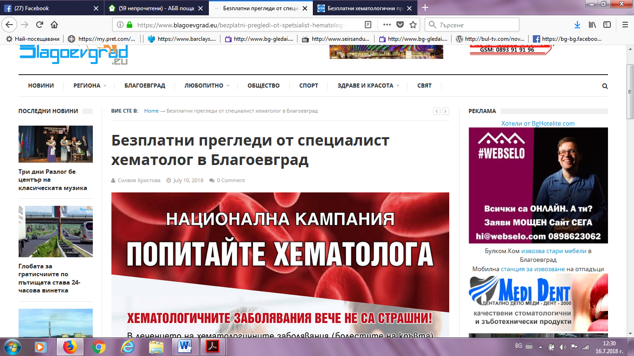
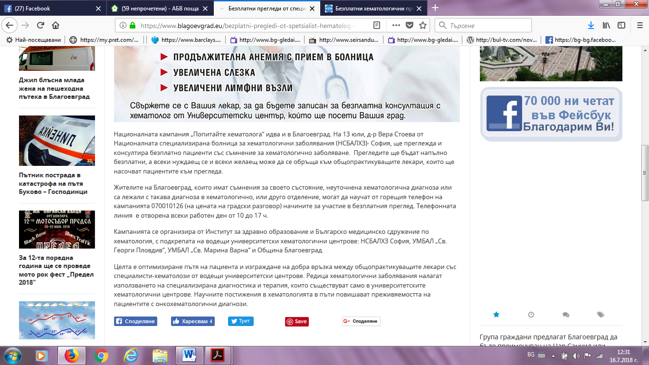

НОВИНАТА.БГ:
https://novinata.bg/?p=253052
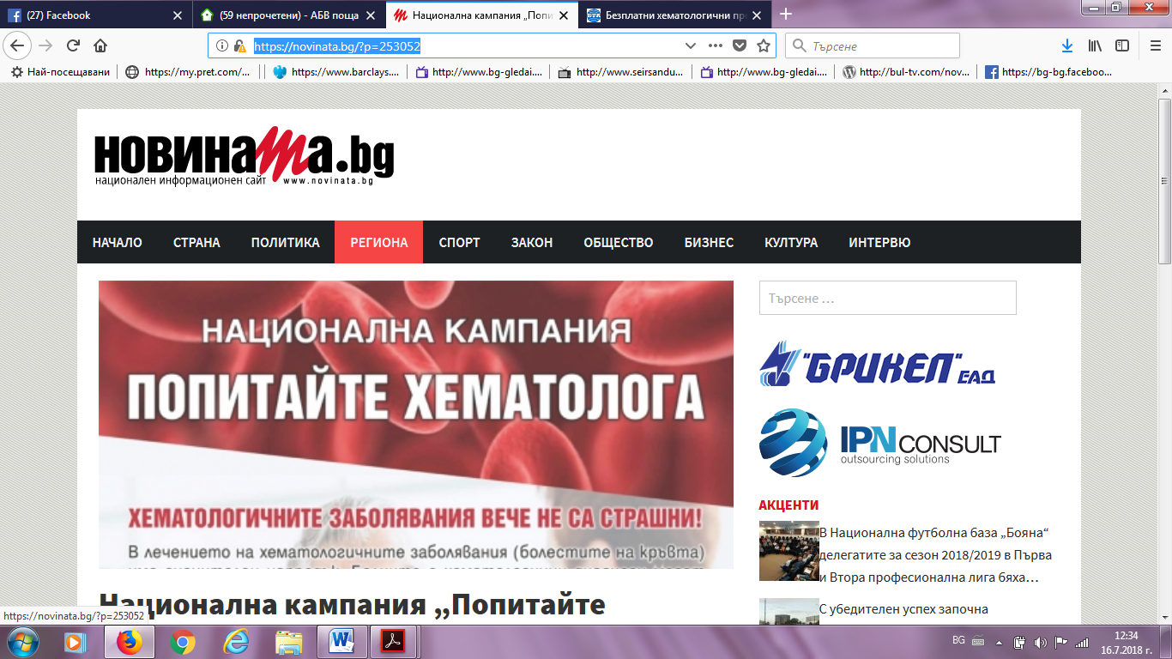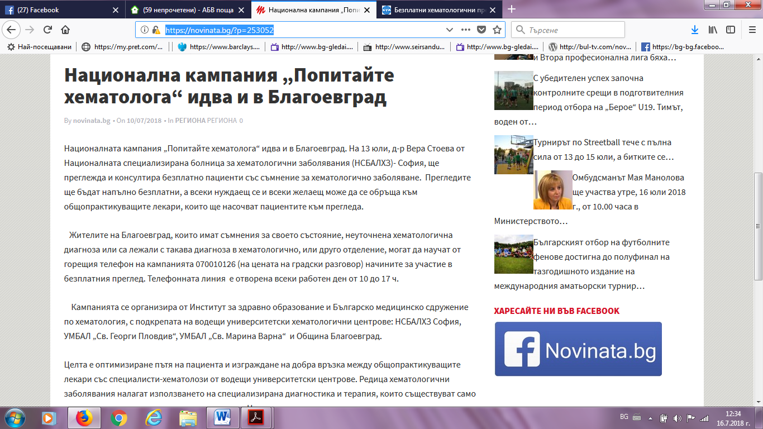

ИЛИНДЕН ПРЕС:
http://ilindenpres.bg/10138-bezplatno-preglezhdat-hora-s-hematologichni-zabolyavaniya-v-blagoevgrad/
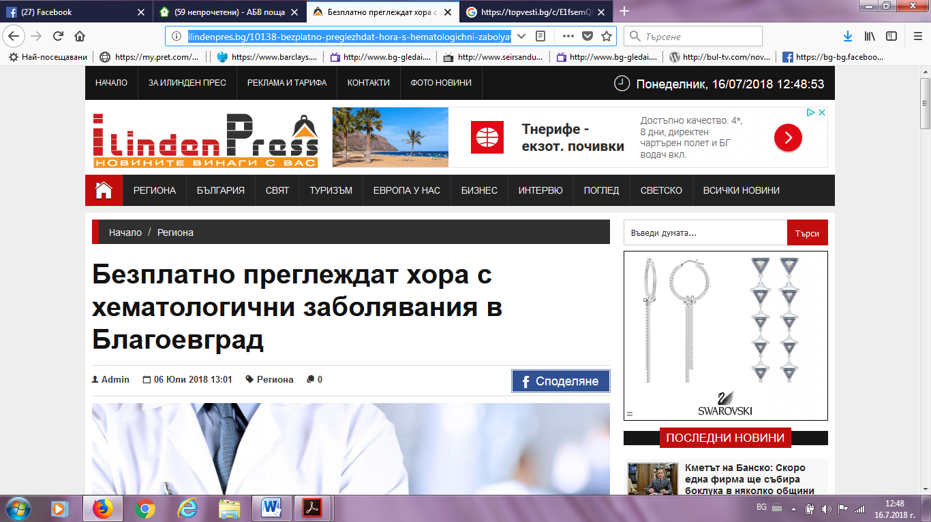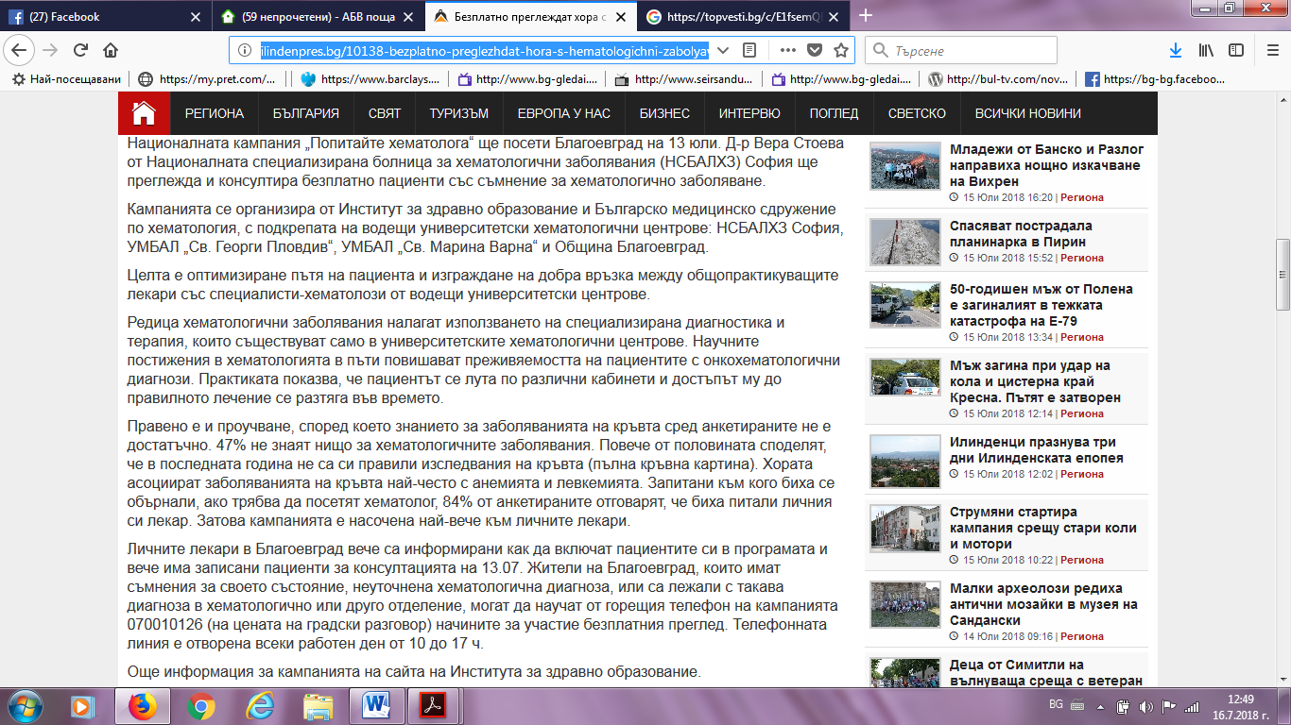

ИЛИНДЕН ПРЕС:
http://ilindenpres.bg/10159-vodeshi-hematolozi-preglezhdat-bezplatno-v-blagoevgrad/
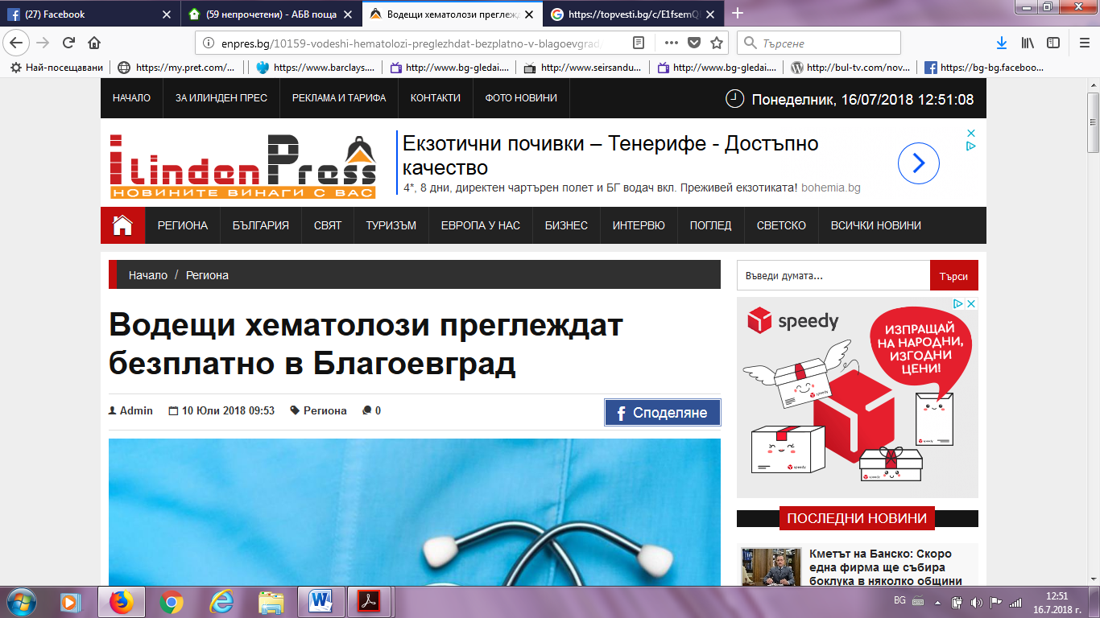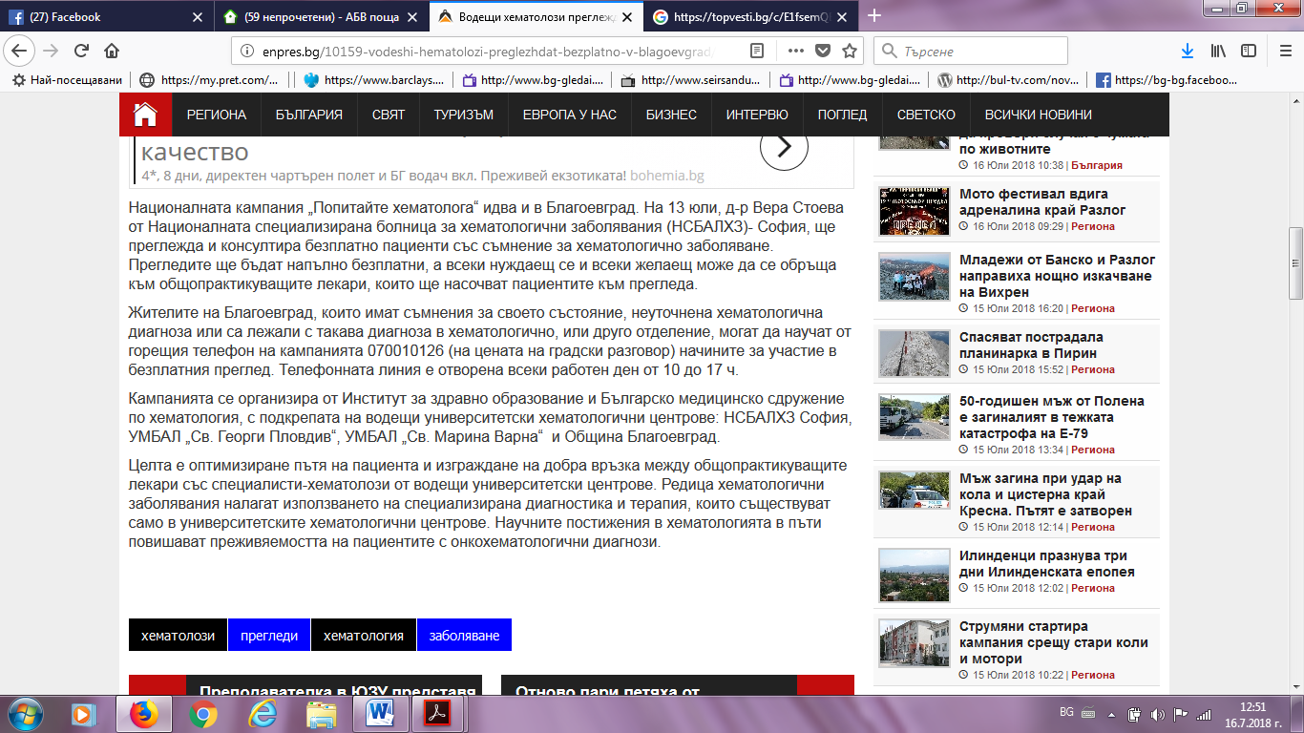

БНР ПЛЕЙ:
https://www.bnr.bg/play/post/100995186https://www.bnr.bg/play/post/100995186
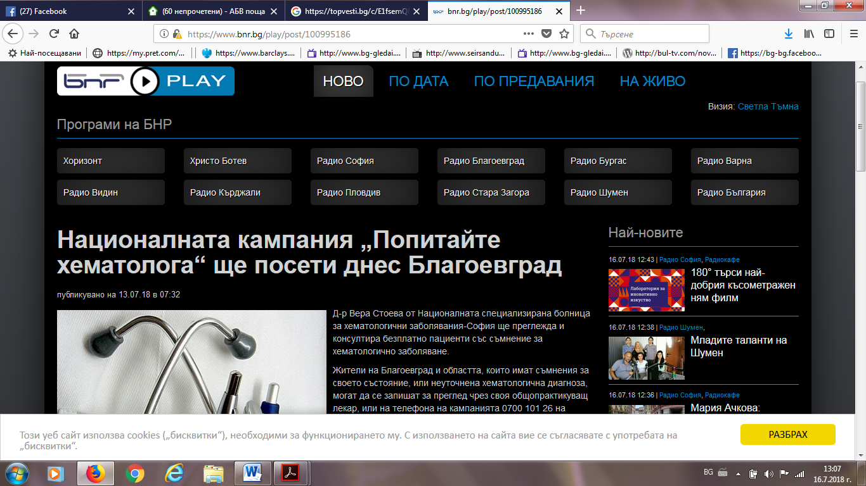
ФЕЙСБУК ОБЩИНА БЛАГОЕВГРАД:
https://www.facebook.com/pg/ObshtinaBlagoevgrad/posts/https://www.facebook.com/pg/ObshtinaBlagoevgrad/posts/
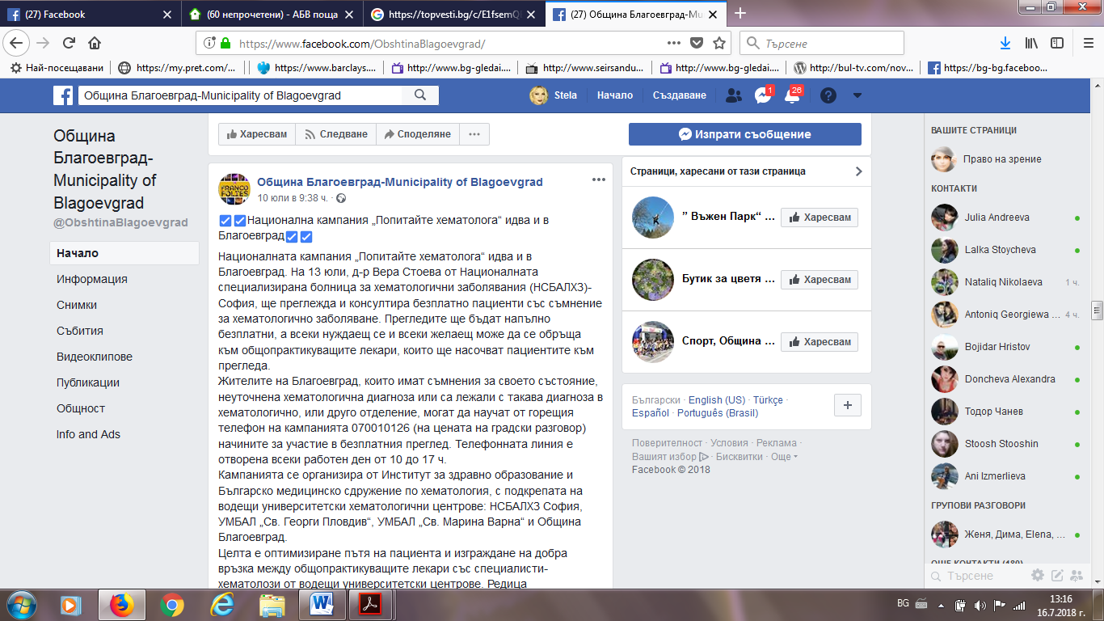

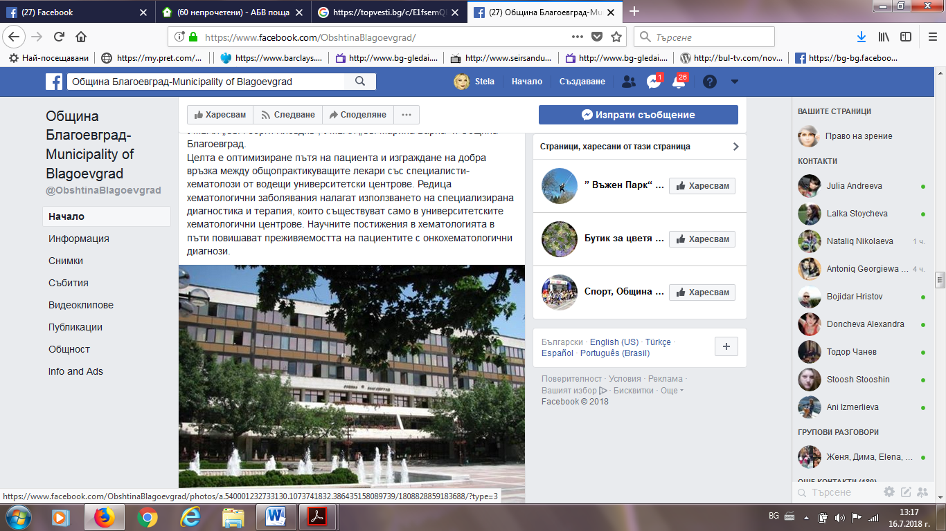
ФЕЙСБУК БЛАГОЕВГРАД:
https://www.facebook.com/groups/459287560922554/search/?query=%D0%9F%D0%9E%D0%9F%D0%98%D0%A2%D0%90%D0%99%D0%A2%D0%95%20%D0%A5%D0%95%D0%9C%D0%90%D0%A2%D0%9E%D0%9B%D0%9E%D0%93%D0%90https://www.facebook.com/groups/459287560922554/search/?query=%D0%9F%D0%9E%D0%9F%D0%98%D0%A2%D0%90%D0%99%D0%A2%D0%95%20%D0%A5%D0%95%D0%9C%D0%90%D0%A2%D0%9E%D0%9B%D0%9E%D0%93%D0%90
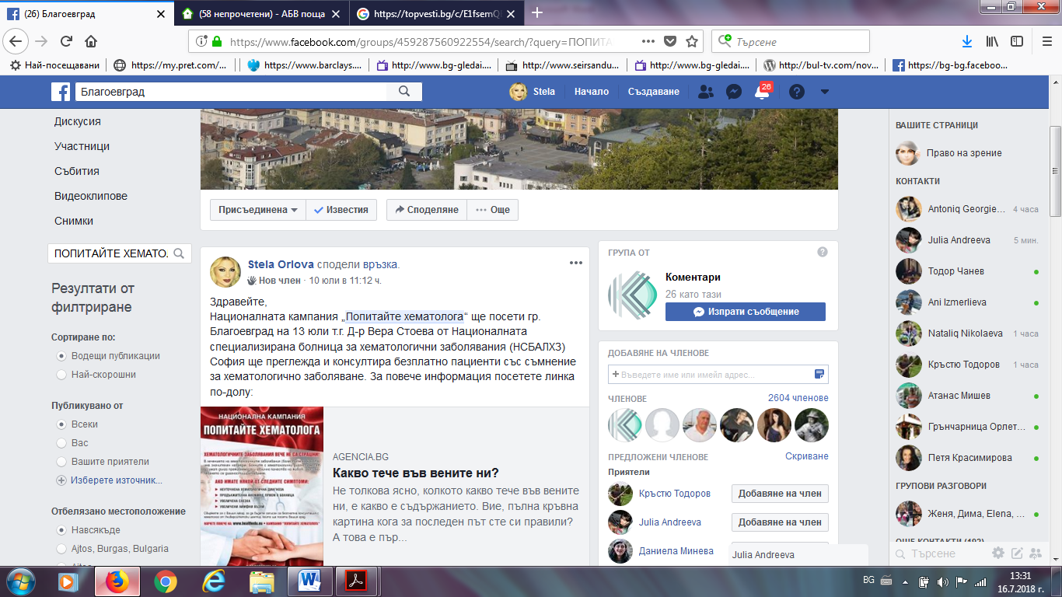

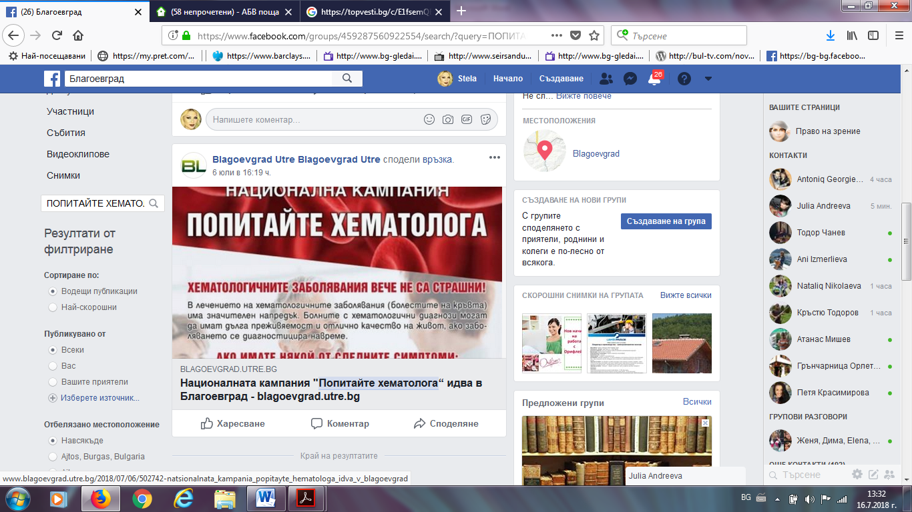
ФЕЙСБУК БЛАГОЕВГРАД ГРУПА:
https://www.facebook.com/groups/blagoevgrad/search/?query=%D0%9F%D0%9E%D0%9F%D0%98%D0%A2%D0%90%D0%99%D0%A2%D0%95%20%D0%A5%D0%95%D0%9C%D0%90%D0%A2%D0%9E%D0%9B%D0%9E%D0%93%D0%90
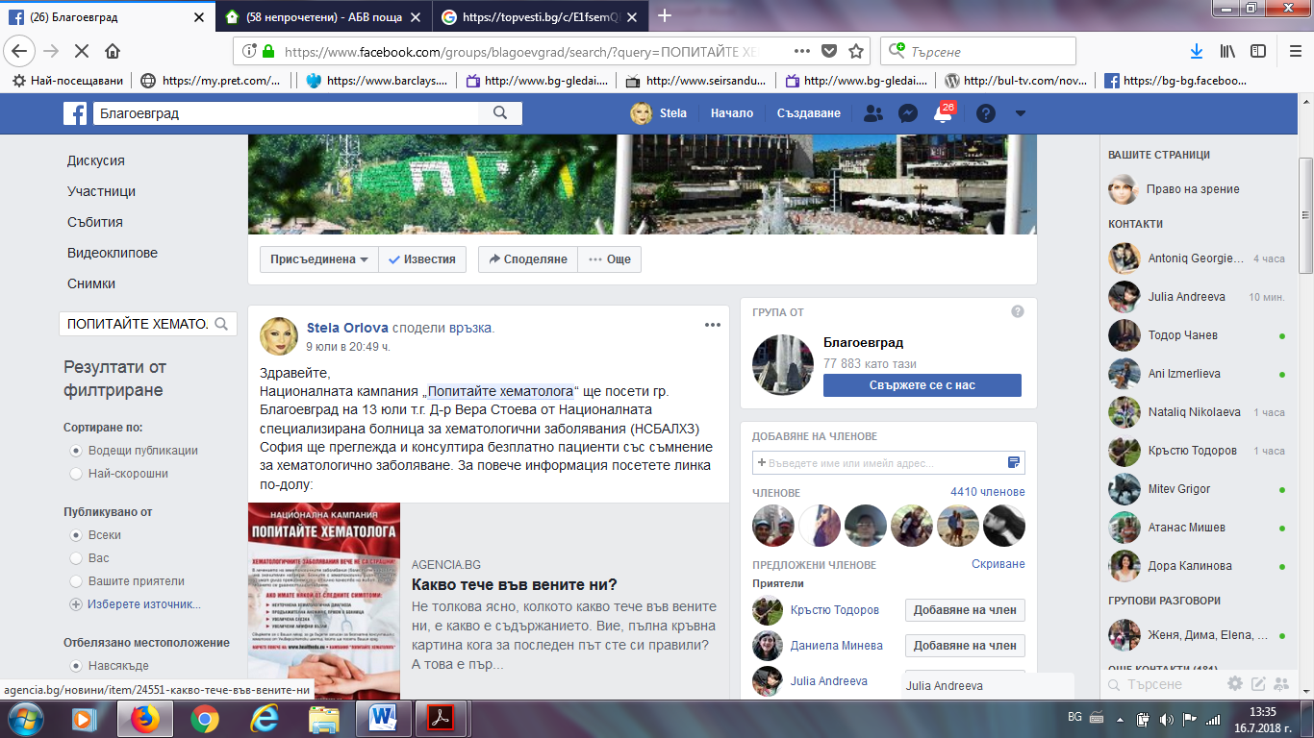

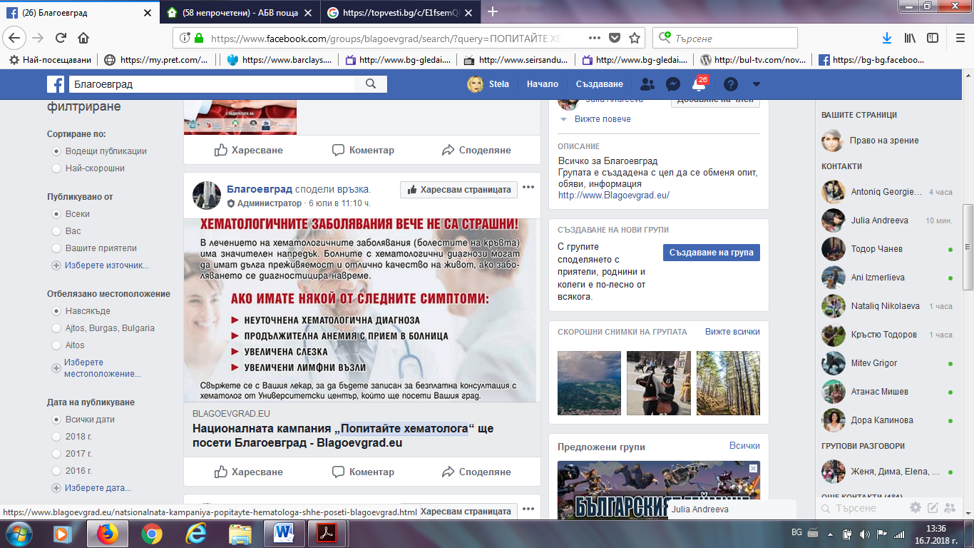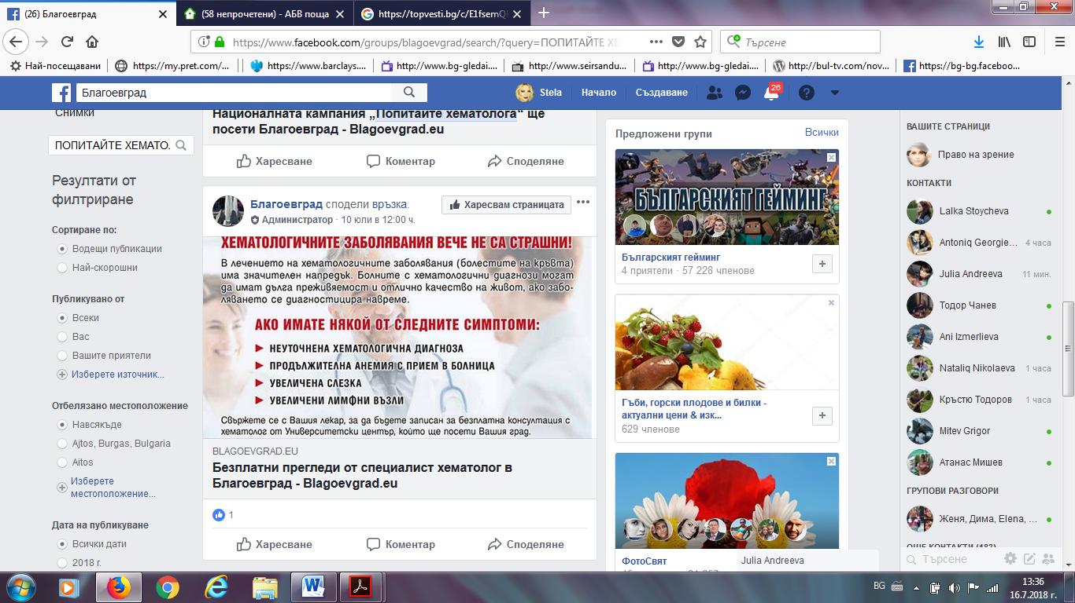

ФЕЙСБУК – НОВИНИ ОТ БЛАГОЕВГРАД И РЕГИОНА:
https://www.facebook.com/groups/444891855877725/search/?query=%D0%BF%D0%BE%D0%BF%D0%B8%D1%82%D0%B0%D0%B9%D1%82%D0%B5%20%D1%85%D0%B5%D0%BC%D0%B0%D1%82%D0%BE%D0%BB%D0%BE%D0%B3%D0%B0https://www.facebook.com/groups/444891855877725/search/?query=%D0%BF%D0%BE%D0%BF%D0%B8%D1%82%D0%B0%D0%B9%D1%82%D0%B5%20%D1%85%D0%B5%D0%BC%D0%B0%D1%82%D0%BE%D0%BB%D0%BE%D0%B3%D0%B0

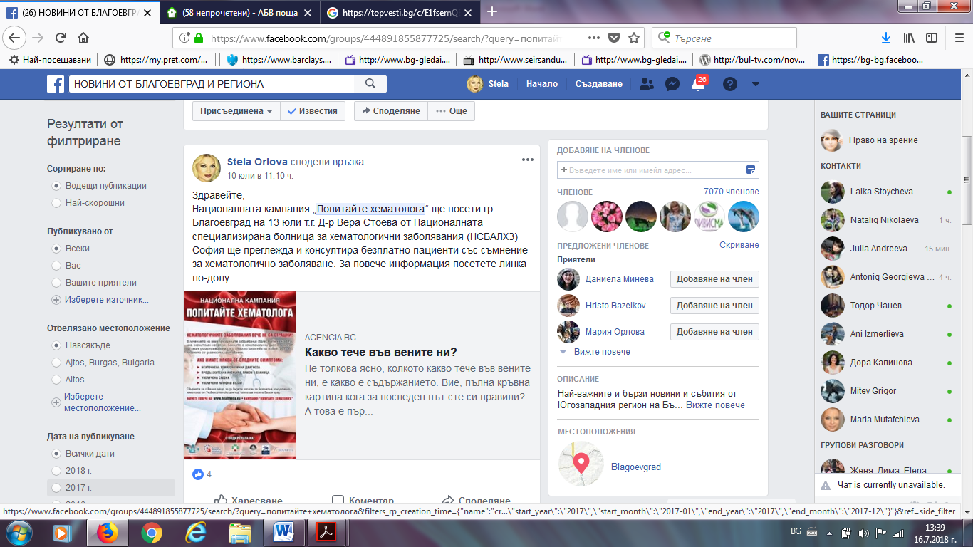

ФЕЙСБУК – ЗАБЕЛЯЗАНО В БЛАГОЕВГРАД:
https://www.facebook.com/groups/1896523683693731/search/?query=%D0%9F%D0%9E%D0%9F%D0%98%D0%A2%D0%90%D0%99%D0%A2%D0%95%20%D0%A5%D0%95%D0%9C%D0%90%D0%A2%D0%9E%D0%9B%D0%9E%D0%93%D0%90https://www.facebook.com/groups/1896523683693731/search/?query=%D0%9F%D0%9E%D0%9F%D0%98%D0%A2%D0%90%D0%99%D0%A2%D0%95%20%D0%A5%D0%95%D0%9C%D0%90%D0%A2%D0%9E%D0%9B%D0%9E%D0%93%D0%90https://www.facebook.com/groups/1896523683693731/search/?query=%D0%9F%D0%9E%D0%9F%D0%98%D0%A2%D0%90%D0%99%D0%A2%D0%95%20%D0%A5%D0%95%D0%9C%D0%90%D0%A2%D0%9E%D0%9B%D0%9E%D0%93%D0%90https://www.facebook.com/groups/1896523683693731/search/?query=%D0%9F%D0%9E%D0%9F%D0%98%D0%A2%D0%90%D0%99%D0%A2%D0%95%20%D0%A5%D0%95%D0%9C%D0%90%D0%A2%D0%9E%D0%9B%D0%9E%D0%93%D0%90
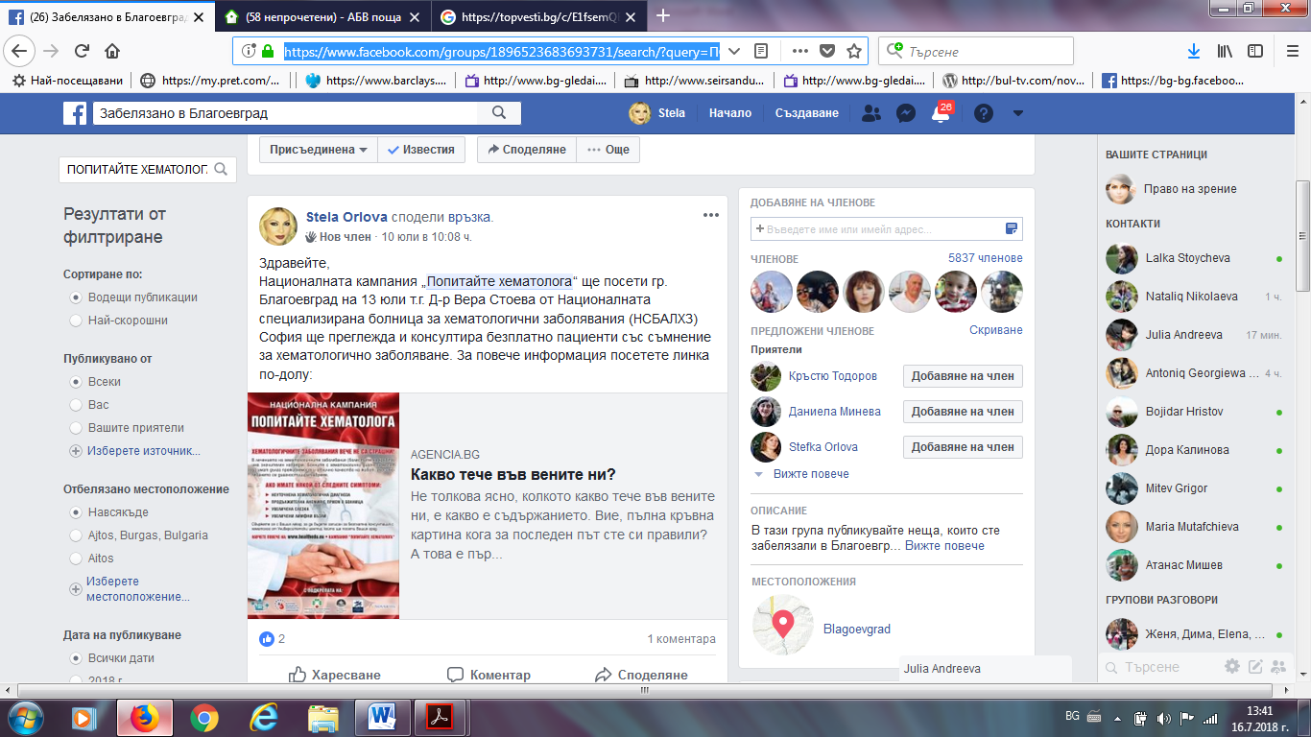

БНР:
http://bnr.bg/blagoevgrad/post/100995186
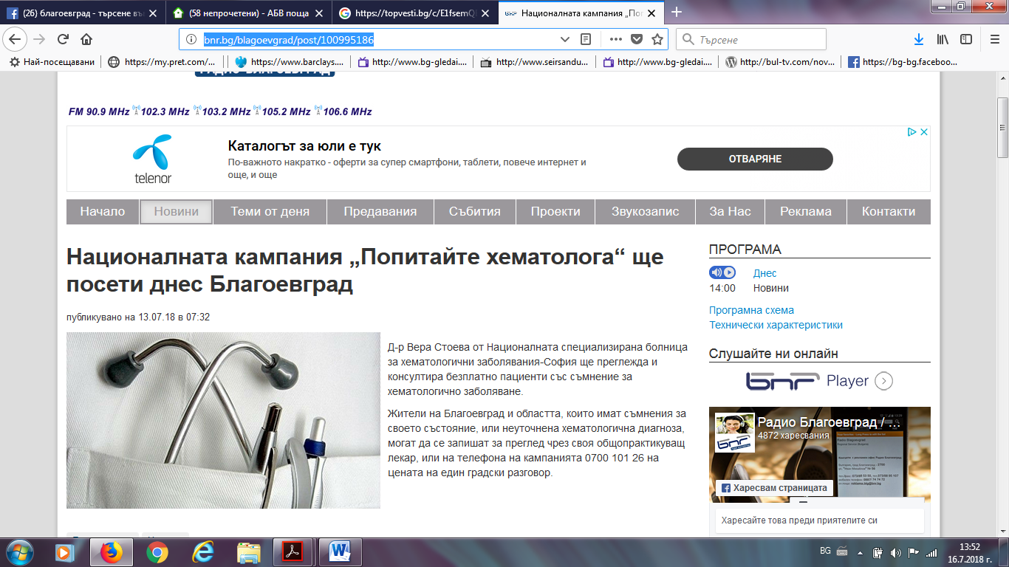

ТОП ВЕСТИ:
https://topvesti.bg/c/hWLfkmQBKbq5uwD7dgmR/2018-07-13/akcenti-v-predavaneto-%E2%80%9Echasut-na-blagoevgrad-na-radio-%E2%80%9Efokus-%E2%80%93-pirinhttps://topvesti.bg/c/hWLfkmQBKbq5uwD7dgmR/2018-07-13/akcenti-v-predavaneto-%E2%80%9Echasut-na-blagoevgrad-na-radio-%E2%80%9Efokus-%E2%80%93-pirin
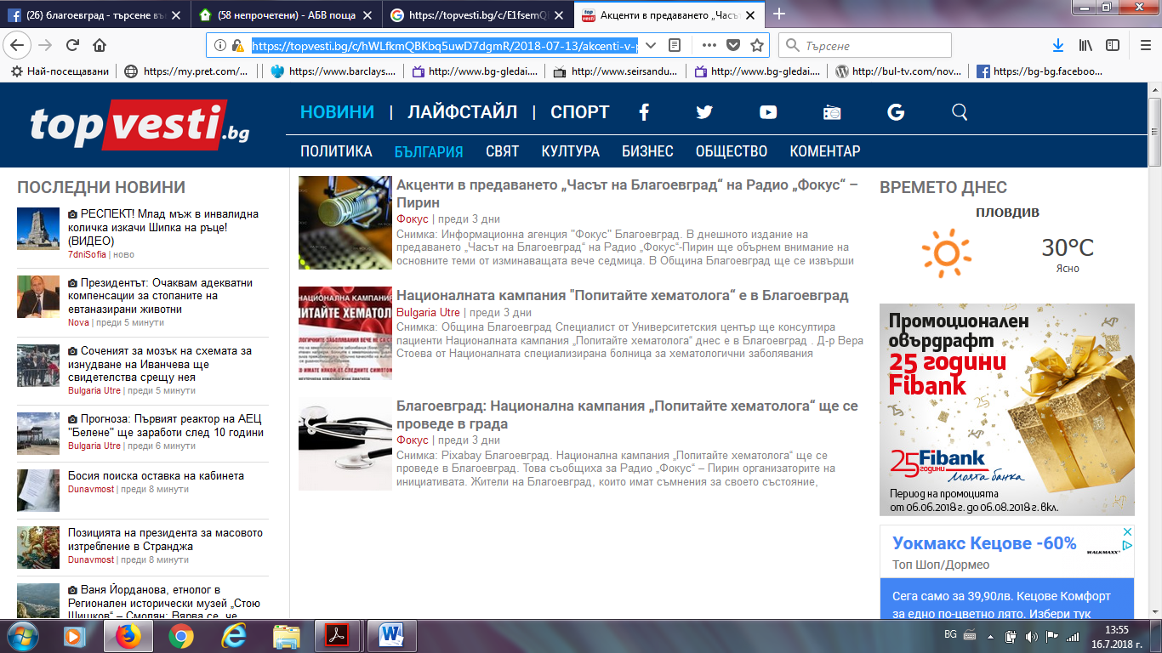
ФОКУС НЮЗ:
http://focus-news.bg/news/2018/07/13/2544843/blagoevgrad-natsionalna-kampaniya-popitayte-hematologa-shte-se-provede-v-grada.htmlhttp://focus-news.bg/news/2018/07/13/2544843/blagoevgrad-natsionalna-kampaniya-popitayte-hematologa-shte-se-provede-v-grada.html
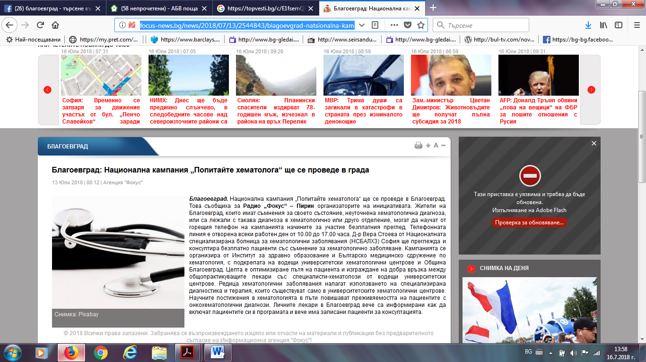
БЛАГОЕВГРАД НЮЗ:
http://blagoevgrad-news.com/nacionalna-kampaniq-popitaite-hemoglobina/
