МЕДИА МОНИТОРИНГ ХЕМАТОЛОГИЧНИ ЗАБОЛЯВАНИЯ – ЛОВЕЧ

ЛОВЕЧ МЕДИЯ:
https://lovechmedia.com/%d1%81%d0%bf%d1%80%d0%b0%d0%b2%d0%be%d1%87%d0%bd%d0%b8%d0%ba/%d1%81%d0%bf%d0%b5%d1%86%d0%b8%d0%b0%d0%bb%d0%b8%d1%81%d1%82-%d1%85%d0%b5%d0%bc%d0%b0%d1%82%d0%be%d0%bb%d0%be%d0%b3-%d1%89%d0%b5-%d0%bf%d1%80%d0%b5%d0%b3%d0%bb%d0%b5%d0%b6%d0%b4%d0%b0-%d0%b1%d0%b5/
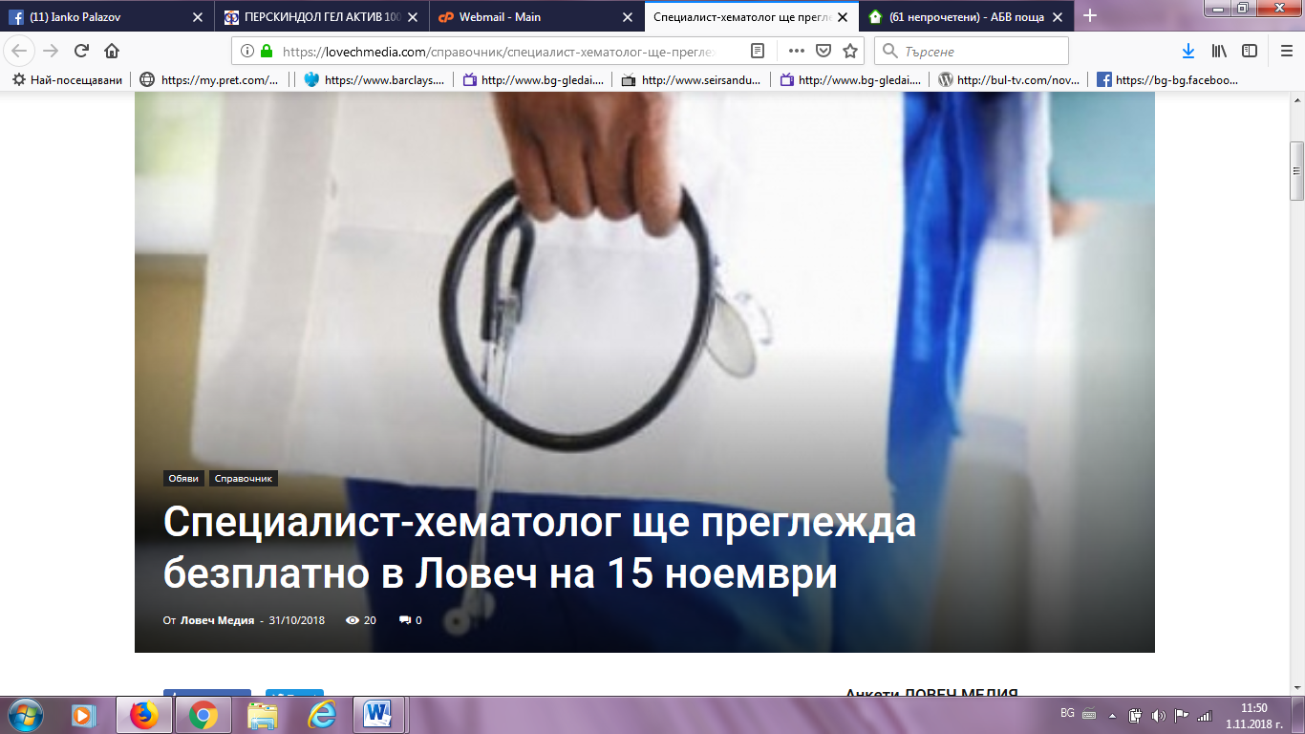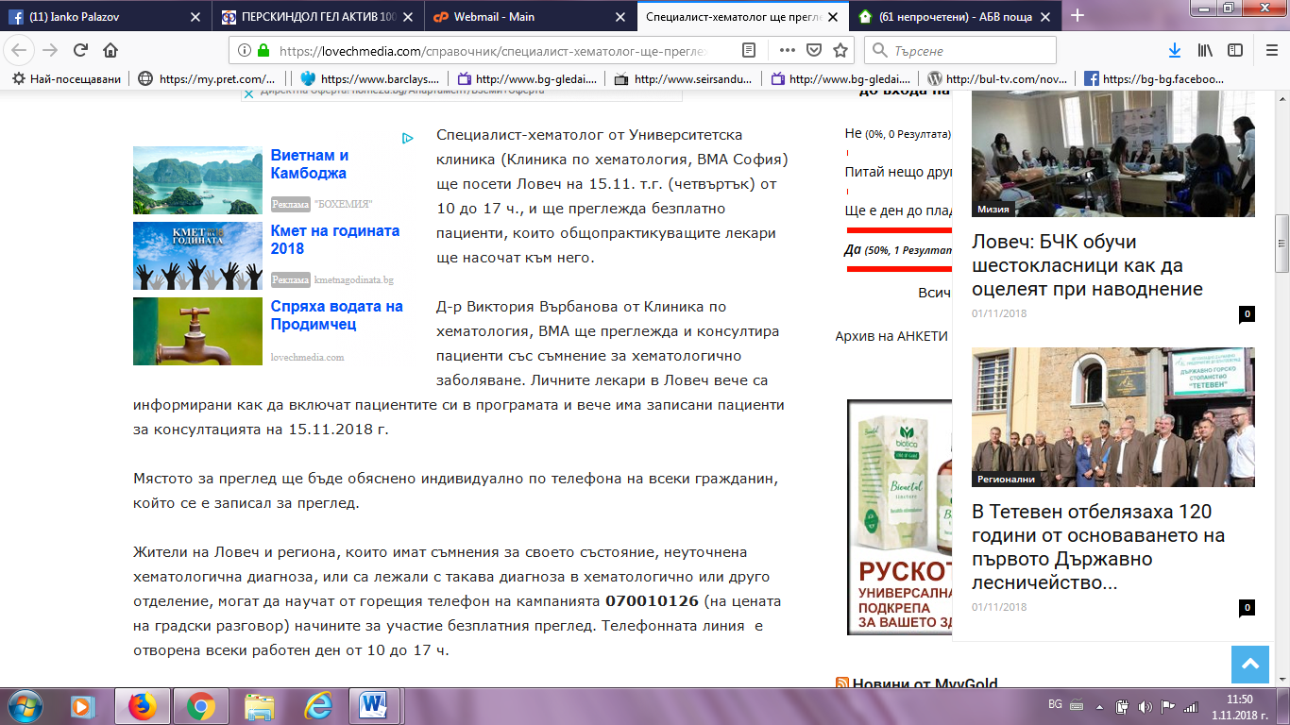
ОБЩИНА ЛОВЕЧ:
http://www.lovech.bg/bg/novini/spetsialist-hematolog-shte-preglezhda-bezplatno-v-lovech-na-15-noemvri
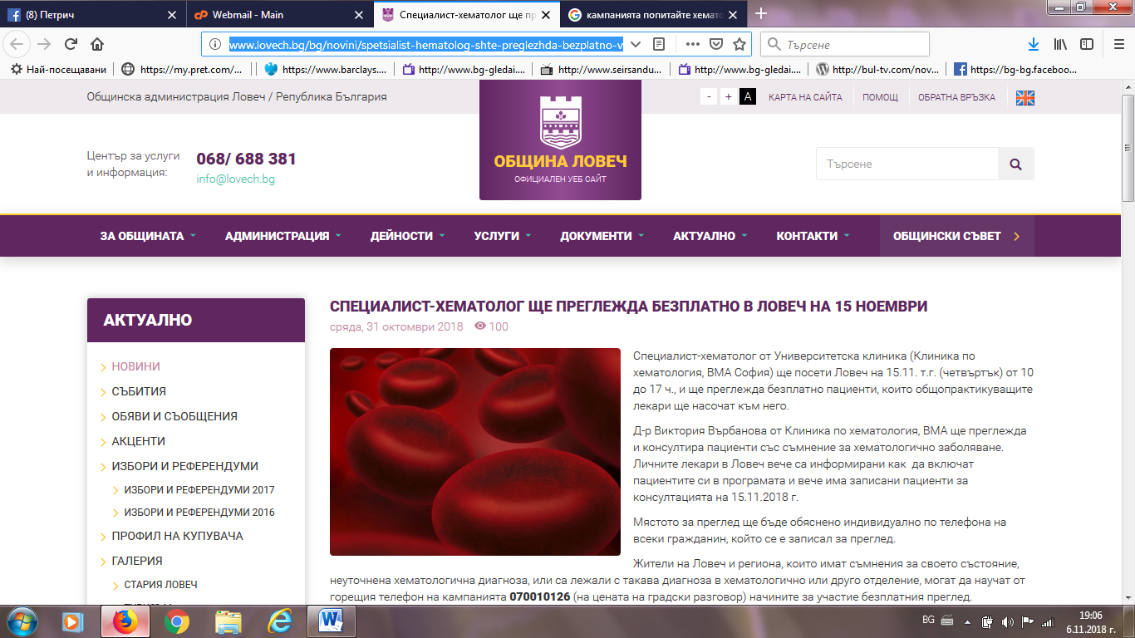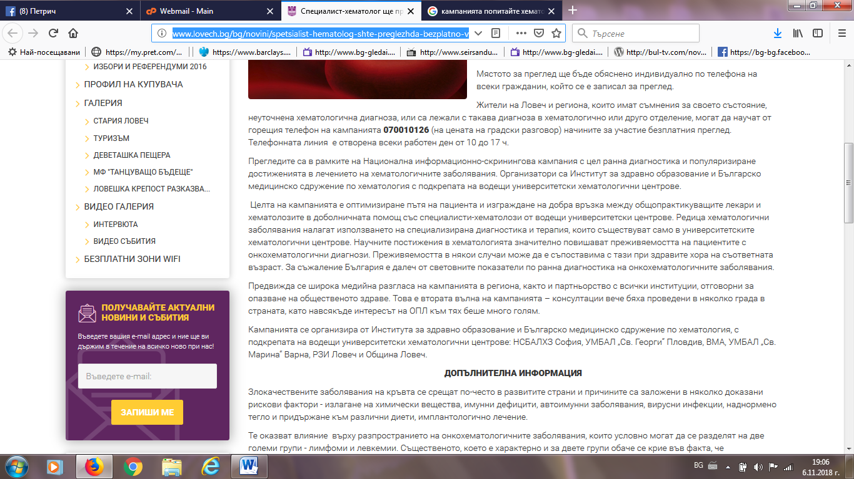

ЗЕТРА МЕДИА:
http://zetramedia.com/?p=80004
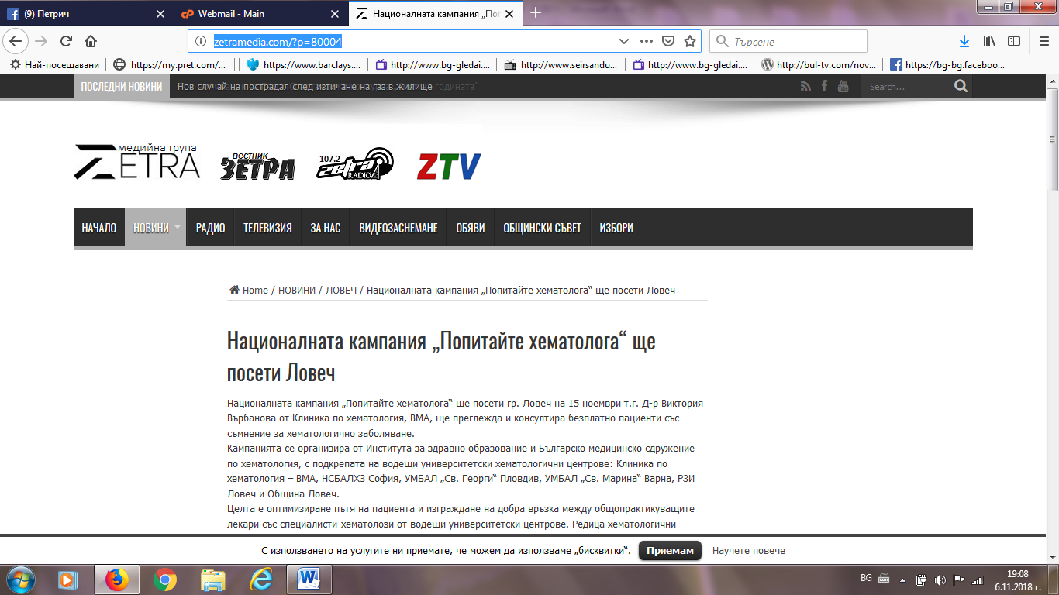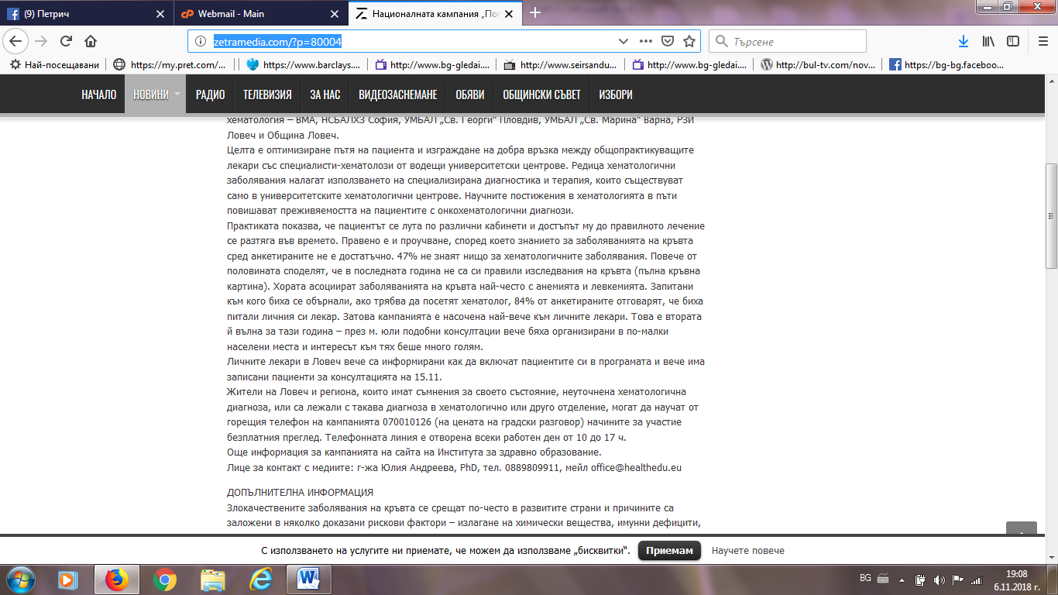

ЗЕТРА НОВИНИТЕ ФЕЙСБУК:
https://www.facebook.com/zetramedia/

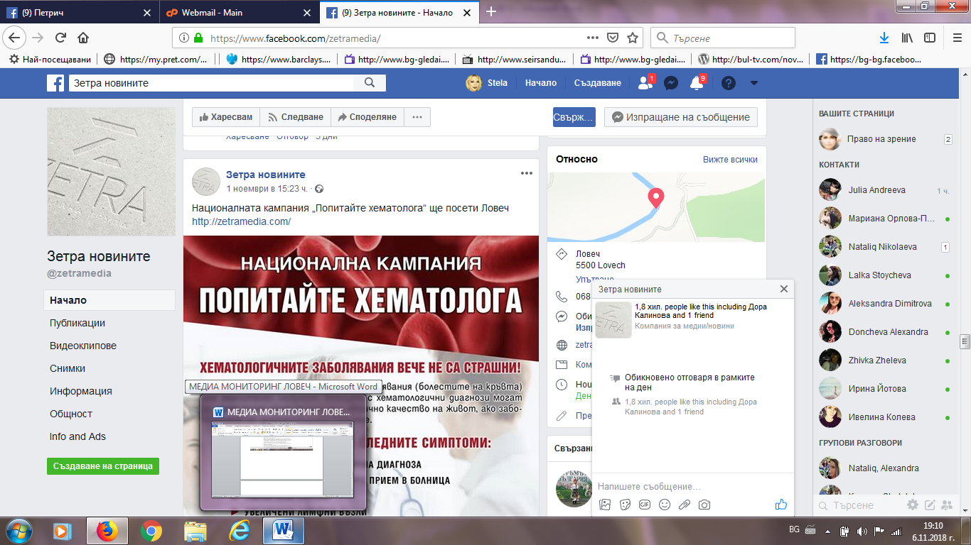
ВМА:
http://www.vma.bg/bg/novini/popitayte-hematologa-lekari-ot-vma-preglezhdat-bezplatno-v-tsyala-balgariya-596.html
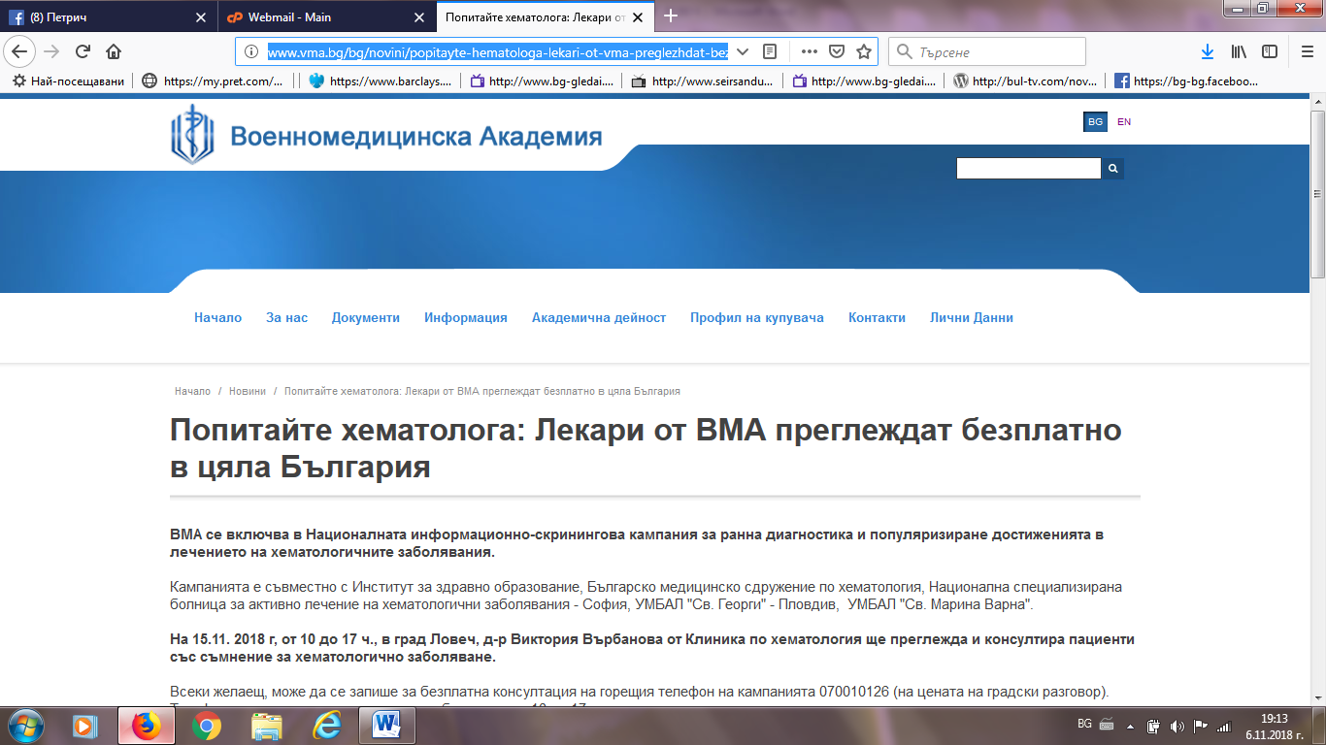

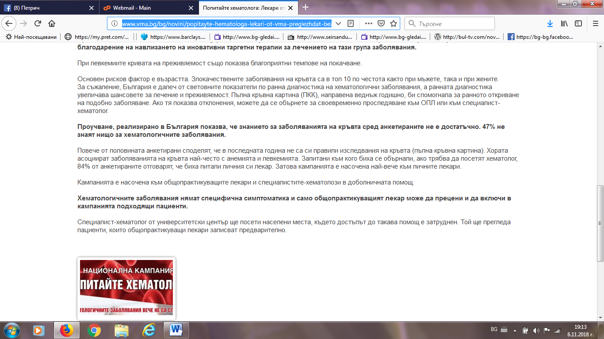

ЛУКОВИТ НЮЗ:
http://lukovit-news.com/natsionalnata-kampaniya-popitayte-hematologa-shhe-poseti-gr-lovech-na-15-noemvri-t-g.html
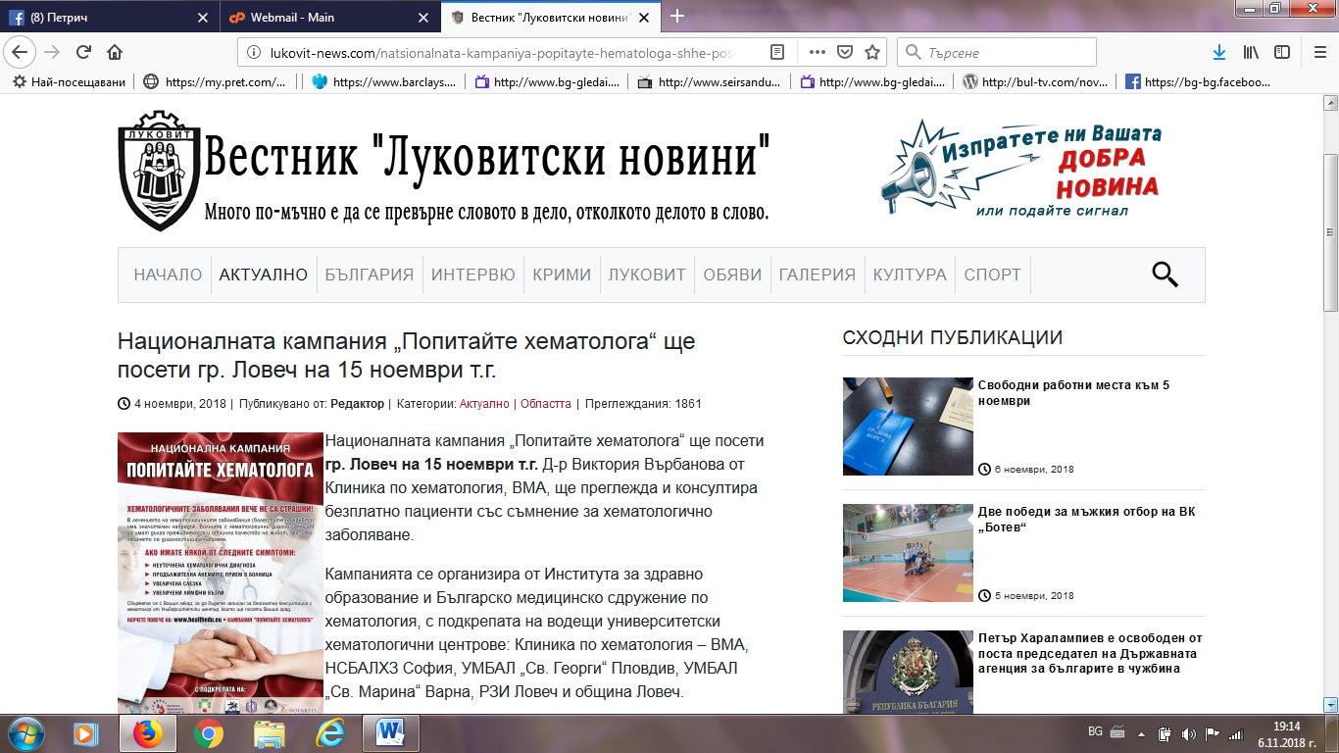

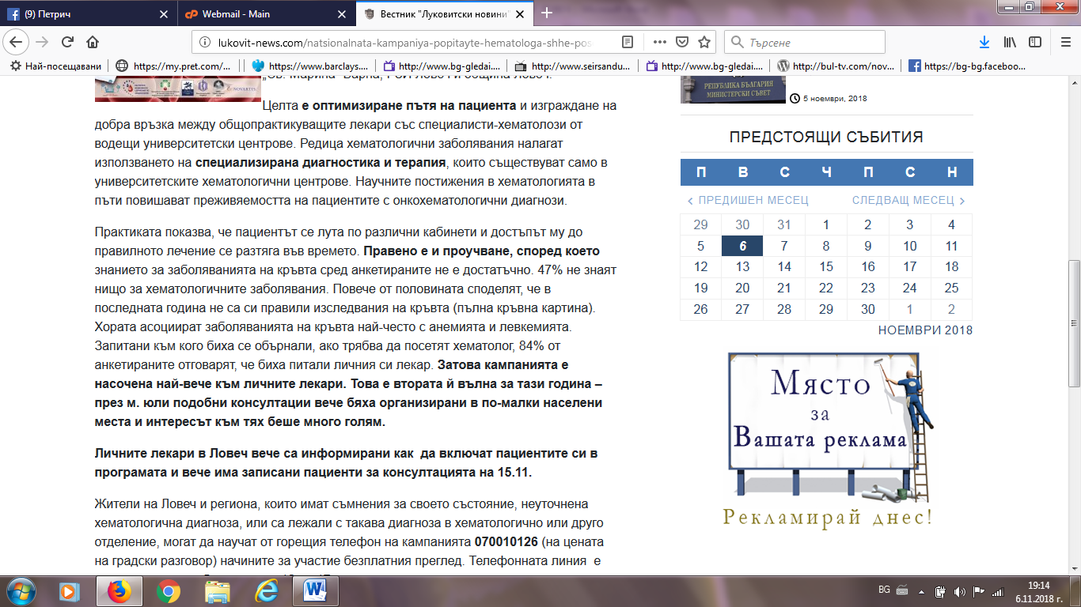
ВМА ФЕЙСБУК:
https://www.facebook.com/mma.vma/?__tn__=kC-R&eid=ARBvzN0ZdvPnbJisKRlSqOPcDIpZbb4MAI-mKUUUZ1fC08SlgVsrVa5rz1doks9BKaRzHSdae0kfJRas&hc_ref=ARTjDiPevQXE2pRpfhyQ75J4-jRYScVIveQswGk7jhWoya2AV2kdhSvJ5CkLy5V4y9c&fref=nf&__xts__[0]=68.ARBm9dcdYKV-2D8kQt8AADXYxKGaLBZ82z_Wf6SXbjyh7gPD_C8lrI9xCNjTLif4S6TTGhSExbtVBUeG6y0Kc-L4yOn4fF7TOtt_nQIzY2GCL9fhWZAnAmnfD4HMiYZekmWg8pjYrzJsaZ7BZvK2uss2dQY6gSZEEBQN7LYw6VODNqakyAMp-ExI7T8LRU7_eM1RLA
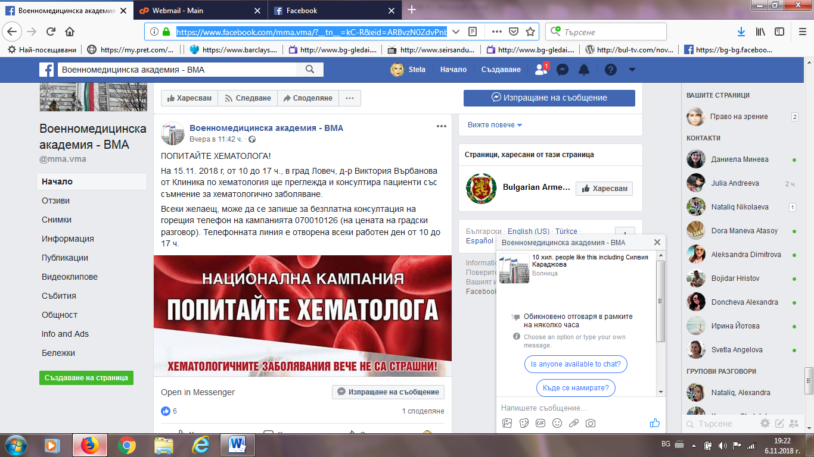

ТРЕТА ВЪЗРАСТ:
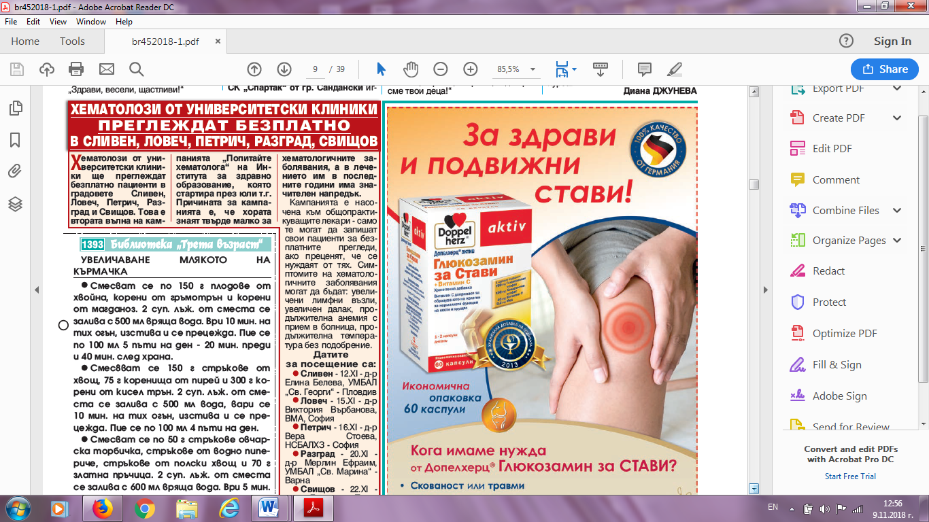
АЛМА НЮЗ:
https://almanews.bg/2018/11/04/%D1%81%D0%BF%D0%B5%D1%86%D0%B8%D0%B0%D0%BB%D0%B8%D1%81%D1%82-%D1%85%D0%B5%D0%BC%D0%B0%D1%82%D0%BE%D0%BB%D0%BE%D0%B3-%D1%89%D0%B5-%D0%BF%D1%80%D0%B5%D0%B3%D0%BB%D0%B5%D0%B6%D0%B4%D0%B0-%D0%B1%D0%B5/
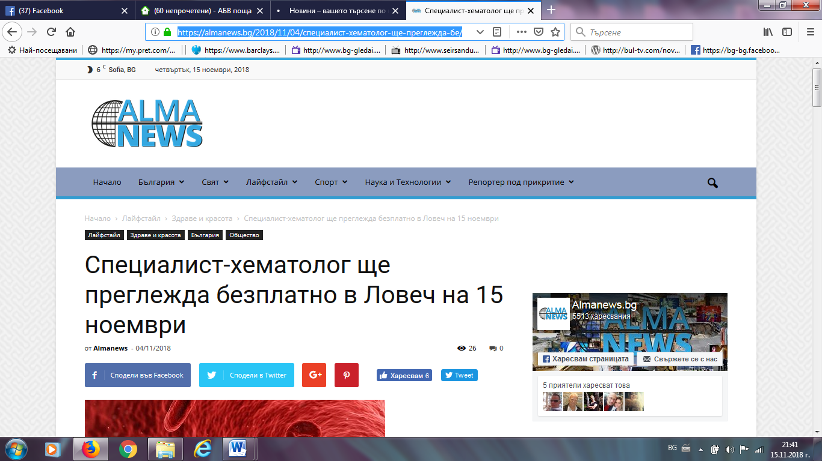

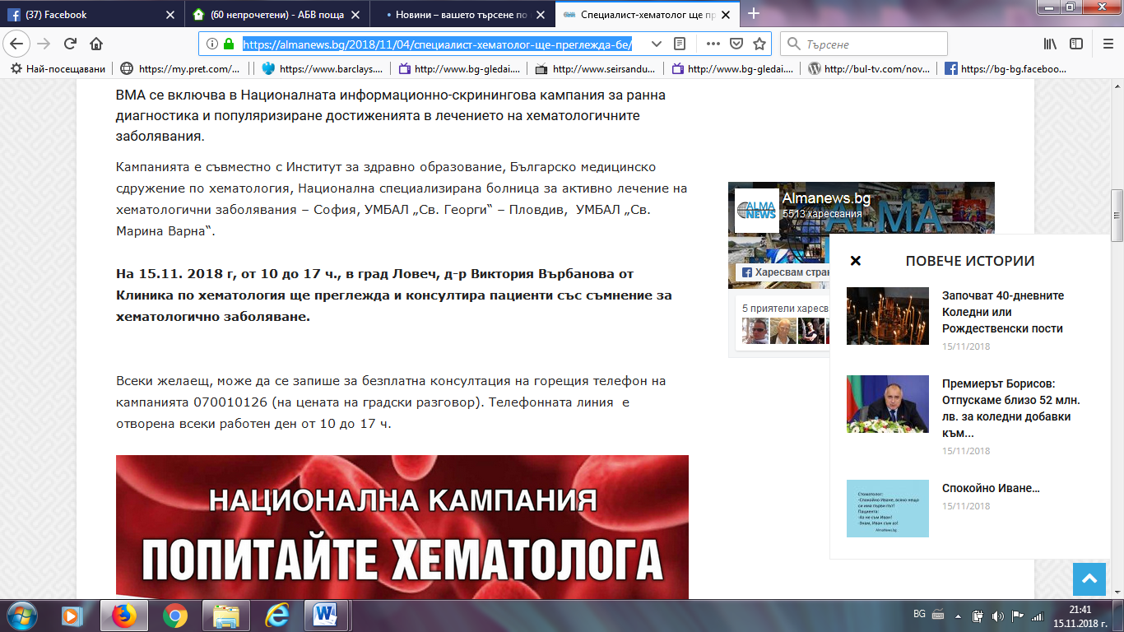

ЛОВЕЧ МЕДИА:
https://lovechmedia.com/%d0%b1%d1%8a%d0%bb%d0%b3%d0%b0%d1%80%d0%b8%d1%8f/%d0%b6%d0%b8%d1%82%d0%b5%d0%bb%d0%b8-%d0%bd%d0%b0-%d0%bb%d0%be%d0%b2%d0%b5%d1%87-%d0%bf%d0%be%d0%bb%d1%83%d1%87%d0%b8%d1%85%d0%b0-%d0%b1%d1%8a%d1%80%d0%b7-%d0%b4%d0%be%d1%81%d1%82%d1%8a%d0%bf-%d0%b4/
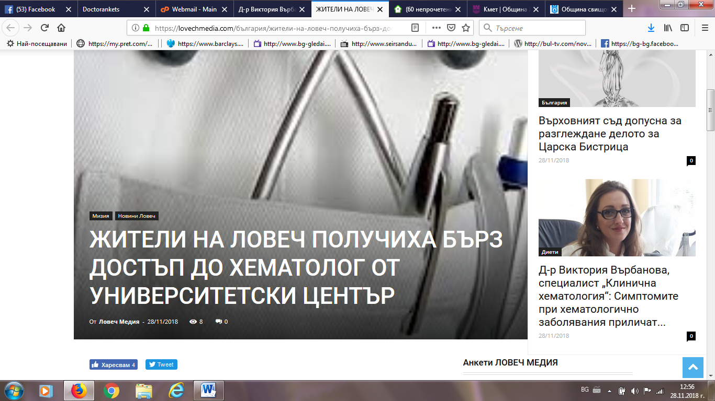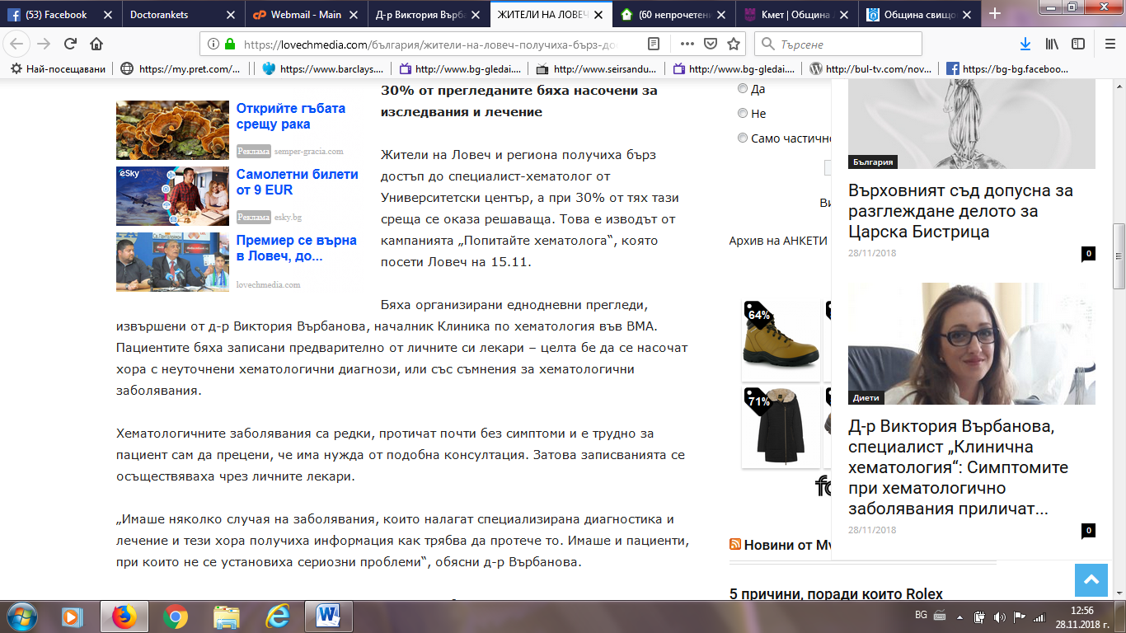

ЗЕТРА МЕДИА:
http://zetramedia.com/?p=80835
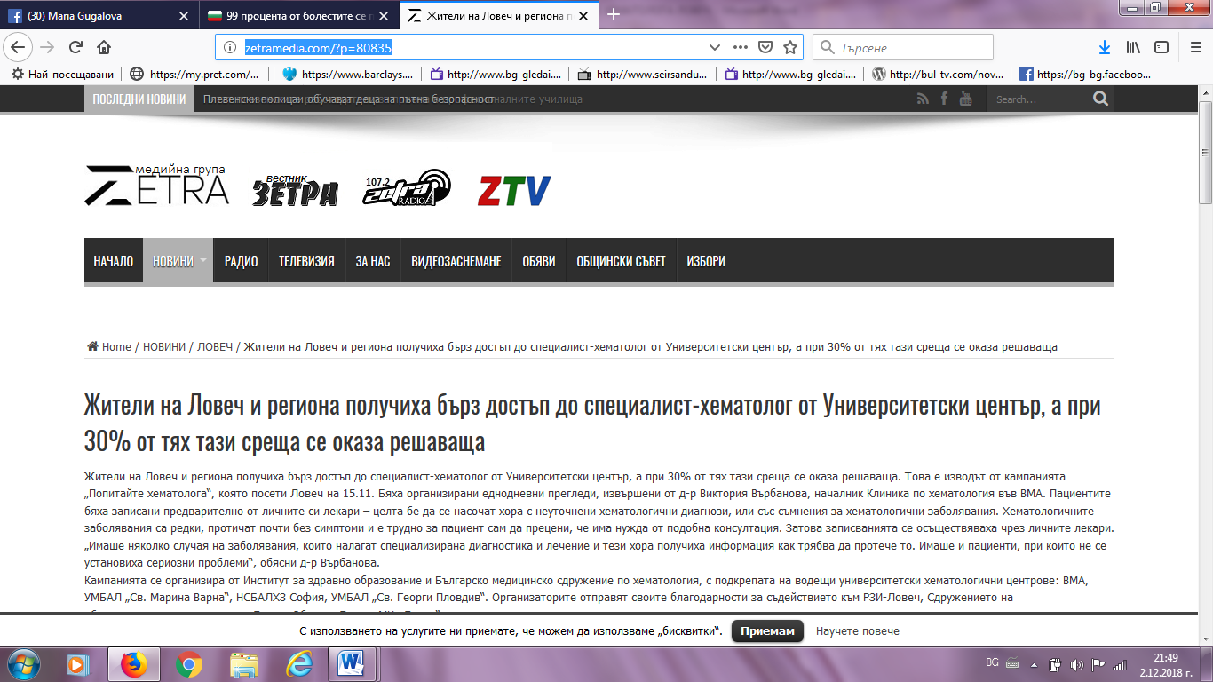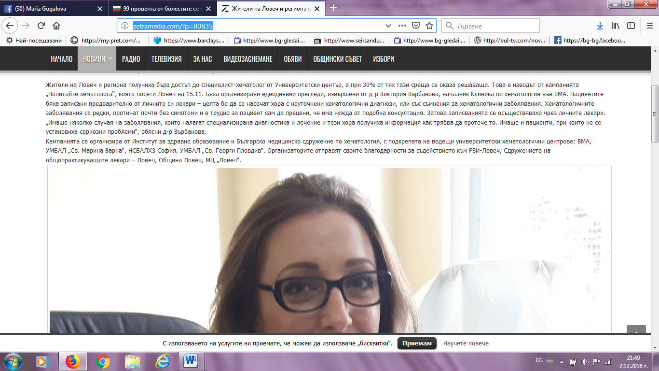

ВМА ФЕЙСБУК:
https://www.facebook.com/pg/mma.vma/posts/
