МЕДИА МОНИТОРИНГ ХЕМАТОЛОГИЧНИ ЗАБОЛЯВАНИЯ – ПЕТРИЧ

БЛАГОЕВГРАД ЕУ:
https://www.blagoevgrad.eu/natsionalnata-kampaniya-popitayte-hematologa-shhe-poseti-petrich.html
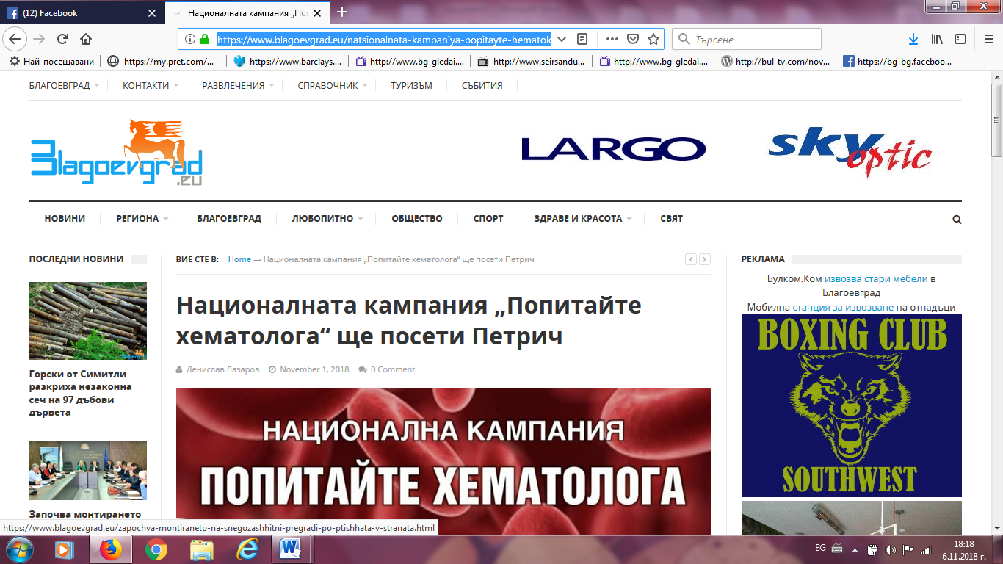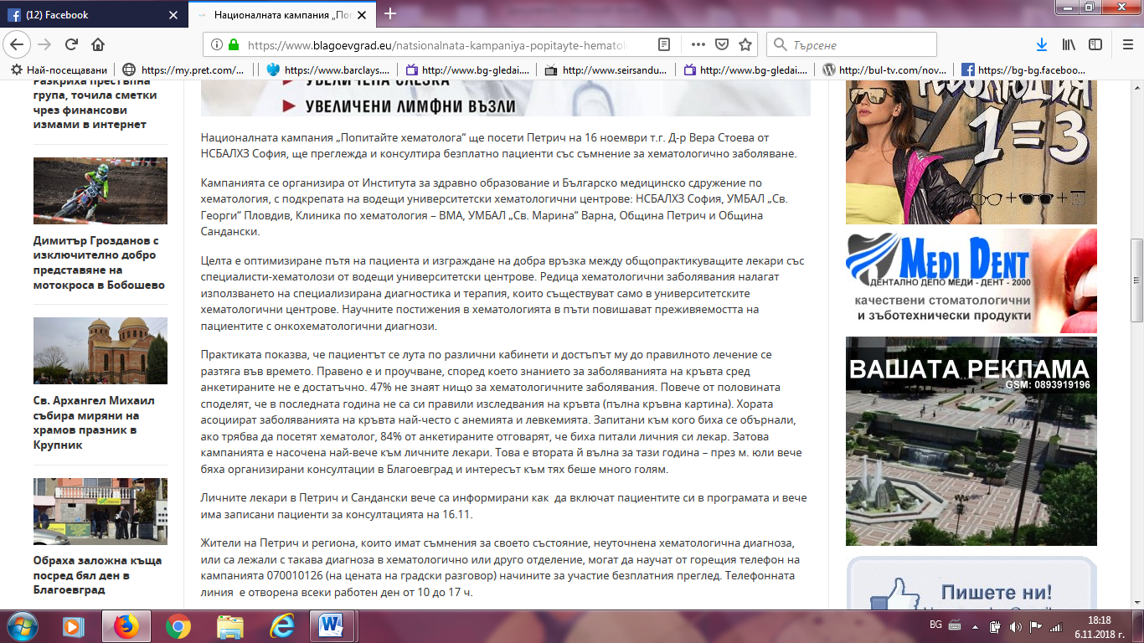

ИНФОМРЕЖА:
http://infomreja.bg/akciq-na-mvr-razkri-sklad-za-narkotici-v-petrich-58043.html
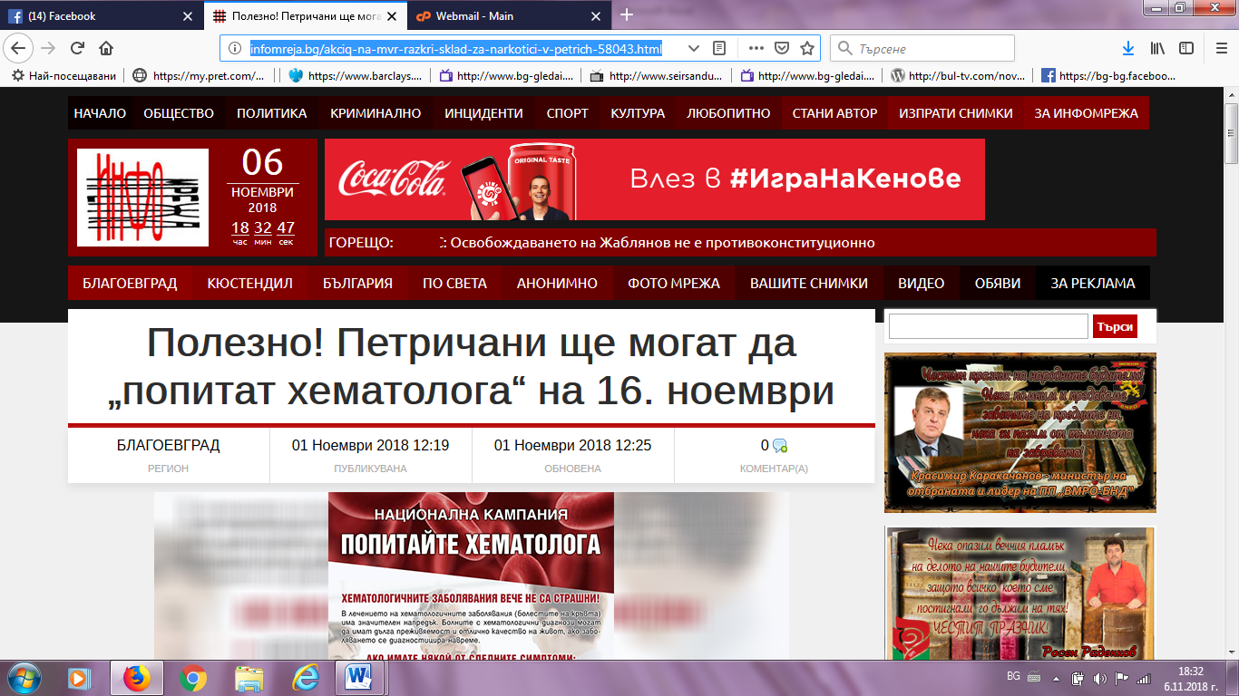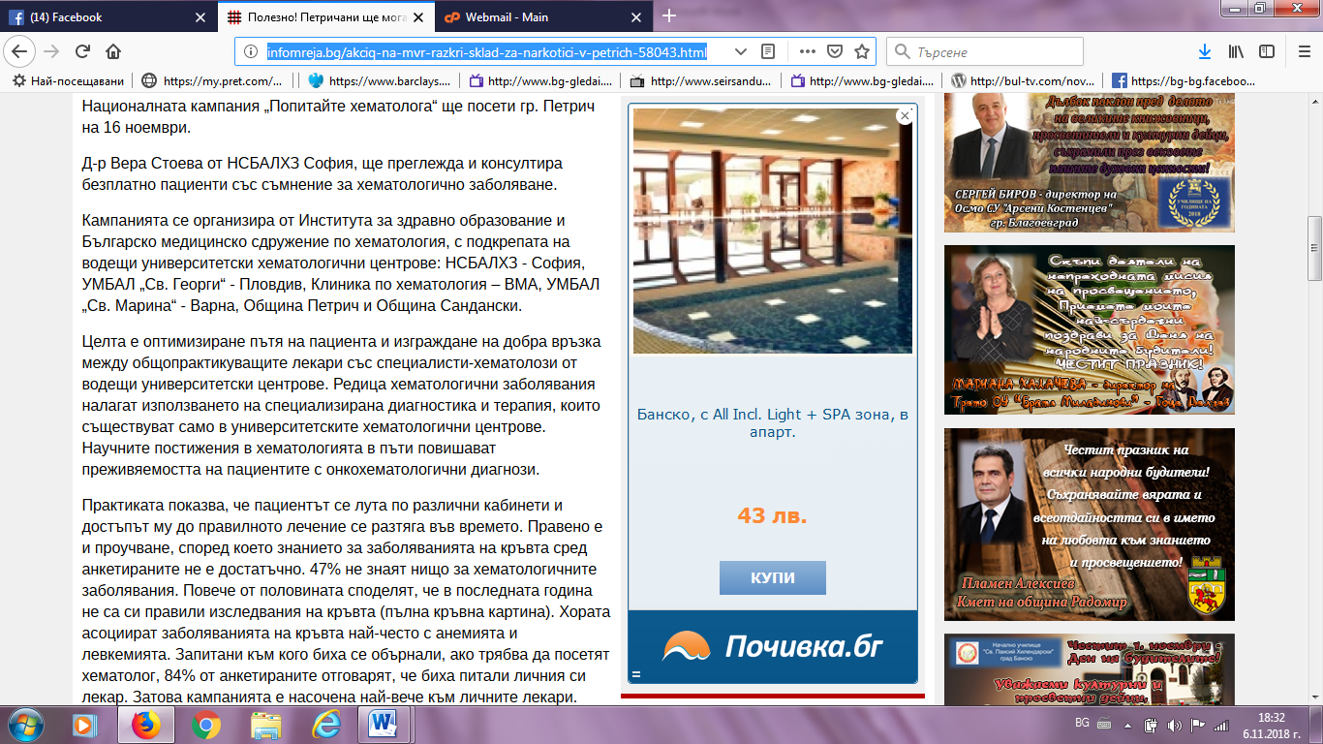

БЛАГОЕВГРАД УТРЕ:
http://www.blagoevgrad.utre.bg/2018/11/01/518971-natsionalnata_kampania_popitayte_hematologa_shte_poseti_petrich
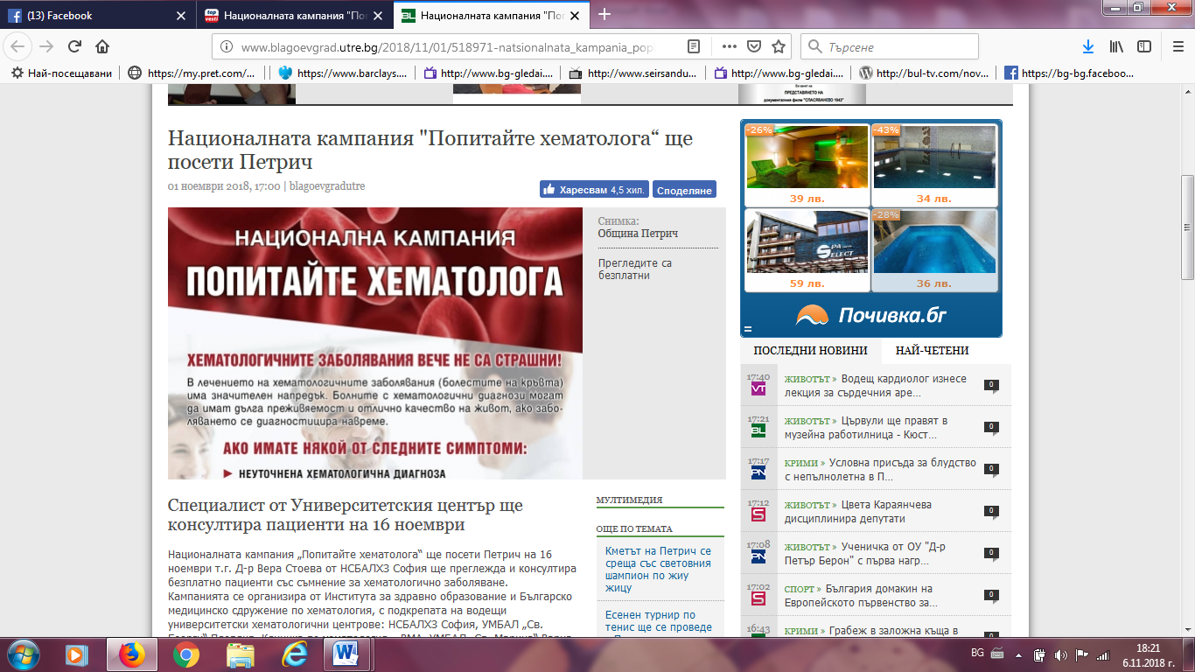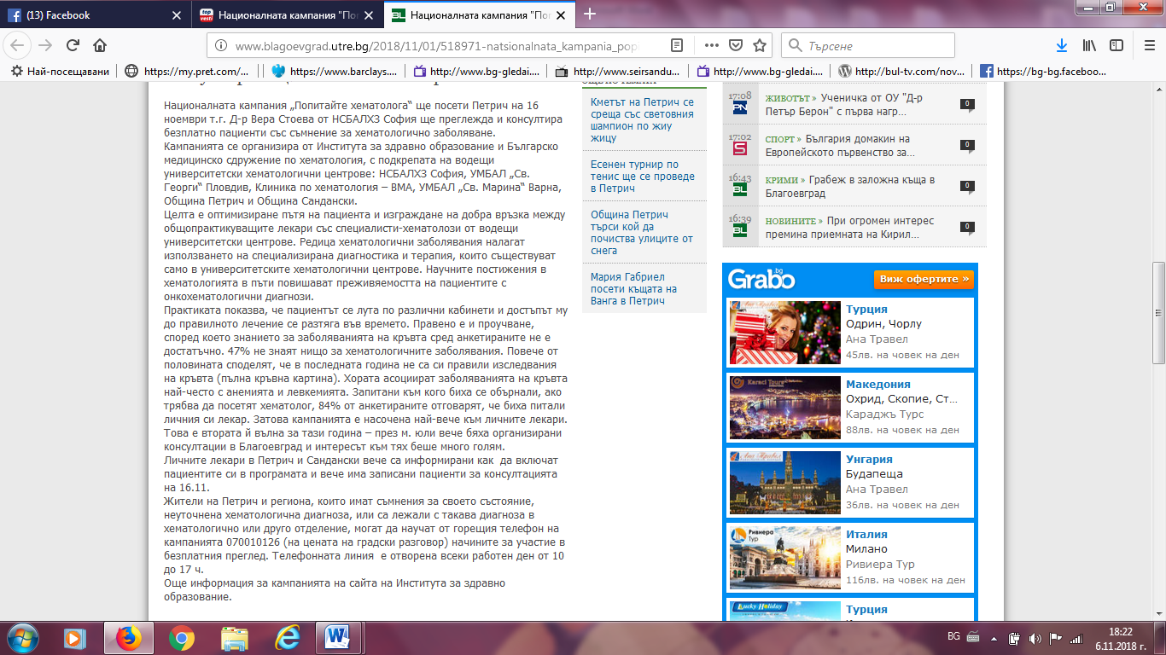

КМЕТА:
http://www.kmeta.bg/hematolog-preglejda-bezplatno-v-petrich
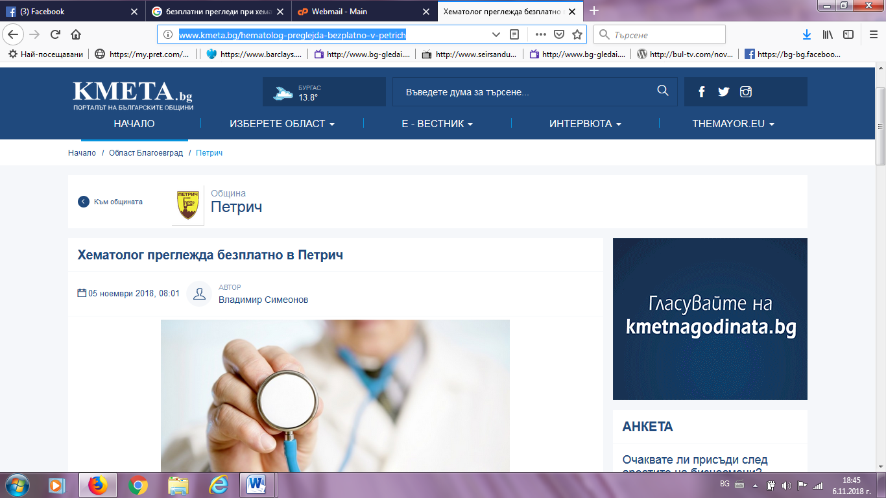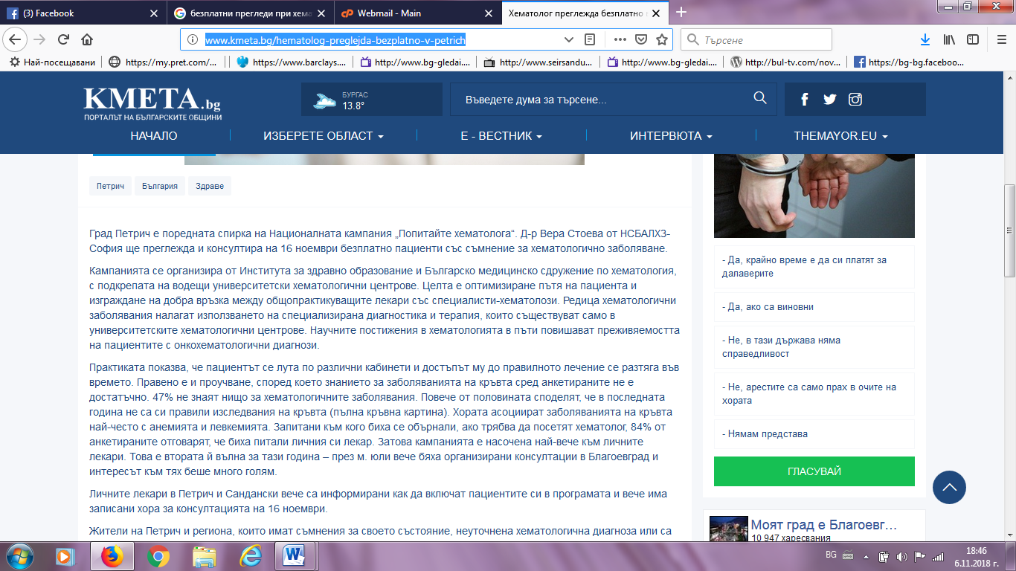

ПЕТРИЧ ФЕЙСБУК:
https://www.facebook.com/groups/527038027334721/permalink/1992669910771518/
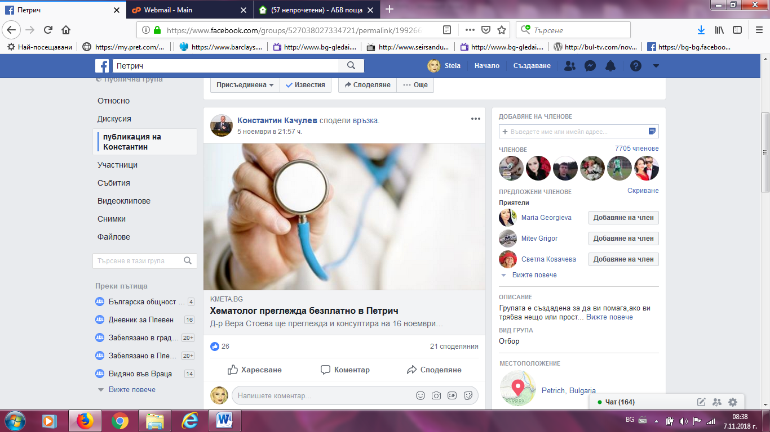

ДАРИК НЮЗ:
https://dariknews.bg/regioni/blagoevgrad/v-petrich-preglezhdat-bezplatno-pacienti-s-hematologichni-zaboliavaniia-2130201
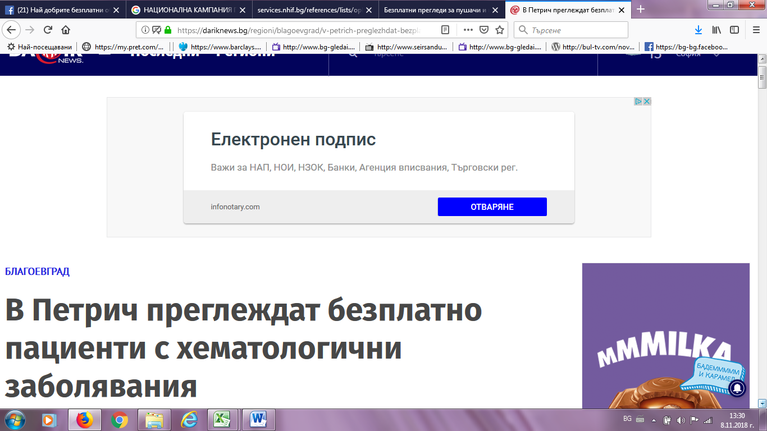

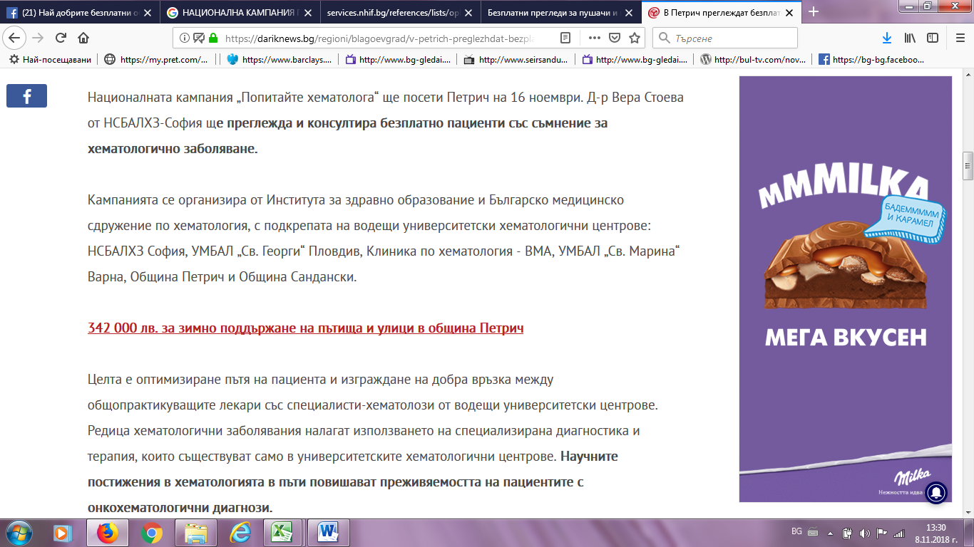
ПЕТРИЧ НЮЗ:
https://petrich-news.com/stolichen-hematolog-shte-preglejda-bezplatno-v-petrich-na-16-noemvri/
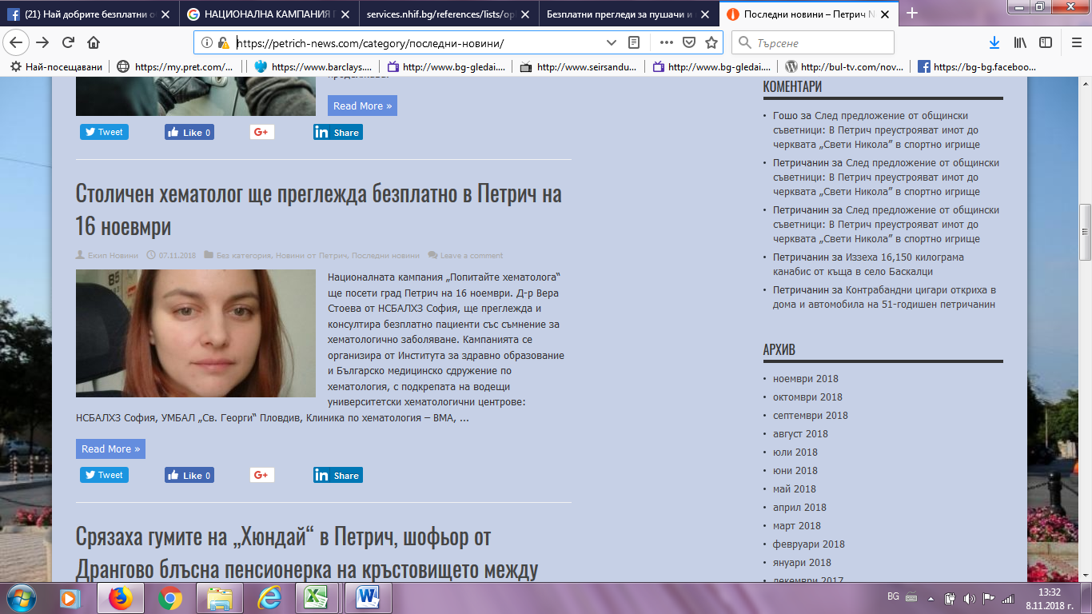

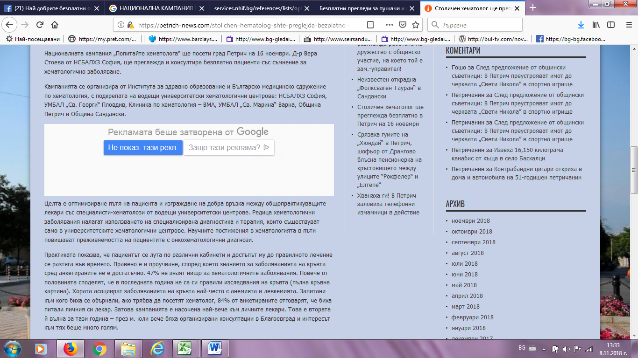
ЗА ПЕТРИЧ:
http://zapetrich.com/%D0%9D%D0%90%D0%A6%D0%98%D0%9E%D0%9D%D0%90%D0%9B%D0%9D%D0%90%D0%A2%D0%90-%D0%9A%D0%90%D0%9C%D0%9F%D0%90%D0%9D%D0%98%D0%AF-%E2%80%9E%D0%9F%D0%9E%D0%9F%D0%98%D0%A2%D0%90%D0%99%D0%A2%D0%95-%D0%A5%D0%95%D0%9C%D0%90%D0%A2%D0%9E%D0%9B%D0%9E%D0%93%D0%90%E2%80%9C-%D0%A9%D0%95-%D0%9F%D0%9E%D0%A1%D0%95%D0%A2%D0%98-%D0%9F%D0%95%D0%A2%D0%A0%D0%98%D0%A7.html
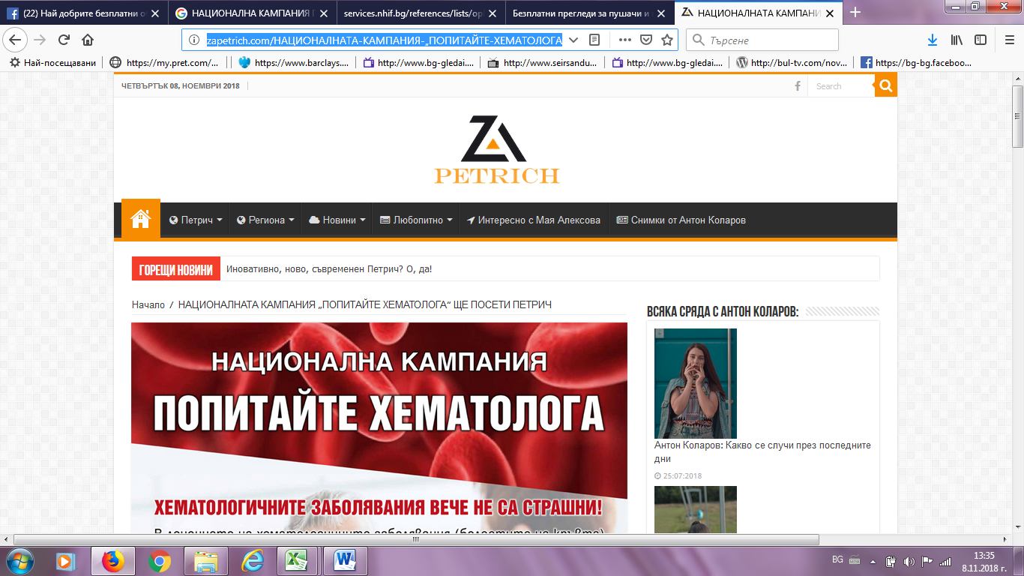

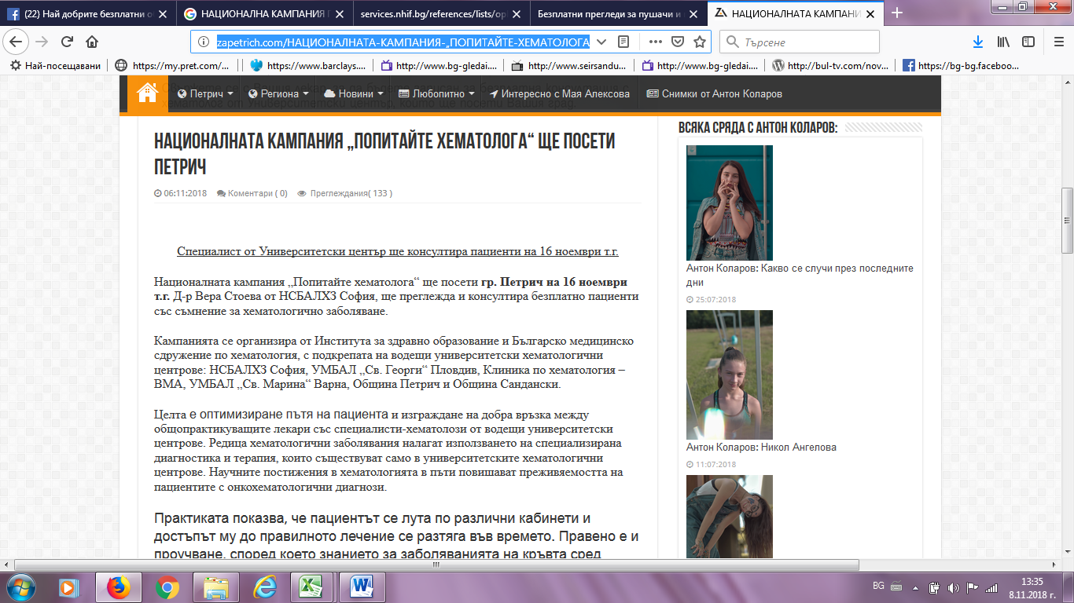
ОБЩИНА ПЕТРИЧ ФЕЙСБУК:
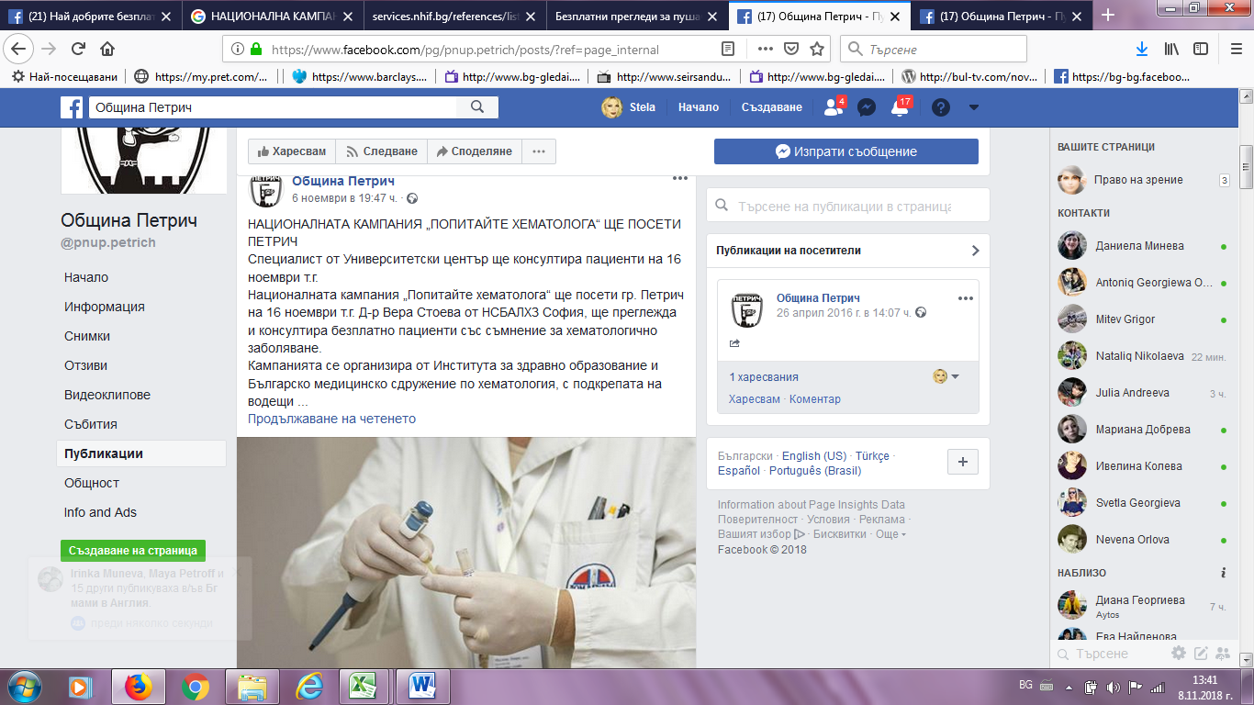

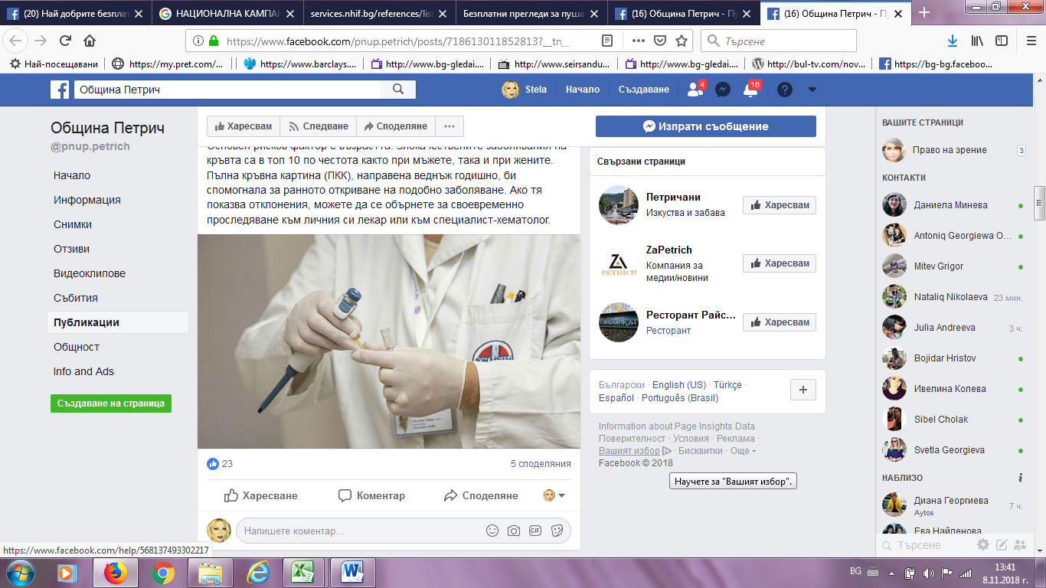
Е-79:
http://www.e-79.com/news-116957.html
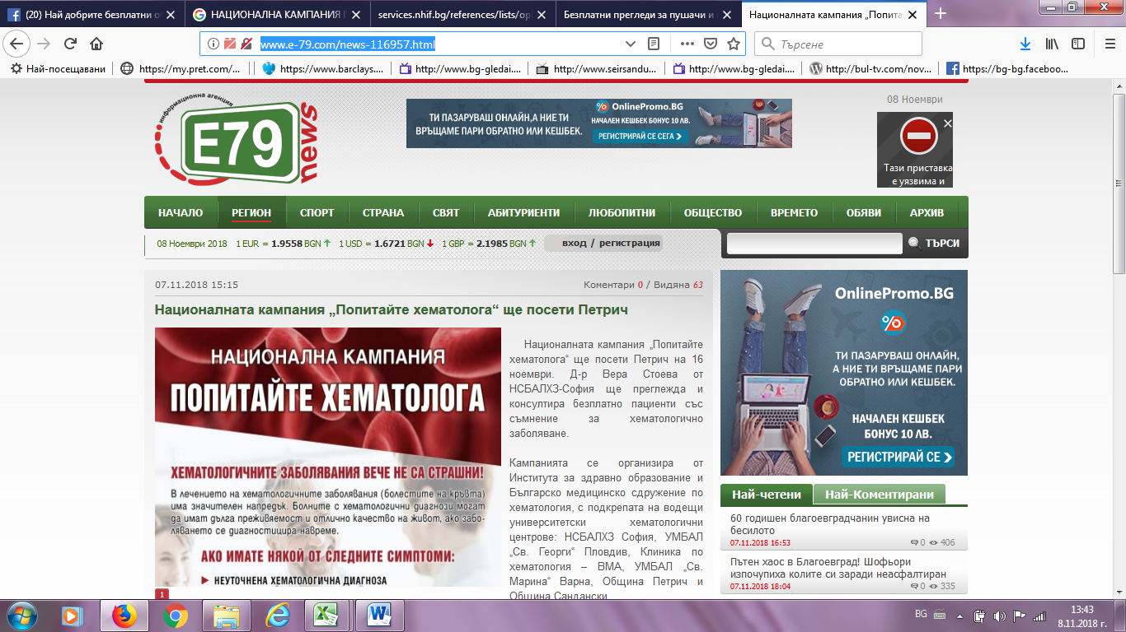

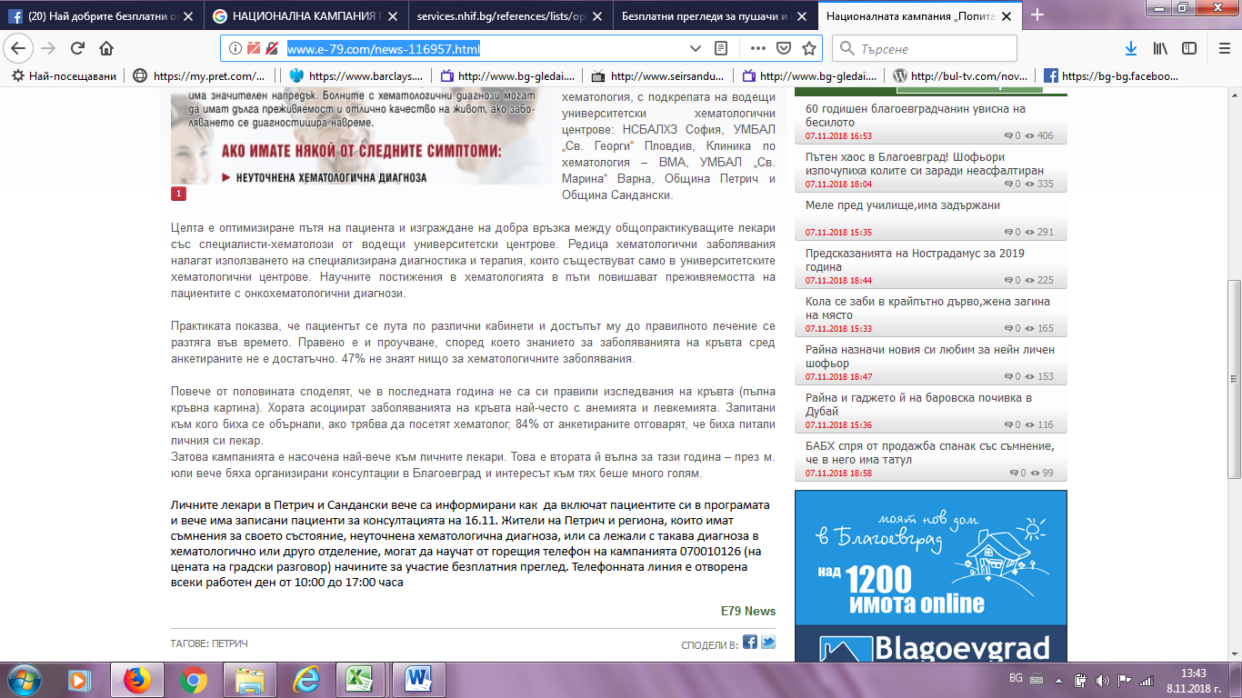
ПАЛО БГ:
http://www.palo.bg/a/%D0%BD%D0%B0%D1%86%D0%B8%D0%BE%D0%BD%D0%B0%D0%BB%D0%BD%D0%B0%D1%82%D0%B0-%D0%BA%D0%B0%D0%BC%D0%BF%D0%B0%D0%BD%D0%B8%D1%8F-%D0%BF%D0%BE%D0%BF%D0%B8%D1%82%D0%B0%D0%B9%D1%82%D0%B5-%D1%85%D0%B5%D0%BC%D0%B0%D1%82%D0%BE%D0%BB%D0%BE%D0%B3%D0%B0-%D1%89%D0%B5-%D0%BF%D0%BE%D1%81%D0%B5%D1%82%D0%B8-%D0%BF%D0%B5%D1%82%D1%80%D0%B8%D1%87-436958
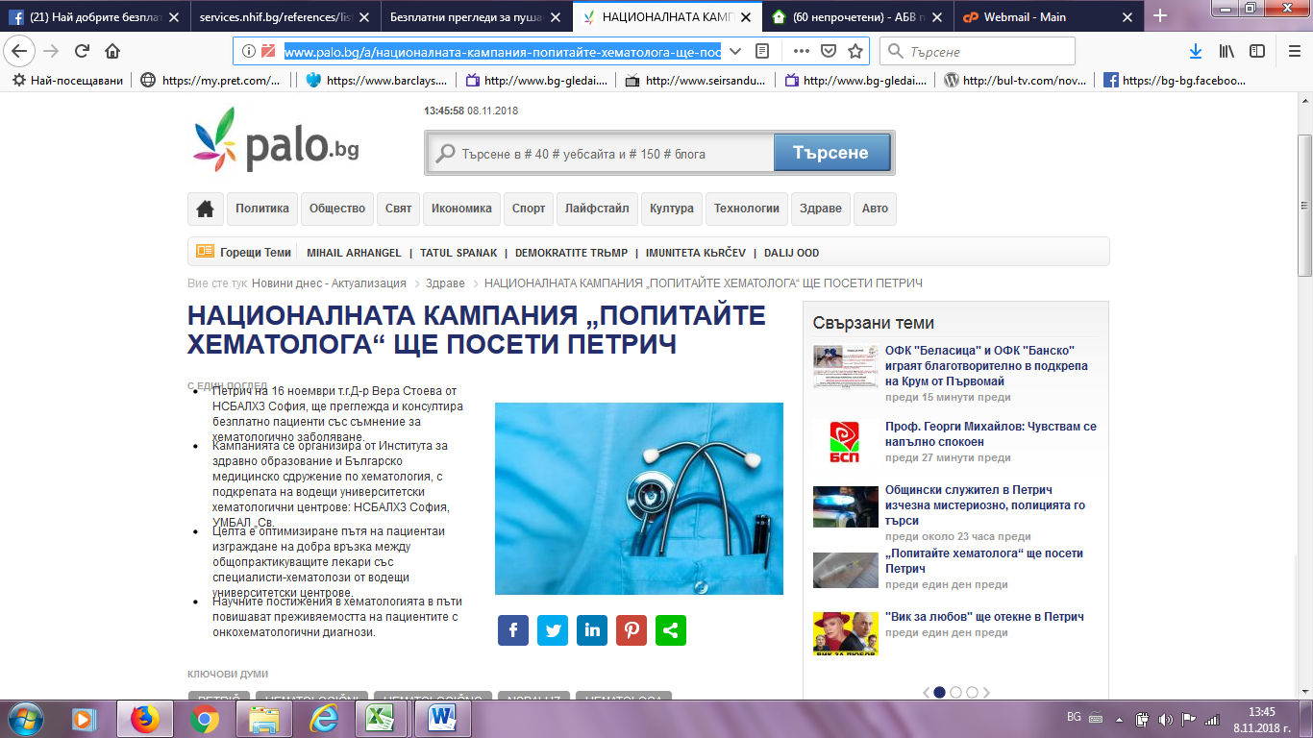

Пирин прес:
http://pirinpress.bg/dir/?p=61954
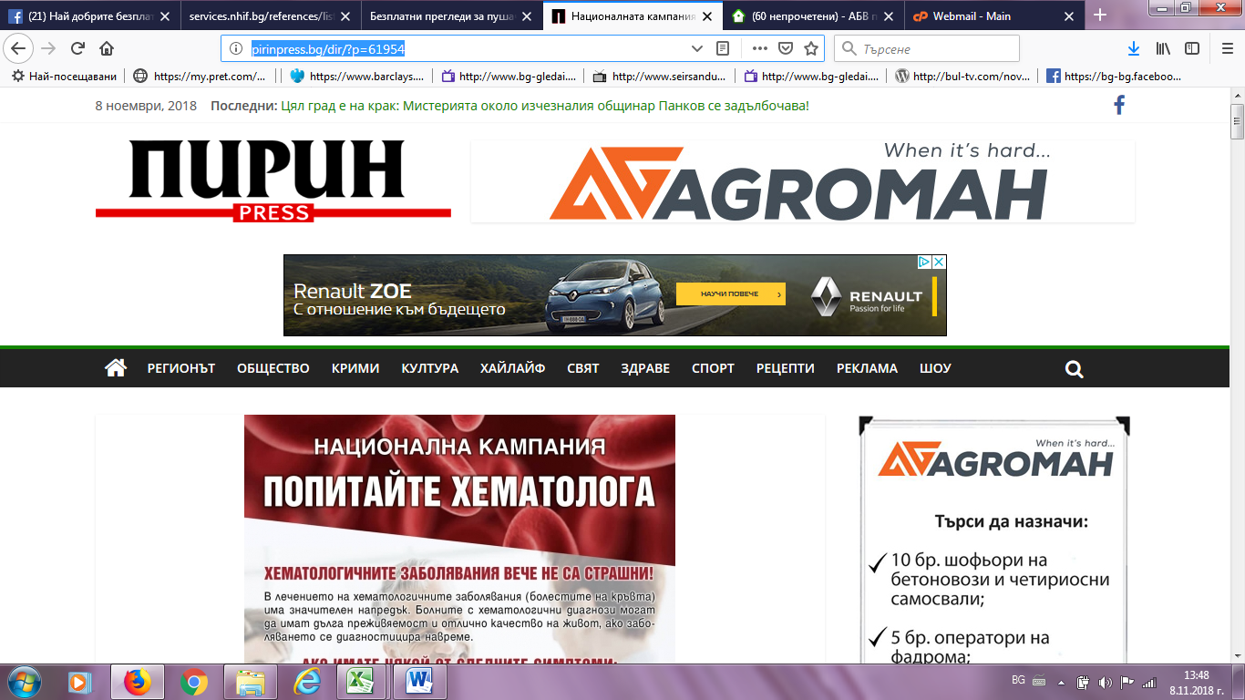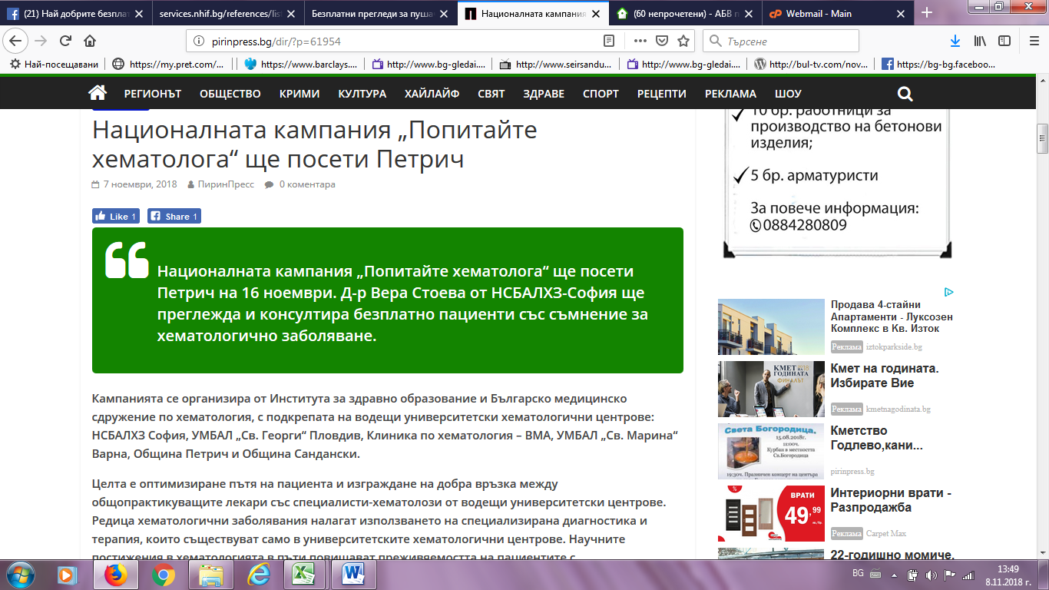

ВОКС 64:
https://vox64.com/%D0%BD%D0%B0%D1%86%D0%B8%D0%BE%D0%BD%D0%B0%D0%BB%D0%BD%D0%B0%D1%82%D0%B0-%D0%BA%D0%B0%D0%BC%D0%BF%D0%B0%D0%BD%D0%B8%D1%8F-%D0%BF%D0%BE%D0%BF%D0%B8%D1%82%D0%B0%D0%B9%D1%82%D0%B5-%D1%85%D0%B5/
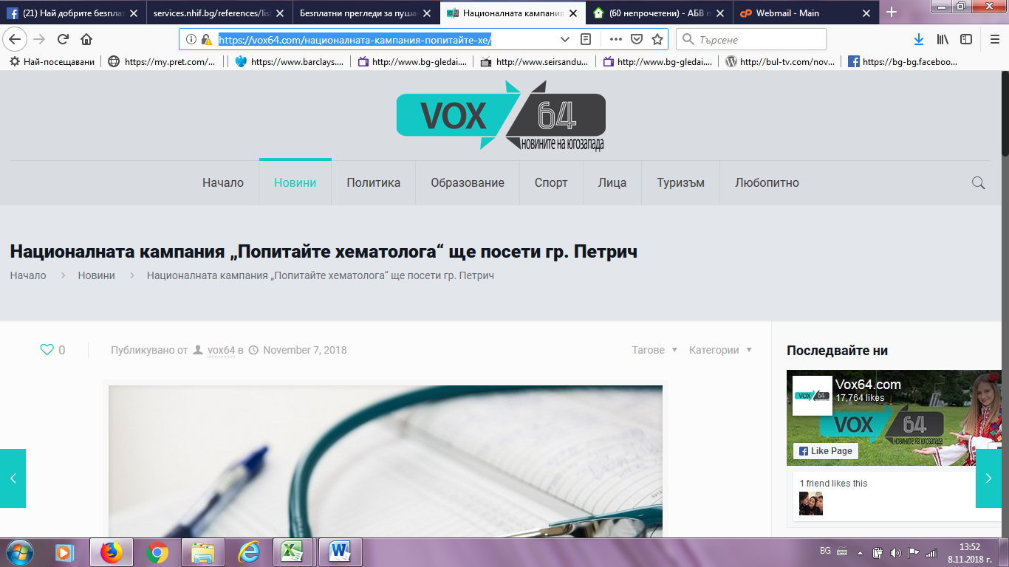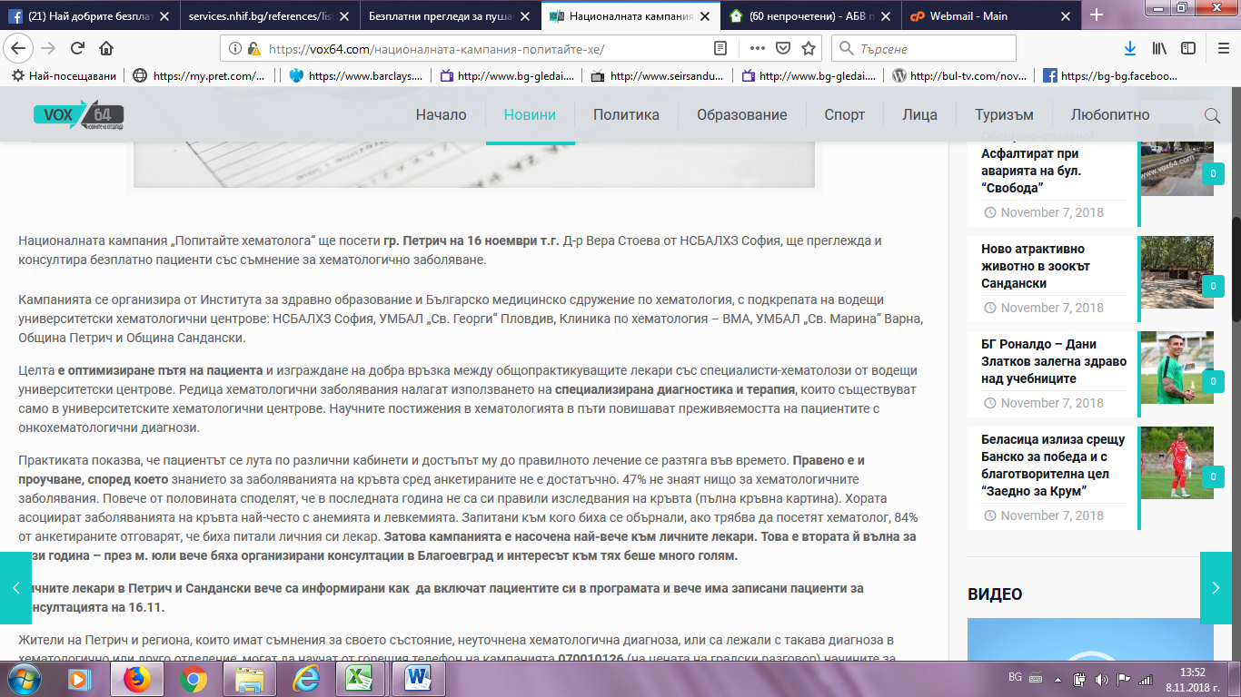

САНДАНСКИ 1:
http://sandanski1.com/sandanski1.php?subaction=showfull&id=1541511419&archive=&start_from=&ucat=34
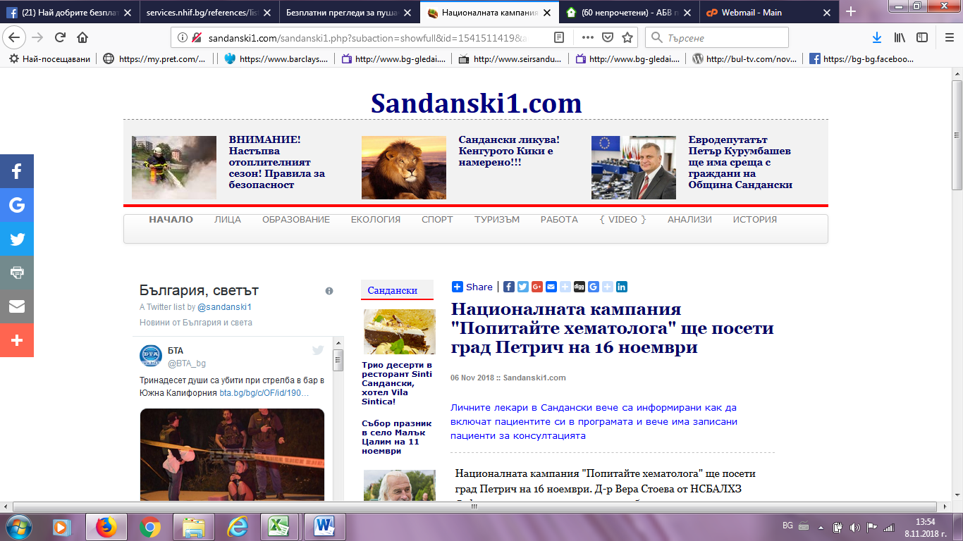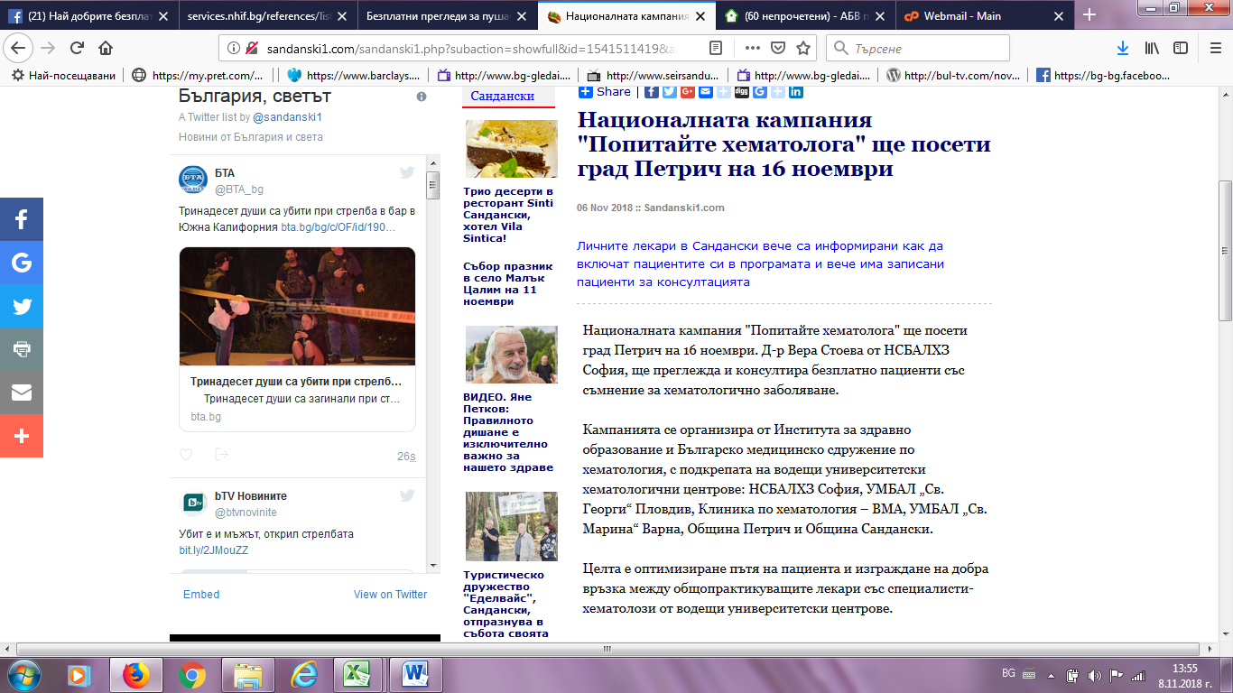

РАЗЛОГ ИНФО:
https://razloginfo.eu/%D0%BD%D0%B0%D1%86%D0%B8%D0%BE%D0%BD%D0%B0%D0%BB%D0%BD%D0%B0%D1%82%D0%B0-%D0%BA%D0%B0%D0%BC%D0%BF%D0%B0%D0%BD%D0%B8%D1%8F-%D0%BF%D0%BE%D0%BF%D0%B8%D1%82%D0%B0%D0%B9%D1%82%D0%B5-%D1%85%D0%B5/
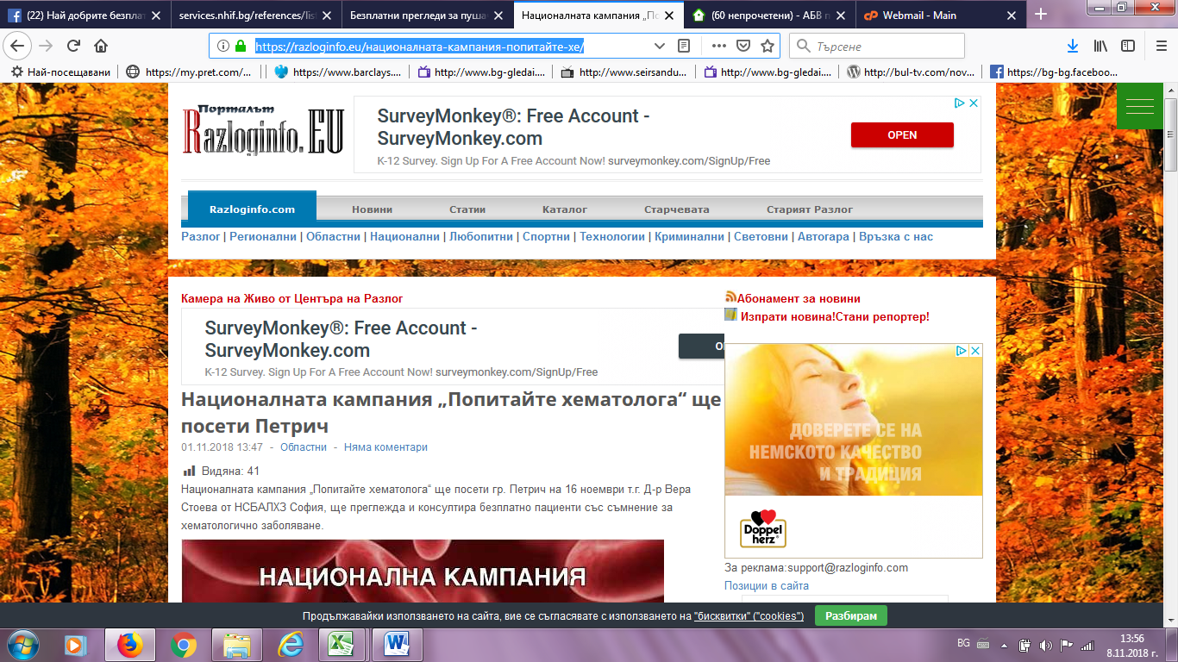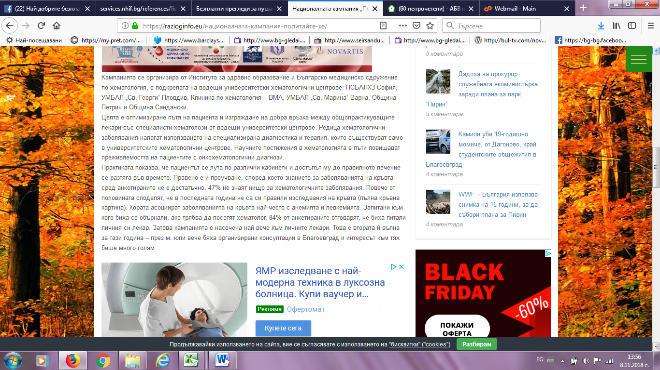

ПИРИНСКО:
http://pirinsko.com/nacionalnata-kampaniq-popitajte-hematologa-shte-poseti-petrich-53121.html
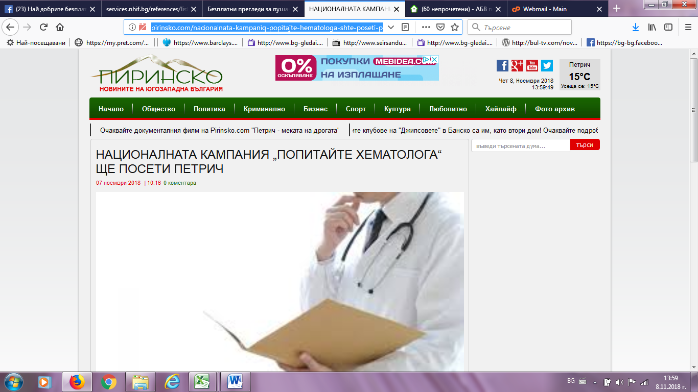
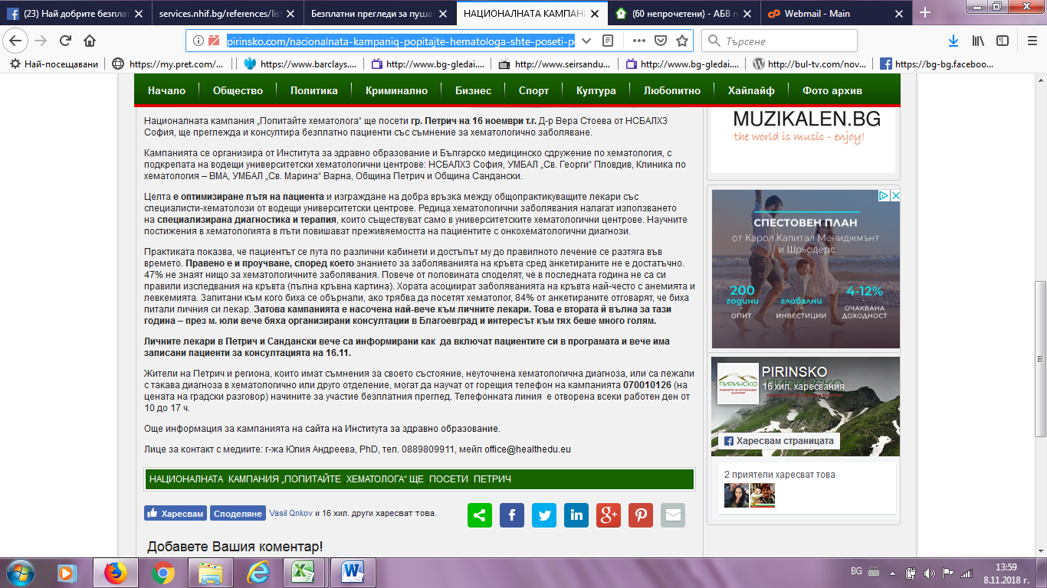

ТРЕТА ВЪЗРАСТ:
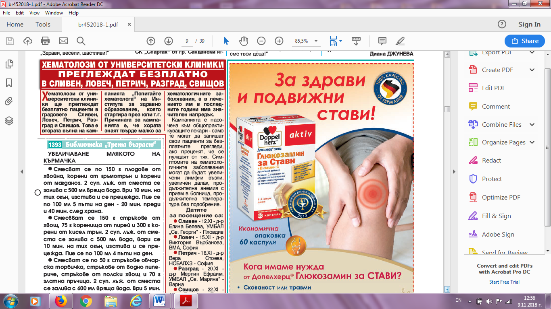
АГЕНЦИЯ БГ:
https://agencia.bg/2018/11/10/41450/
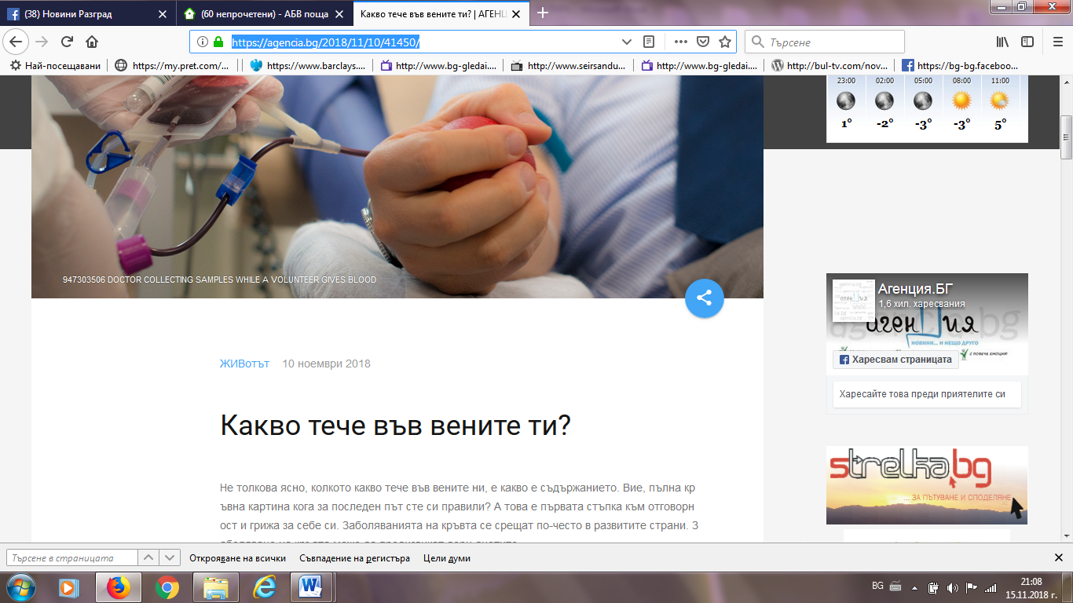

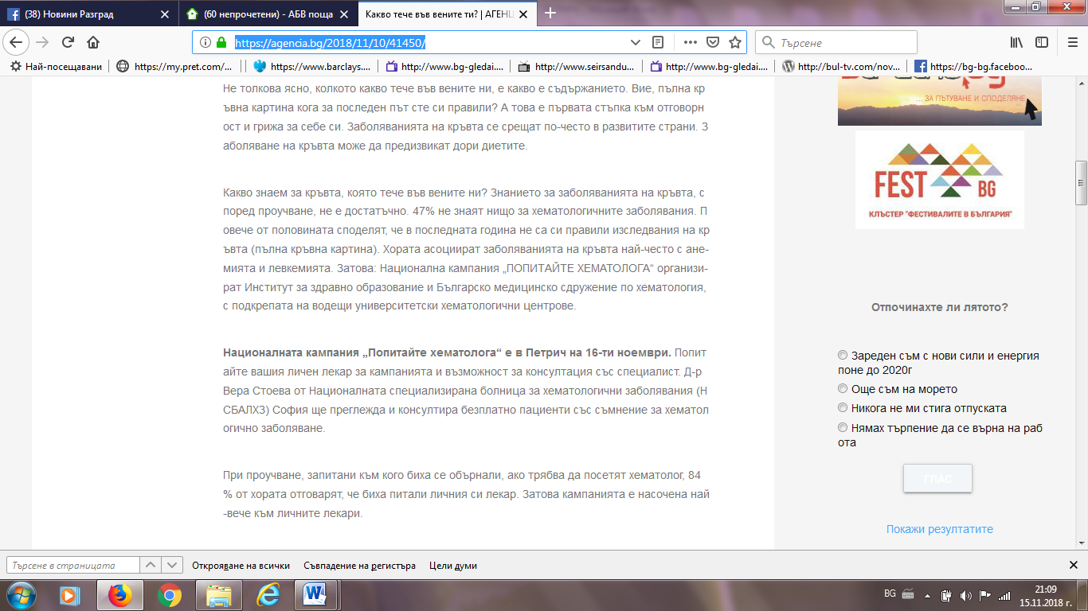
КЛИНИКА БГ:
https://clinica.bg/6667-%D0%A5%D0%B5%D0%BC%D0%B0%D1%82%D0%BE%D0%BB%D0%BE%D0%B7%D0%B8-%D0%BF%D1%80%D0%B5%D0%B3%D0%BB%D0%B5%D0%B6%D0%B4%D0%B0%D1%82-%D0%B2-%D0%9F%D0%B5%D1%82%D1%80%D0%B8%D1%87
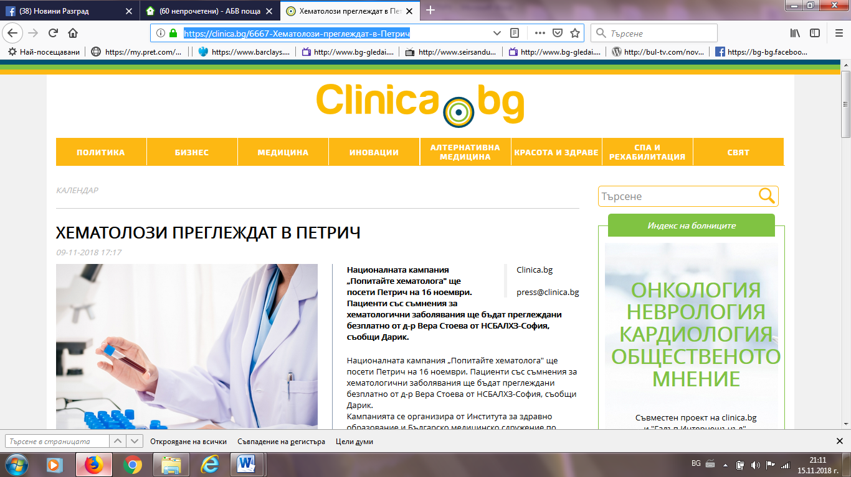

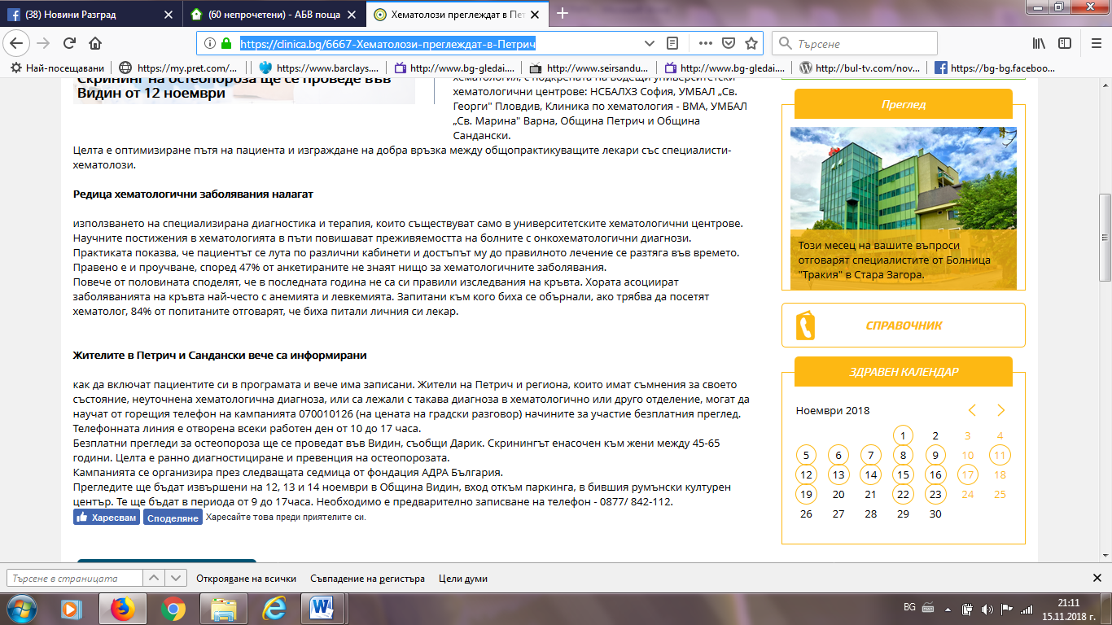
ВЯРА НЮЗ:
http://viaranews.com/?p=288596
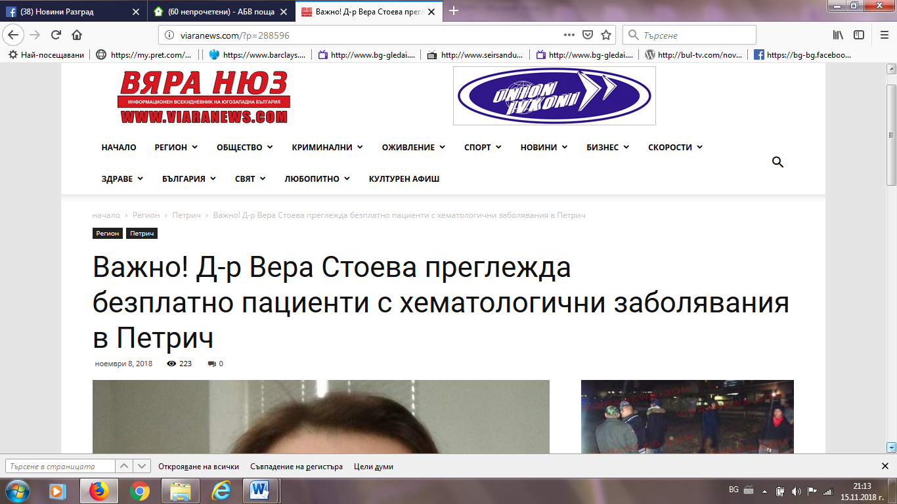

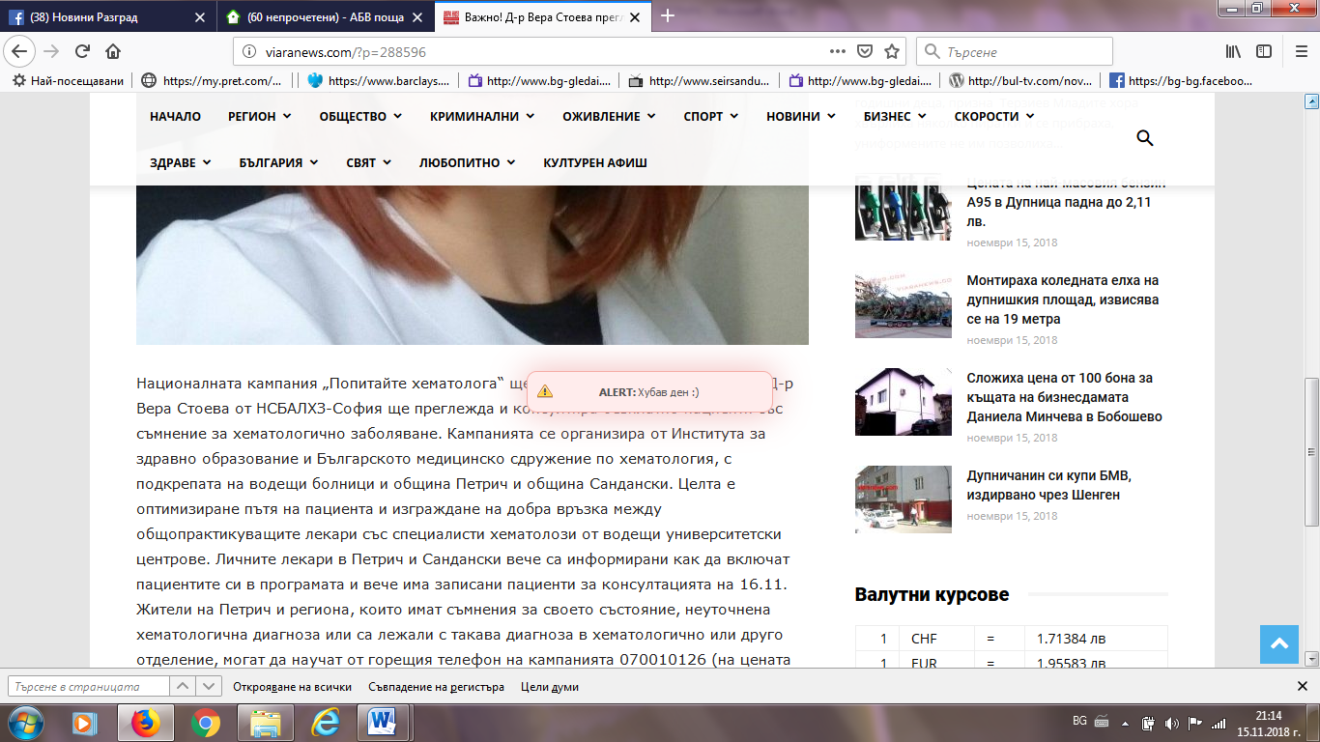
РАДИО БЕЛЛА:
http://www.radiobella.com/news/item/7093-%D0%BD%D0%B0%D1%86%D0%B8%D0%BE%D0%BD%D0%B0%D0%BB%D0%BD%D0%B0%D1%82%D0%B0-%D0%BA%D0%B0%D0%BC%D0%BF%D0%B0%D0%BD%D0%B8%D1%8F-%E2%80%9E%D0%BF%D0%BE%D0%BF%D0%B8%D1%82%D0%B0%D0%B9%D1%82%D0%B5-%D1%85%D0%B5%D0%BC%D0%B0%D1%82%D0%BE%D0%BB%D0%BE%D0%B3%D0%B0%E2%80%9C-%D1%89%D0%B5-%D0%BF%D0%BE%D1%81%D0%B5%D1%82%D0%B8-%D0%BF%D0%B5%D1%82%D1%80%D0%B8%D1%87-%D0%BD%D0%B0-16-%D0%BD%D0%BE%D0%B5%D0%BC%D0%B2%D1%80%D0%B8.html
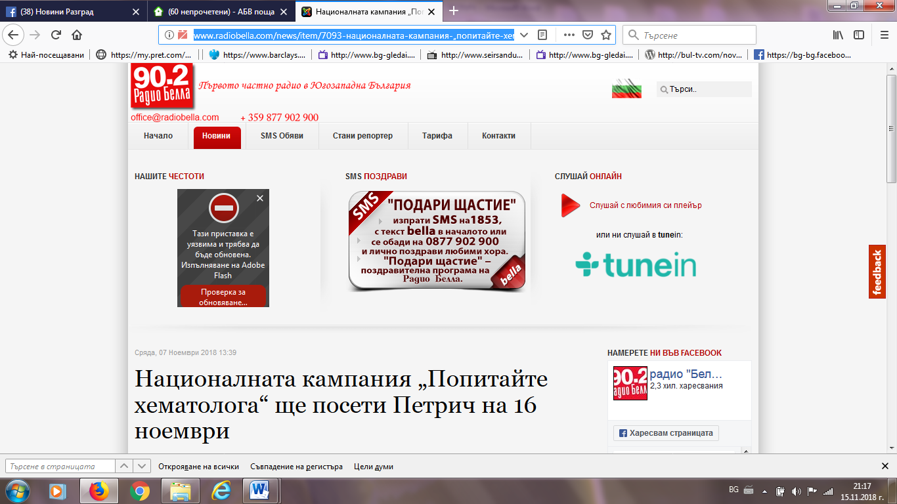
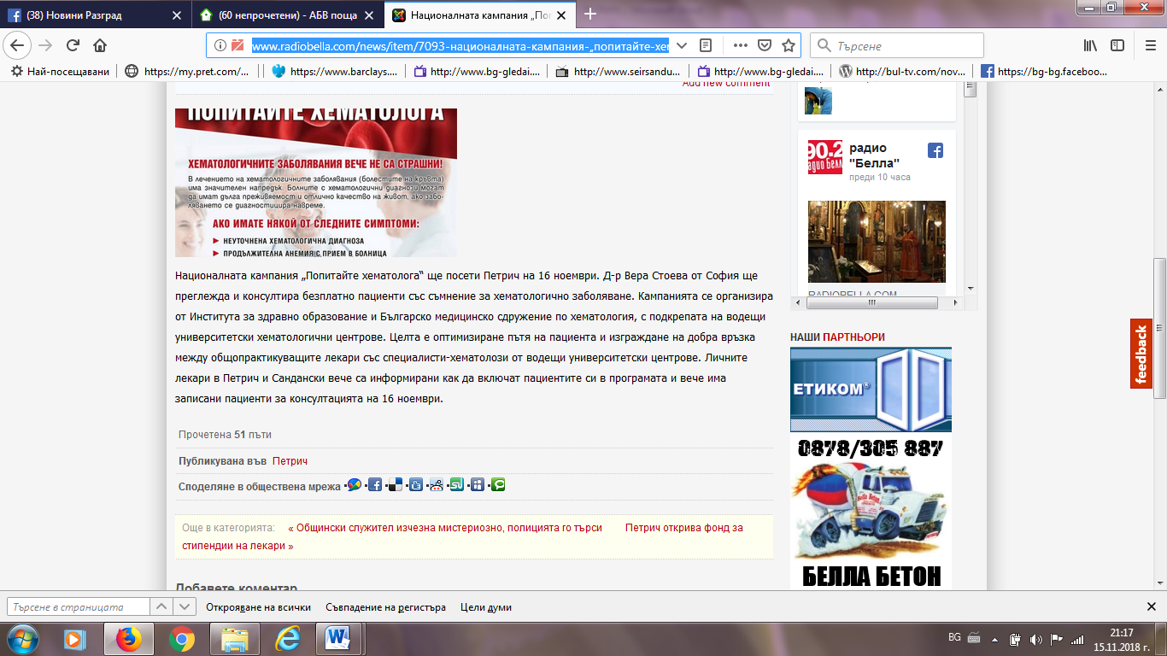
Е НОВИНА:
http://enovina.bg/novina/bezplatni-pregledi-v-petrich-i-sandanski-6183/
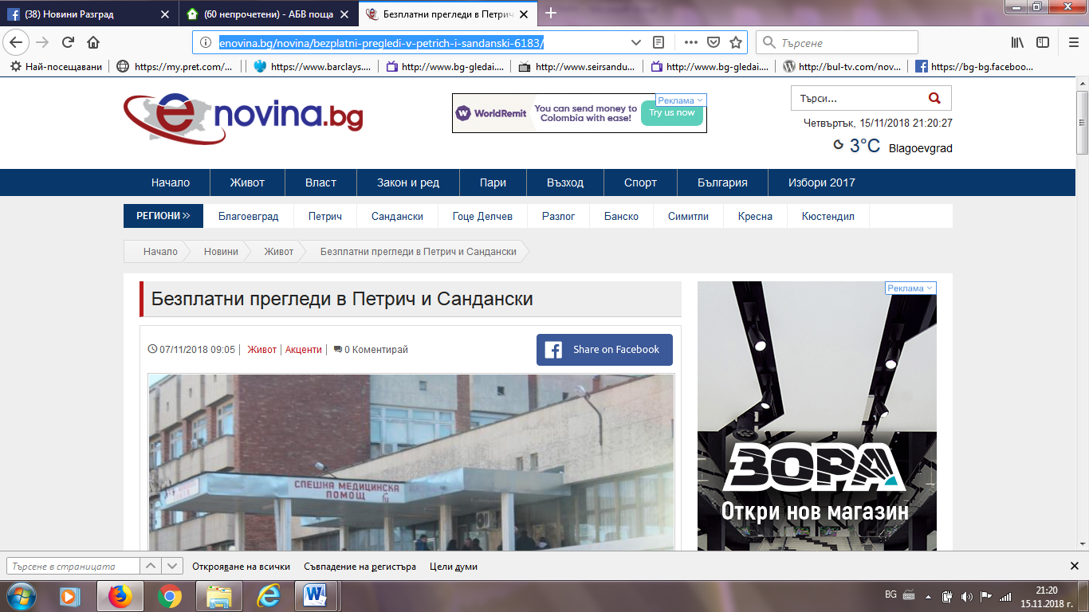

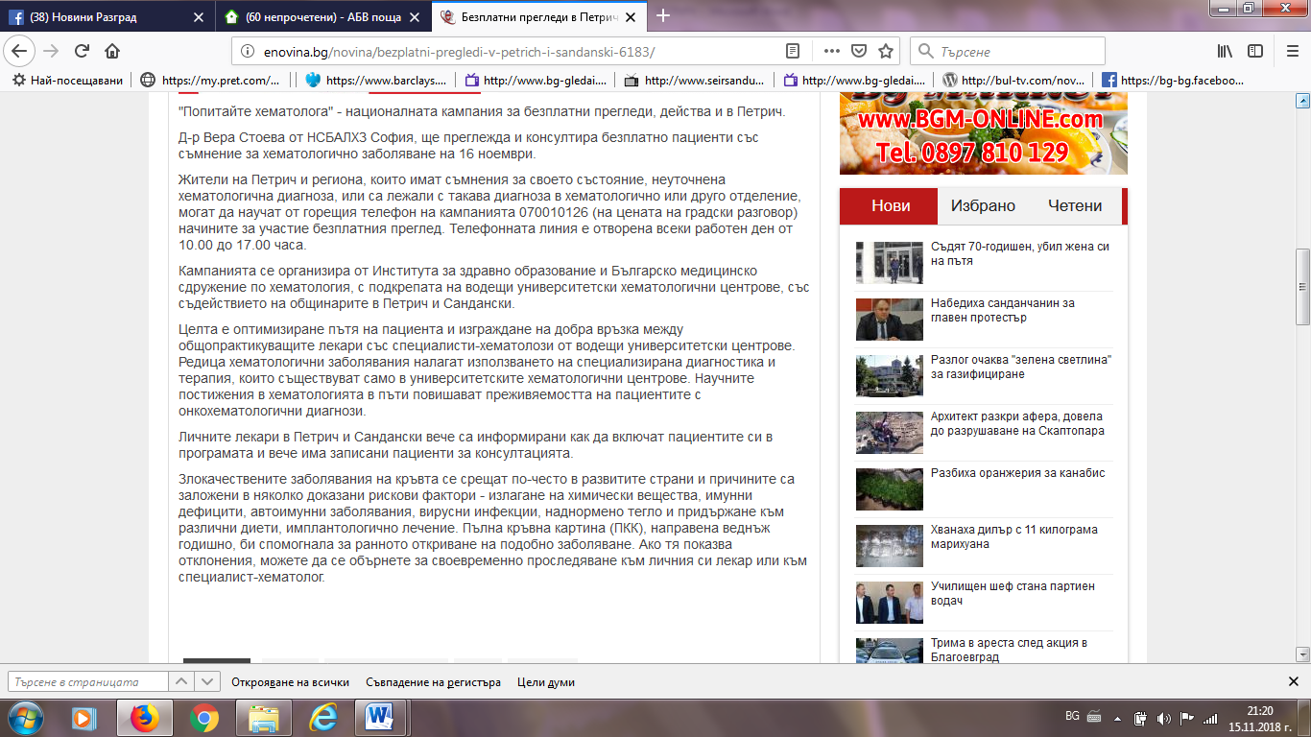
БЛАГОЕВГРАД НЮЗ:
http://blagoevgrad-news.com/stolichen-hematolog-shte-preglejda-bezplatno-v-petrich-na-16-noemvri/
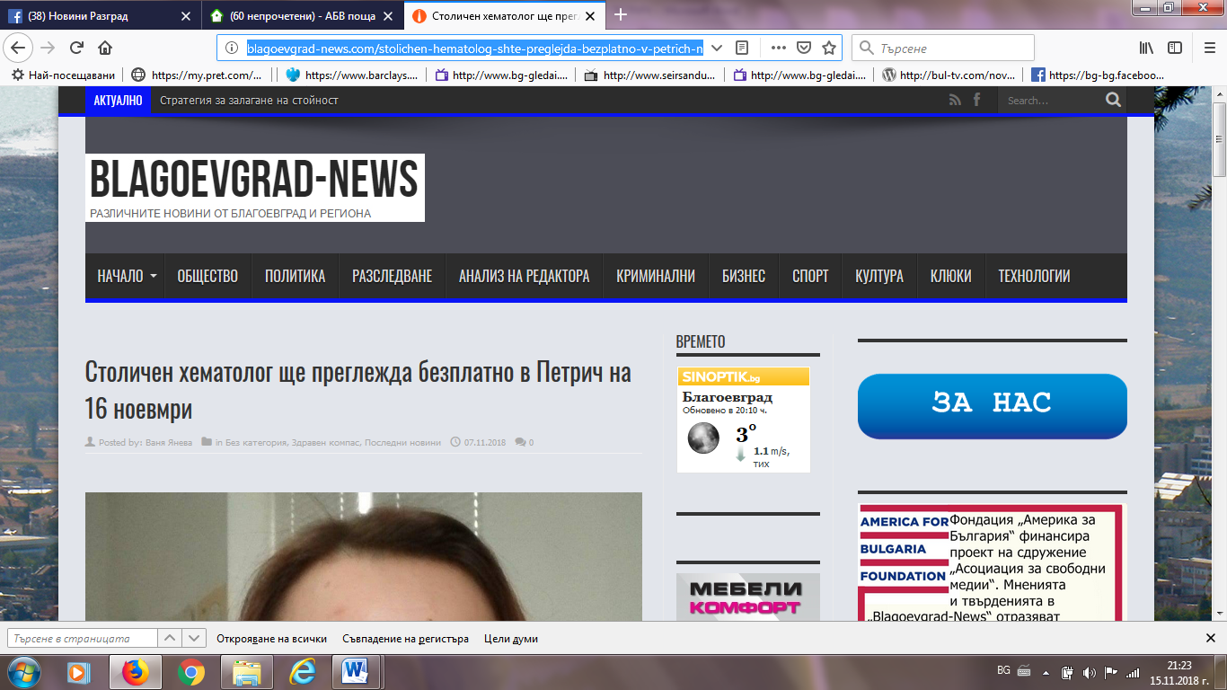

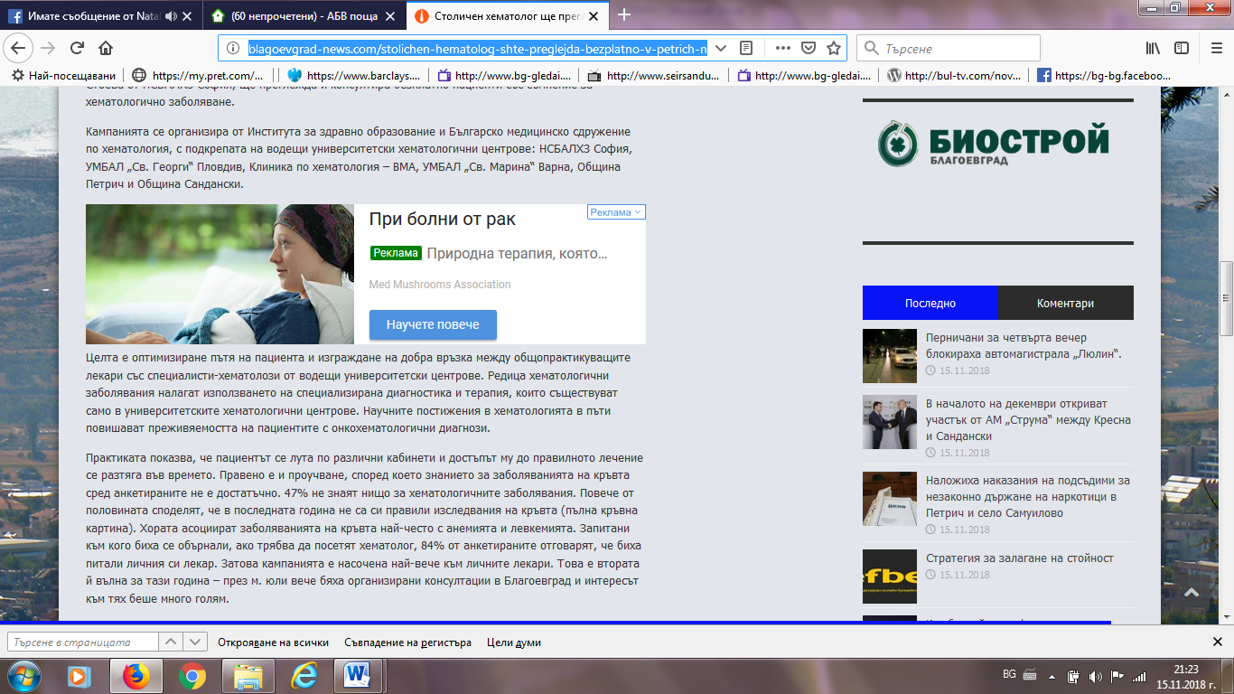
ЗА ПЕТРИЧ ФЕЙСБУК:
https://www.facebook.com/Zapetrichcom/
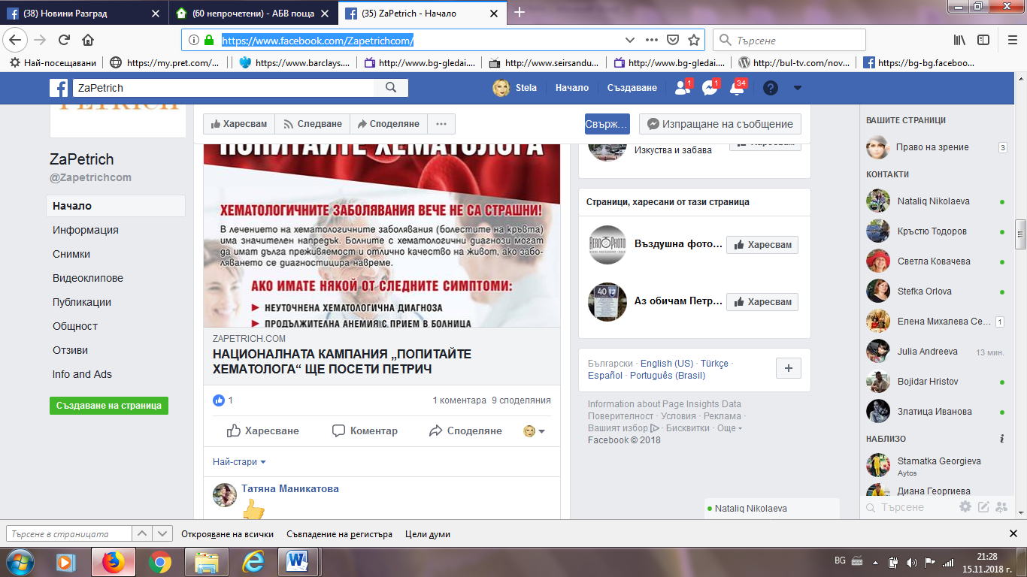

ТОП ПРЕСА БГ:
http://toppresa.bg/158590/%d0%a5%d0%b5%d0%bc%d0%b0%d1%82%d0%be%d0%bb%d0%be%d0%b7%d0%b8-%d0%bf%d1%80%d0%b5%d0%b3%d0%bb%d0%b5%d0%b6%d0%b4%d0%b0%d1%85%d0%b0-%d0%b1%d0%b5%d0%b7%d0%bf%d0%bb%d0%b0%d1%82%d0%bd%d0%be-%d0%b2-%d0%9f
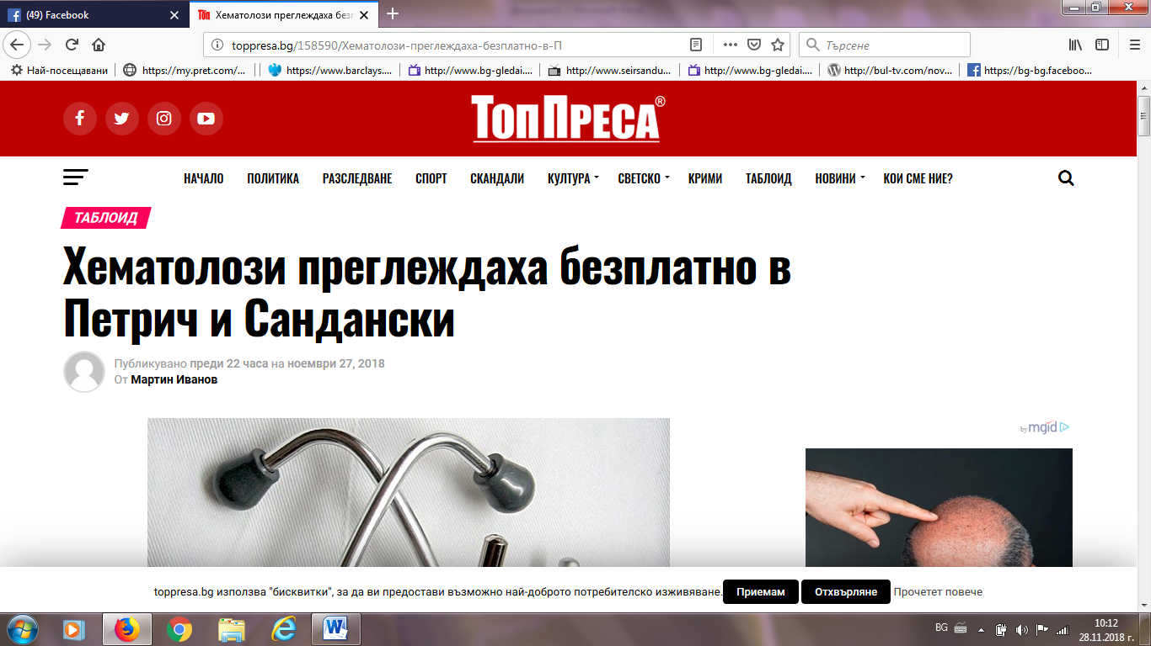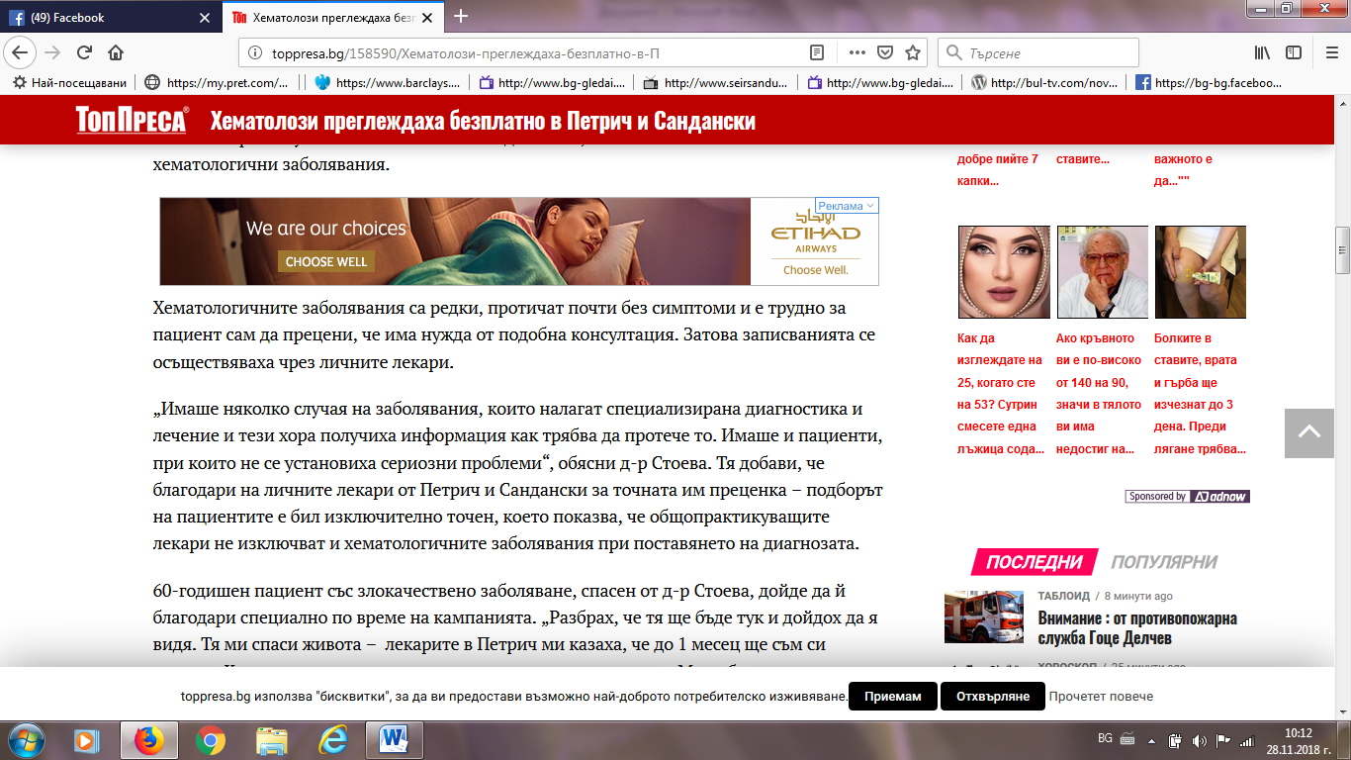

АГЕНЦИЯ БГ:
https://agencia.bg/2018/11/27/%D1%85%D0%B5%D0%BC%D0%B0%D1%82%D0%BE%D0%BB%D0%BE%D0%B3-%D1%81%D0%BF%D0%B0%D1%81%D0%B8-%D0%B6%D0%B8%D0%B2%D0%BE%D1%82%D0%B0-%D0%BD%D0%B0-60-%D0%B3%D0%BE%D0%B4%D0%B8%D1%88%D0%B5%D0%BD-%D0%BF%D0%B5%D1%82/
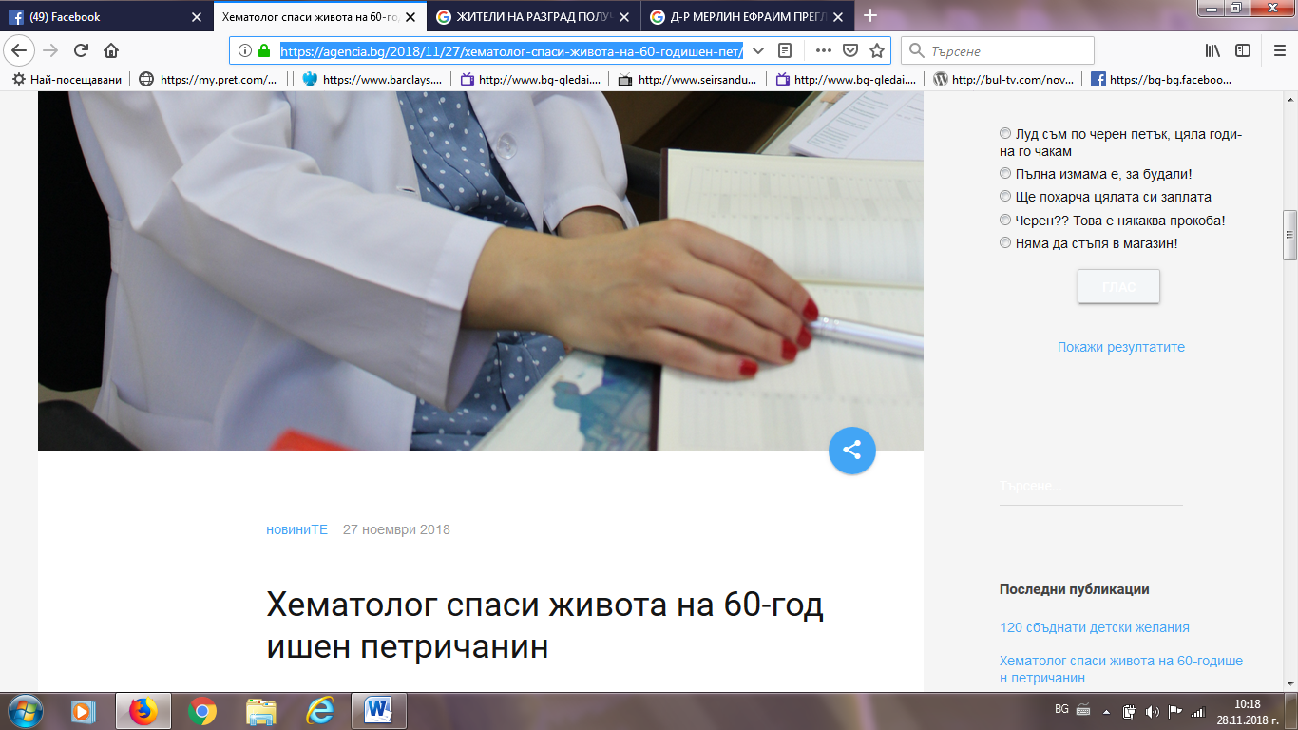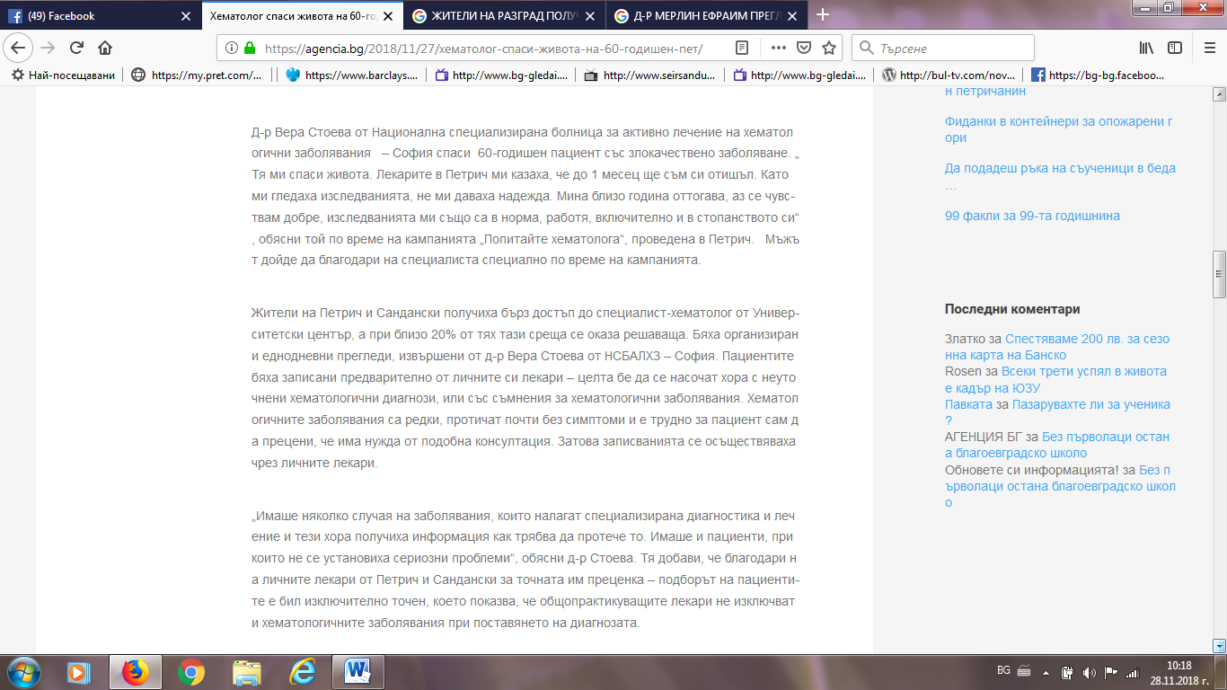

РАЗЛОГ ИНФО (ИНТЕРВЮ):
https://razloginfo.eu/%D0%B6%D0%B8%D1%82%D0%B5%D0%BB%D0%B8-%D0%BD%D0%B0-%D0%BF%D0%B5%D1%82%D1%80%D0%B8%D1%87-%D0%BF%D0%BE%D0%BB%D1%83%D1%87%D0%B8%D1%85%D0%B0-%D0%B1%D1%8A%D1%80%D0%B7-%D0%B4%D0%BE%D1%81%D1%82%D1%8A%D0%BF/
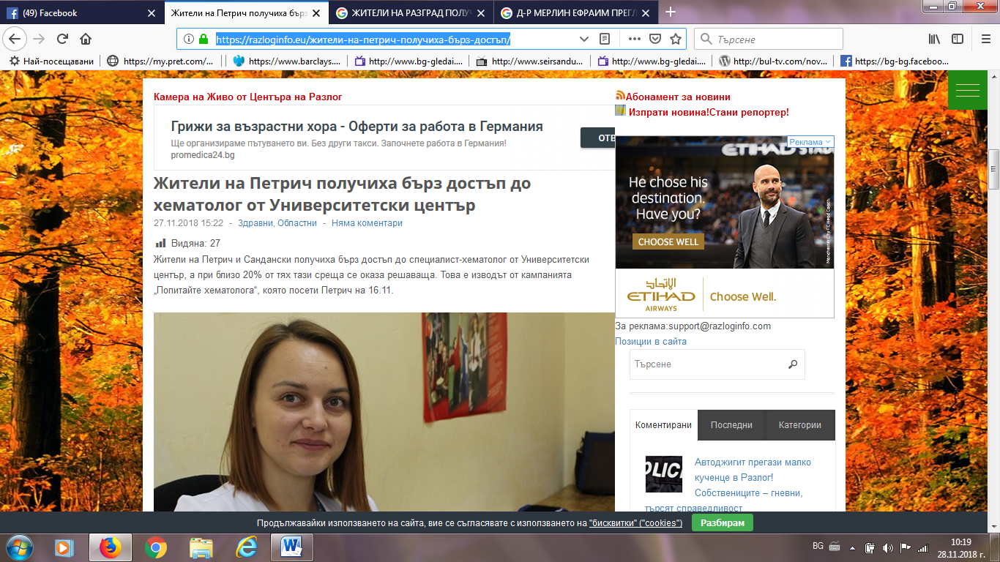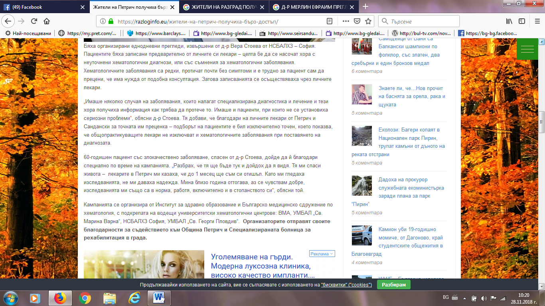

РАЗЛОГ ИНФО ФЕЙСБУК:
https://www.facebook.com/portalatnarazlog/posts/10155681166087307
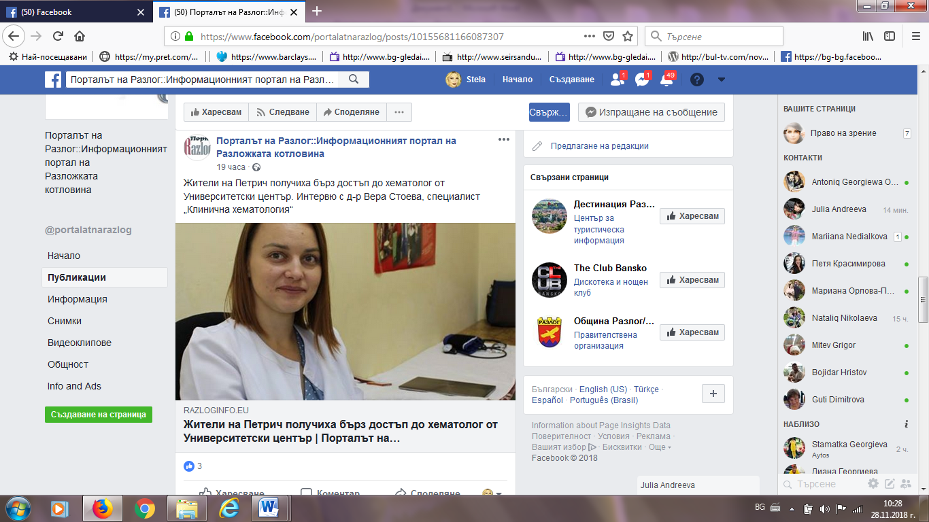
БНР:
http://bnr.bg/blagoevgrad/post/101050660
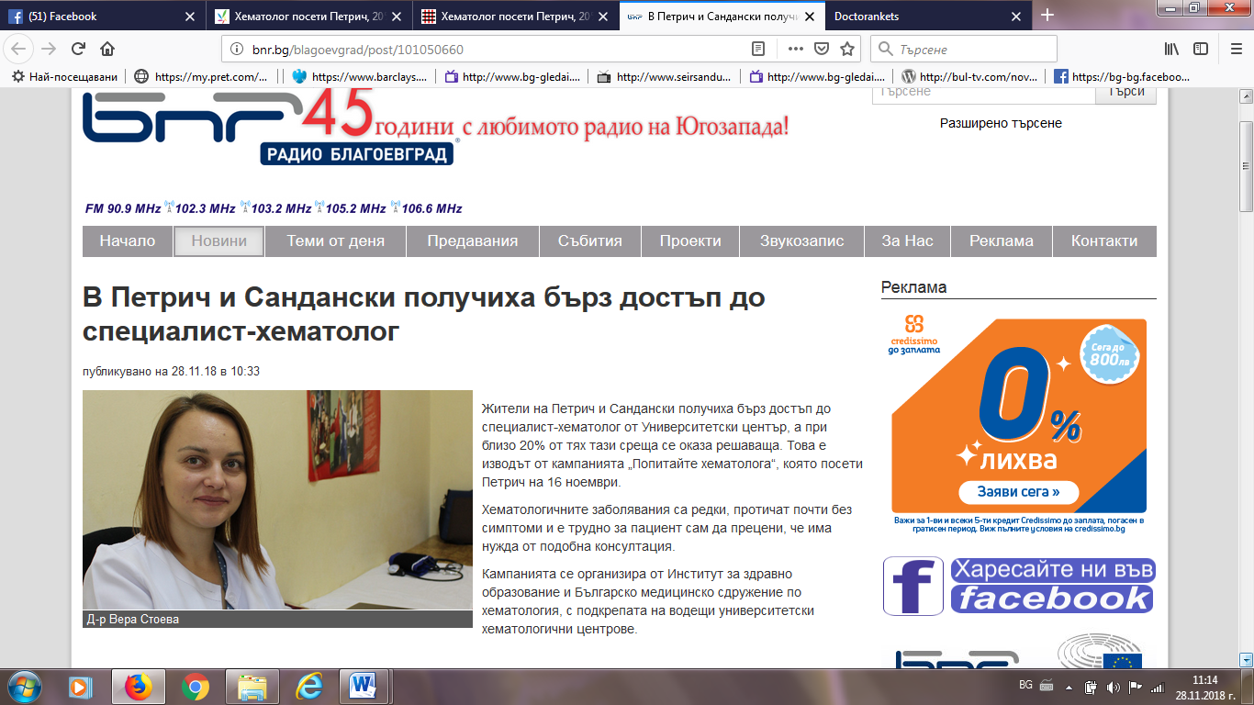

ИНФОМРЕЖА:
http://infomreja.bg/hematolog-poseti-petrich-20-ot-pregledanite-sa-nasocheni-za-izsledvaniq-i-lechenie-58876.html
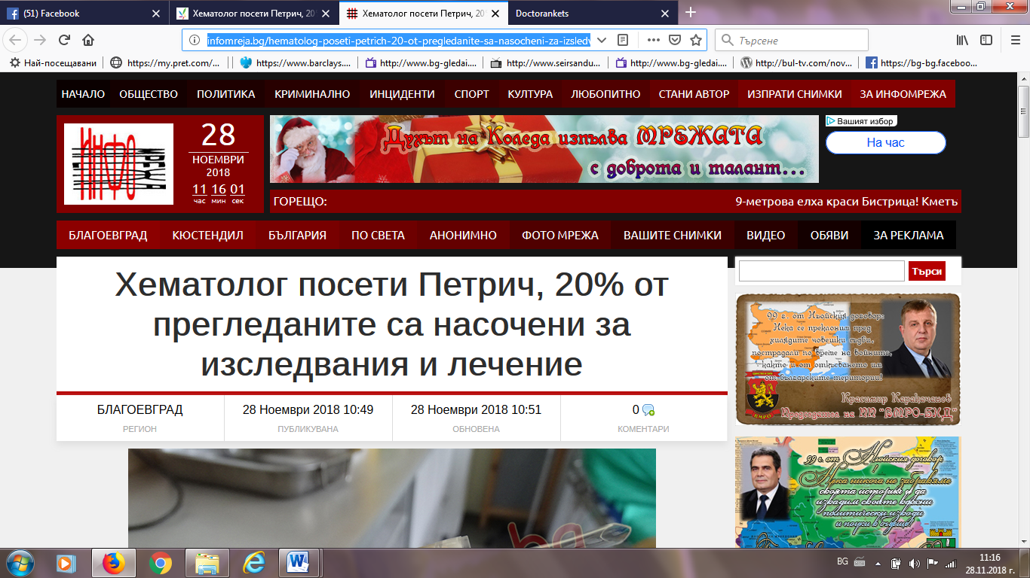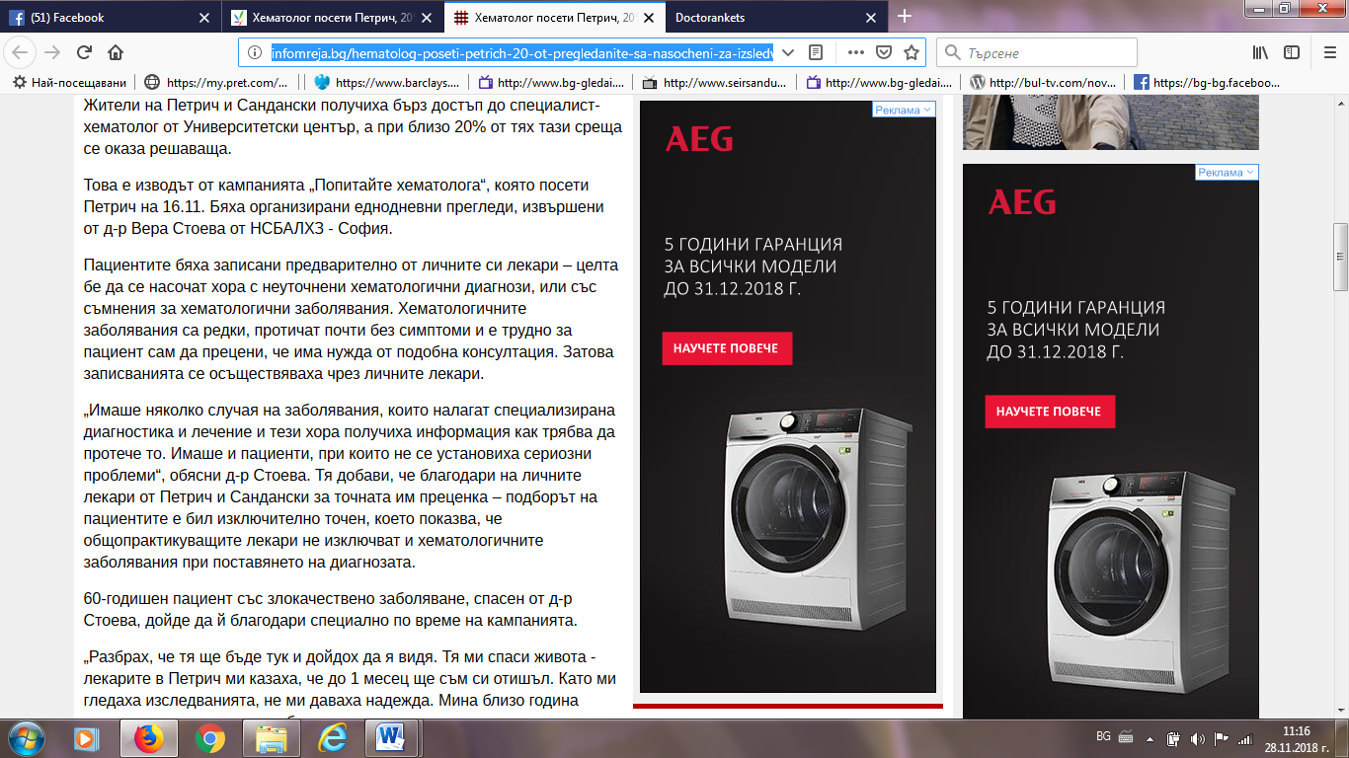

ПАЛО БГ:
http://www.palo.bg/a/%D1%85%D0%B5%D0%BC%D0%B0%D1%82%D0%BE%D0%BB%D0%BE%D0%B3-%D0%BF%D0%BE%D1%81%D0%B5%D1%82%D0%B8-%D0%BF%D0%B5%D1%82%D1%80%D0%B8%D1%87-20-%D0%BE%D1%82-%D0%BF%D1%80%D0%B5%D0%B3%D0%BB%D0%B5%D0%B4%D0%B0%D0%BD%D0%B8%D1%82%D0%B5-%D1%81%D0%B0-%D0%BD%D0%B0%D1%81%D0%BE%D1%87%D0%B5%D0%BD%D0%B8-%D0%B7%D0%B0-%D0%B8%D0%B7%D1%81%D0%BB%D0%B5%D0%B4%D0%B2%D0%B0%D0%BD%D0%B8%D1%8F-%D0%B8-%D0%BB%D0%B5%D1%87%D0%B5%D0%BD%D0%B8%D0%B5-475659
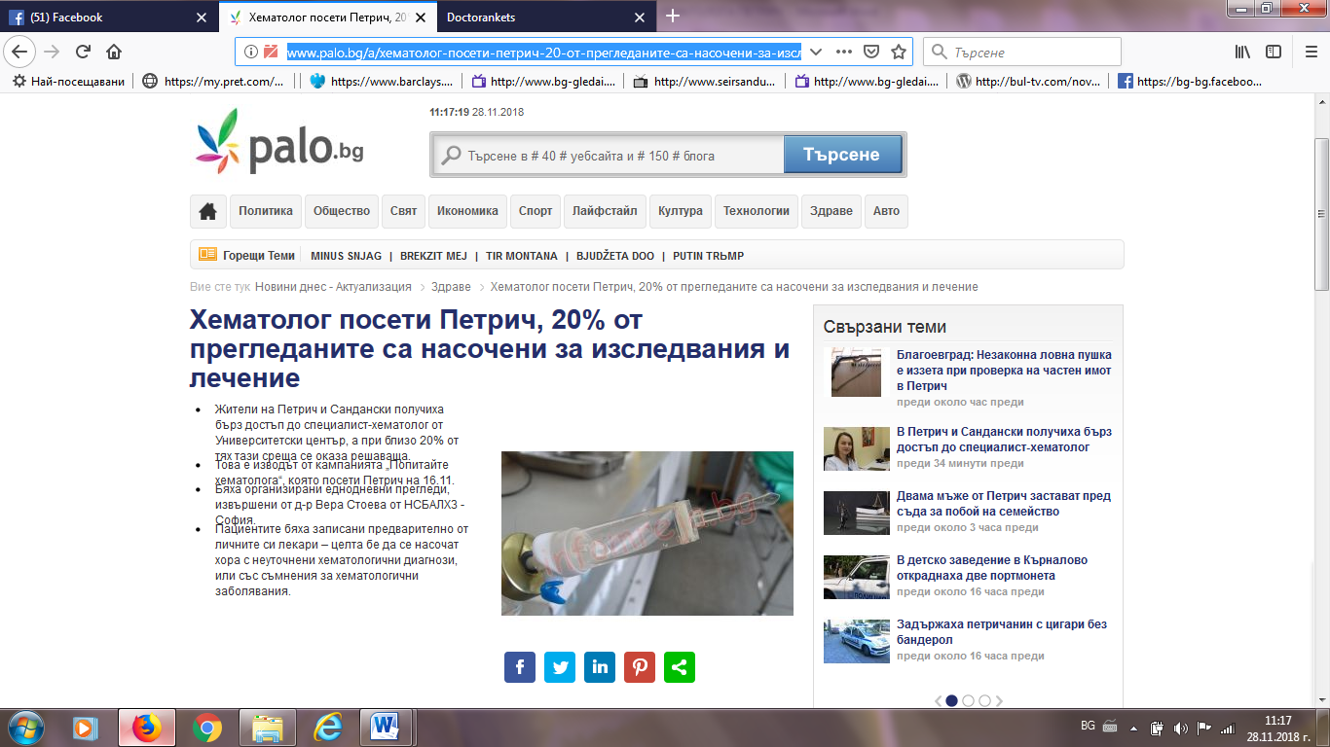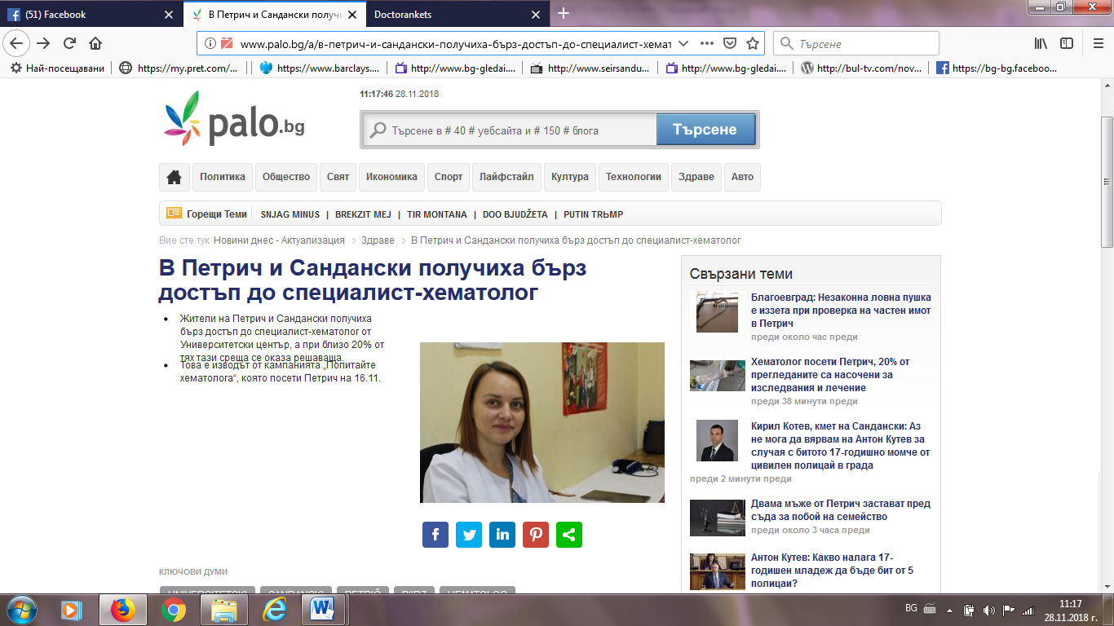

ДНЕВНИК БГ:
https://www.dnevnik.bg/blogosfera/article/347664
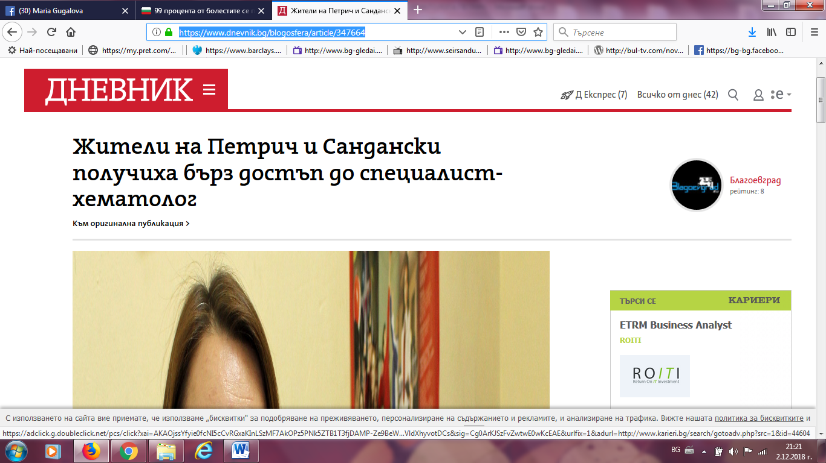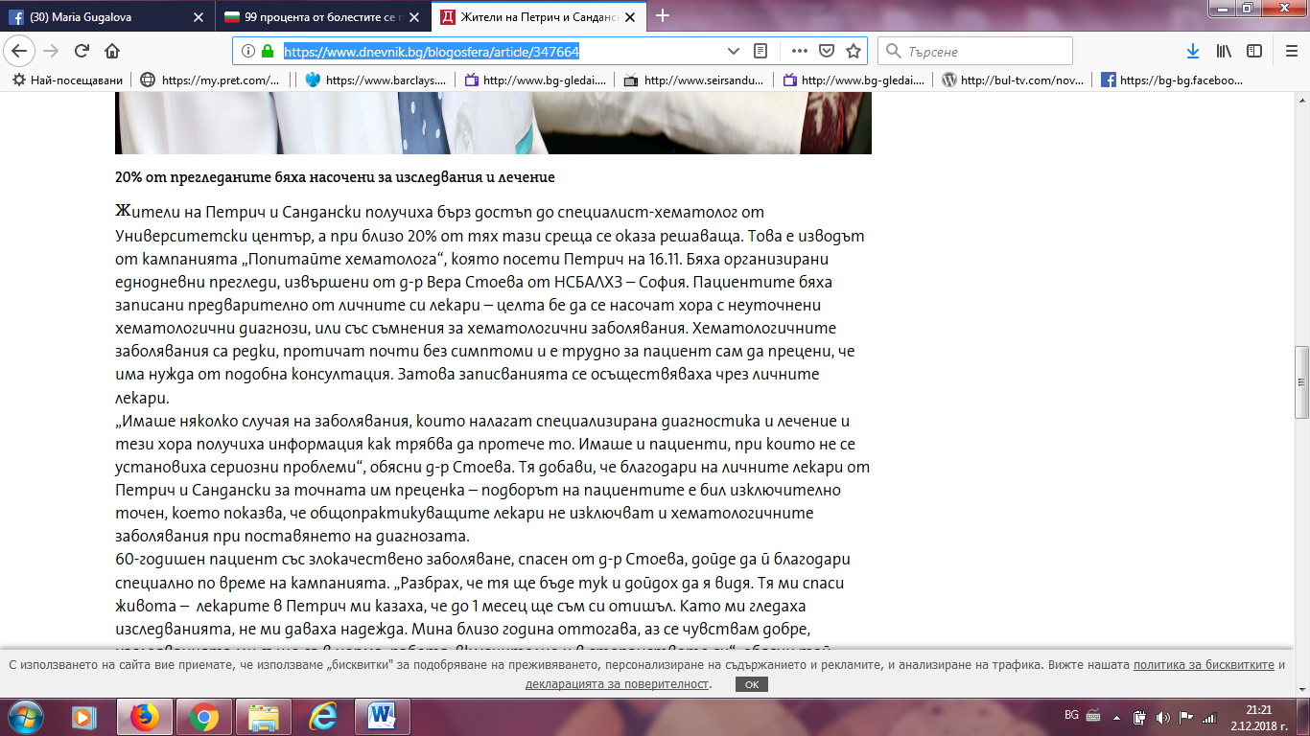

БЛАГОЕВГРАД УТРЕ:
http://www.blagoevgrad.utre.bg/2018/11/27/521320-zhiteli_na_sandanski_i_petrich_poluchiha_burz_dostup_do_hematolog
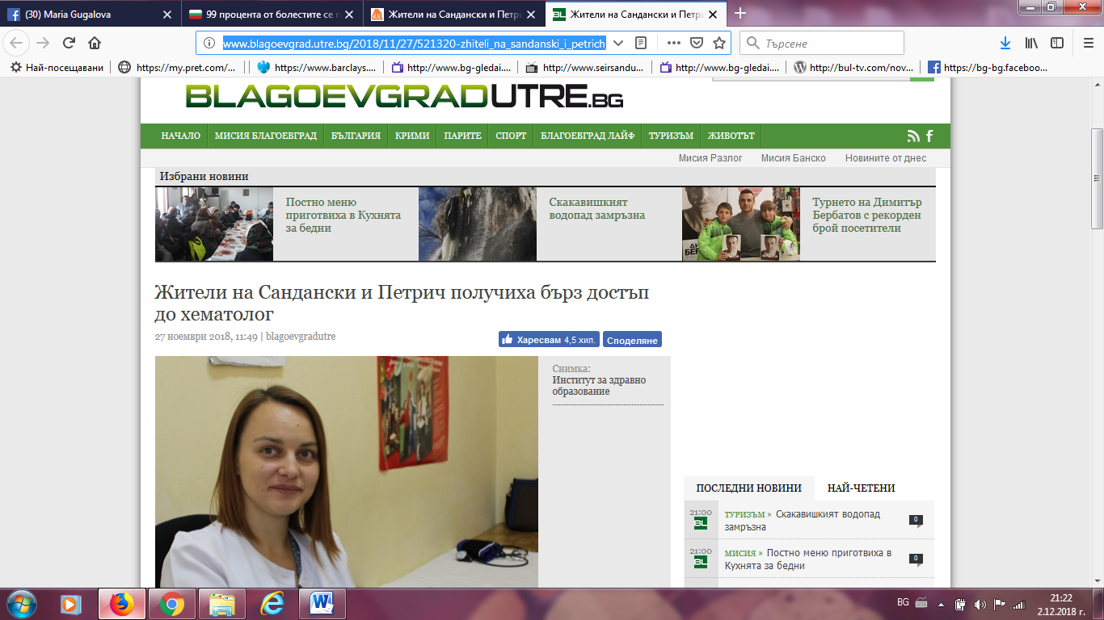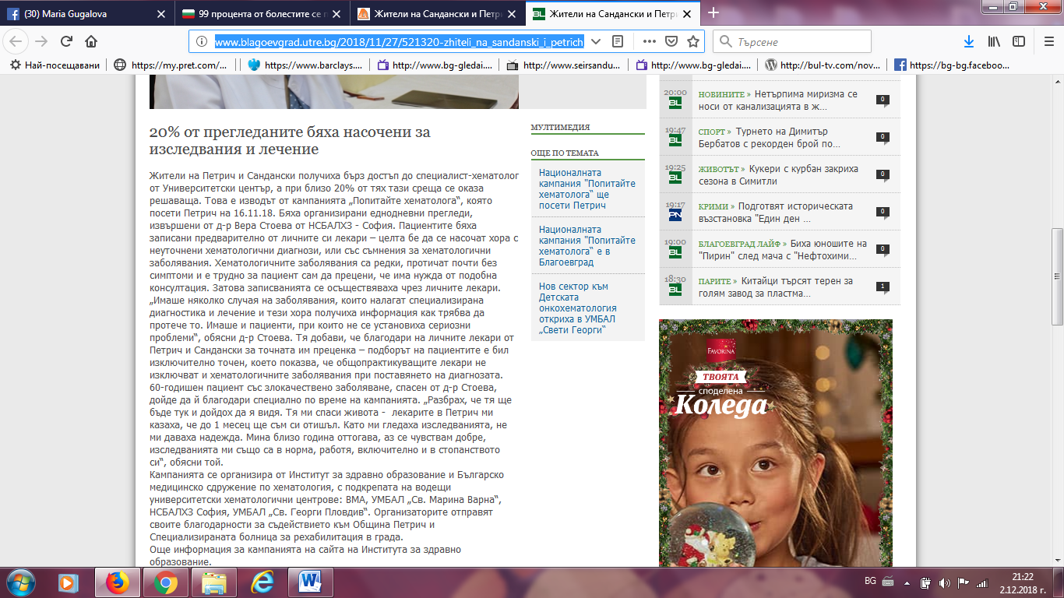

ДИР БГ:
http://novini.dir.bg/news.php?id=27319516
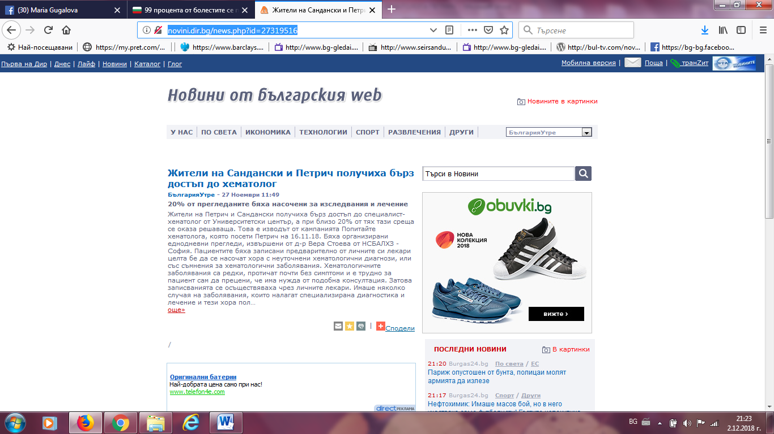
ГЛАС БГ:
https://cdn.glas.bg/1536413/blagoevgrad-zhiteli-na-petrich-poluchiha-brz-dostp-do-hemato
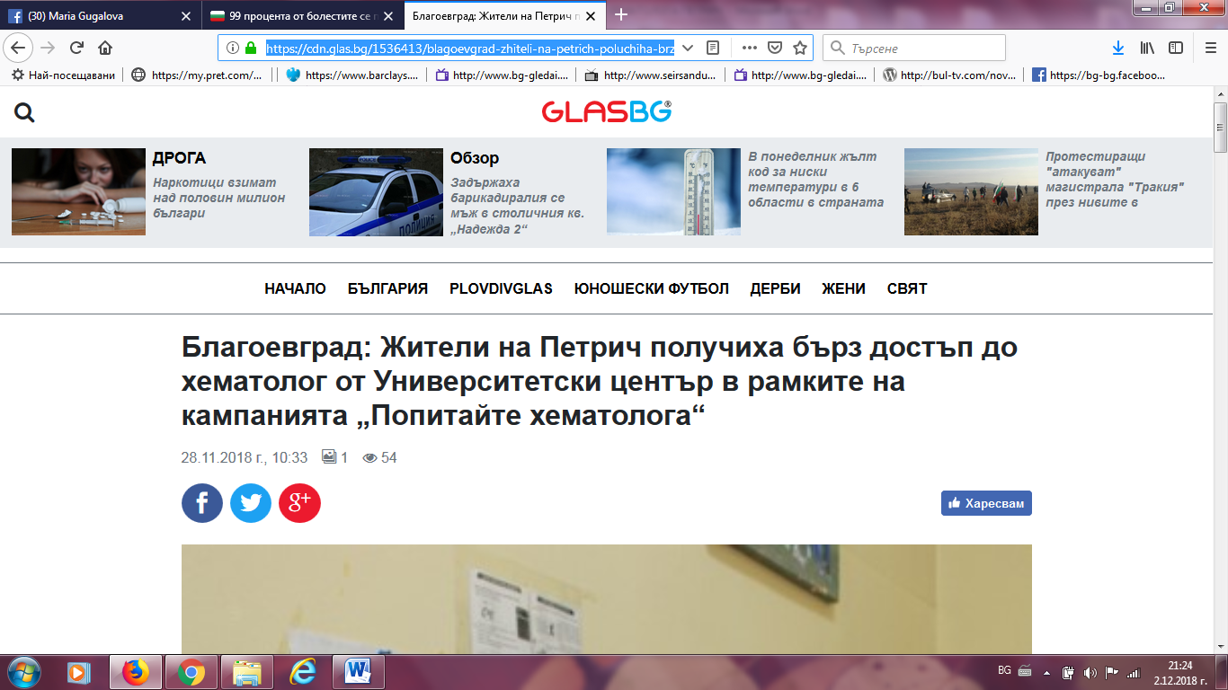

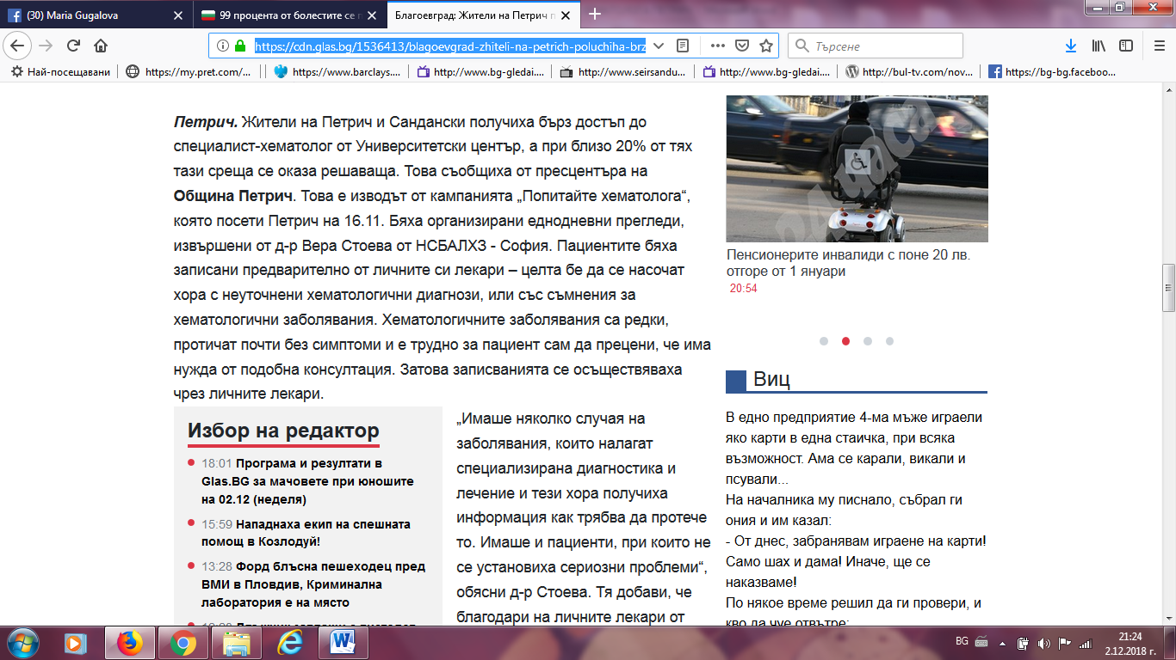

БУЛ БОКС:
https://bulbox.net/gen.php?catg=regioni-blagoevg&aid=7067851
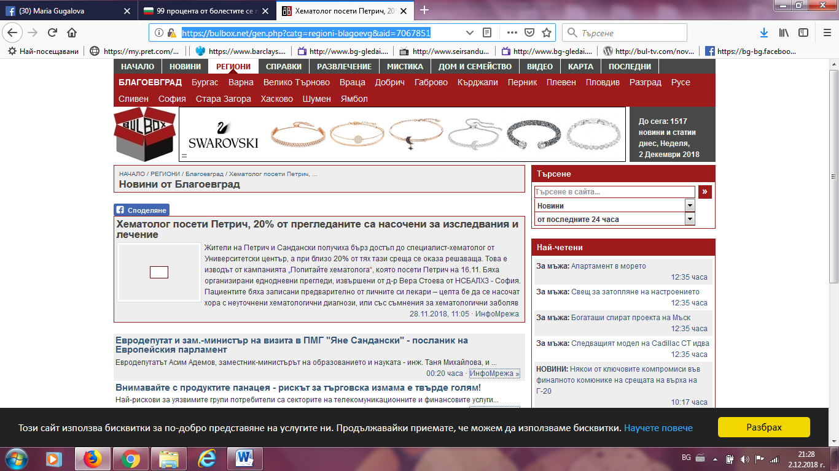

КМЕТА БГ:
http://www.kmeta.bg/hematolog-pregleda-pacienti-ot-petrich-i-sandanski
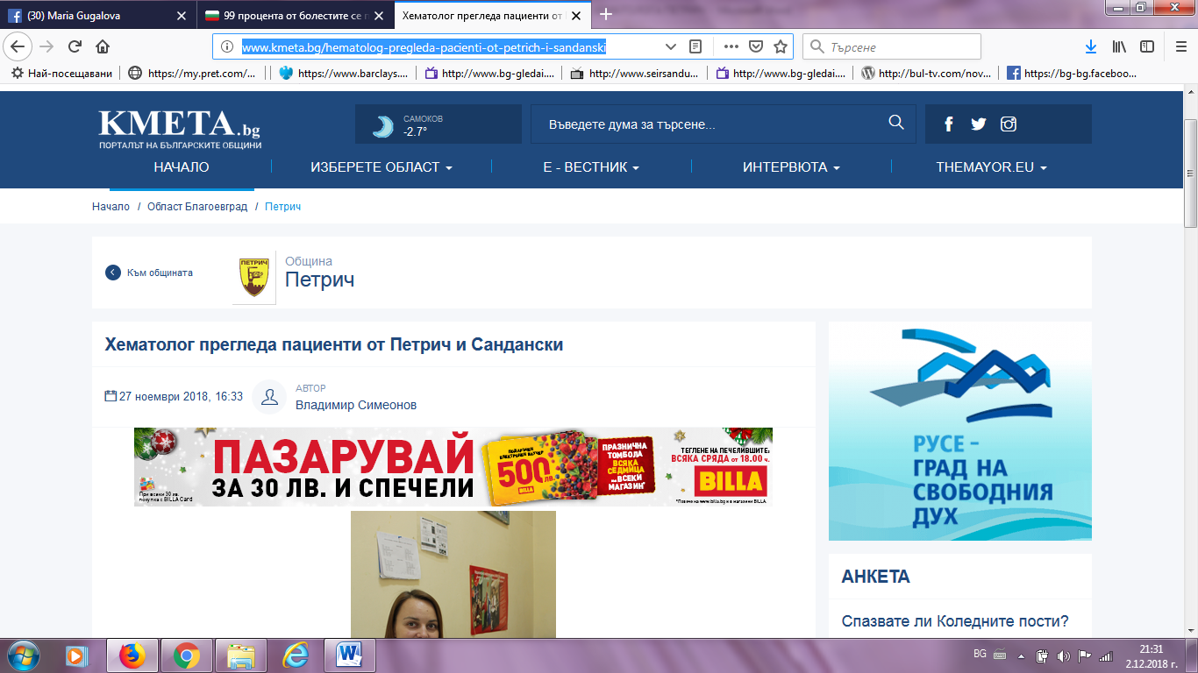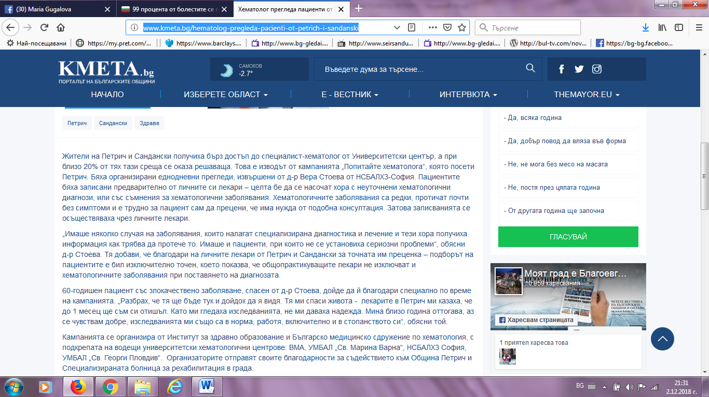

ТОП ПРЕСА:
http://toppresa.bg/158590/%D0%A5%D0%B5%D0%BC%D0%B0%D1%82%D0%BE%D0%BB%D0%BE%D0%B7%D0%B8-%D0%BF%D1%80%D0%B5%D0%B3%D0%BB%D0%B5%D0%B6%D0%B4%D0%B0%D1%85%D0%B0-%D0%B1%D0%B5%D0%B7%D0%BF%D0%BB%D0%B0%D1%82%D0%BD%D0%BE-%D0%B2-%D0%9F
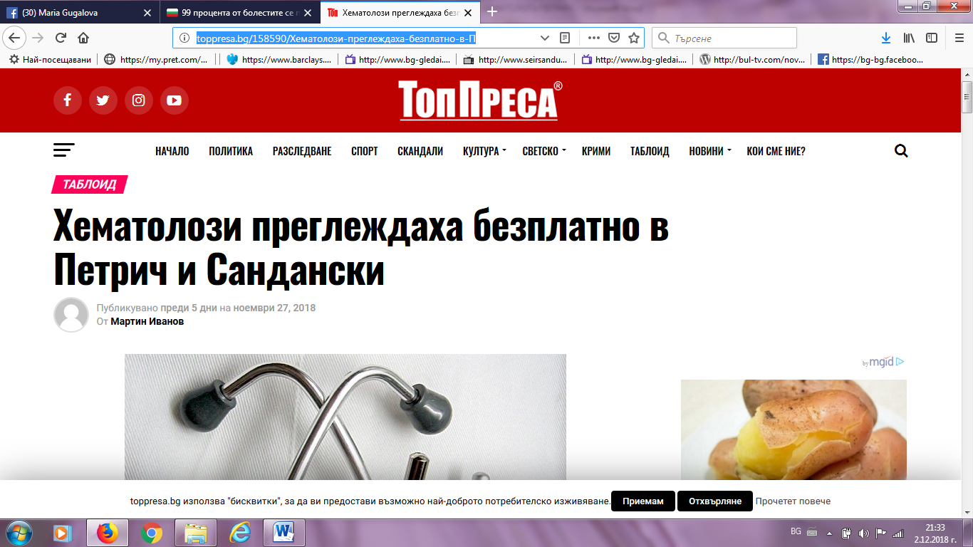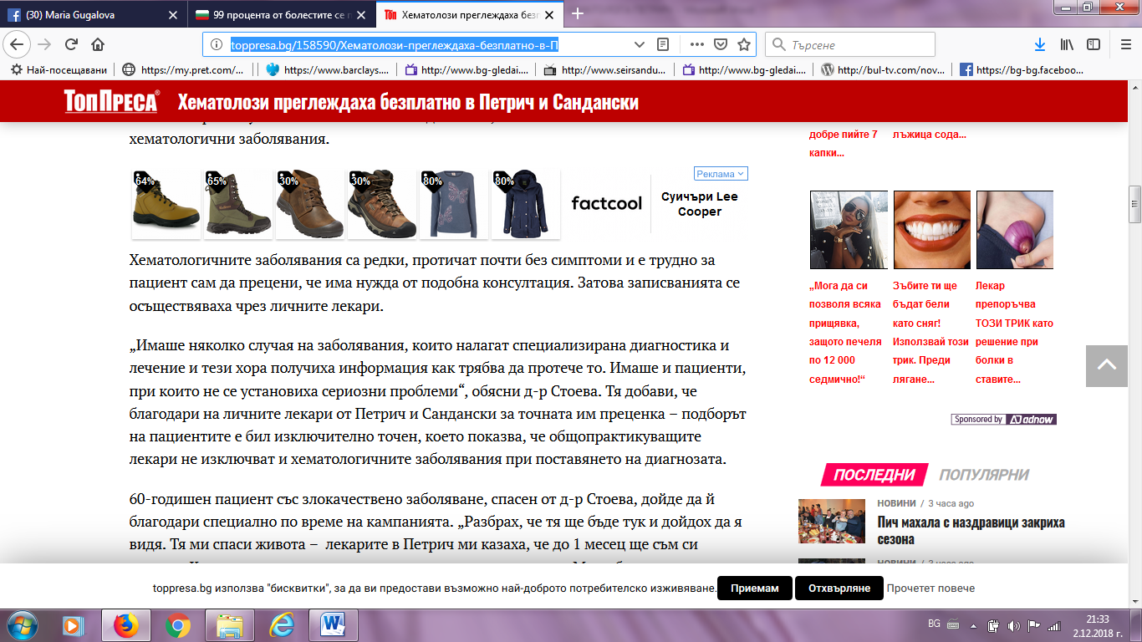

ЗА ПЕТРИЧ:http://zapetrich.com/%D0%96%D0%98%D0%A2%D0%95%D0%9B%D0%98-%D0%9D%D0%90-%D0%9F%D0%95%D0%A2%D0%A0%D0%98%D0%A7-%D0%9F%D0%9E%D0%9B%D0%A3%D0%A7%D0%98%D0%A5%D0%90-%D0%91%D0%AA%D0%A0%D0%97-%D0%94%D0%9E%D0%A1%D0%A2%D0%AA%D0%9F-%D0%94%D0%9E-%D0%A5%D0%95%D0%9C%D0%90%D0%A2%D0%9E%D0%9B%D0%9E%D0%93-%D0%9E%D0%A2-%D0%A3%D0%9D%D0%98%D0%92%D0%95%D0%A0%D0%A1%D0%98%D0%A2%D0%95%D0%A2%D0%A1%D0%9A%D0%98-%D0%A6%D0%95%D0%9D%D0%A2%D0%AA%D0%A0.html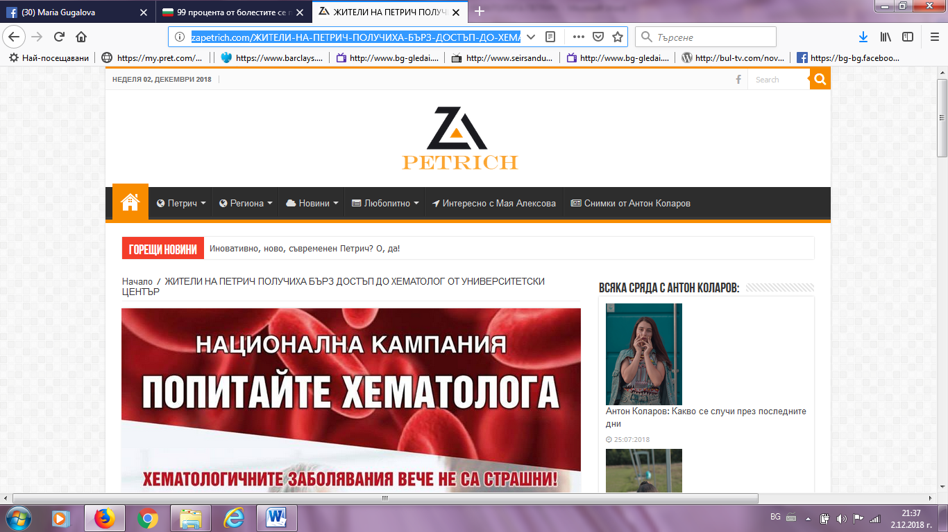

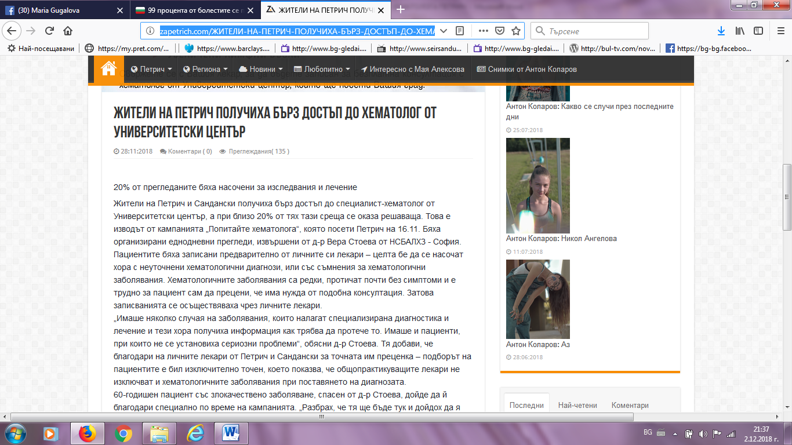
ФОКУС НЮЗ:
http://focus-news.net/news/2018/11/28/2595567/blagoevgrad-zhiteli-na-petrich-poluchiha-barz-dostap-do-hematolog-ot-universitetski-tsentar-v-ramkite-na-kampaniyata-popitayte-hematologa.html
