МЕДИА МОНИТОРИНГ ХЕМАТОЛОГИЧНИ ЗАБОЛЯВАНИЯ – СВИЩОВ
РЕГ НЮЗ:
https://www.regnews.net/bg/natsionalnata-kampaniya-popitayte-hematologa-shte-poseti-svishtov#.W-HYxzGkLIU
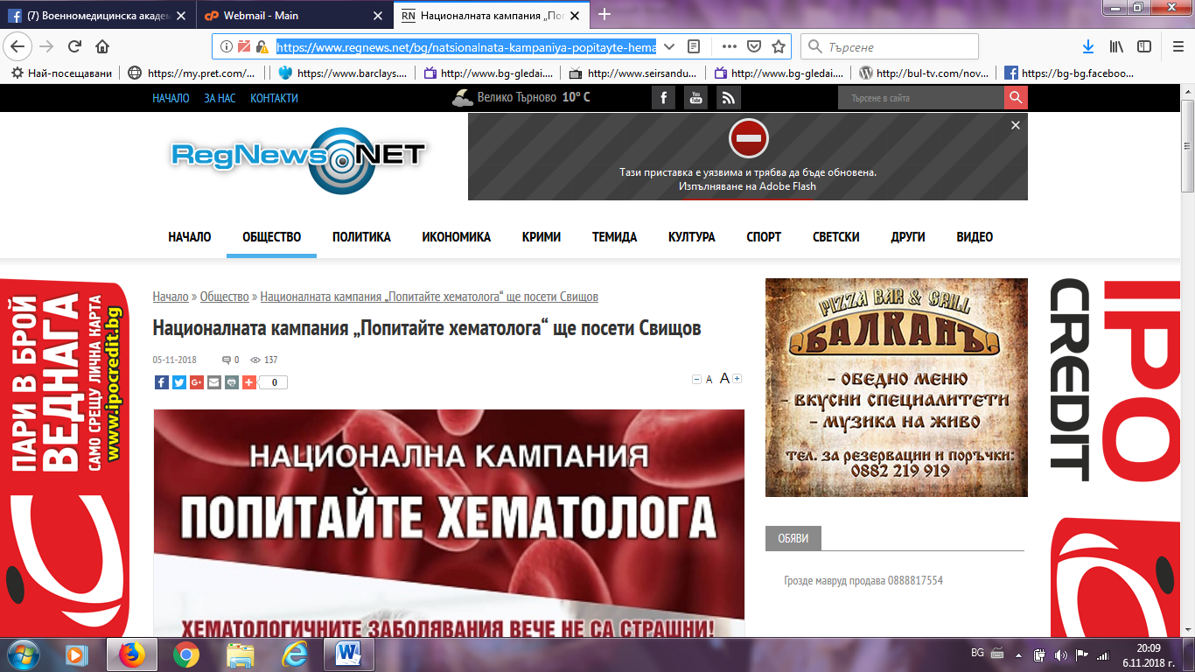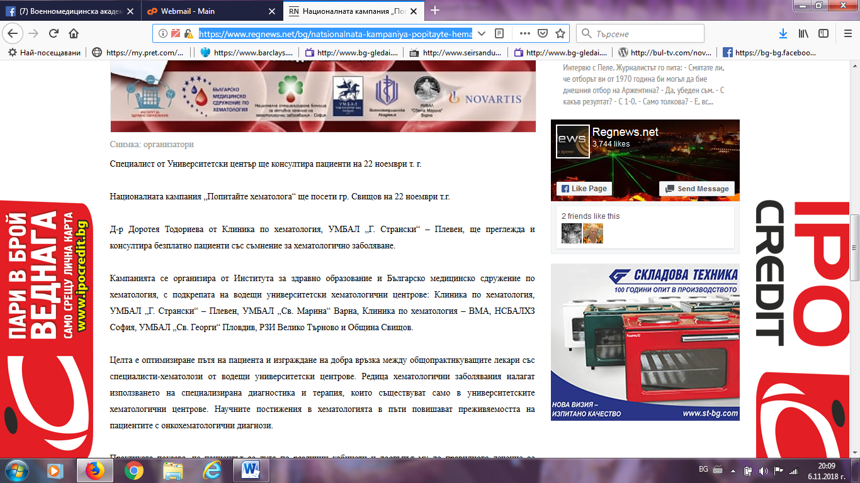

КОРЕСПОНДЕНТ ФЕЙСБУК:
https://www.facebook.com/permalink.php?story_fbid=2296091257339249&id=1631219410493107&__xts__[0]=68.ARC35uQl3NNUDMNOcT-6IWAtBnAh18krgduNxJsRC5Y3ZCHkq4vhjMuXthfYGokbNNz5cnliI6bjmILltrLvxmgVKNgGKr-OFF_ExGXWbsKMkgi005FG4BpM-giUVFIz7g9zBz98e6tmx6RbaMATNdX2MwzV2tBqDnvrneaYeIjTy_KXJlI36mRfZMSfIxtUo8fXtMdbfptQwTmnZnKp3-krwWk&__tn__=-UC-R
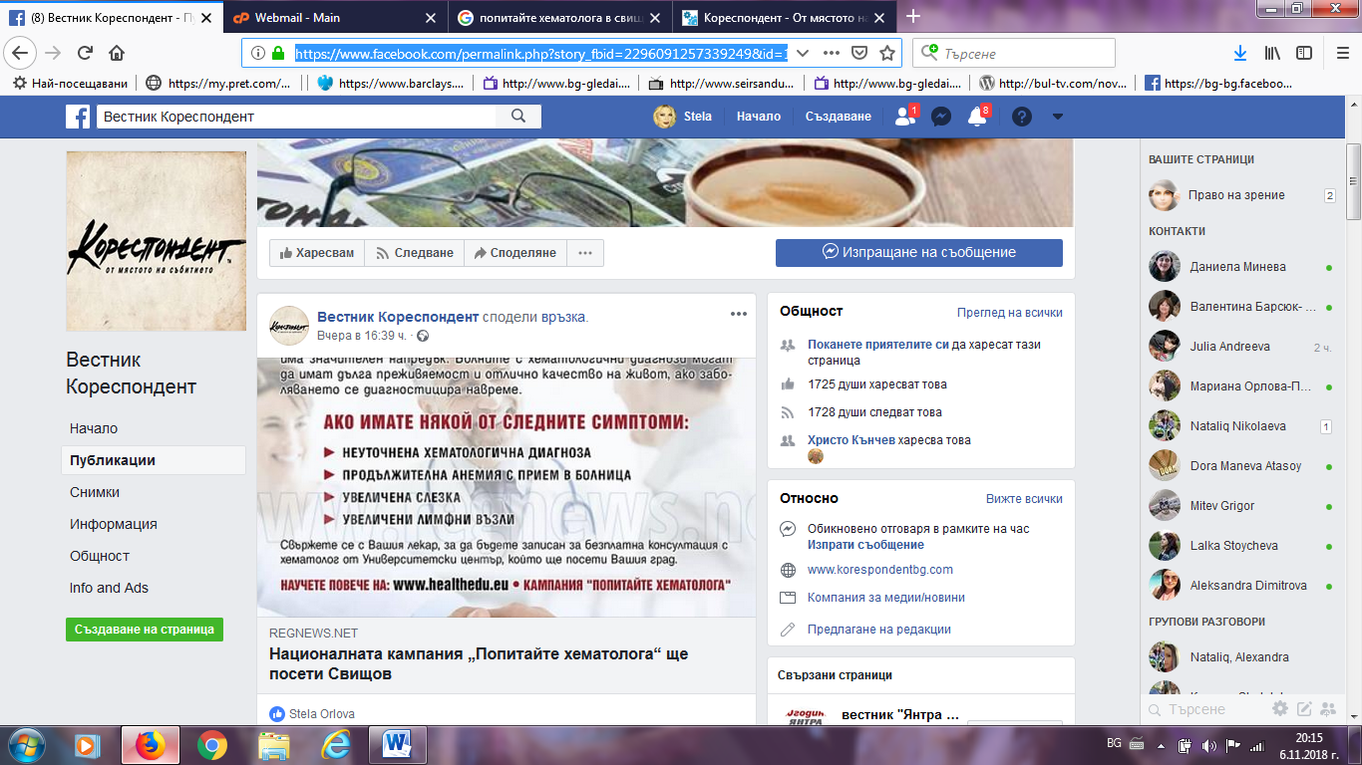
ТРЕТА ВЪЗРАСТ:
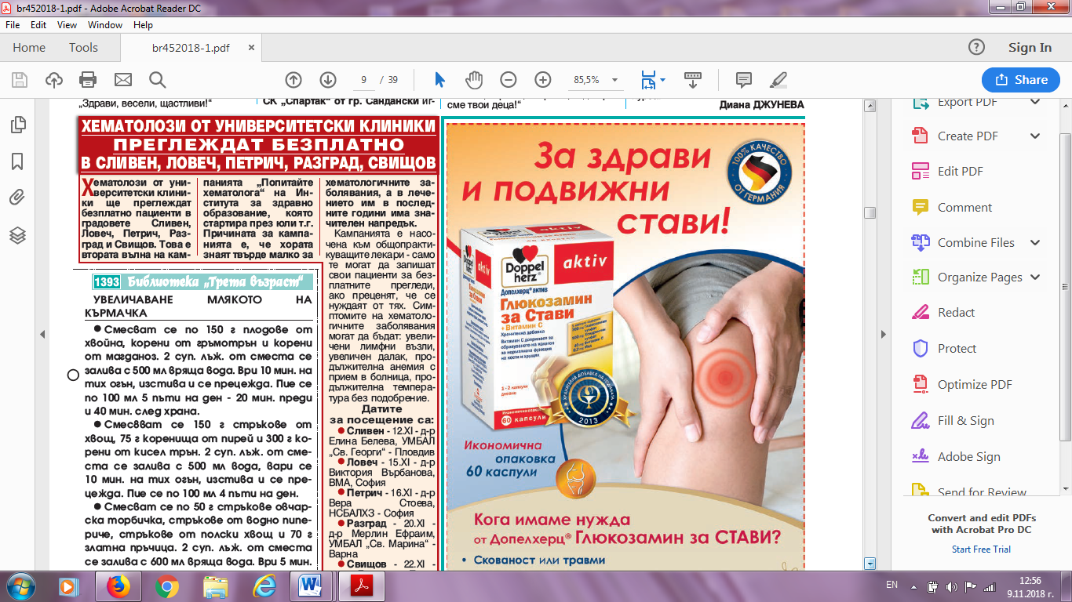
ОБЩИНА СВИЩОВ:
http://www.svishtov.bg/news_detail.php?id=6441
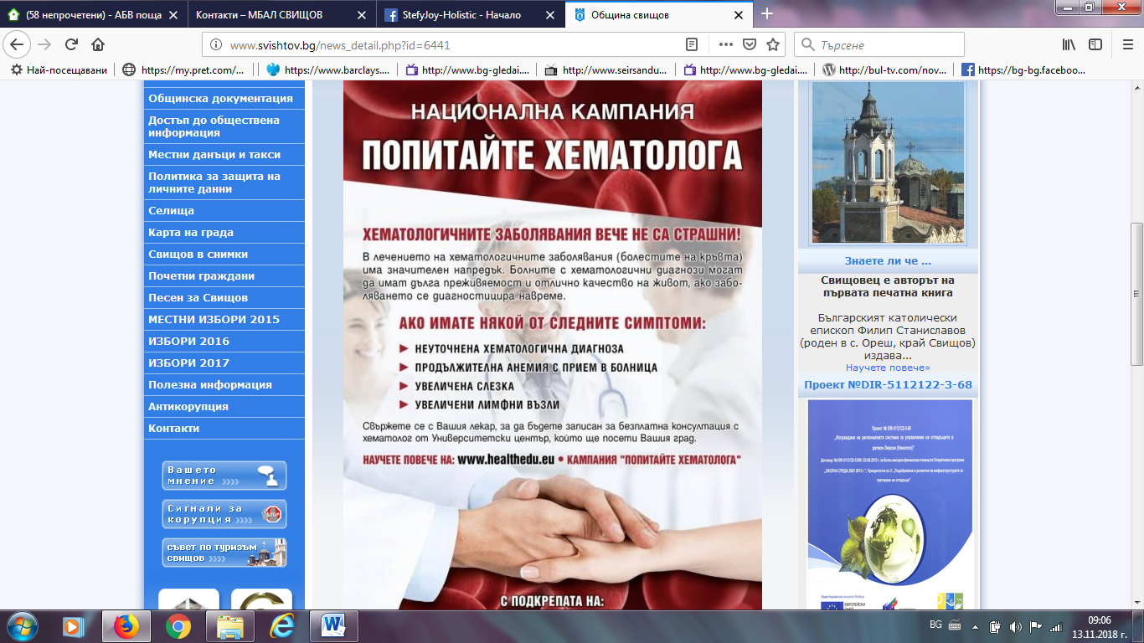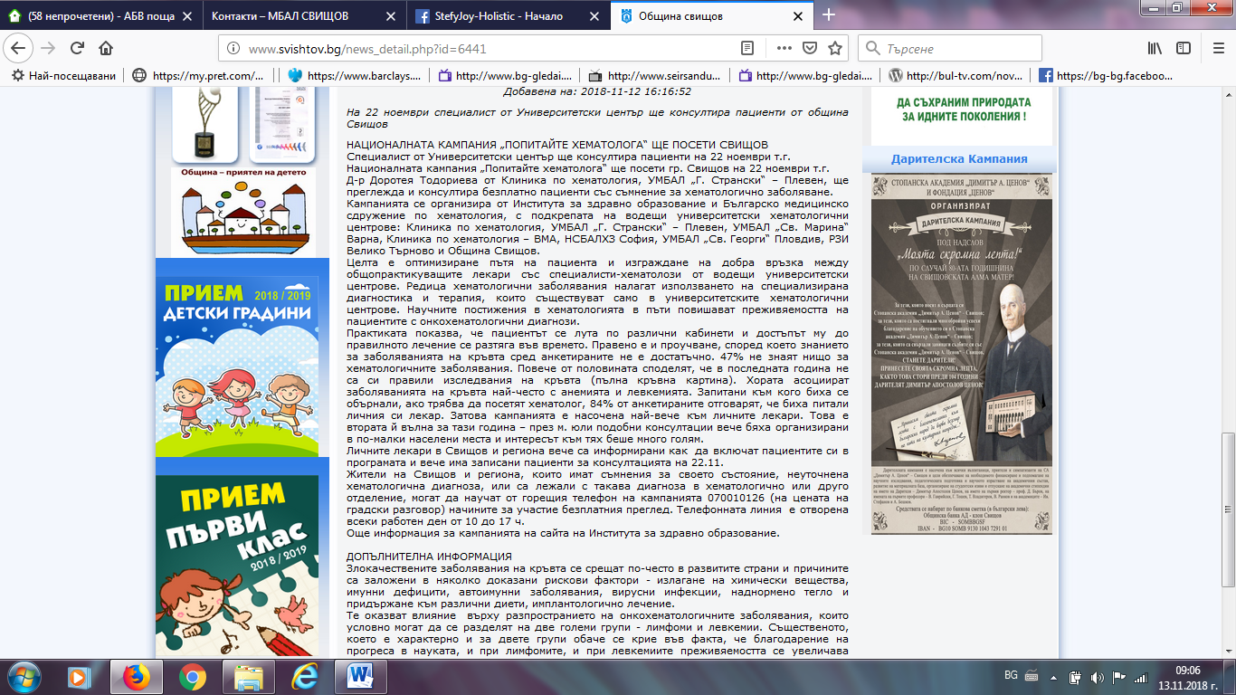

ДАРИК НЮЗ:
https://dariknews.bg/regioni/veliko-tyrnovo/nacionalnata-kampaniia-popitajte-hematologa-shte-poseti-svishtov-2131259
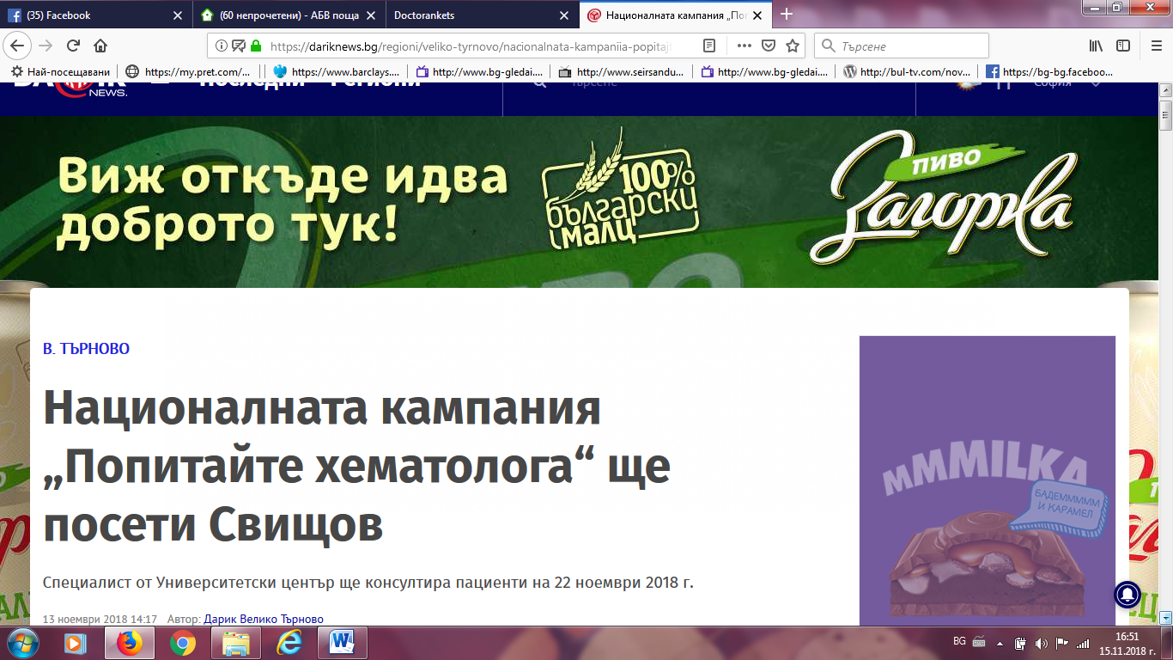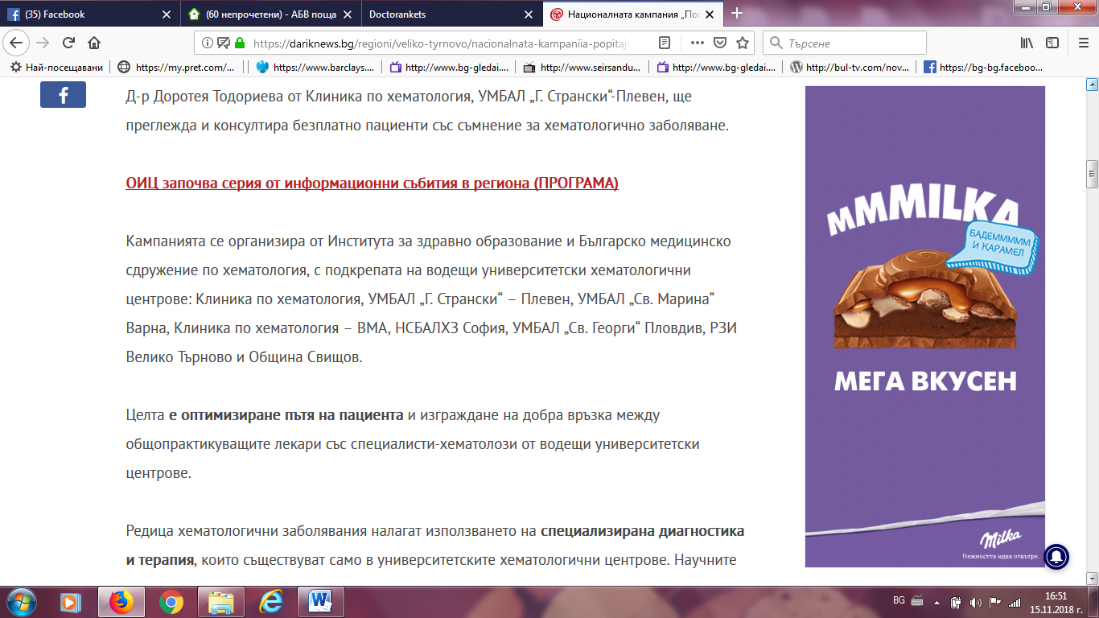

ЯНТРА ДНЕС БГ:
https://www.dnesbg.com/obshtinite/svishtov/v-svishtov-startira-natsionalnata-kampaniya-vpopitayte-hematologav.html
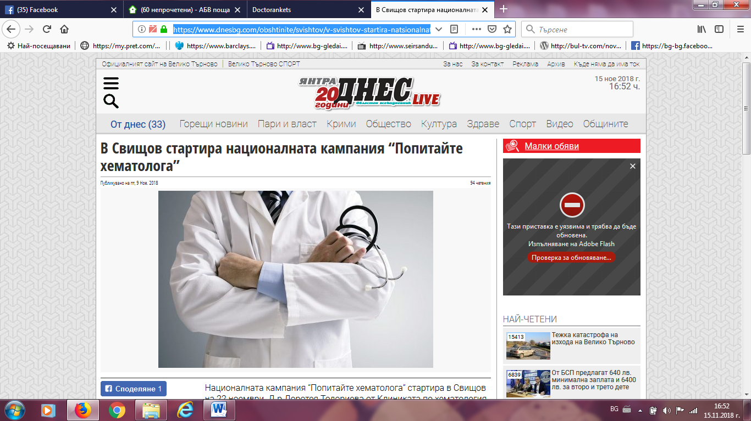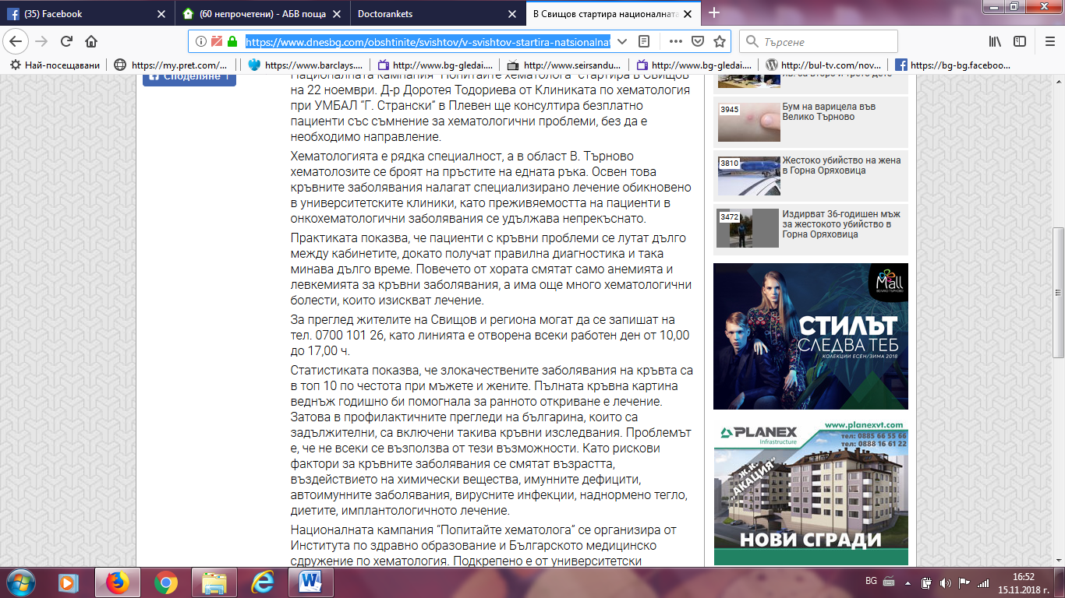

ПАЛО:
http://www.palo.bg/a/nacionalnata-kampaniya-em-popitajte-em-hematologa-she-poseti-svishov-448432
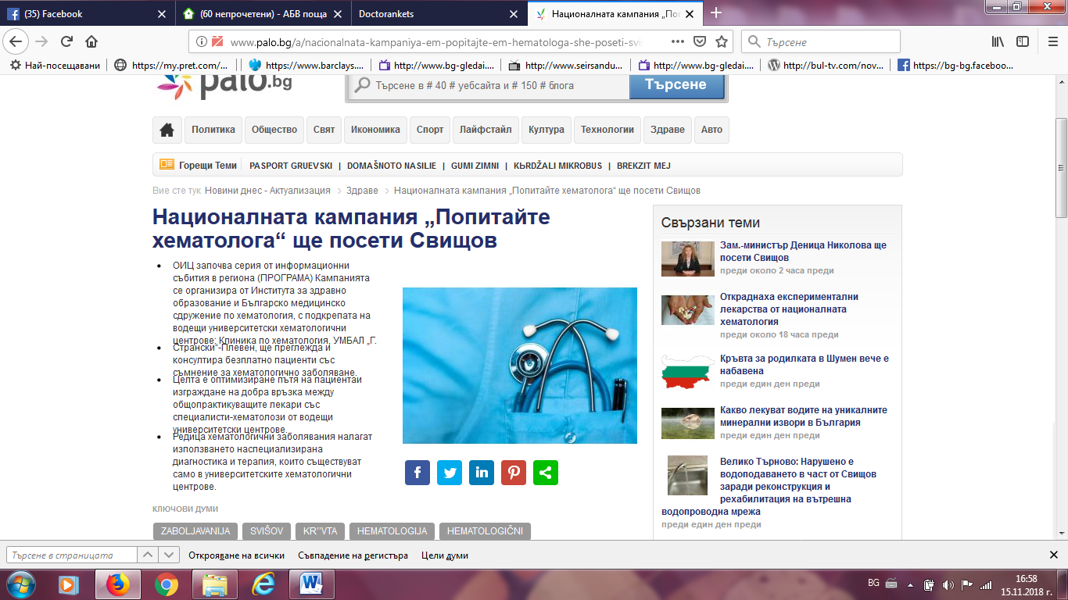
ФЕЙСБУК Свищов:
https://www.facebook.com/groups/118720084813528/search/?query=%D0%BA%D0%BB%D0%B8%D0%BD%D0%B8%D0%BA%D0%B0%20%D0%BF%D0%BE%20%D1%85%D0%B5%D0%BC%D0%B0%D1%82%D0%BE%D0%BB%D0%BE%D0%B3%D0%B8%D1%8F
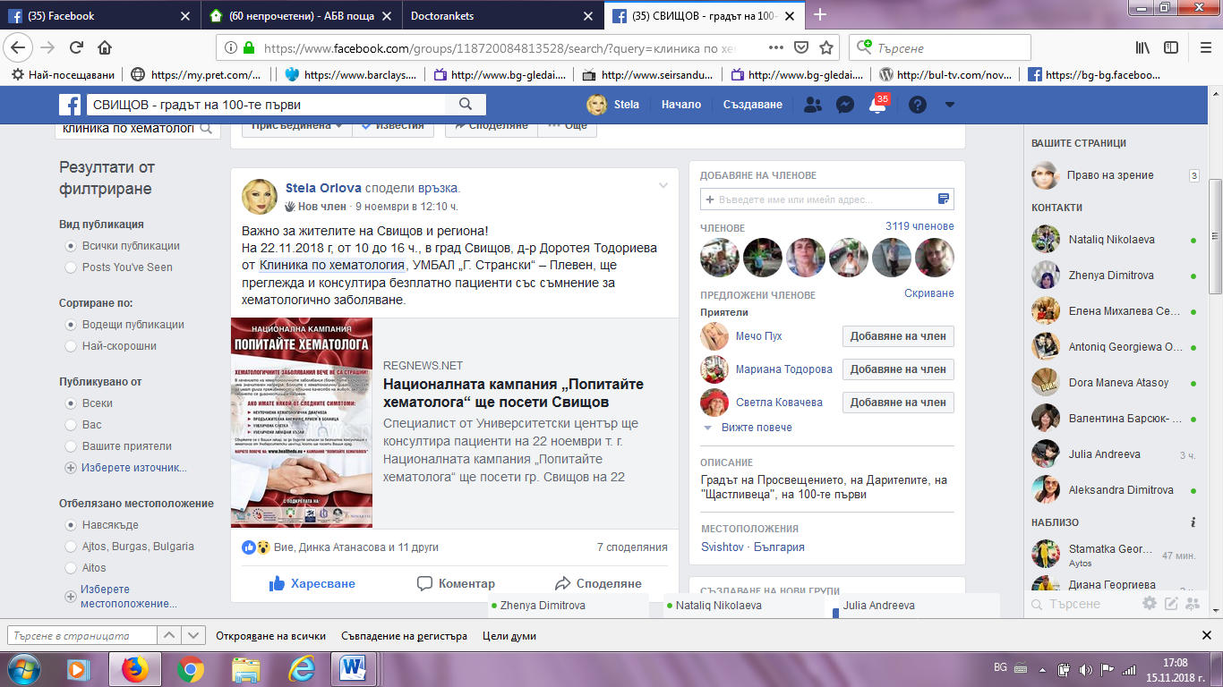

ФРАМАР (пише градовете, в които ще се проведе кампанията):
https://media.framar.bg/%D0%B7%D0%B4%D1%80%D0%B0%D0%B2%D0%BD%D0%B8-%D0%BD%D0%BE%D0%B2%D0%B8%D0%BD%D0%B8/%D0%B5%D0%BA%D0%B8%D0%BF%D1%8A%D1%82-%D0%BD%D0%B0-%D0%BD%D0%B0%D1%86%D0%B8%D0%BE%D0%BD%D0%B0%D0%BB%D0%BD%D0%B0%D1%82%D0%B0-%D0%BA%D0%B0%D0%BC%D0%BF%D0%B0%D0%BD%D0%B8%D1%8F-%D0%BF%D0%BE%D0%BF%D0%B8%D1%82%D0%B0%D0%B9%D1%82%D0%B5-%D1%85%D0%B5%D0%BC%D0%B0%D1%82%D0%BE%D0%BB%D0%BE%D0%B3%D0%B0-%D0%BF%D1%80%D0%B5%D0%B3%D0%BB%D0%B5%D0%B6%D0%B4%D0%B0-%D0%B2-%D1%81%D0%BB%D0%B8%D0%B2%D0%B5%D0%BD
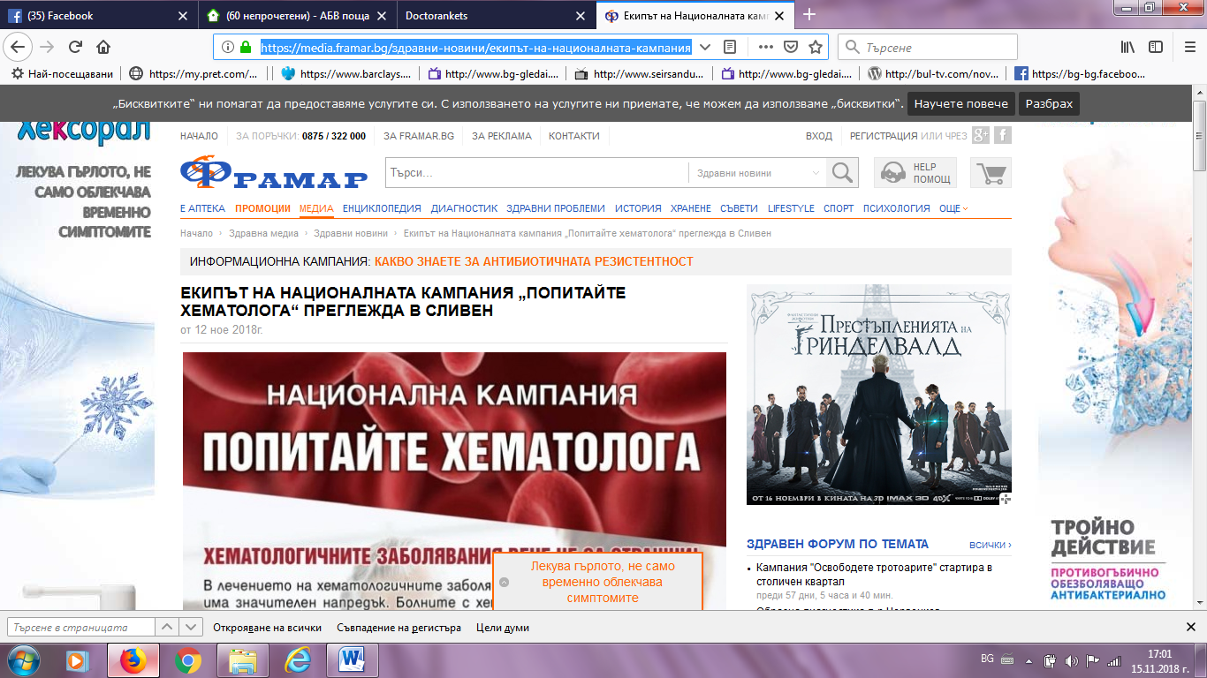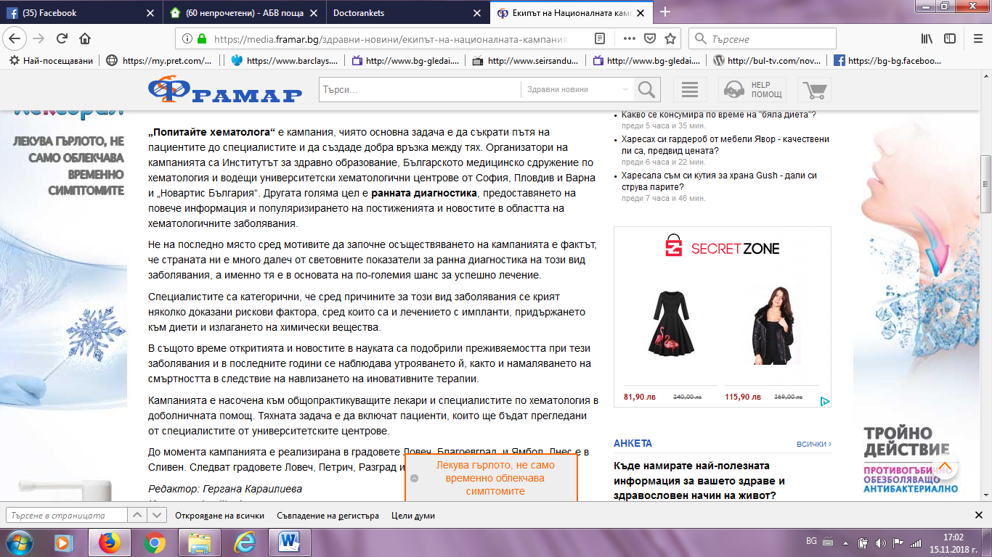
РЗИ В. ТЪРНОВО:
http://www.rzi-vt.bg/informazia5.htm
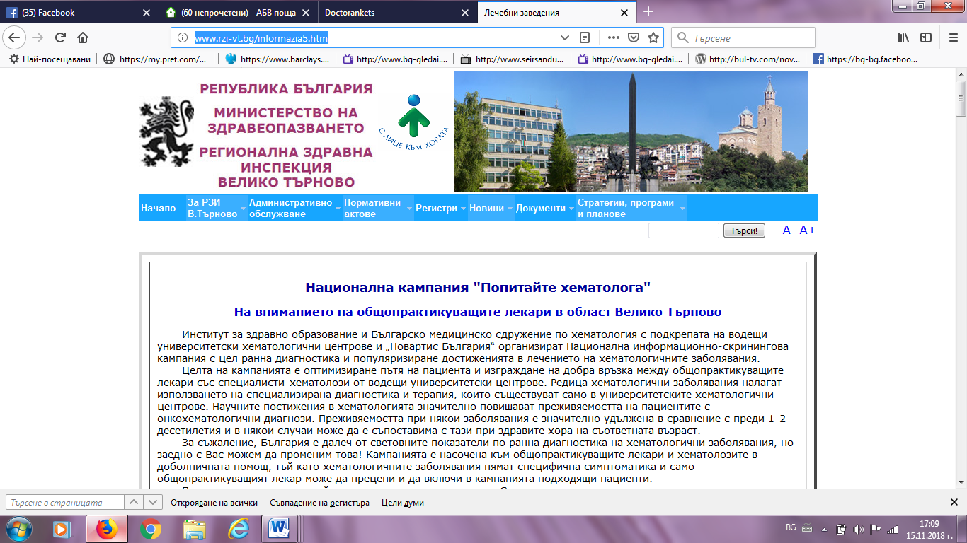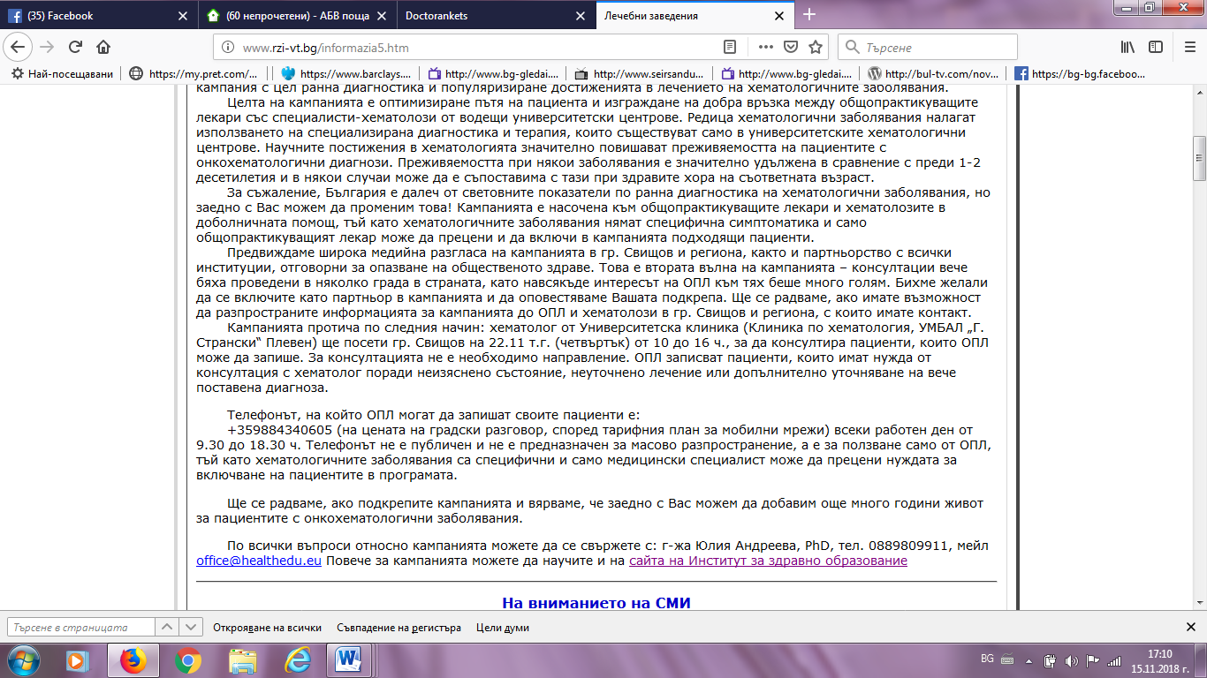

РАДАР:
http://radar.bg/news/pattern/1706?terms=%D0%92%D0%BE%D0%B5%D0%BD%D0%BD%D0%BE%D0%BC%D0%B5%D0%B4%D0%B8%D1%86%D0%B8%D0%BD%D1%81%D0%BA%D0%B0%20%D0%B0%D0%BA%D0%B0%D0%B4%D0%B5%D0%BC%D0%B8%D1%8F#!/2018-11-12/37272719
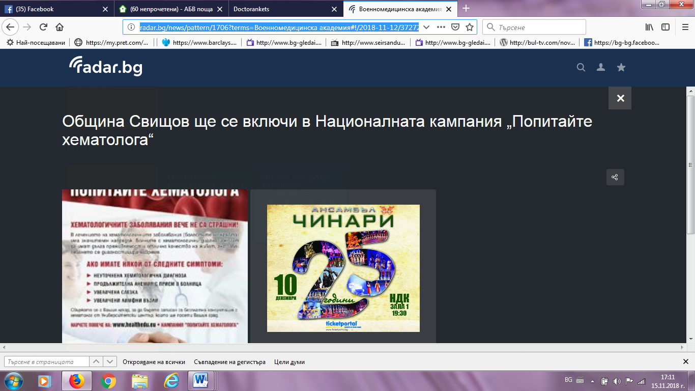
ОБЩИНА ТЪРНОВО:http://veliko-tarnovo.net/novini/obshtina-svishtov-shte-se-vklyutchi-v-natsionalnata-kampaniya-vpopitayte-hematologav.html?utm_source=feedburner&utm_medium=feed&utm_campaign=Feed%3A+VelikoTarnovoNet+%28%D0%9E%D1%84%D0%B8%D1%86%D0%B8%D0%B0%D0%BB%D0%BD%D0%B8%D1%8F%D1%82+%D1%81%D0%B0%D0%B9%D1%82+%D0%BD%D0%B0+%D0%92%D0%B5%D0%BB%D0%B8%D0%BA%D0%BE+%D0%A2%D1%8A%D1%80%D0%BD%D0%BE%D0%B2%D0%BE%29 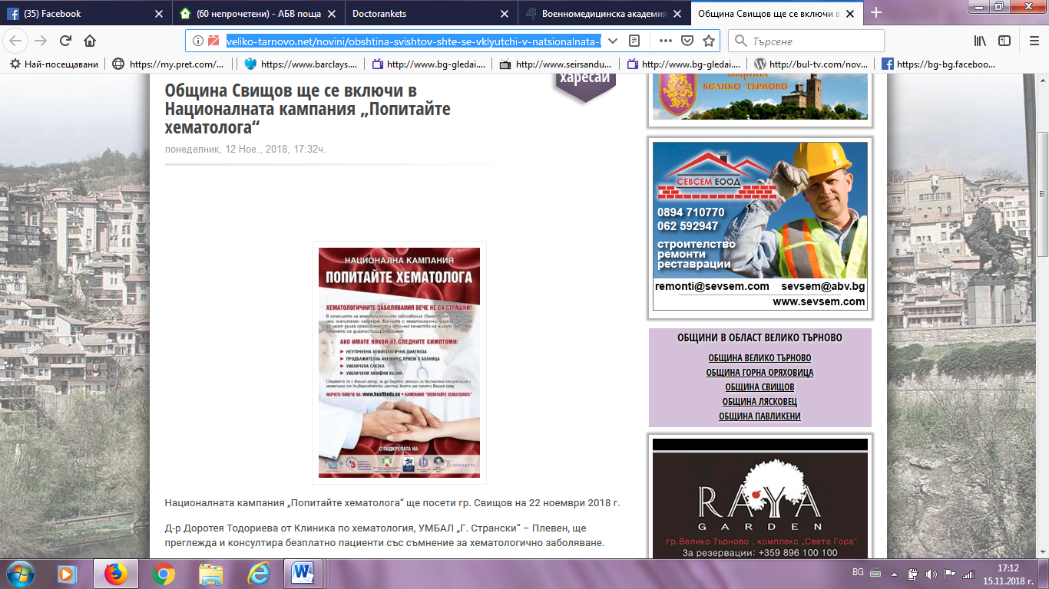
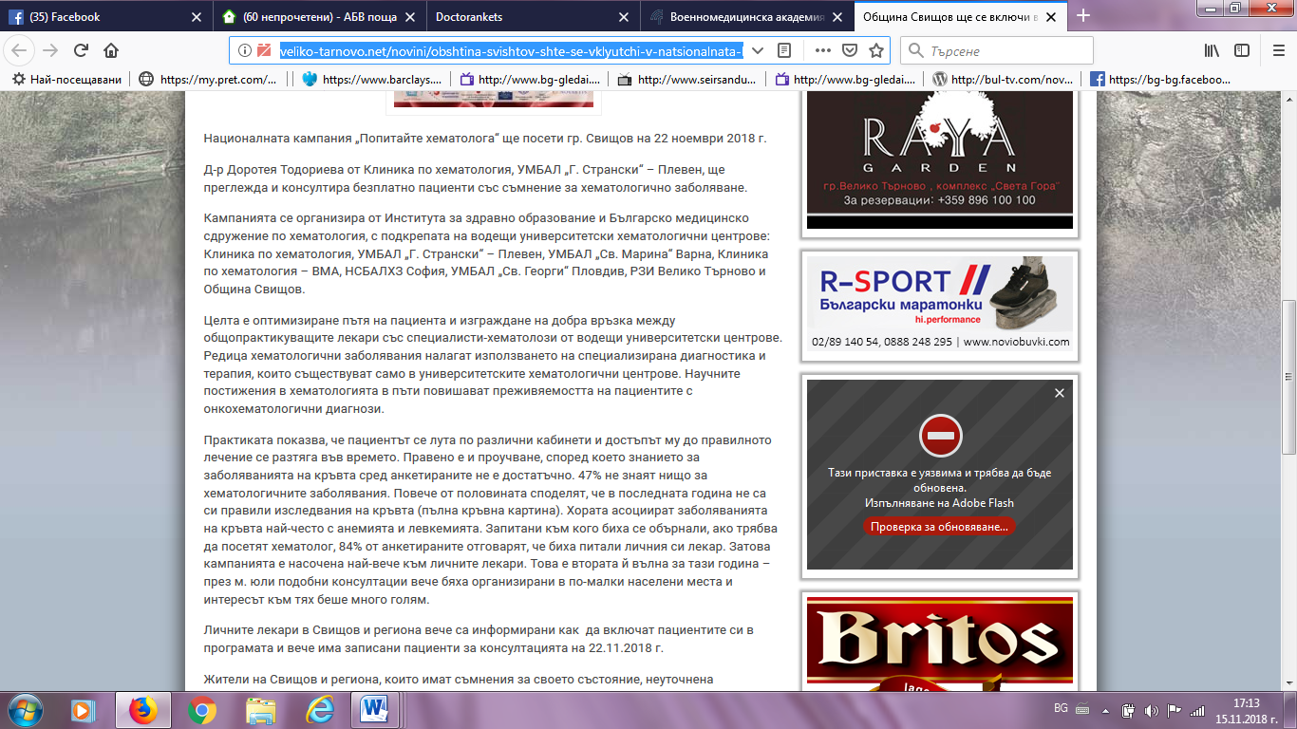
СВИЩОВ НЮЗ:
http://svishtov-news.com/article/3168/
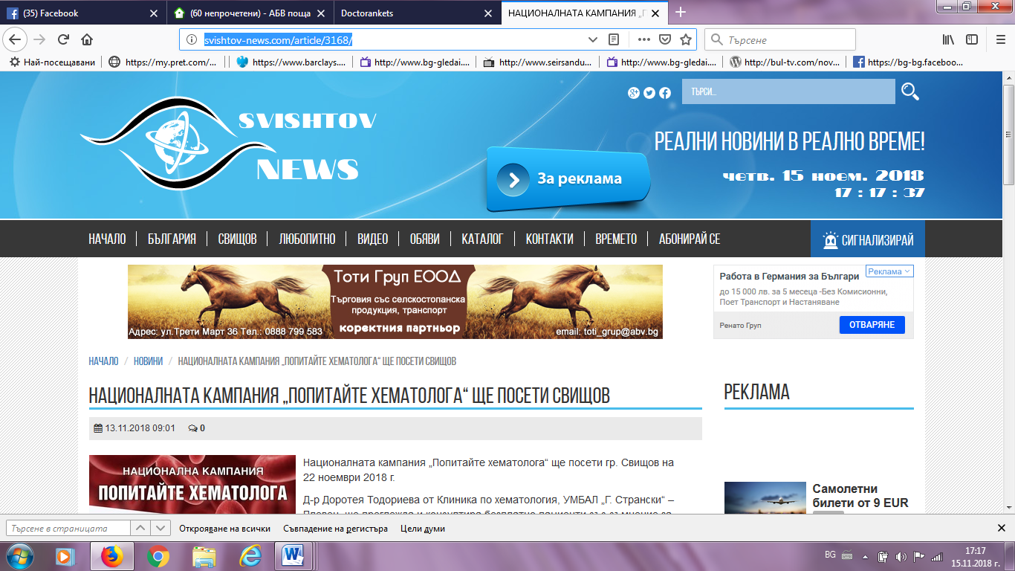

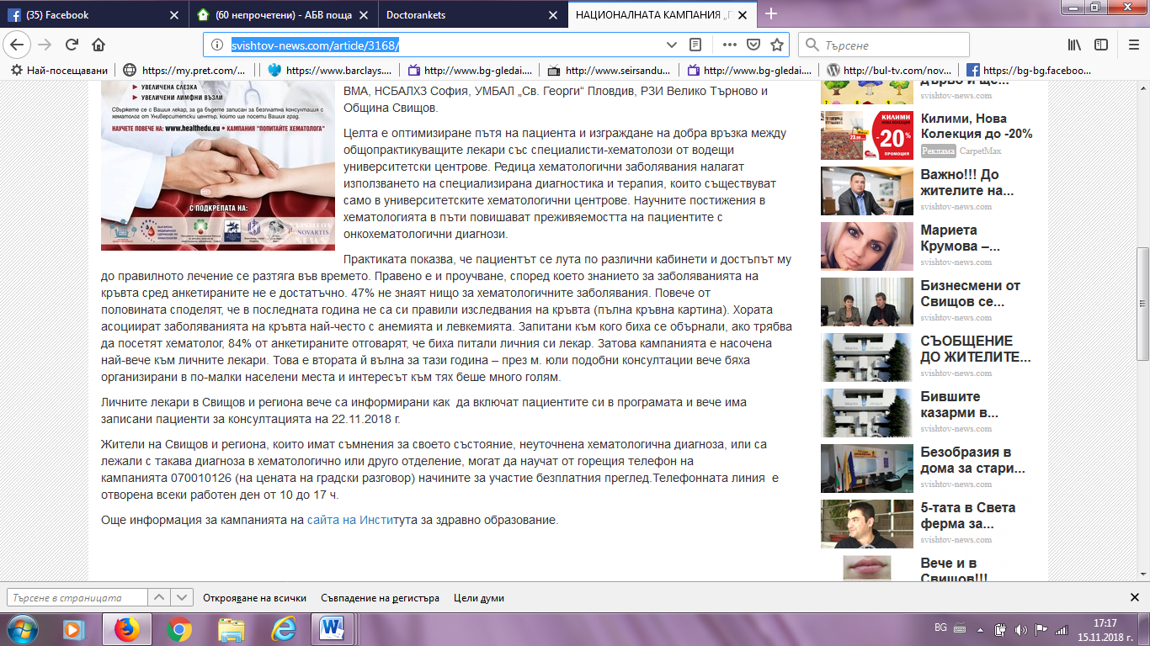
БОРБА БГ:
https://www.borbabg.com/2018/11/12/natsionalnata-kampaniya-popitayte-hematologa-shhe-poseti-svishhov/
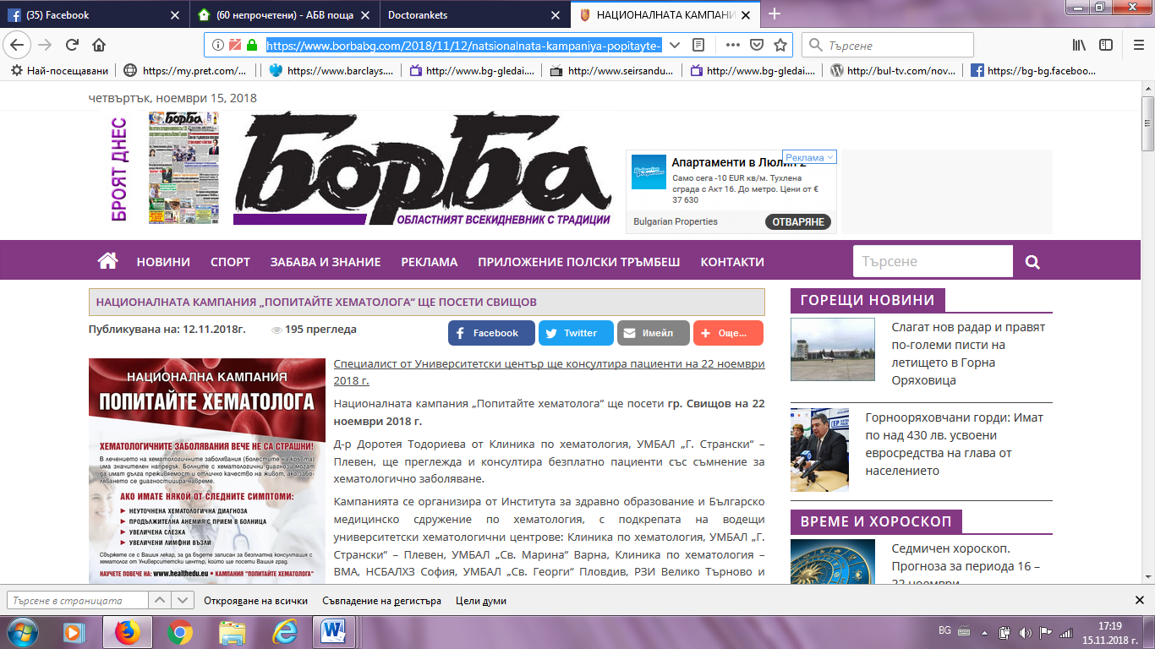

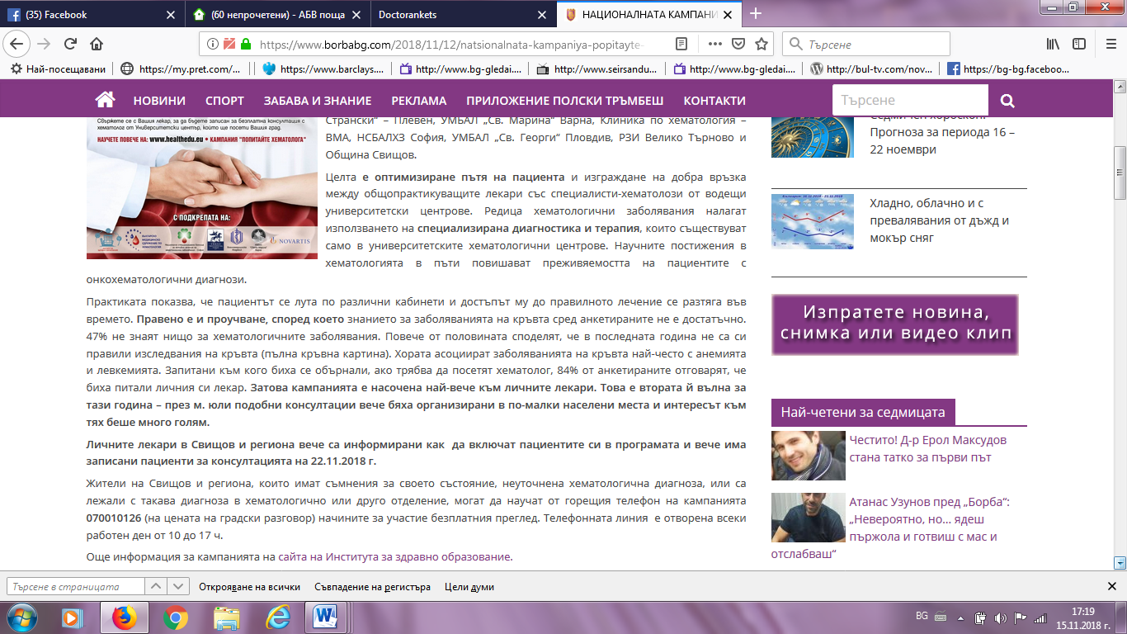
ВЕЛИКО ТЪРНОВО УТРЕ:
http://www.velikotarnovo.utre.bg/2018/11/10/519705-natsionalnata_kampania_popitayte_hematologa_shte_poseti_svishtov
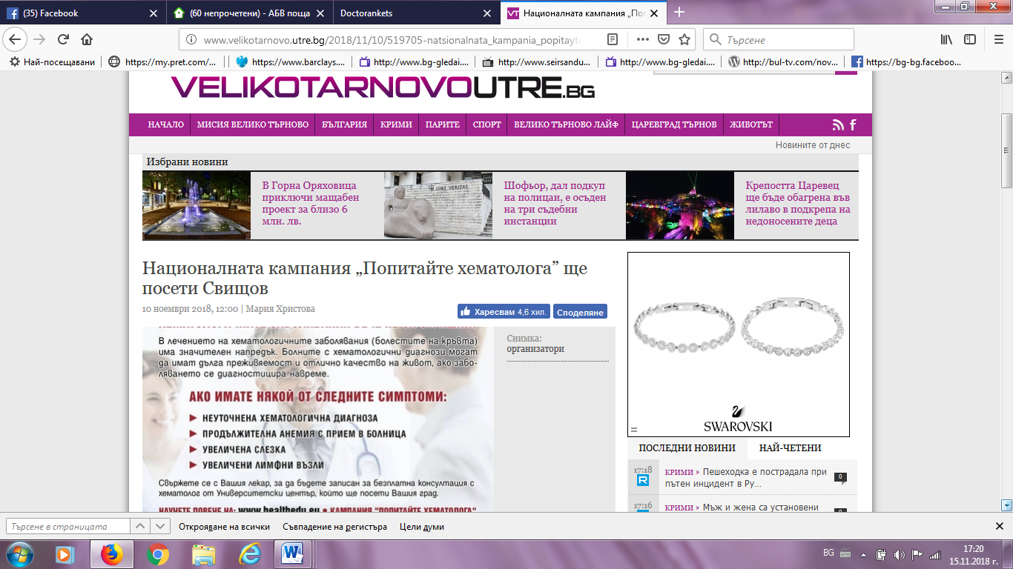

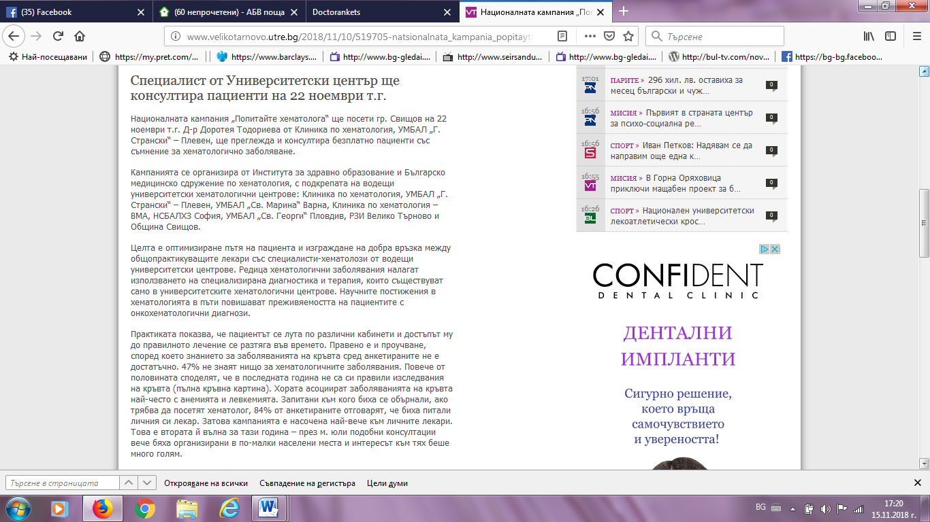
НОВИНАТА БГ:
http://novinata.bg/?p=290476
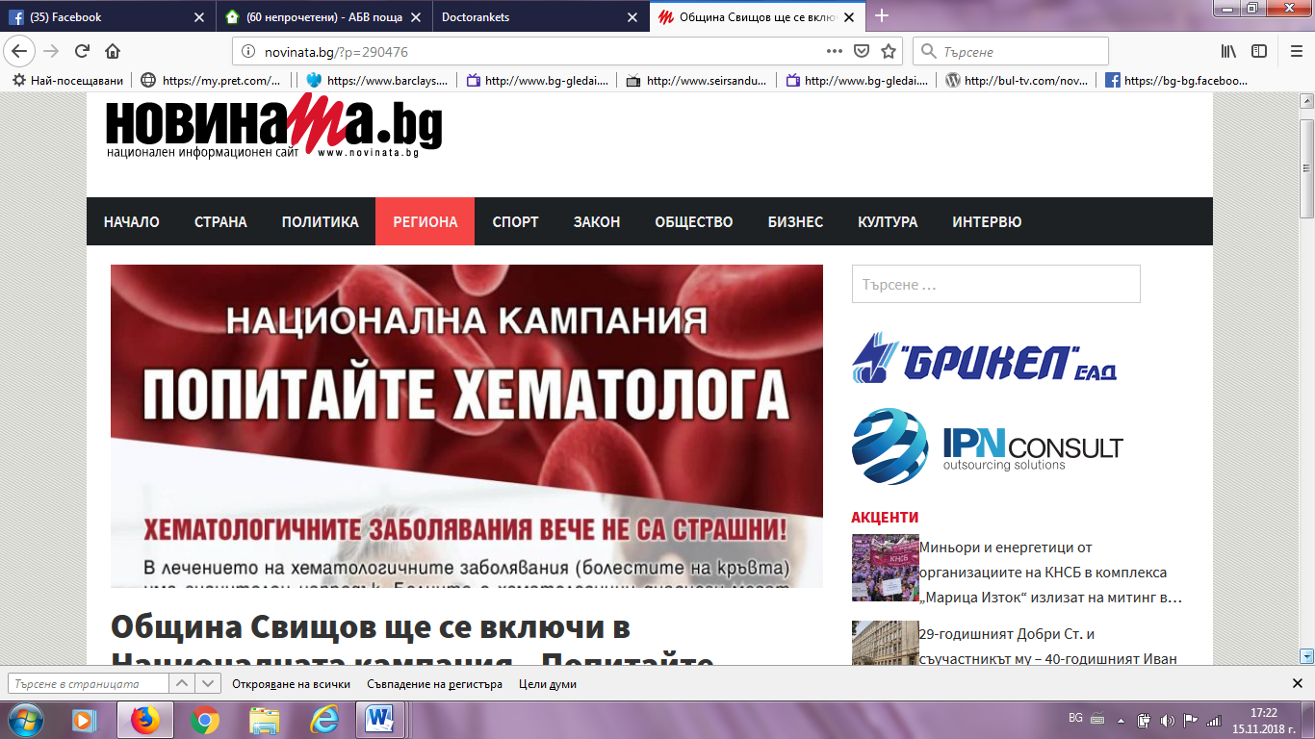

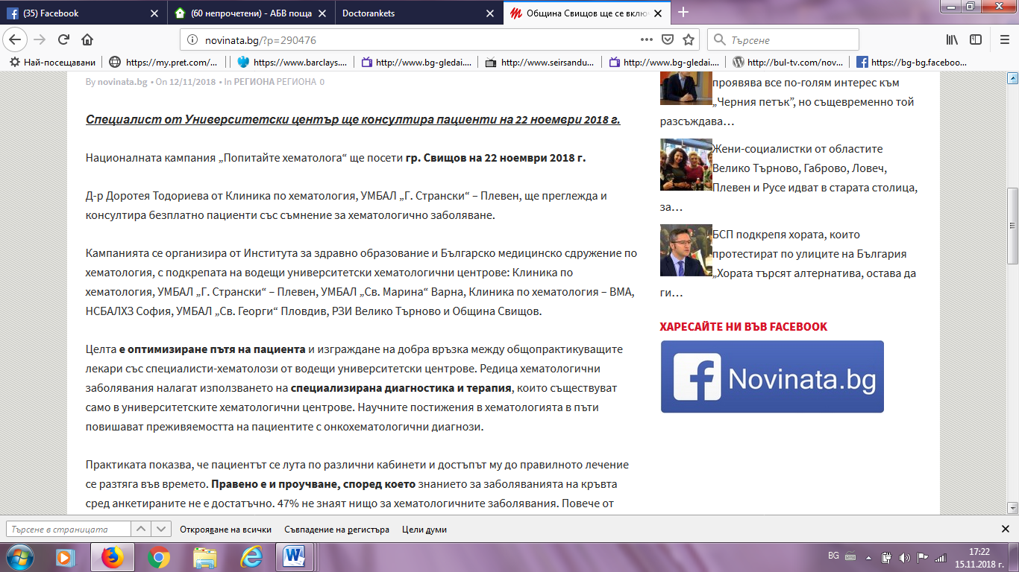

ФЕЙСБУК СВИЩОВ:
https://www.facebook.com/groups/43961778597/search/?query=%D0%BF%D0%B0%D1%86%D0%B8%D0%B5%D0%BD%D1%82%D0%B8%20%D1%81%D1%8A%D1%81%20%D1%81%D1%8A%D0%BC%D0%BD%D0%B5%D0%BD%D0%B8%D0%B5%20%D0%B7%D0%B0%20%D1%85%D0%B5%D0%BC%D0%B0%D1%82%D0%BE%D0%BB%D0%BE%D0%B3%D0%B8%D1%87%D0%BD%D0%BE%20%D0%B7%D0%B0%D0%B1%D0%BE%D0%BB%D1%8F%D0%B2%D0%B0%D0%BD%D0%B5.%20
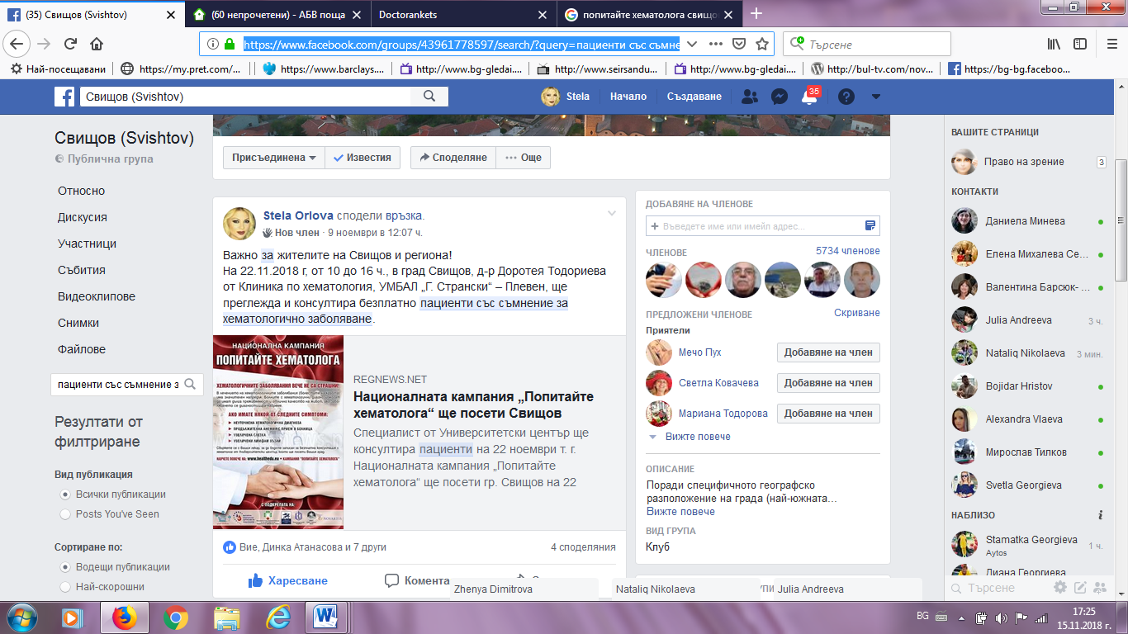

Свищов! Град на Бъдещето! ФЕЙСБУК:https://www.facebook.com/groups/kamelio/search/?query=%D0%BF%D0%B0%D1%86%D0%B8%D0%B5%D0%BD%D1%82%D0%B8%20%D1%81%D1%8A%D1%81%20%D1%81%D1%8A%D0%BC%D0%BD%D0%B5%D0%BD%D0%B8%D0%B5%20%D0%B7%D0%B0%20%D1%85%D0%B5%D0%BC%D0%B0%D1%82%D0%BE%D0%BB%D0%BE%D0%B3%D0%B8%D1%87%D0%BD%D0%BE%20%D0%B7%D0%B0%D0%B1%D0%BE%D0%BB%D1%8F%D0%B2%D0%B0%D0%BD%D0%B5.%20
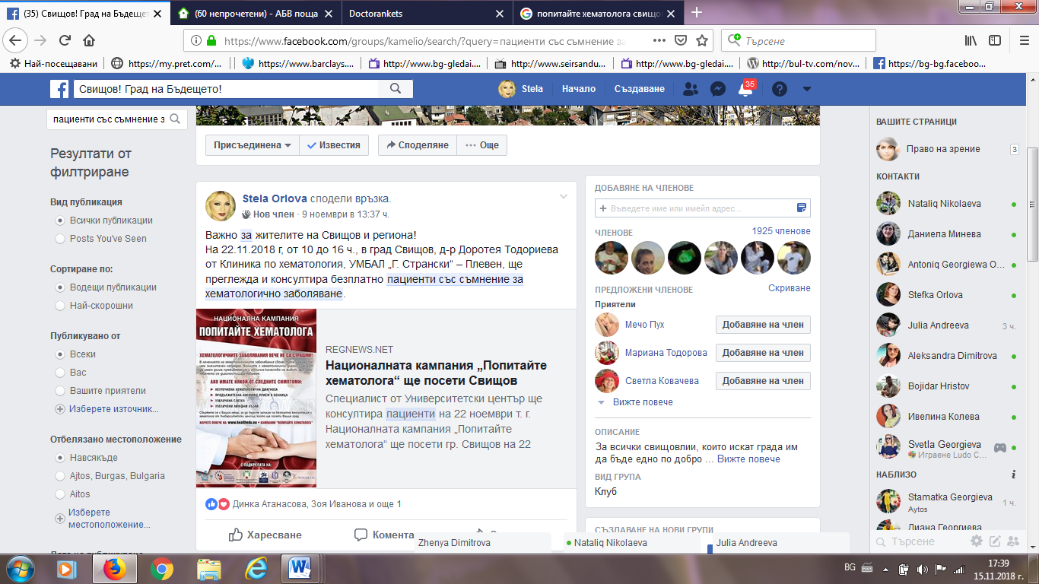
ФОКУС РАДИО: http://focus-radio.net/%D0%BD%D0%B0%D1%86%D0%B8%D0%BE%D0%BD%D0%B0%D0%BB%D0%BD%D0%B0%D1%82%D0%B0-%D0%BA%D0%B0%D0%BC%D0%BF%D0%B0%D0%BD%D0%B8%D1%8F-%D0%BF%D0%BE%D0%BF%D0%B8%D1%82%D0%B0%D0%B9%D1%82%D0%B5-%D1%85%D0%B5-2/ 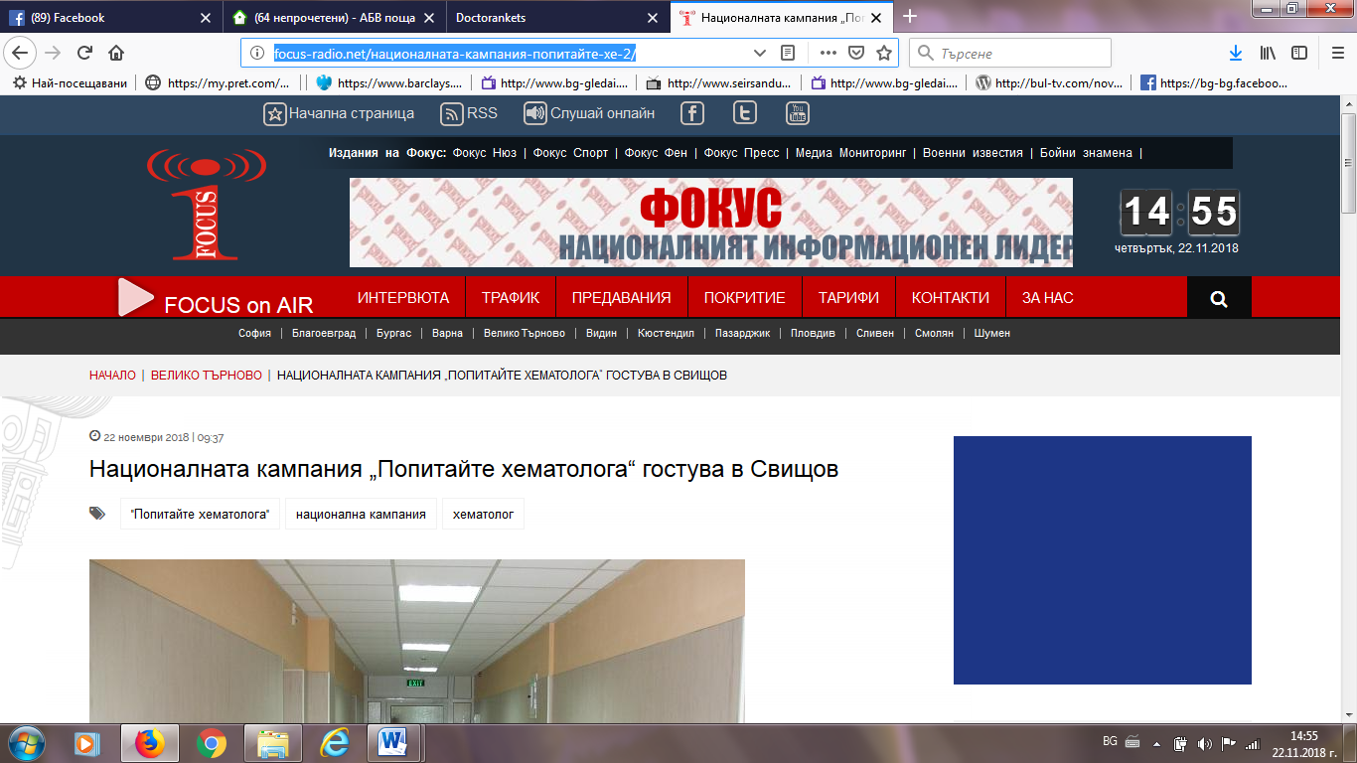
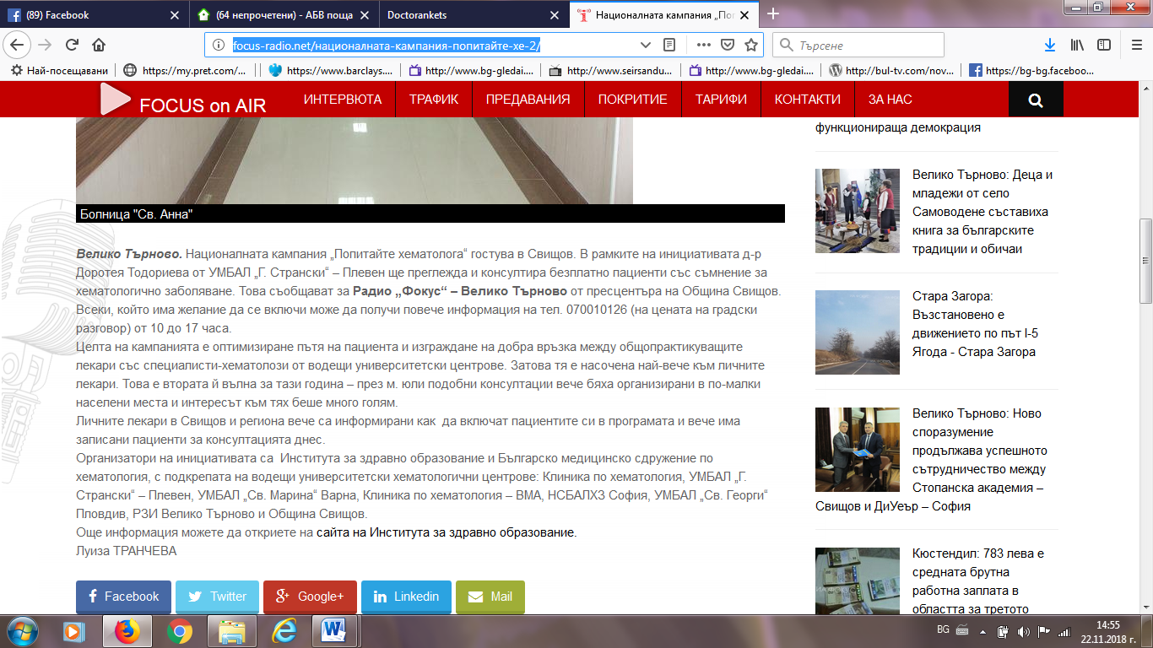
РЕГ НЮЗ:
https://regnews.net/bg/zhiteli-na-svishtov-poluchiha-barz-dostap-do-hematolog-ot-universitetski-tsentar/#.XAQ1cjGkLIU
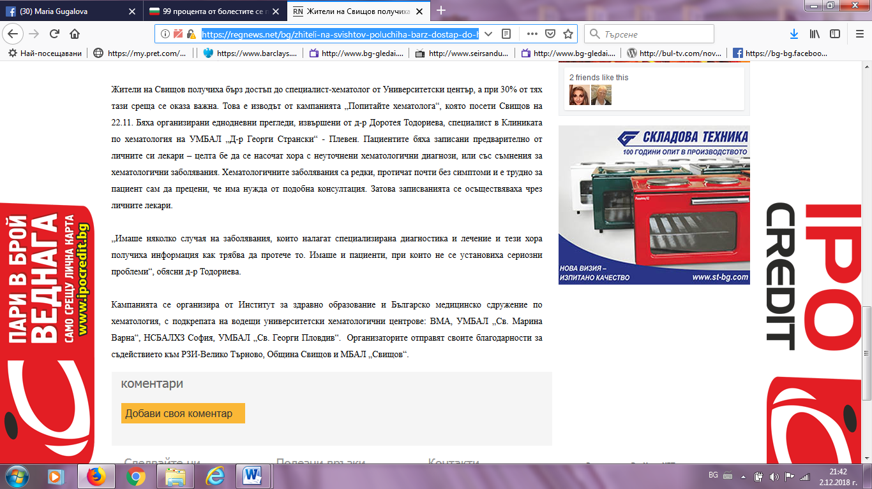

ФОКУС НЮЗ:
http://www.focus-news.net/news/2018/11/28/2595900/zhiteli-na-svishtov-poluchiha-barz-dostap-do-hematolog-30-ot-pregledanite-sa-nasocheni-za-dopalnitelni-izsledvaniya.html
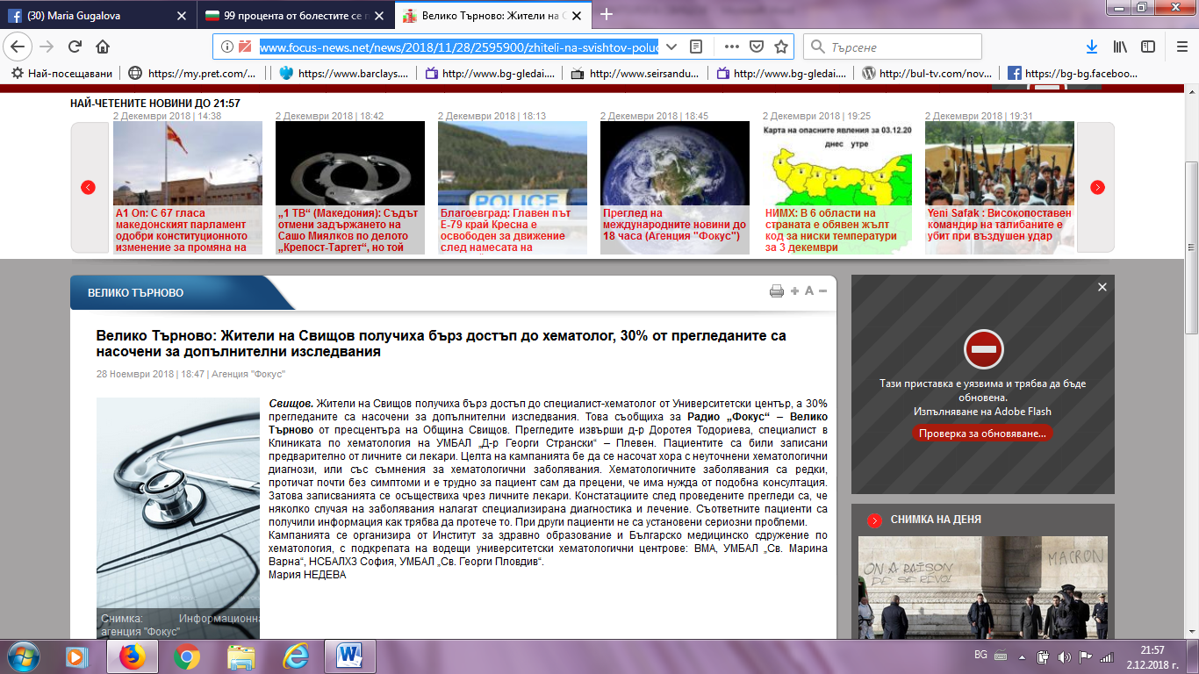
ВЕСТНИК КОРЕСПОНДЕНТ:
https://www.facebook.com/%D0%92%D0%B5%D1%81%D1%82%D0%BD%D0%B8%D0%BA-%D0%9A%D0%BE%D1%80%D0%B5%D1%81%D0%BF%D0%BE%D0%BD%D0%B4%D0%B5%D0%BD%D1%82-1631219410493107/
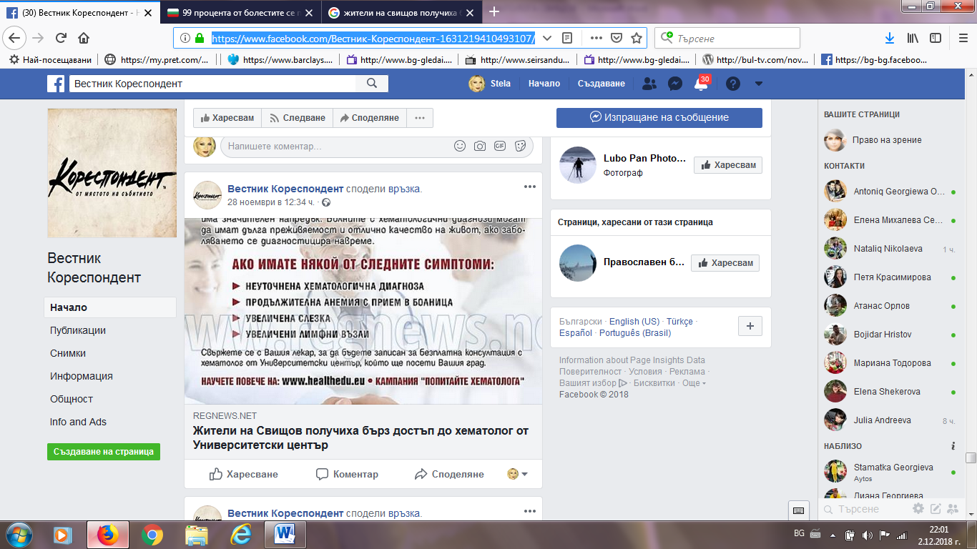

ГЛАС БГ:
http://cdn.glas.bg/1537636/veliko-trnovo-zhiteli-na-svishov-poluchiha-brz-dostp-do-hema
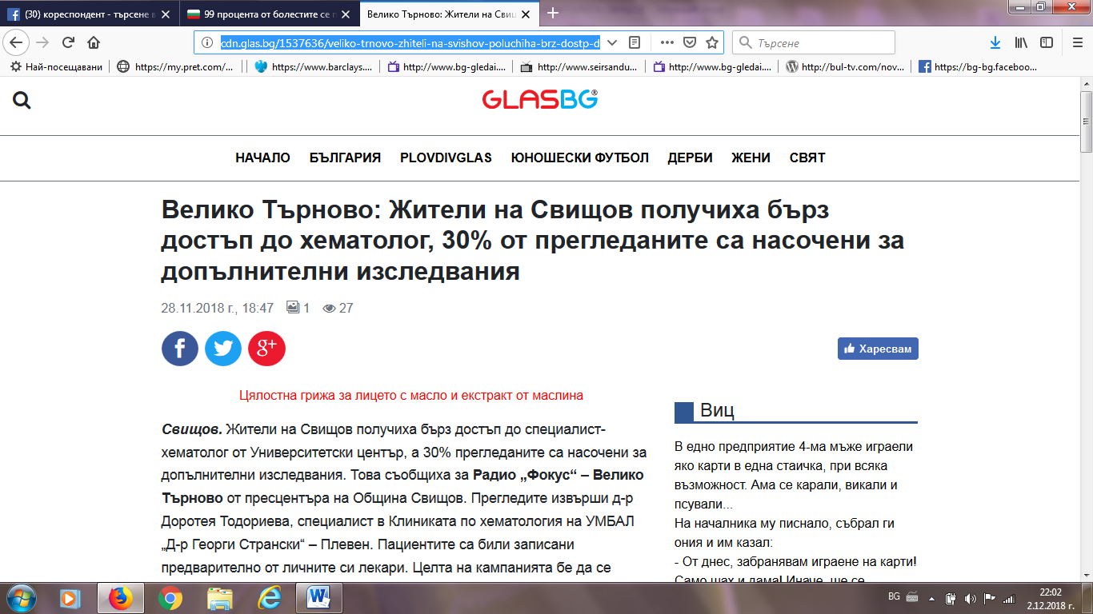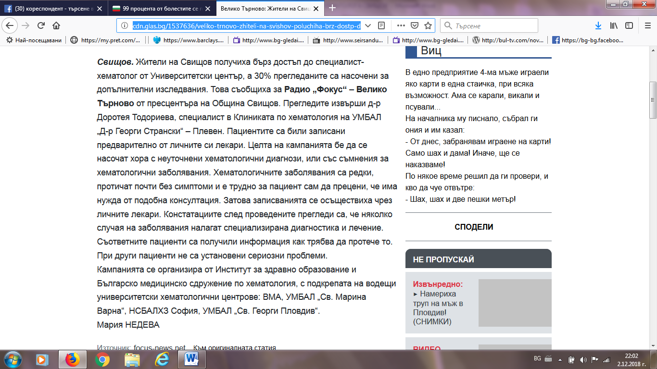

СВИЩОВ ДНЕС:
https://svishtovtoday.com/article/5016/svishtovlii-poluchiha-pregled-ot-spetsialist-hematolog

