МЕДИА МОНИТОРИНГ ХЕМАТОЛОГИЧНИ ЗАБОЛЯВАНИЯ – ШУМЕН

ДАРИК НЮЗ:
https://dariknews.bg/regioni/shumen/bezplatni-pregledi-ot-specialist-hematolog-v-shumen-2107851
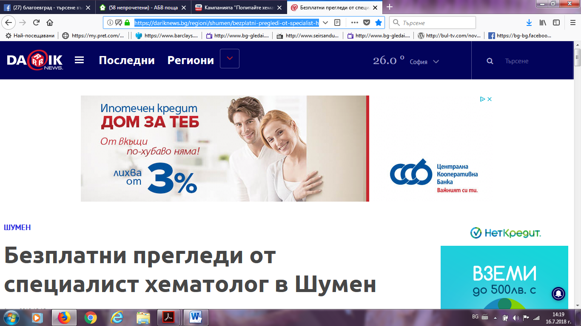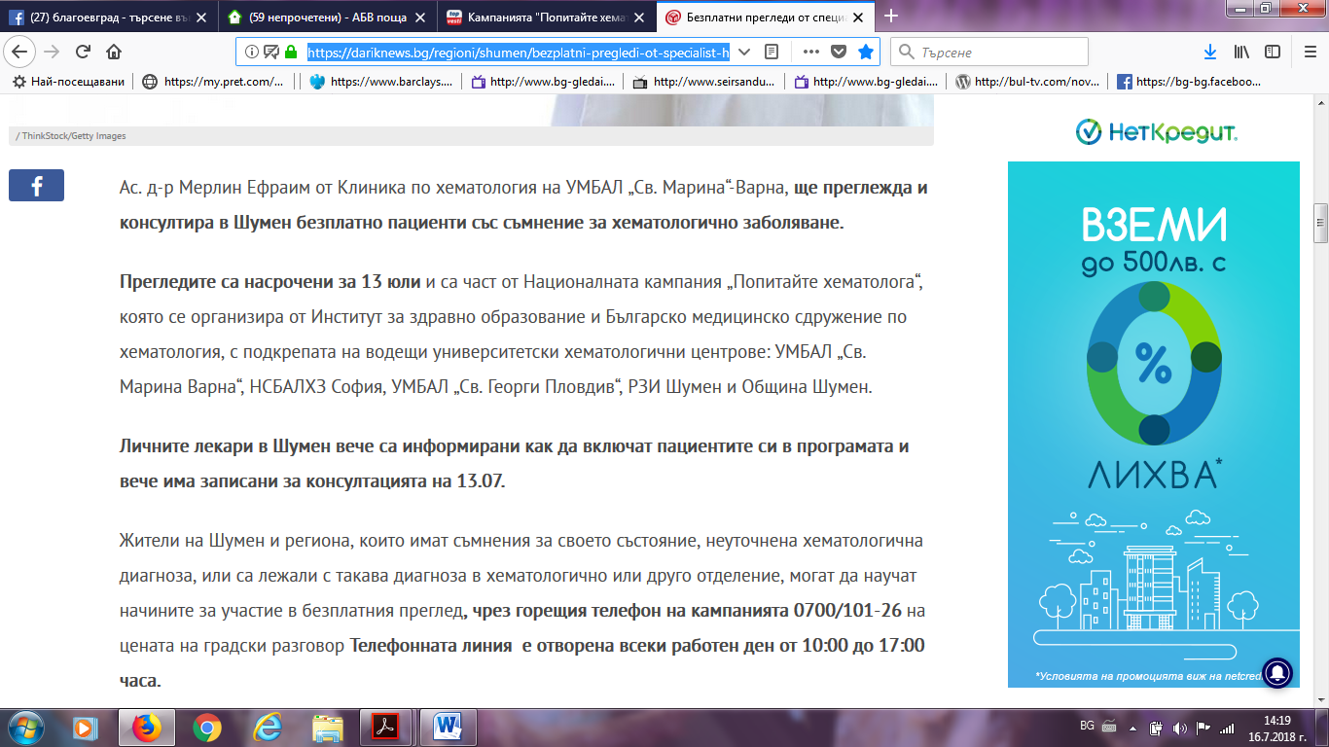

ШУМЕН БГ:
http://www.shum.bg/article/171859/
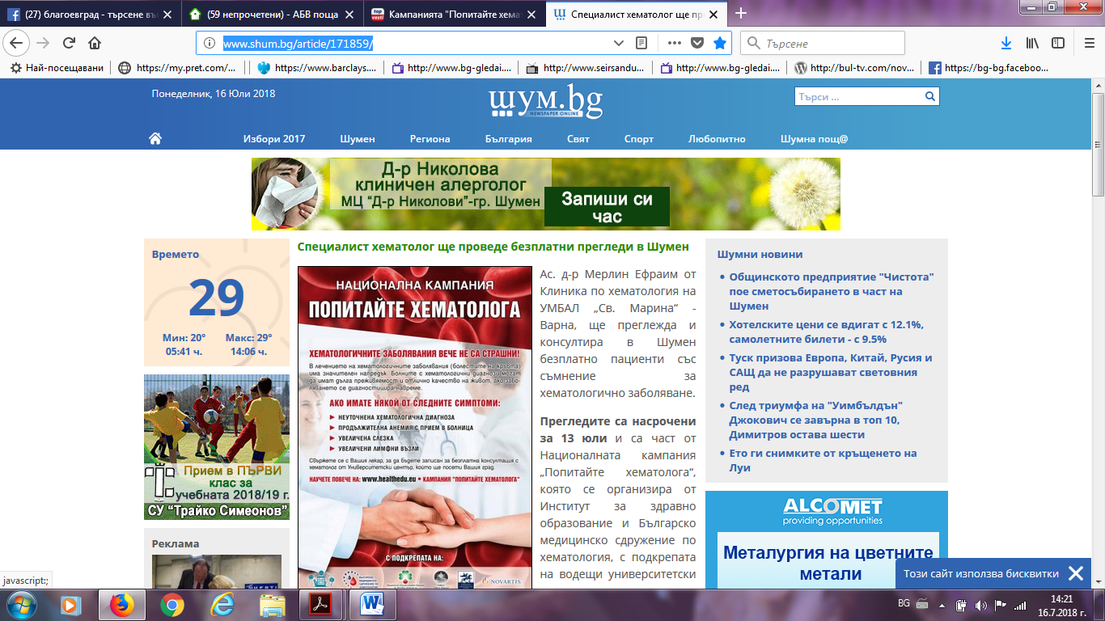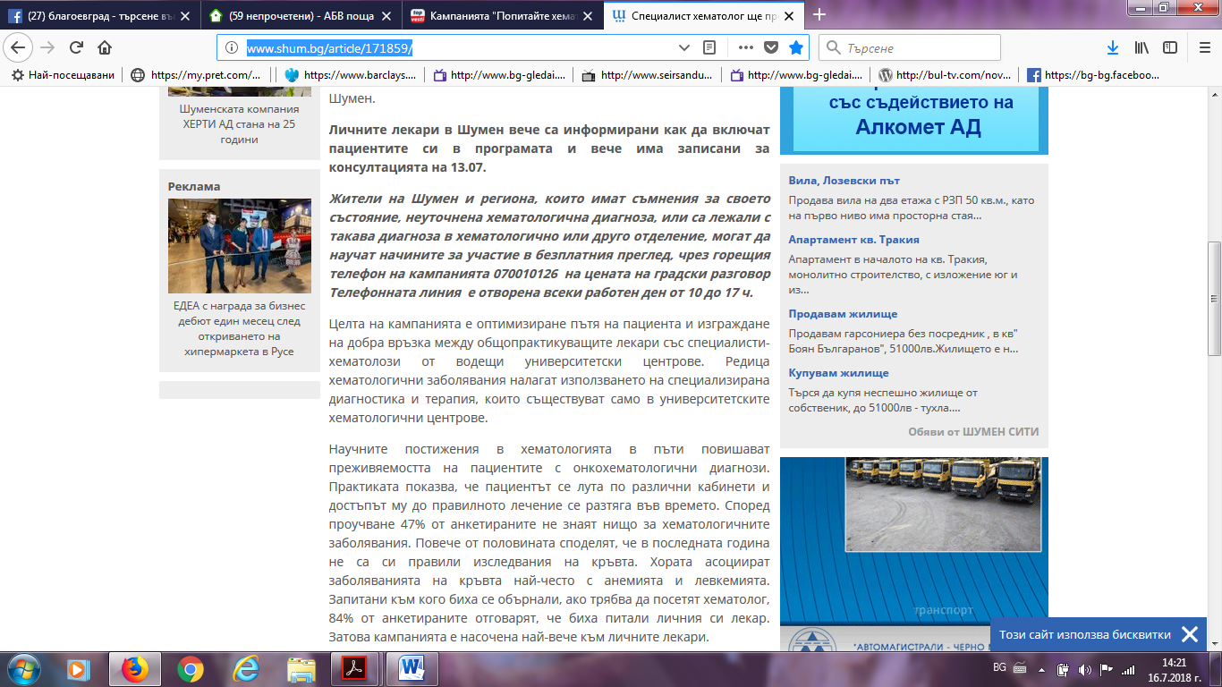

БТА:
http://www.bta.bg/bg/c/BO/id/1832895
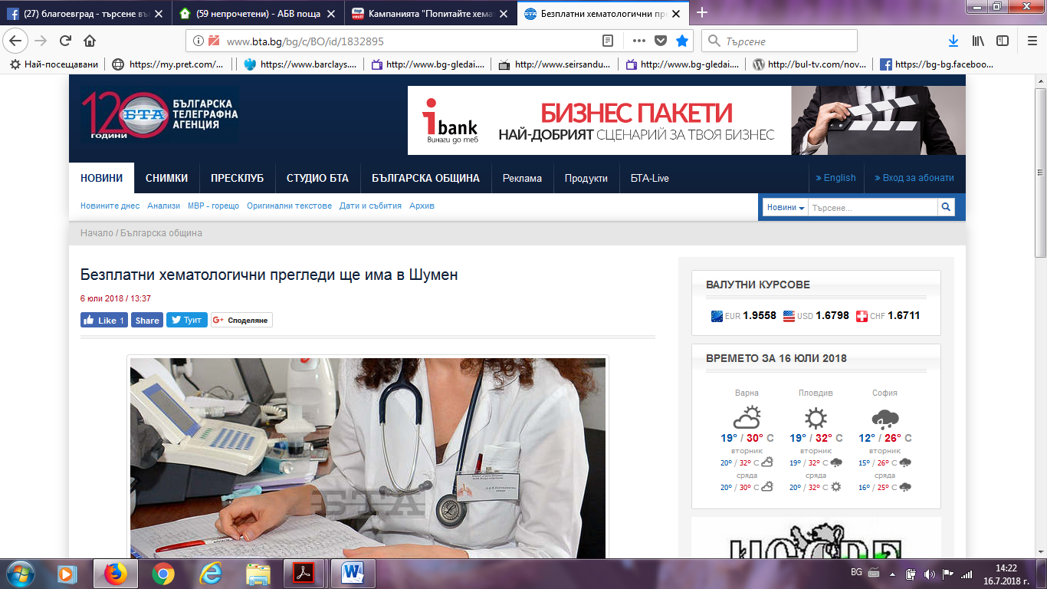
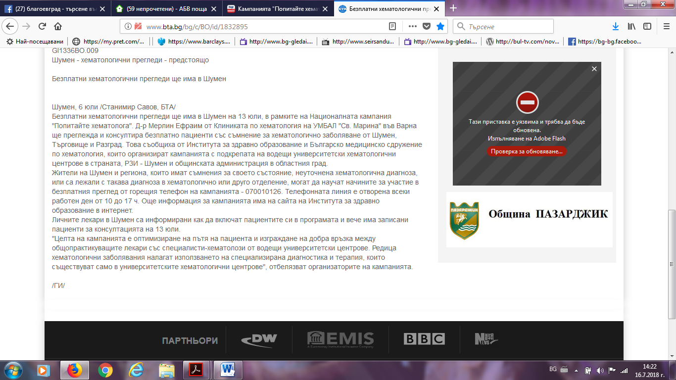

ФОКУС НЮЗ:
http://focus-news.net/news/2018/07/08/2543095/shumen-natsionalnata-kampaniya-popitayte-hematologa-shte-poseti-grada-na-13-yuli.htmlhttp://focus-news.net/news/2018/07/08/2543095/shumen-natsionalnata-kampaniya-popitayte-hematologa-shte-poseti-grada-na-13-yuli.html
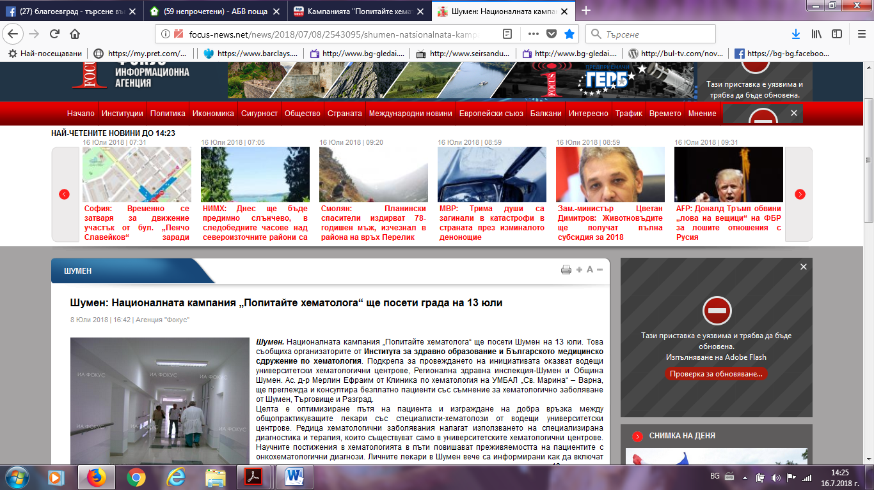
АКТУАЛНО: https://www.actualno.com/shumen/kampanijata-popitajte-hematologa-v-shumen-na-13-uli-news_683852.htmlhttps://www.actualno.com/shumen/kampanijata-popitajte-hematologa-v-shumen-na-13-uli-news_683852.html
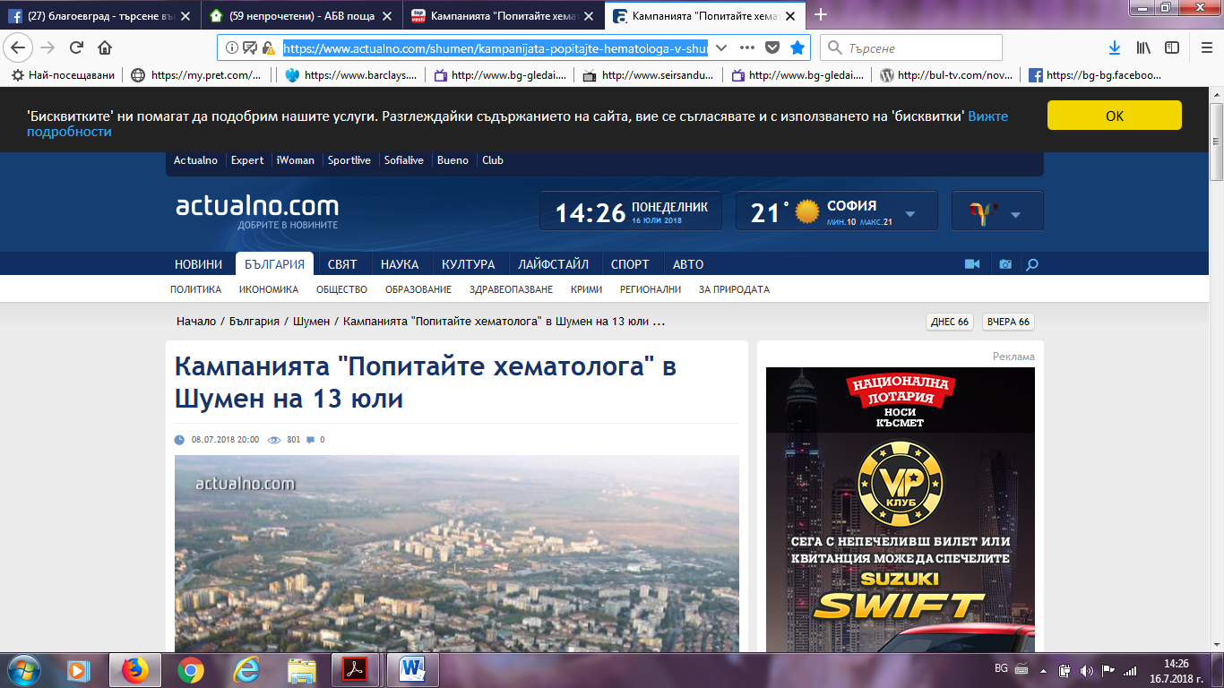
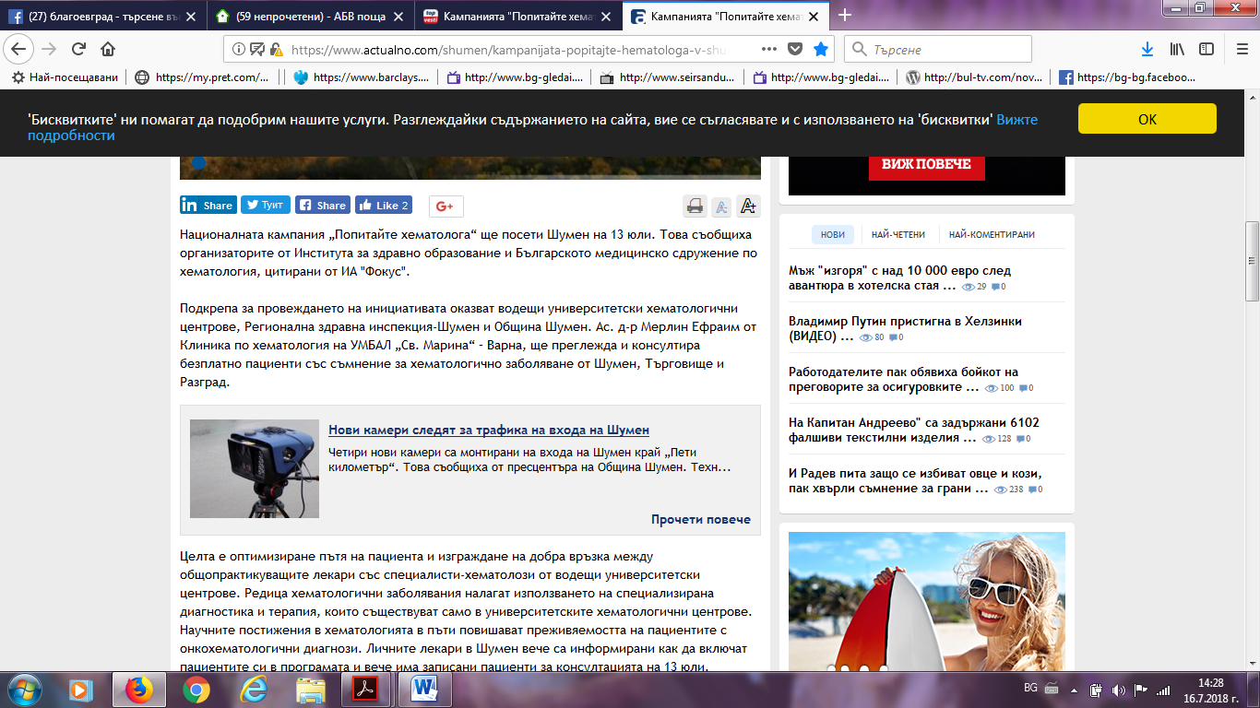
КЛУБ БГ:
https://www.club.bg/news.php?news-url=Kampanijata-Popitajte-hematologa-v-Shumen-na-13-uli
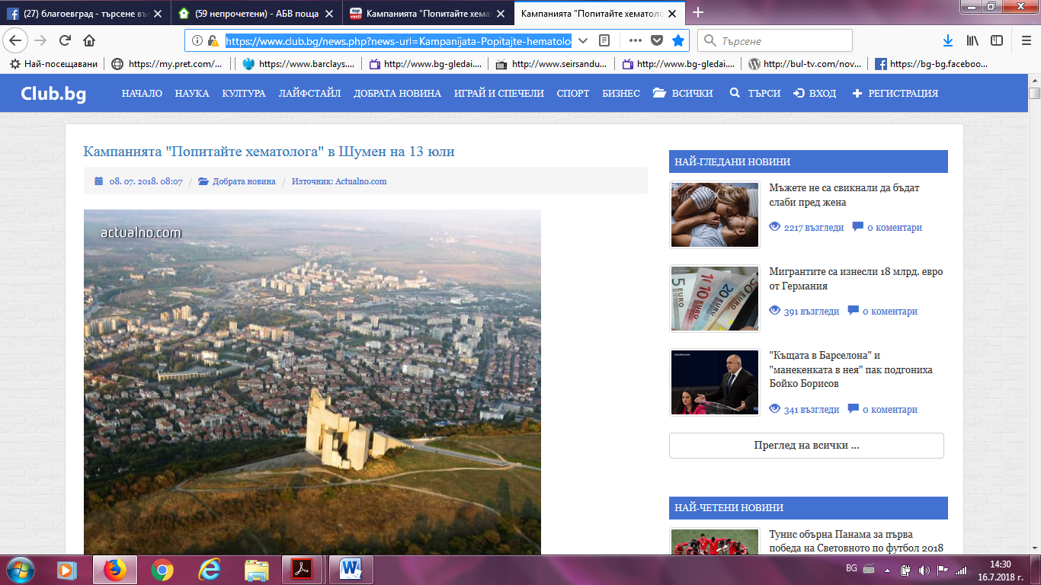

БНР:
http://bnr.bg/shumen/post/100993953/nosete-kravna-kartina-pri-hematologa
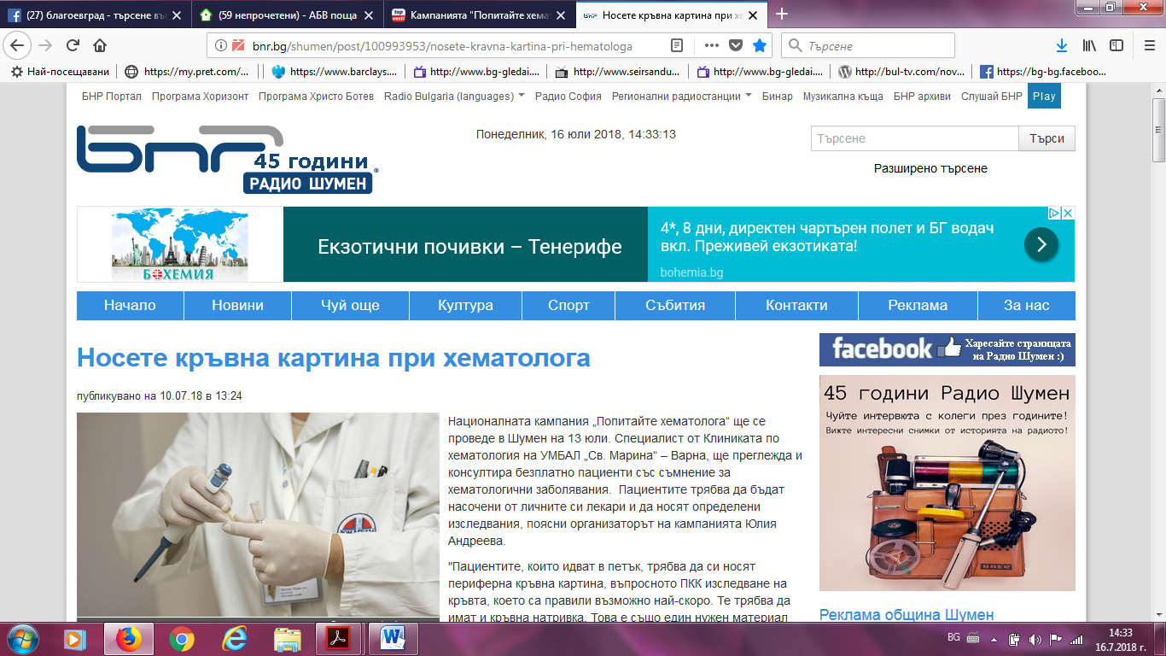
БНР:
http://bnr.bg/shumen/post/100995406
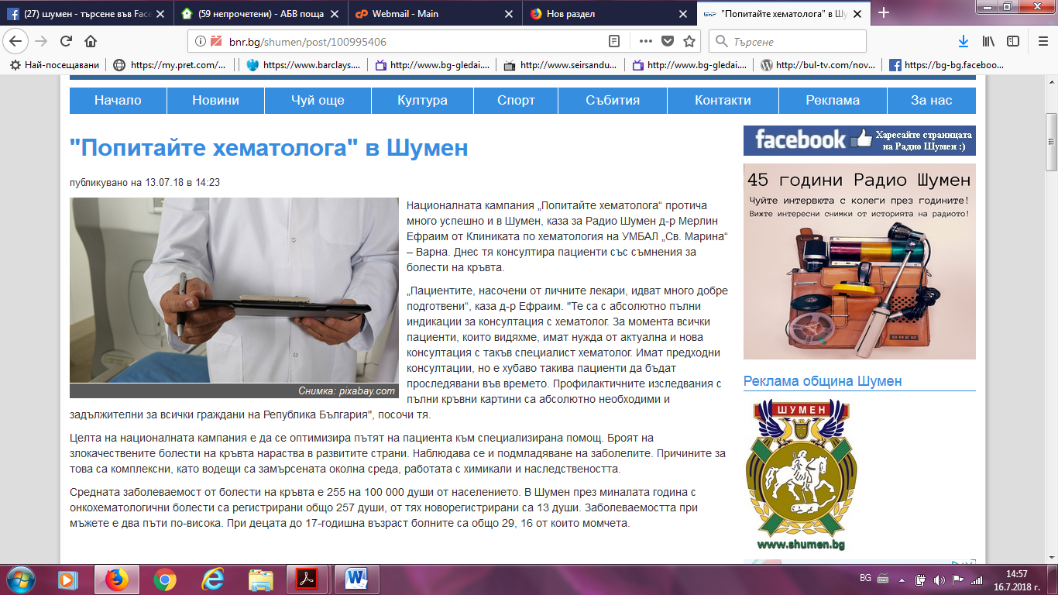

ТВ ШУМЕН:
http://tvshumen.bg/novina/v-shumen-se-provedoha-bezplatni-hematologichni-pregledi/3655
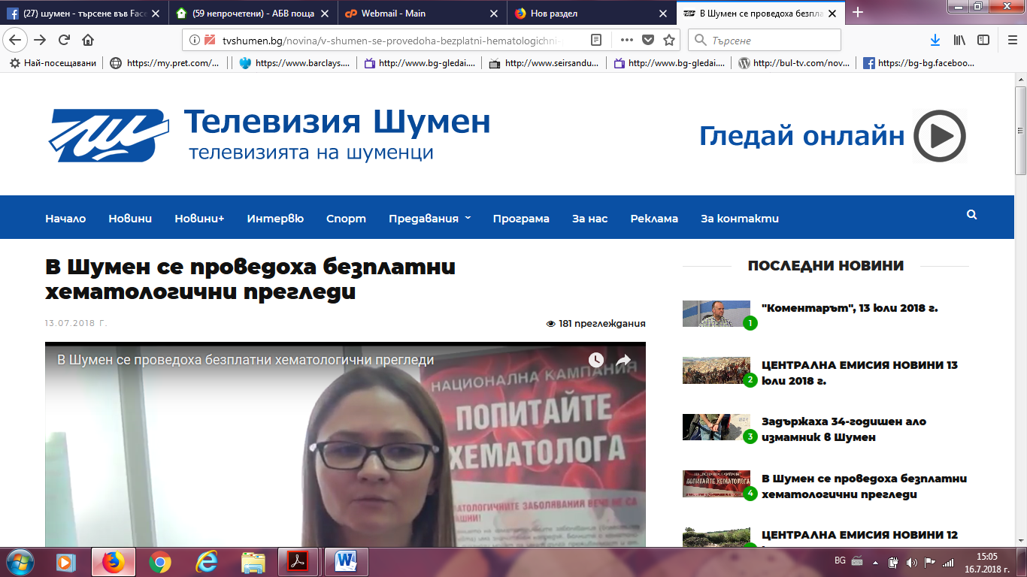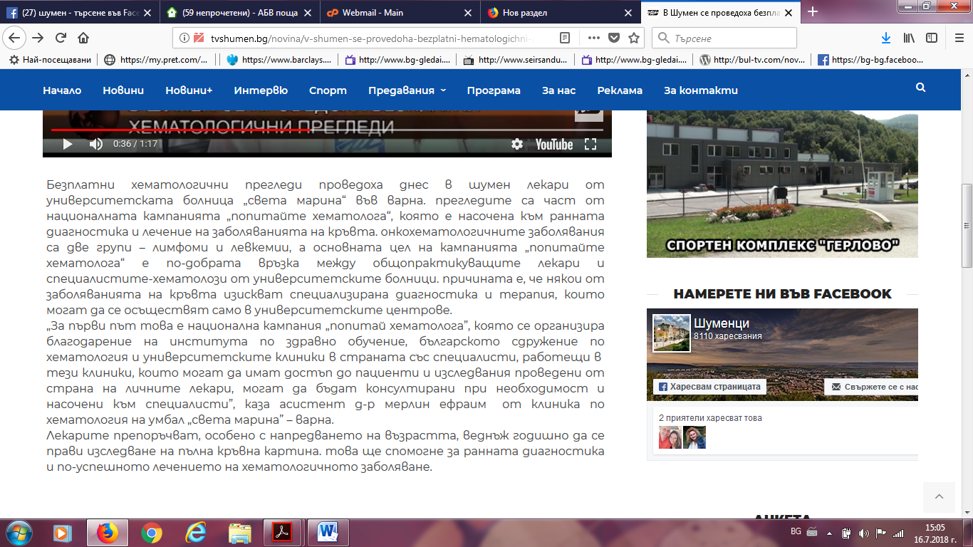

ВИЖ НОВИНИТЕ:
http://vijnovinite.com/news/1247275
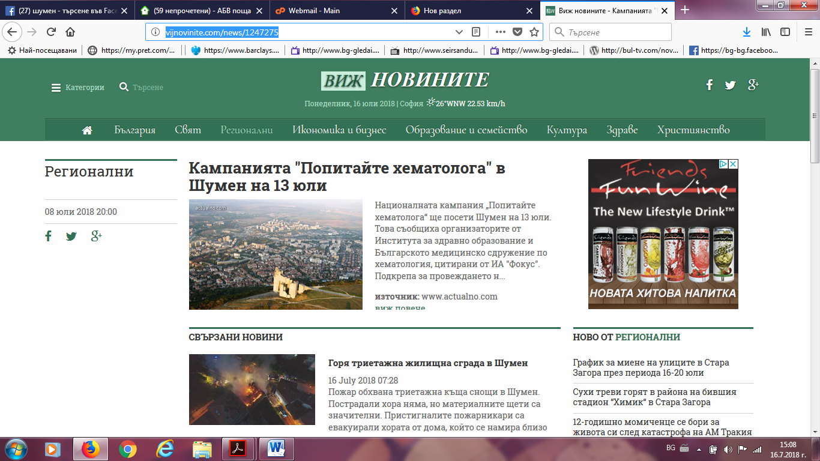
ТВН ШУМЕН:
https://www.facebook.com/tvnshumen/
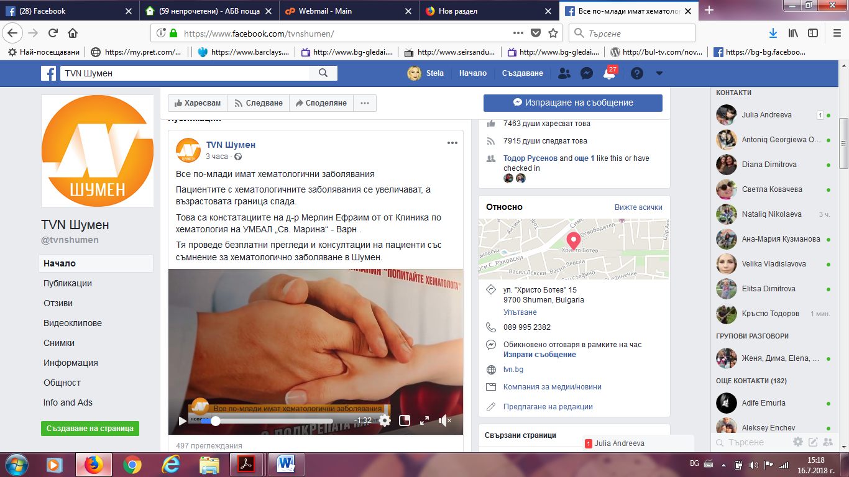

ОБЩИНА ШУМЕН:
http://www.shumen.bg/%D1%88%D1%83%D0%BC%D0%B5%D0%BD-%D1%81%D0%B5-%D0%B2%D0%BA%D0%BB%D1%8E%D1%87%D0%B2%D0%B0-%D0%B2-%D0%BD%D0%B0%D1%86%D0%B8%D0%BE%D0%BD%D0%B0%D0%BB%D0%BD%D0%B0%D1%82%D0%B0-%D0%BA%D0%B0%D0%BC%D0%BF%D0%B0/
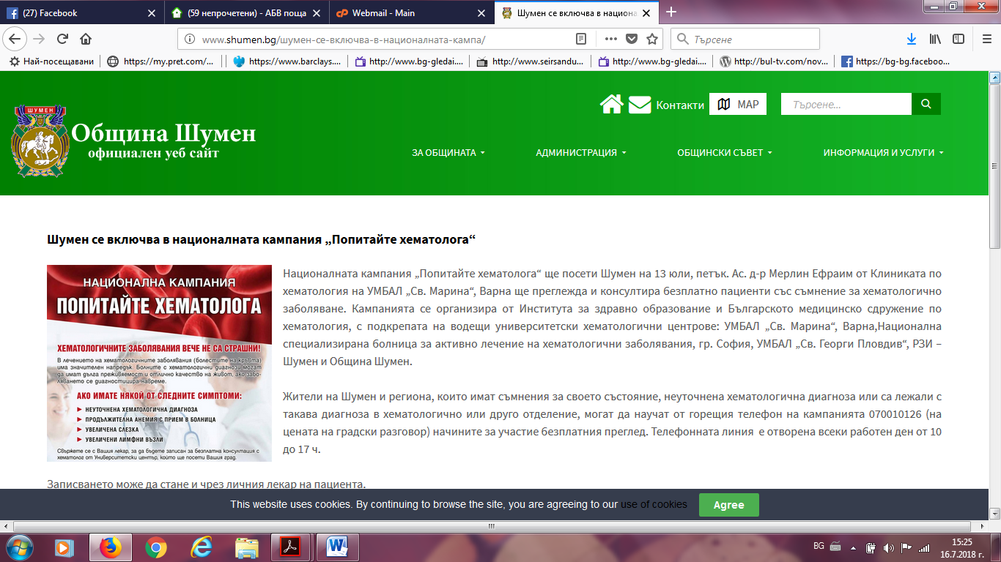
БНР:
http://bnr.bg/shumen/post/100993382/popitai-hematologa
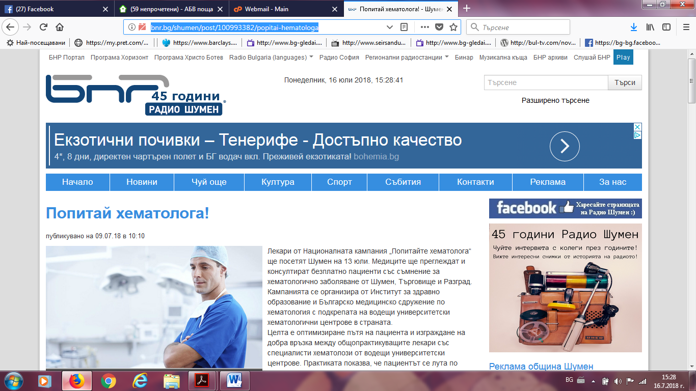

ШМОКО БГ:
http://shmoko.bg/?p=19467
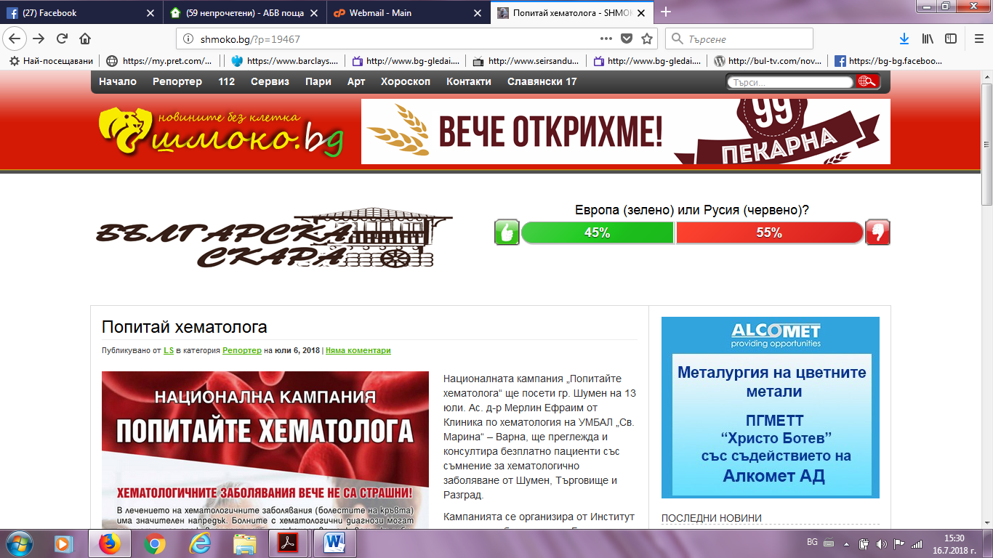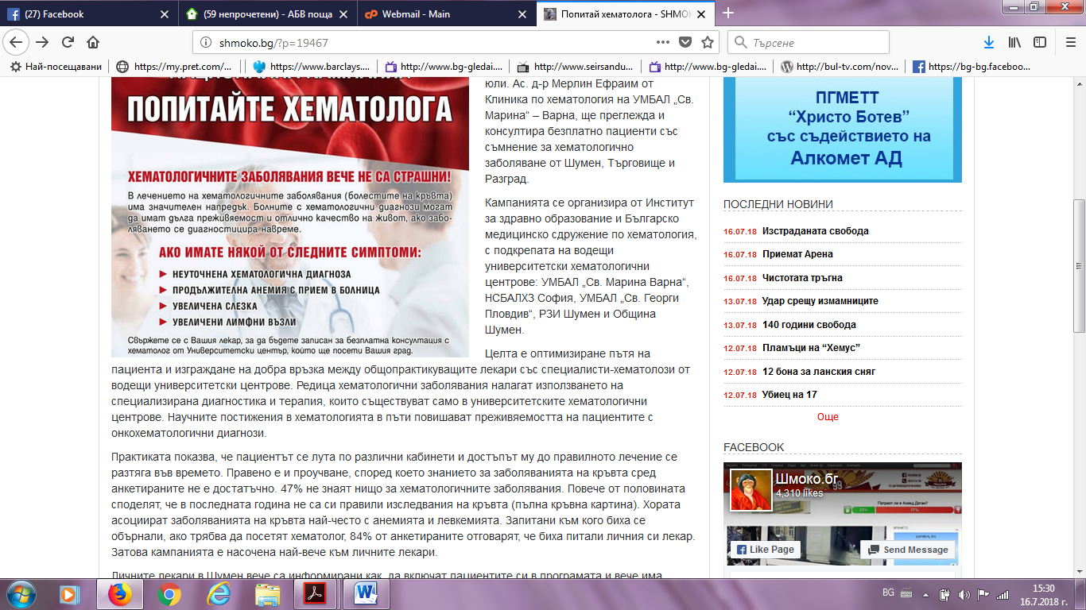

ПАЛОБГ:http://www.palo.bg/a/%D0%BA%D0%B0%D0%BC%D0%BF%D0%B0%D0%BD%D0%B8%D1%8F%D1%82%D0%B0-%D0%BF%D0%BE%D0%BF%D0%B8%D1%82%D0%B0%D0%B9%D1%82%D0%B5-%D1%85%D0%B5%D0%BC%D0%B0%D1%82%D0%BE%D0%BB%D0%BE%D0%B3%D0%B0-%D0%B2-%D1%88%D1%83%D0%BC%D0%B5%D0%BD-%D0%BD%D0%B0-13-%D1%8E%D0%BB%D0%B8-230439
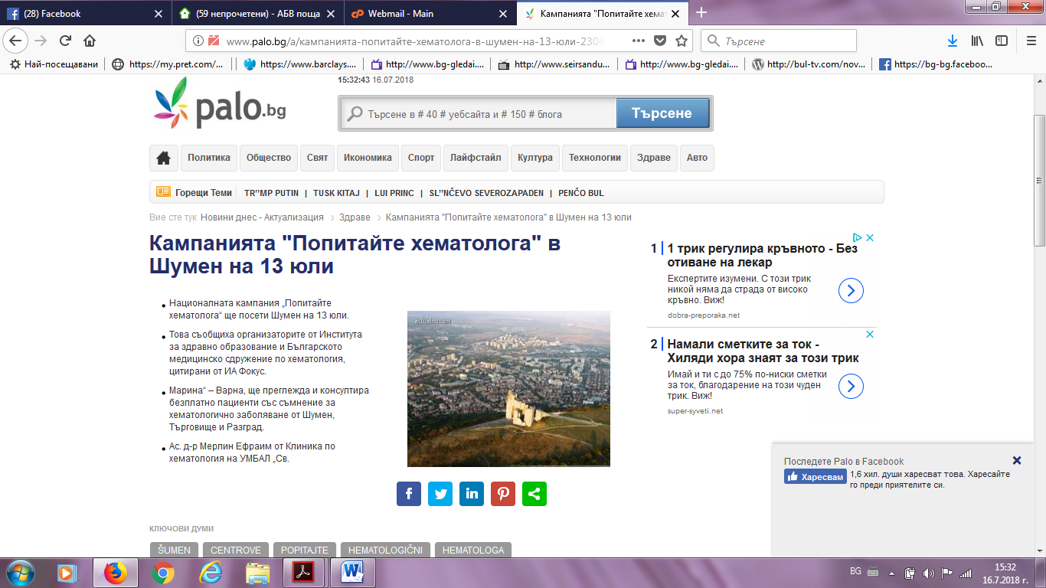
СТРЕЛА БГ:
https://strelabg.com/%D1%81%D0%BF%D0%B5%D1%86%D0%B8%D0%B0%D0%BB%D0%B8%D1%81%D1%82-%D1%85%D0%B5%D0%BC%D0%B0%D1%82%D0%BE%D0%BB%D0%BE%D0%B3-%D1%89%D0%B5-%D0%BF%D1%80%D0%B5%D0%B3%D0%BB%D0%B5%D0%B6%D0%B4%D0%B0-%D0%B1%D0%B5/ 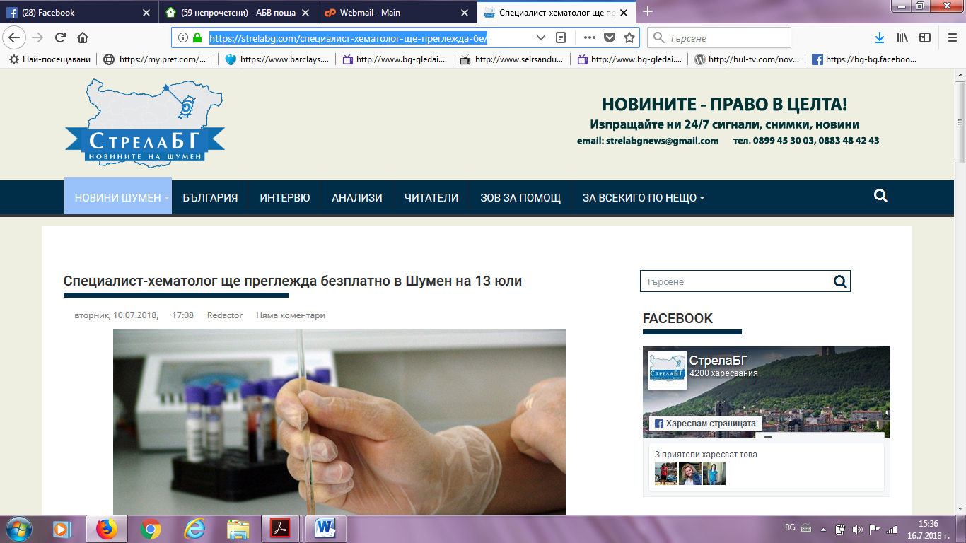
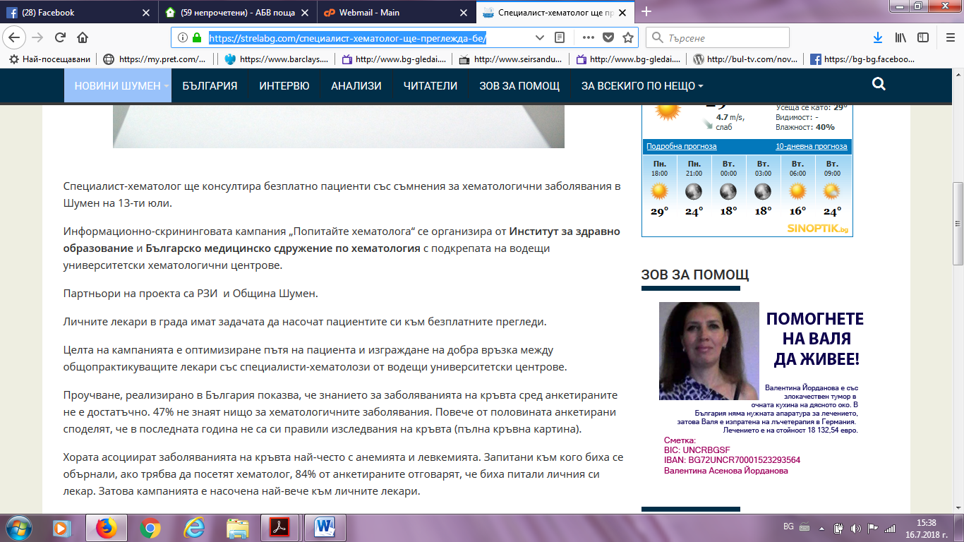
ФРАМАР:
https://media.framar.bg/%D0%B7%D0%B4%D1%80%D0%B0%D0%B2%D0%BD%D0%B8-%D0%BD%D0%BE%D0%B2%D0%B8%D0%BD%D0%B8/%D1%81%D0%BF%D0%B5%D1%86%D0%B8%D0%B0%D0%BB%D0%B8%D1%81%D1%82-%D1%85%D0%B5%D0%BC%D0%B0%D1%82%D0%BE%D0%BB%D0%BE%D0%B3-%D1%89%D0%B5-%D0%BF%D1%80%D0%B5%D0%B3%D0%BB%D0%B5%D0%B6%D0%B4%D0%B0-%D0%BF%D0%B0%D1%86%D0%B8%D0%B5%D0%BD%D1%82%D0%B8-%D0%B2-%D1%88%D1%83%D0%BC%D0%B5%D0%BD-%D0%BD%D0%B0-13-%D1%8E%D0%BB%D0%B8
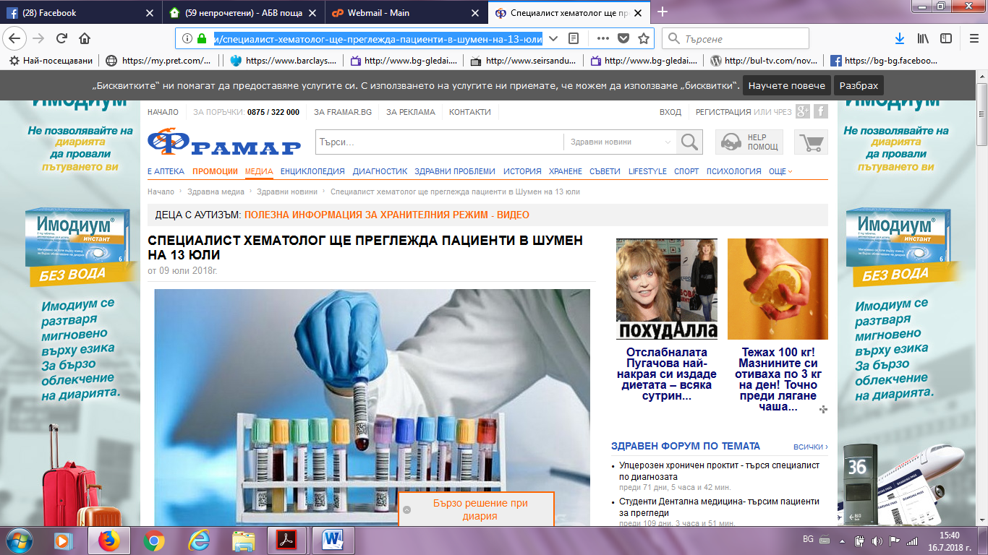

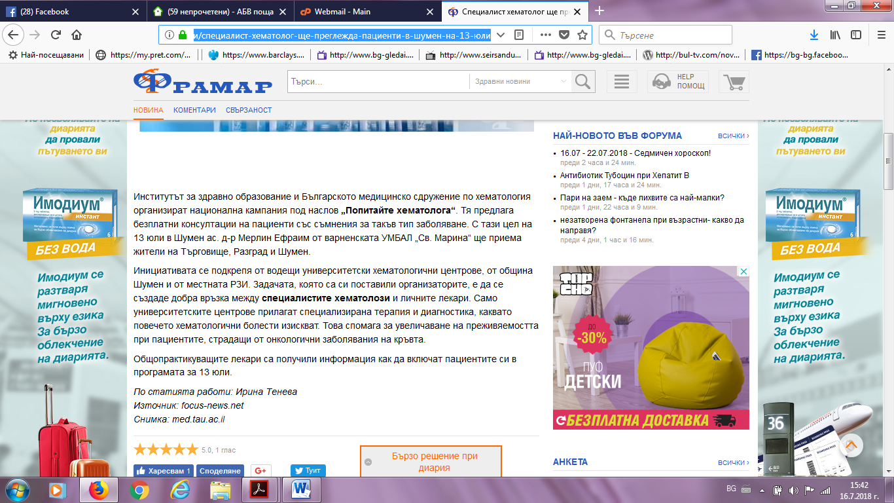
ТЕЛЕГРАФ:
http://telegraf.bg/2018/%D0%BD%D0%BE%D0%B2%D0%B8%D0%BD%D0%B8-%D0%BE%D1%82-%D1%81%D0%B2%D0%B5%D1%82%D0%B0/%D0%BA%D0%B0%D0%BC%D0%BF%D0%B0%D0%BD%D0%B8%D1%8F%D1%82%D0%B0-%D0%BF%D0%BE%D0%BF%D0%B8%D1%82%D0%B0%D0%B9%D1%82%D0%B5-%D1%85%D0%B5%D0%BC%D0%B0%D1%82%D0%BE%D0%BB%D0%BE%D0%B3%D0%B0-%D0%B2/
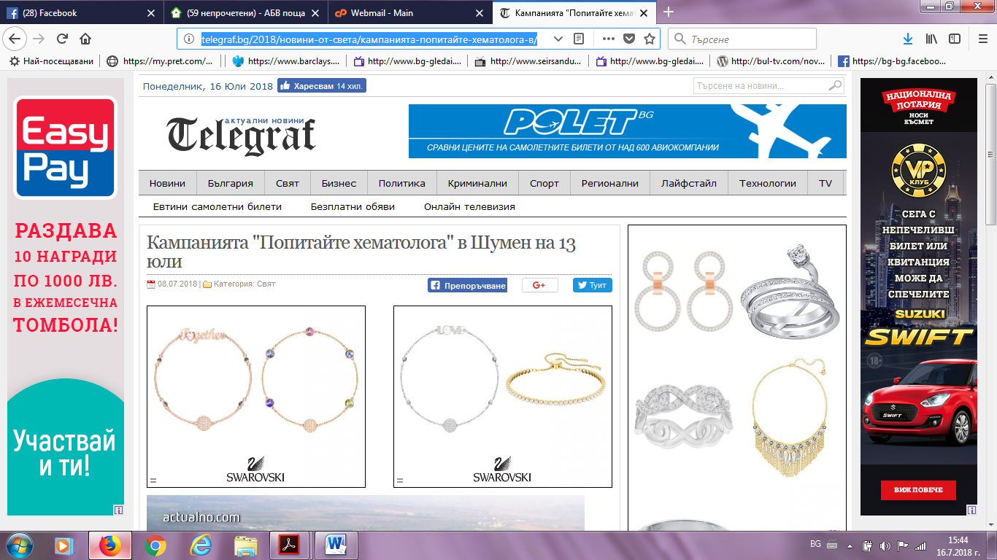

НОВИНИ 247:
https://novini247.com/novini/natsionalnata-kampaniya-popitayte-hematologa-shte-poseti-shumen-na-13-yuli_1065811.html
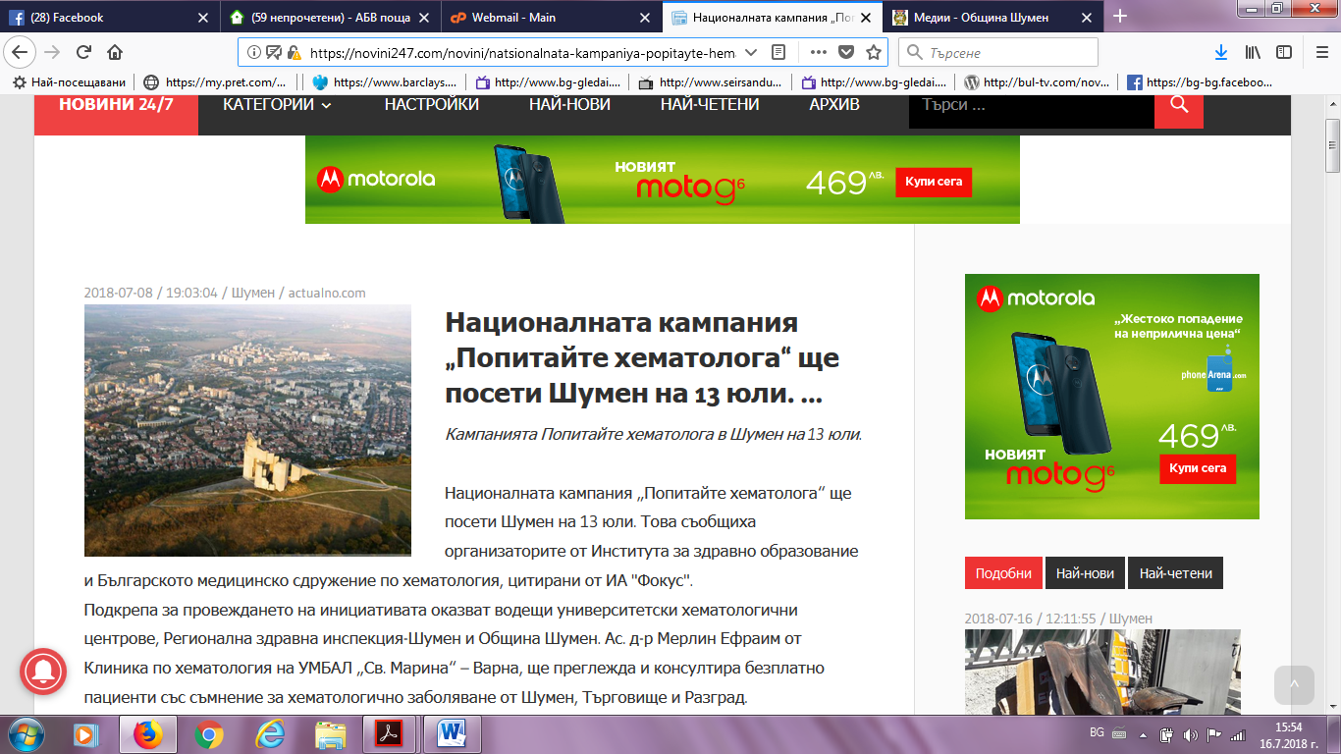
НОВИНАТА БГ:
https://novinata.bg/?p=252956
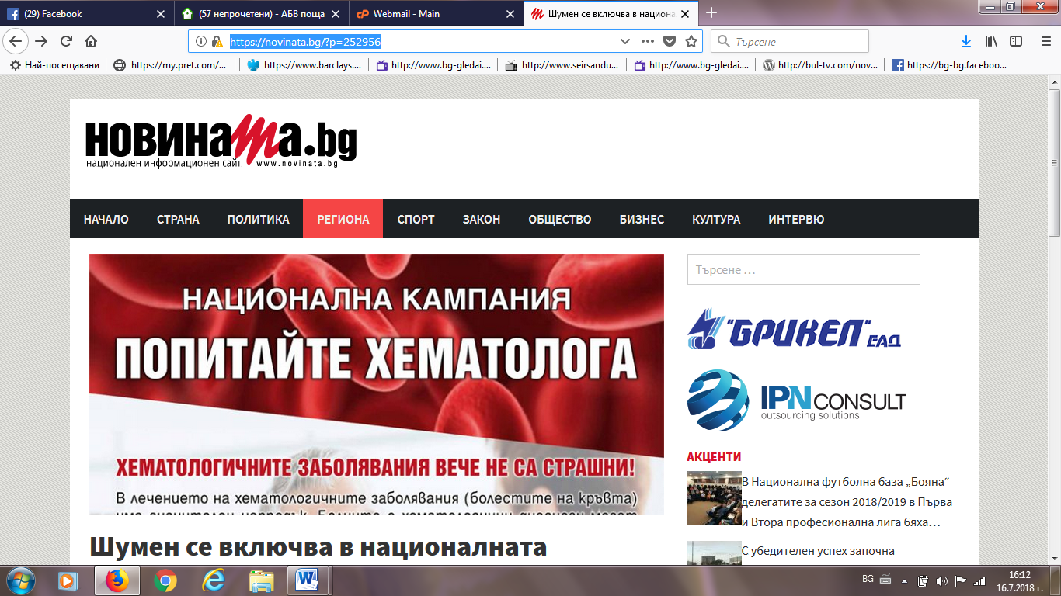

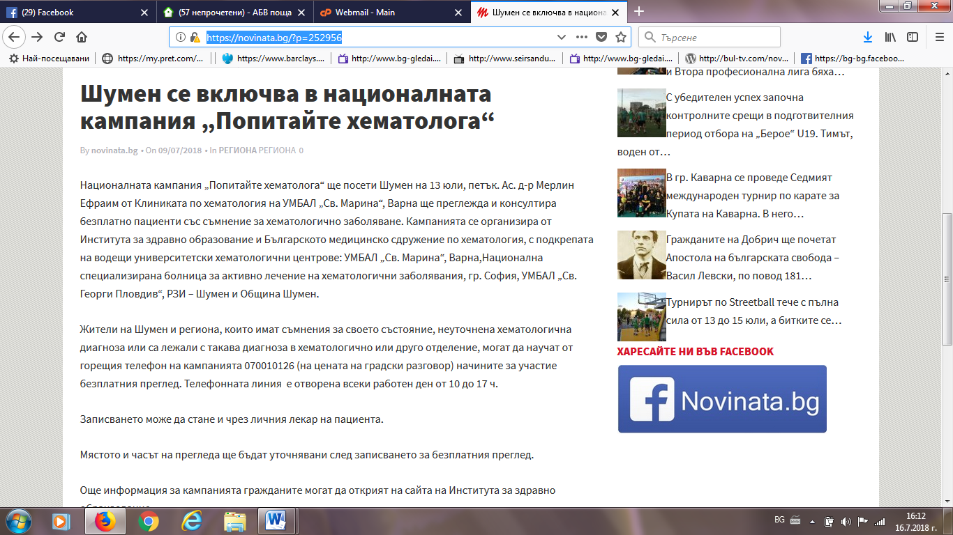
РАДИО ФОКУС:
http://focus-radio.net/%d0%b4-%d1%80-%d0%bc%d0%b5%d1%80%d0%bb%d0%b8%d0%bd-%d0%b5%d1%84%d1%80%d0%b0%d0%b8%d0%bc-%d0%bd%d0%b5-%d0%b2%d1%8a%d0%b2-%d0%b2%d1%81%d0%b8%d1%87%d0%ba%d0%b8-%d1%81%d0%bb%d1%83%d1%87%d0%b0%d0%b8/

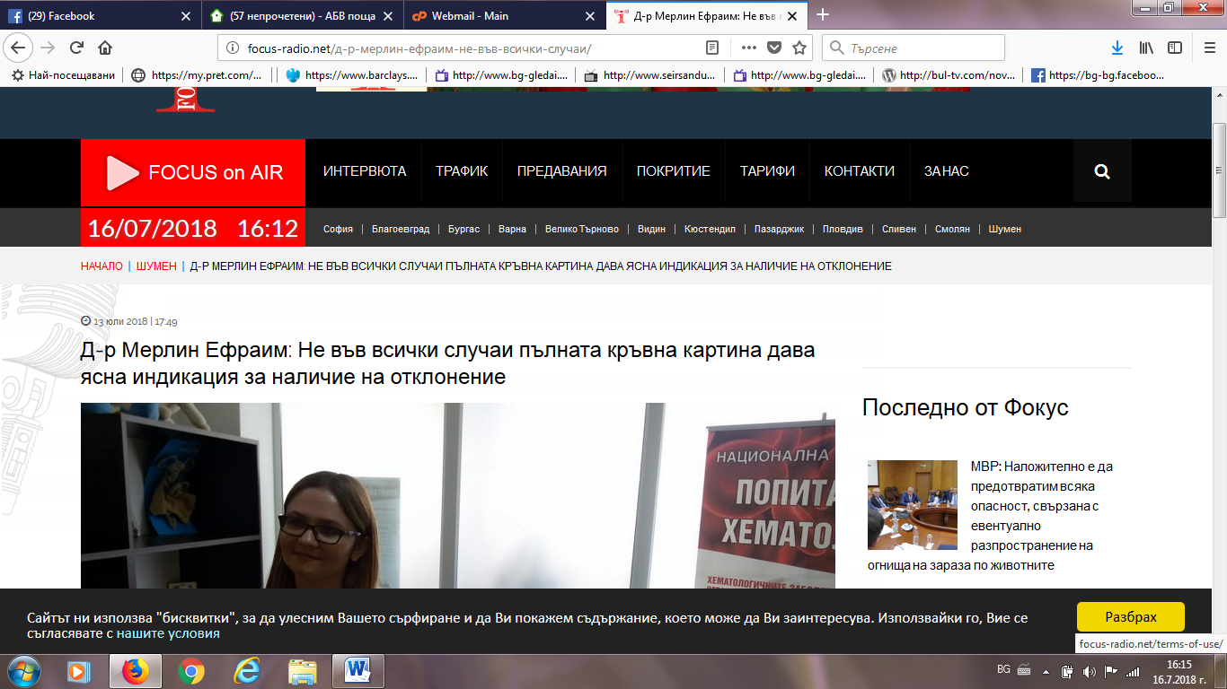

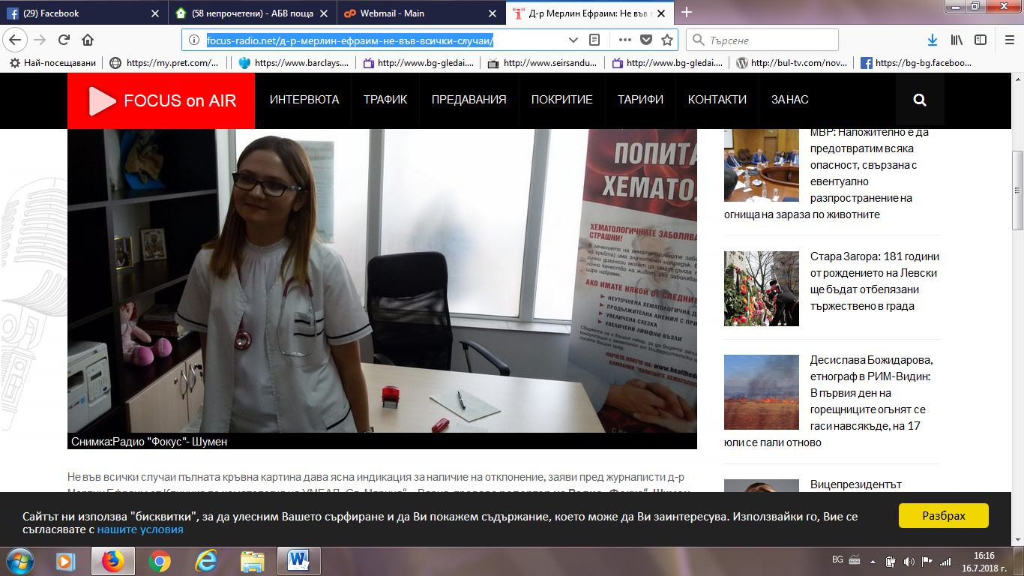
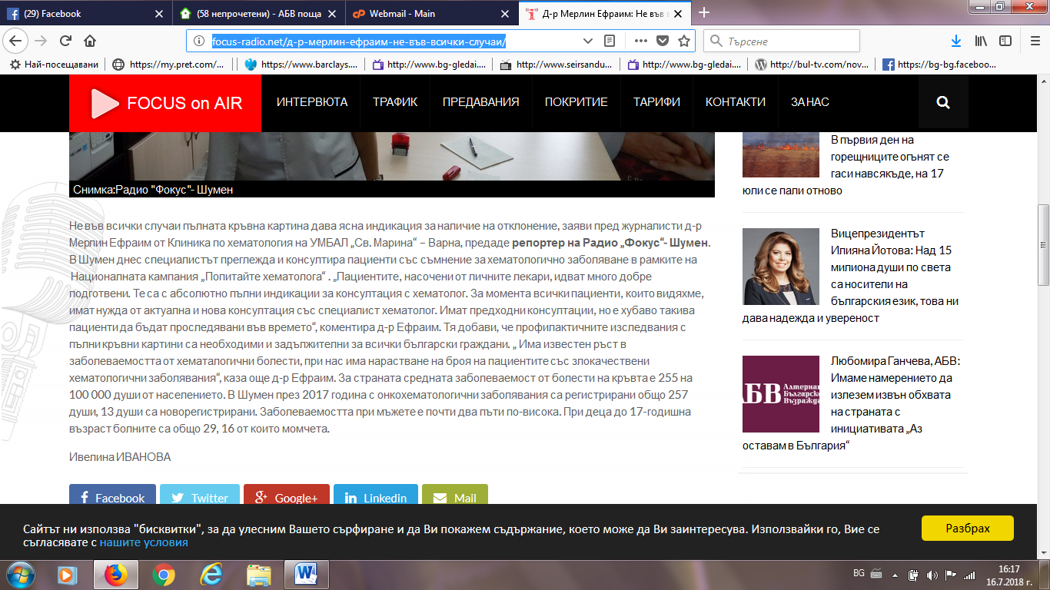

ФЕЙСБУК РАДИО ШУМЕН:
https://www.facebook.com/RadioShumen/
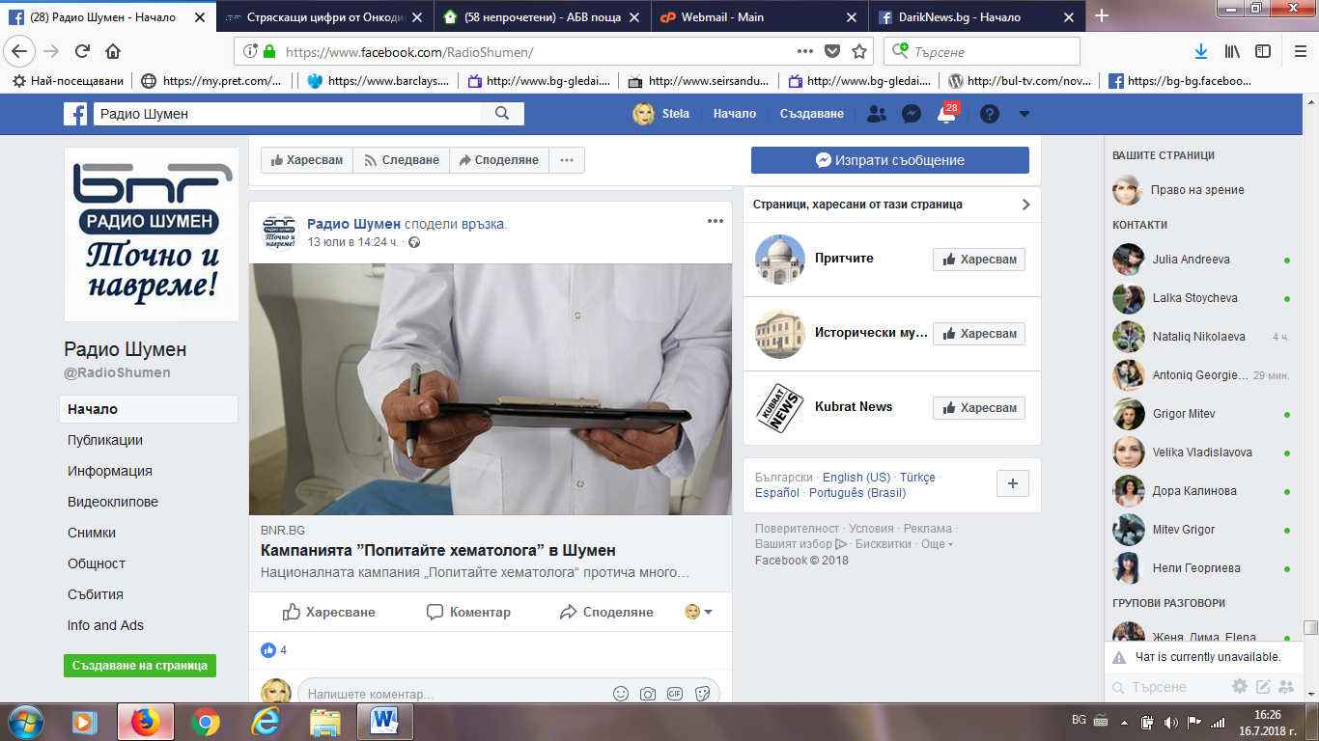
ФЕЙСБУК ШУМЕН:
https://www.facebook.com/groups/Shumen.City/search/?query=%D0%BA%D0%B0%D0%BC%D0%BF%D0%B0%D0%BD%D0%B8%D1%8F%20%D1%85%D0%B5%D0%BC%D0%B0%D1%82%D0%BE%D0%BB%D0%BE%D0%B3%D0%B8%D1%87%D0%BD%D0%B8
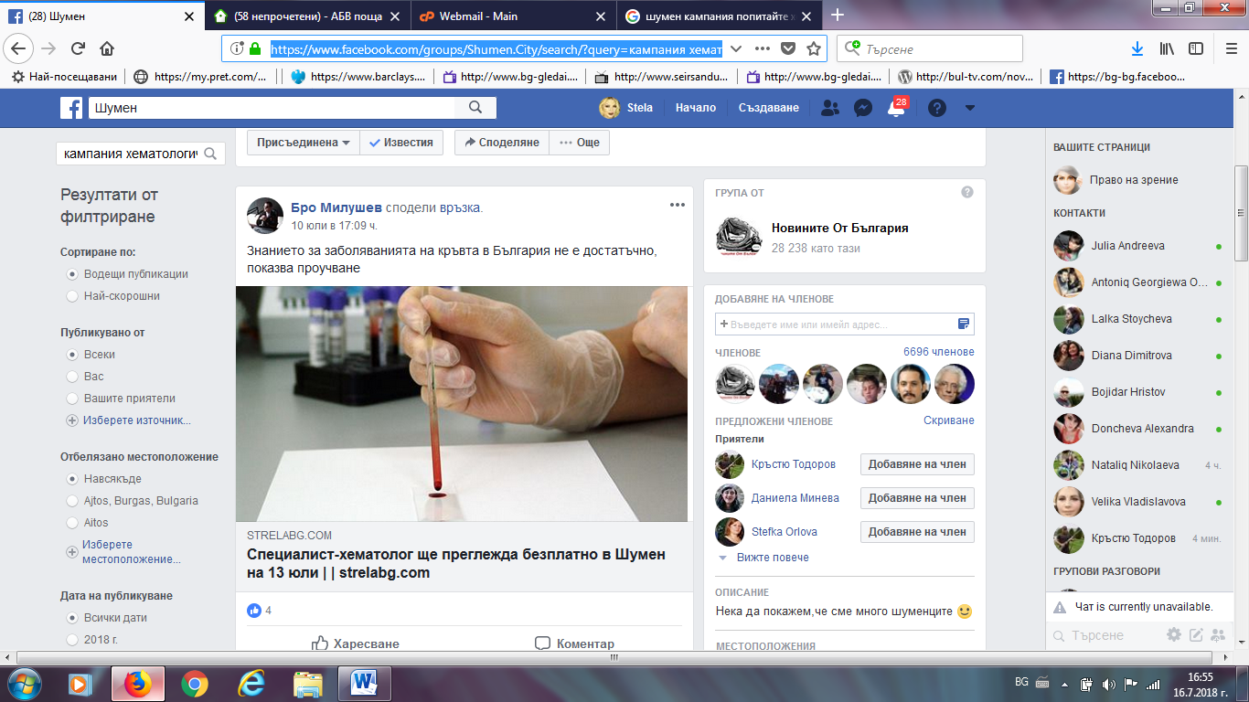

ФЕЙСБУК ШУМЕН ДНЕС:
https://www.facebook.com/groups/ShumenDnes/search/?query=%D0%BF%D0%BE%D0%BF%D0%B8%D1%82%D0%B0%D0%B9%D1%82%D0%B5%20%D1%85%D0%B5%D0%BC%D0%B0%D1%82%D0%BE%D0%BB%D0%BE%D0%B3%D0%B0
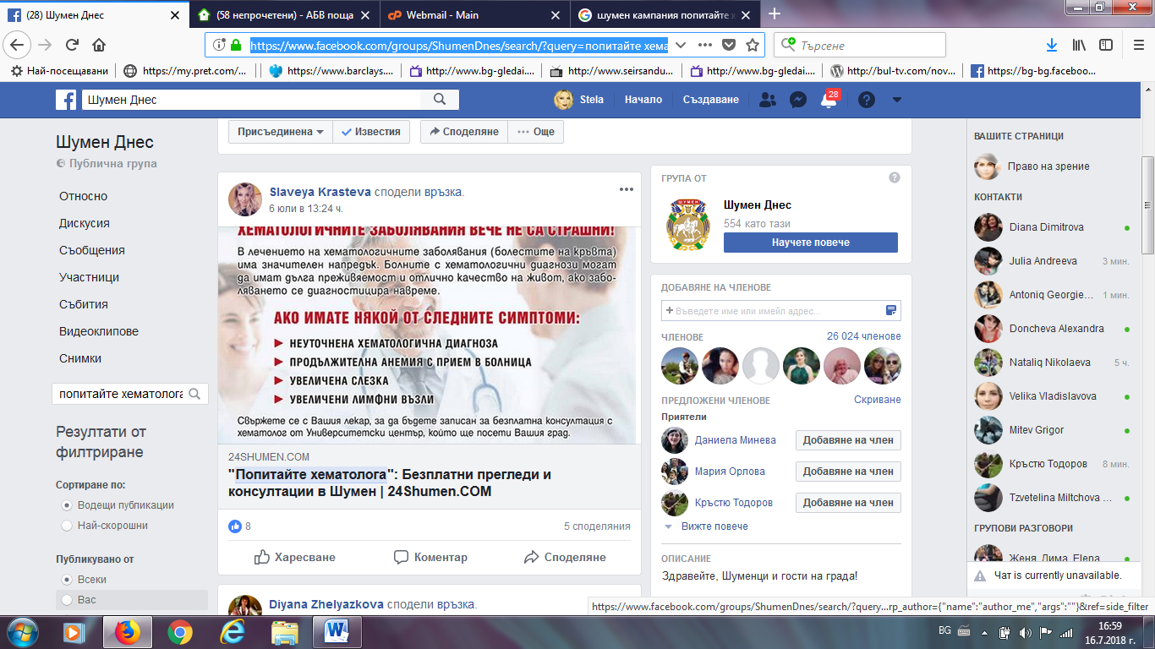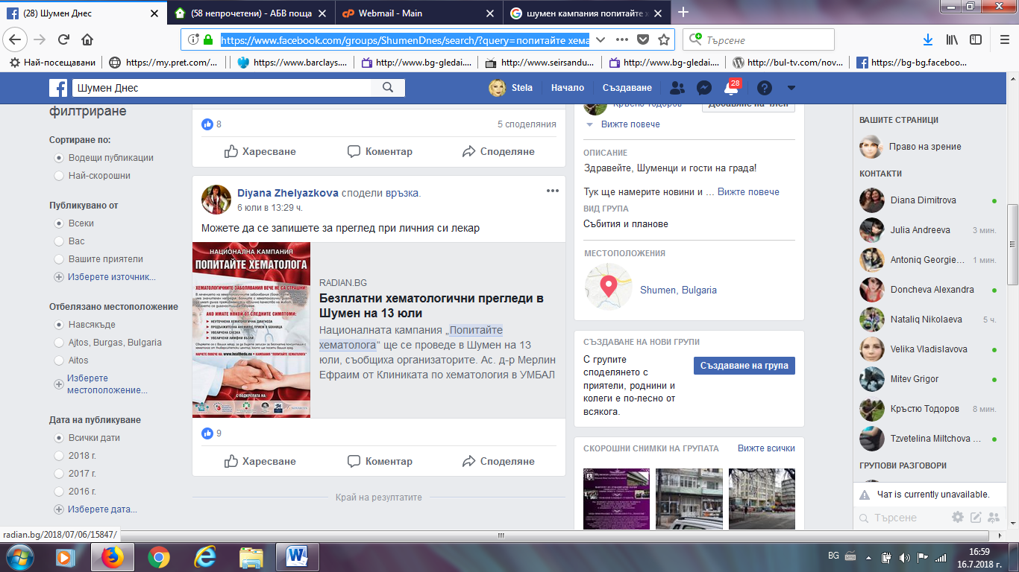

РАДИАН БГ:
http://radian.bg/2018/07/06/15847/
