МЕДИА МОНИТОРИНГ ХЕМАТОЛОГИЧНИ ЗАБОЛЯВАНИЯ – ЯМБОЛ
ЯМБОЛ ПРЕС:
http://yambolpress.bg/%d0%bd%d0%b0%d1%86%d0%b8%d0%be%d0%bd%d0%b0%d0%bb%d0%bd%d0%b0%d1%82%d0%b0-%d0%ba%d0%b0%d0%bc%d0%bf%d0%b0%d0%bd%d0%b8%d1%8f-%d0%bf%d0%be%d0%bf%d0%b8%d1%82%d0%b0%d0%b9%d1%82%d0%b5-%d1%85%d0%b5/
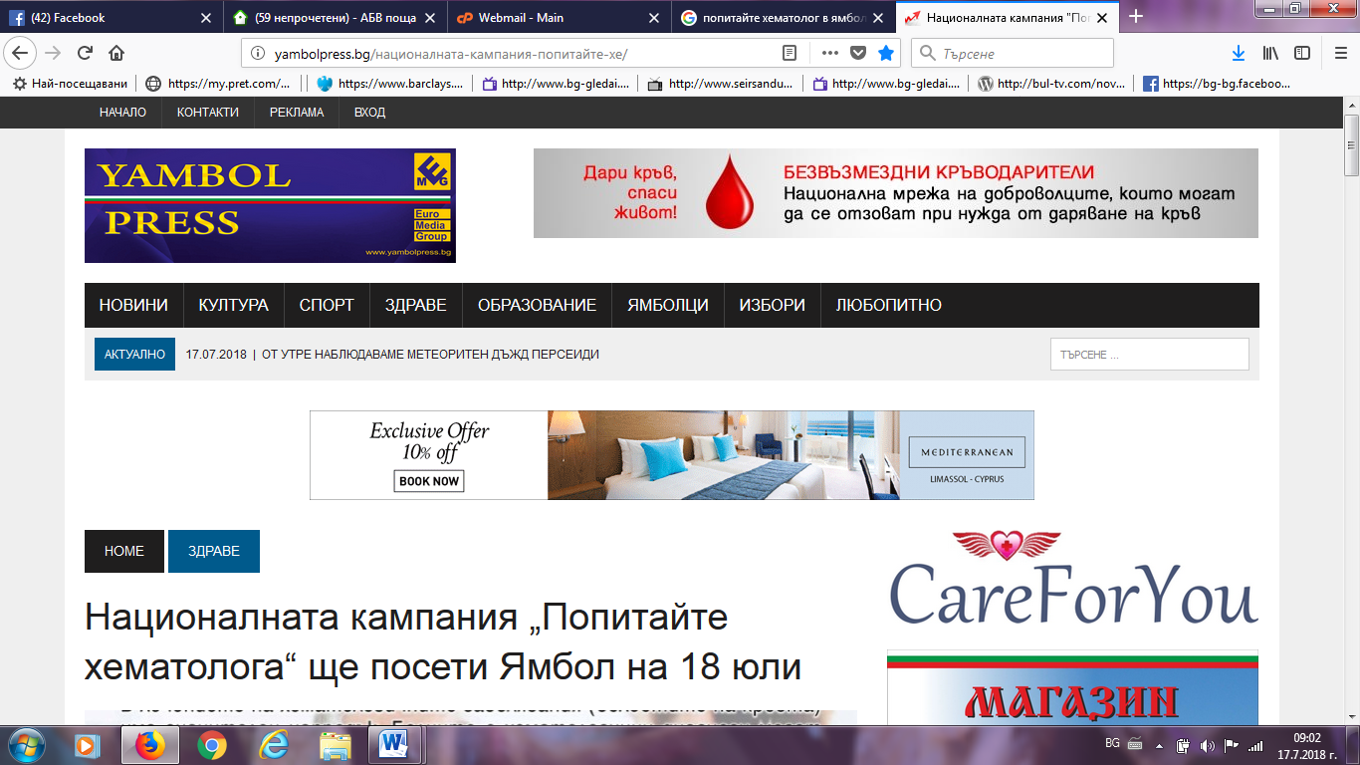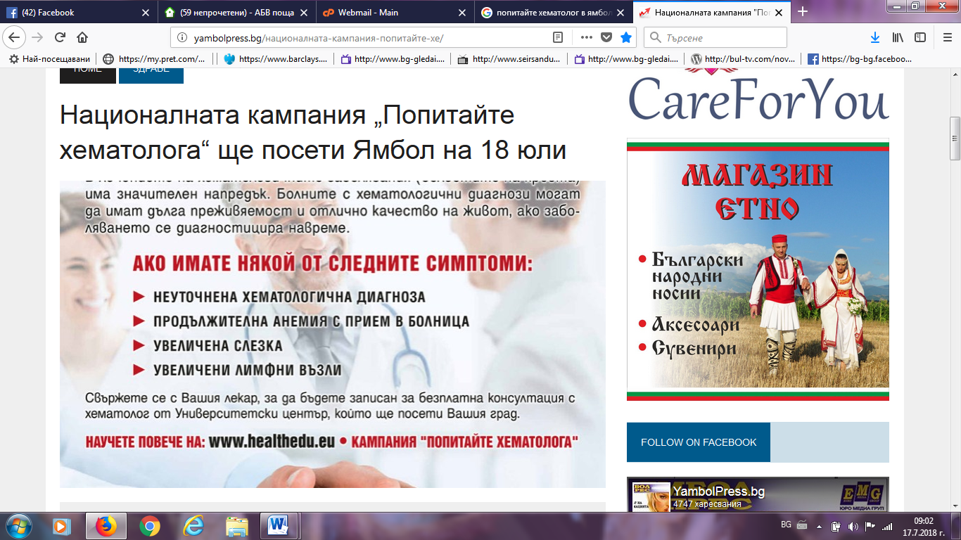

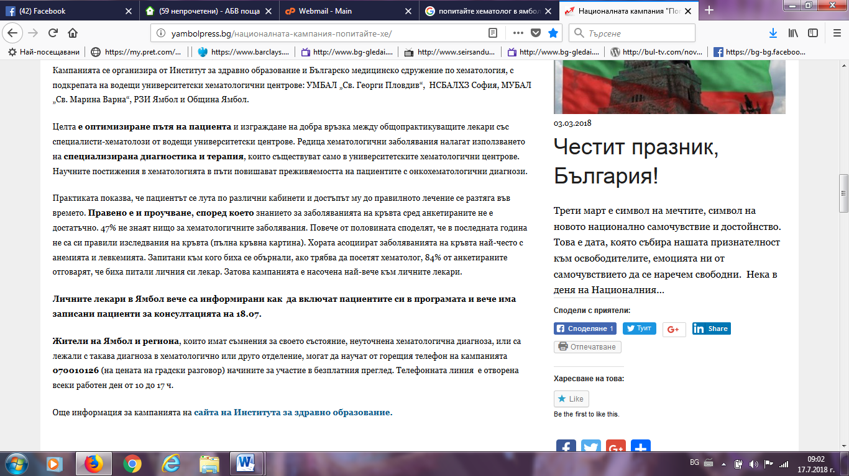
ОБЩИНА ЯМБОЛ:
http://yambol.bg/%D0%BD%D0%BE%D0%B2%D0%B8%D0%BD%D0%B8/%D0%BF%D1%80%D0%B5%D0%B3%D0%BB%D0%B5%D0%B4/4001
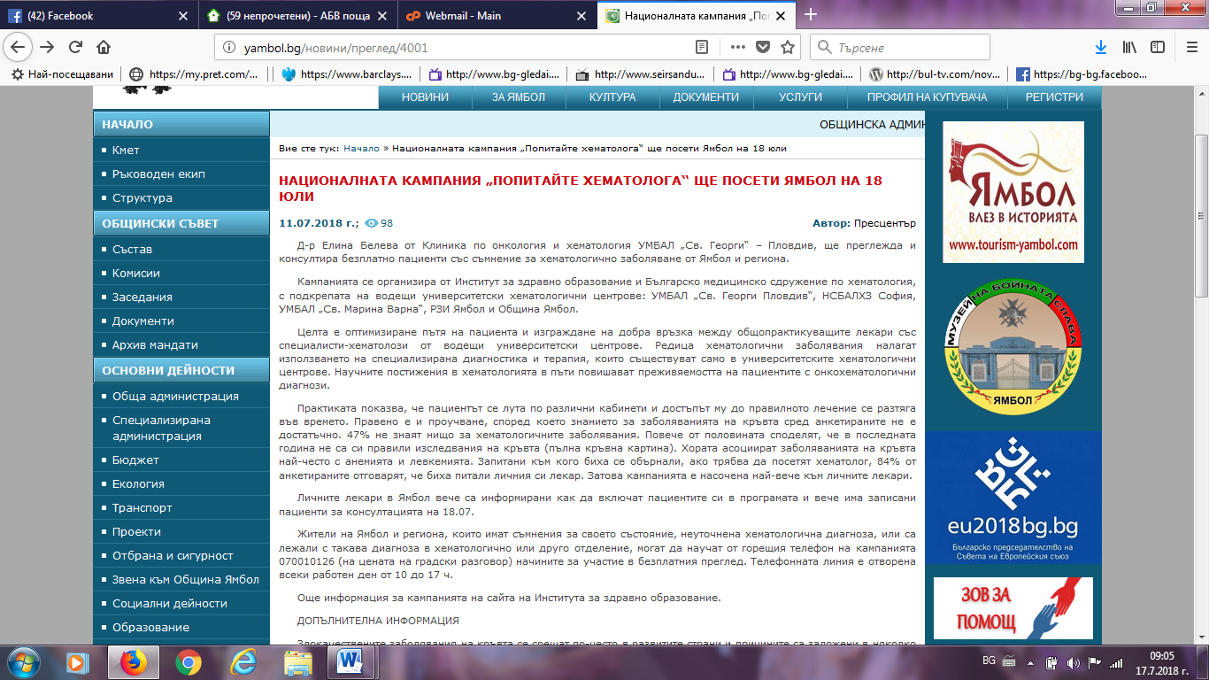

РАДИО 999:
http://radio999bg.com/?id=32118
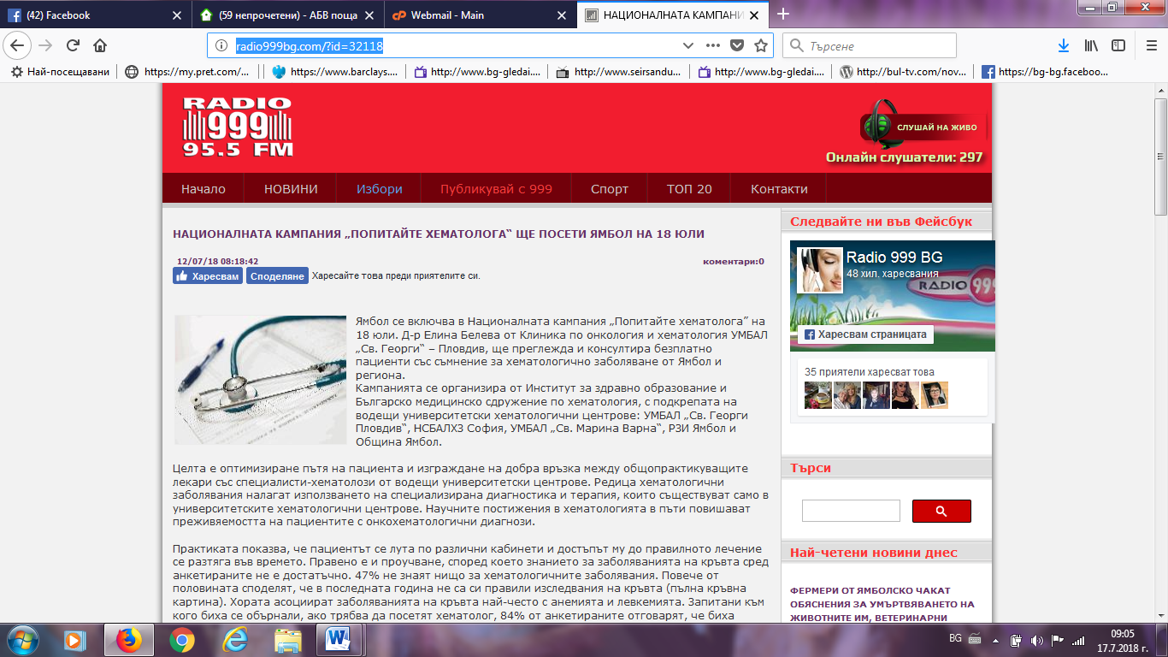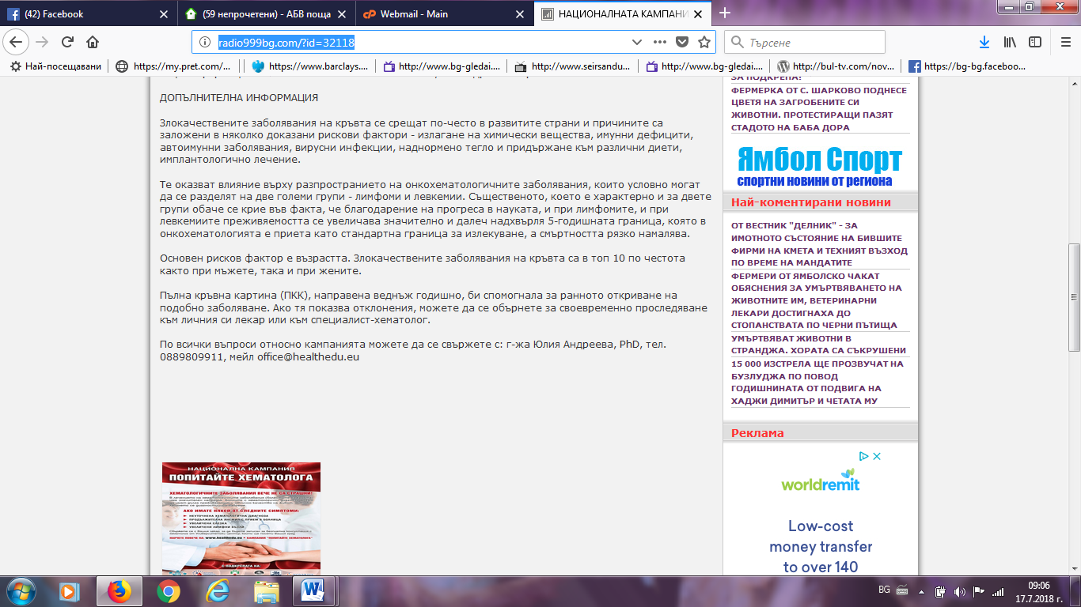

ФЕЙСБУК ЯМБОЛ:
https://www.facebook.com/pg/%D0%AF%D0%BC%D0%B1%D0%BE%D0%BB-Yambol-257920550585/posts/
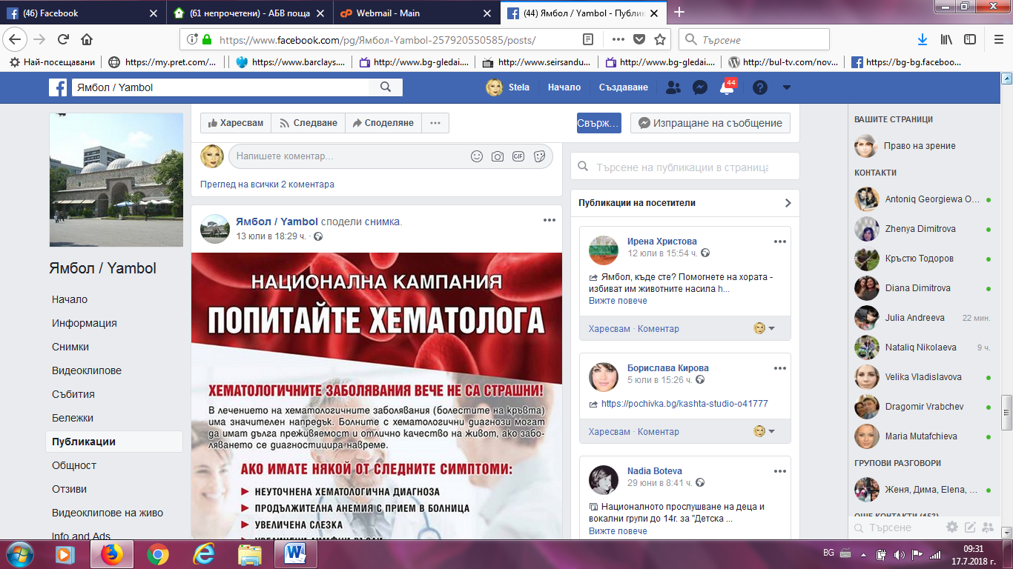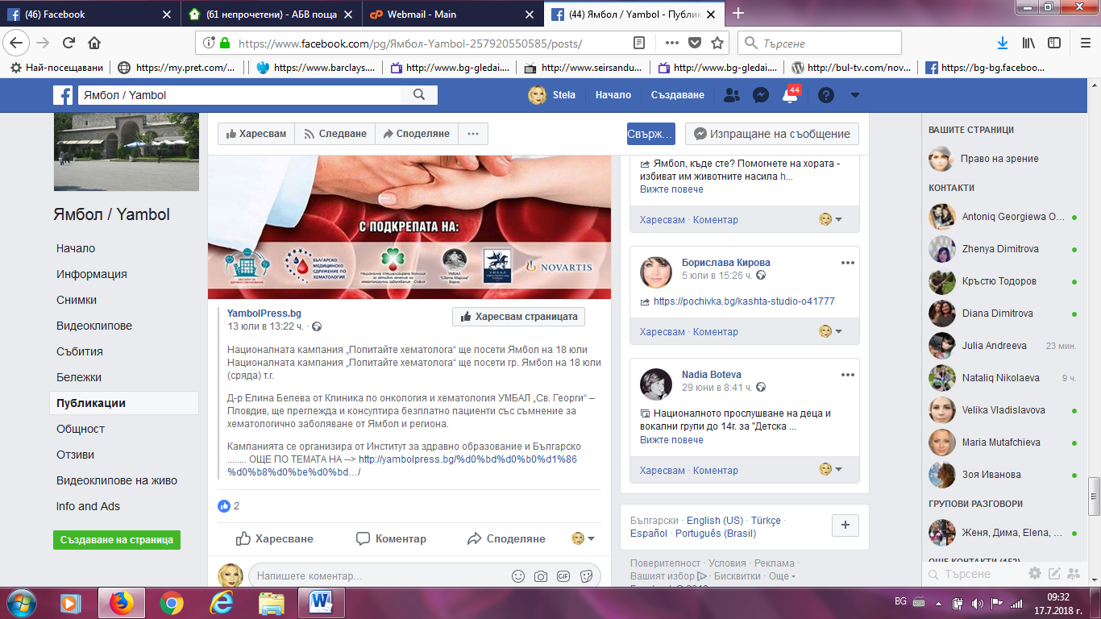

ЯМБОЛ НЮЗ:
http://yambolnews.net/obshtina-yambol/item/30416-popitaite-bezplatno-hematologa-na-18-yuli-v-yambol
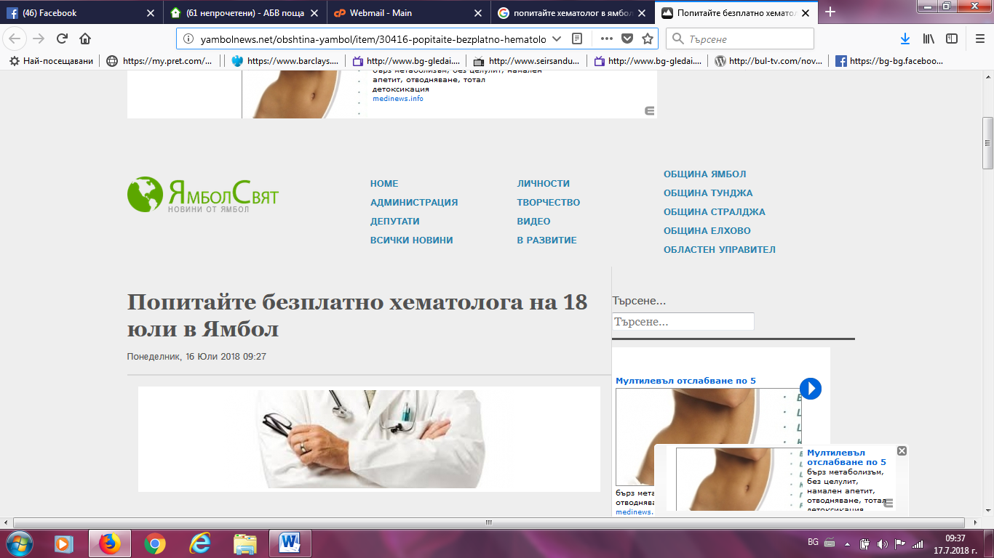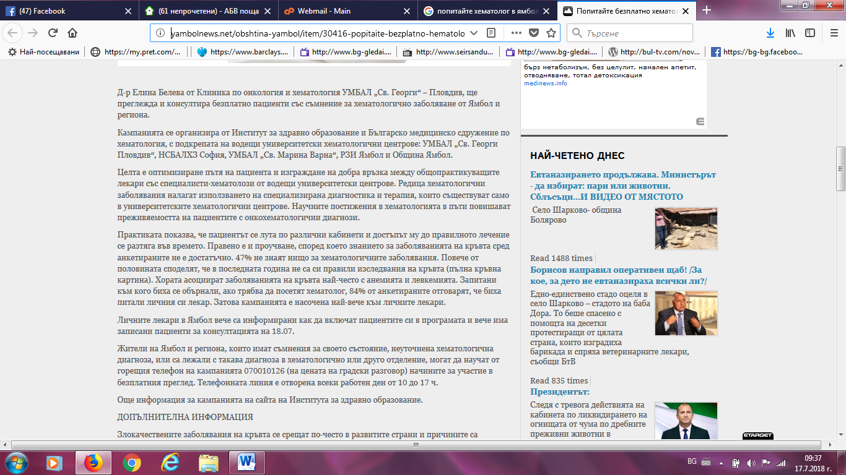

ЕЛХОВО НЮЗ:
https://elhovo.news/?p=105056
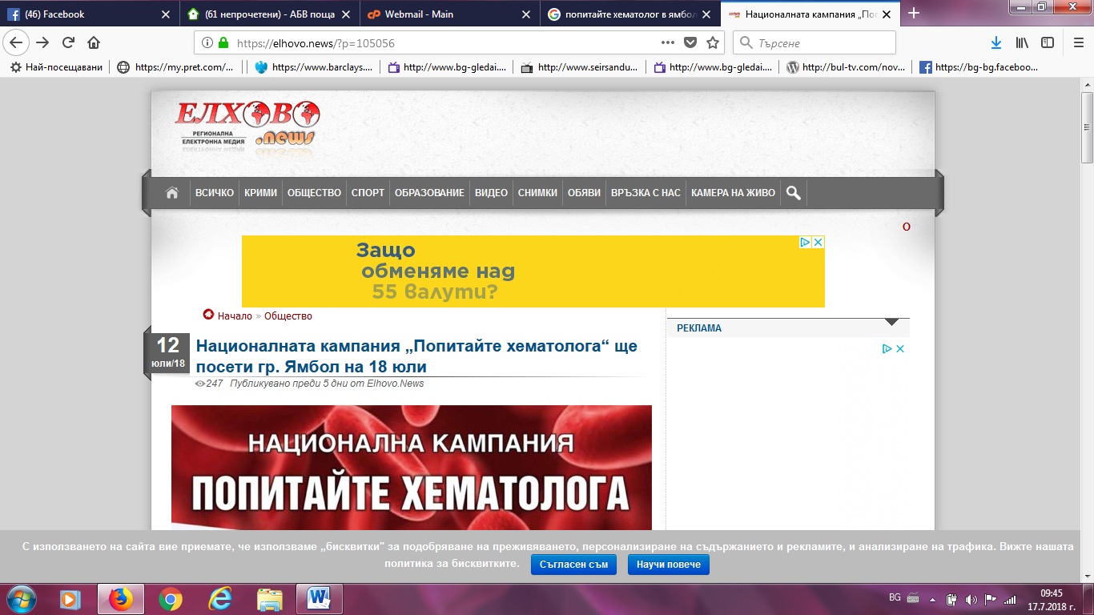
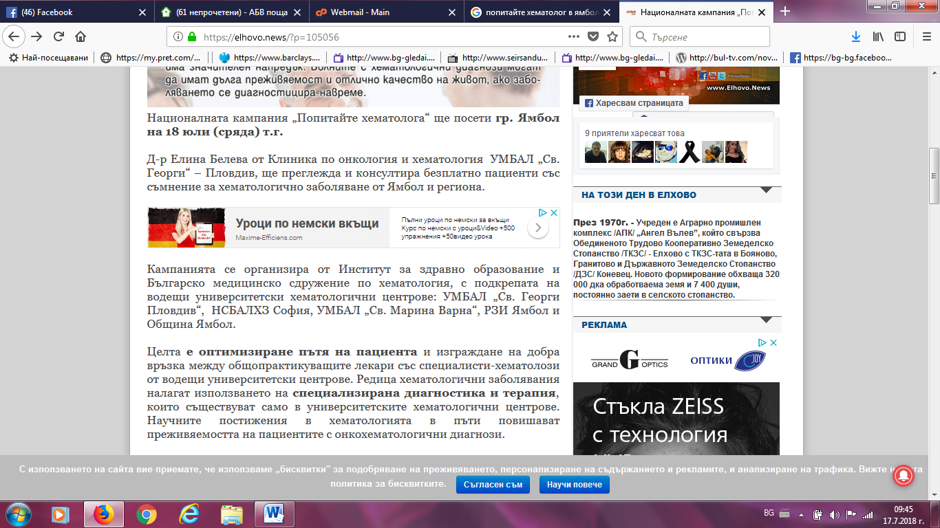

TWITTER:
https://twitter.com/koravko?lang=bg
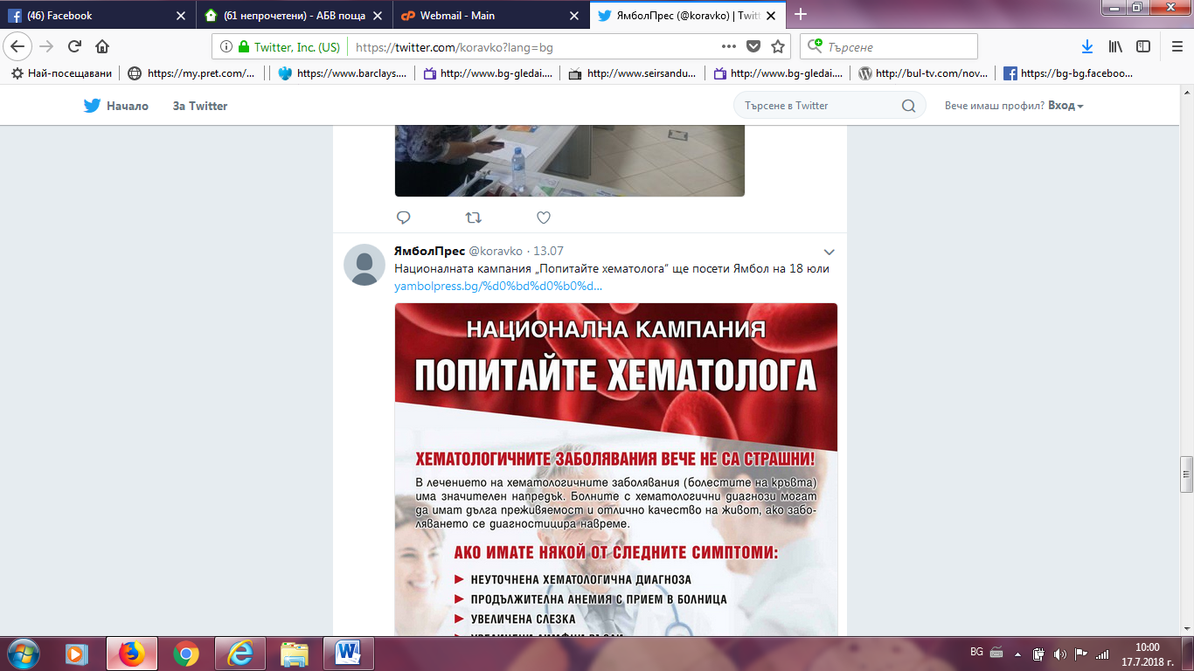
ДЕЛНИК:
http://delnik.net/%D0%BD%D0%B0%D1%86%D0%B8%D0%BE%D0%BD%D0%B0%D0%BB%D0%BD%D0%B0%D1%82%D0%B0-%D0%BA%D0%B0%D0%BC%D0%BF%D0%B0%D0%BD%D0%B8%D1%8F-%D0%BF%D0%BE%D0%BF%D0%B8%D1%82%D0%B0%D0%B9-%D1%85%D0%B5%D0%BC%D0%B0%D1%82/
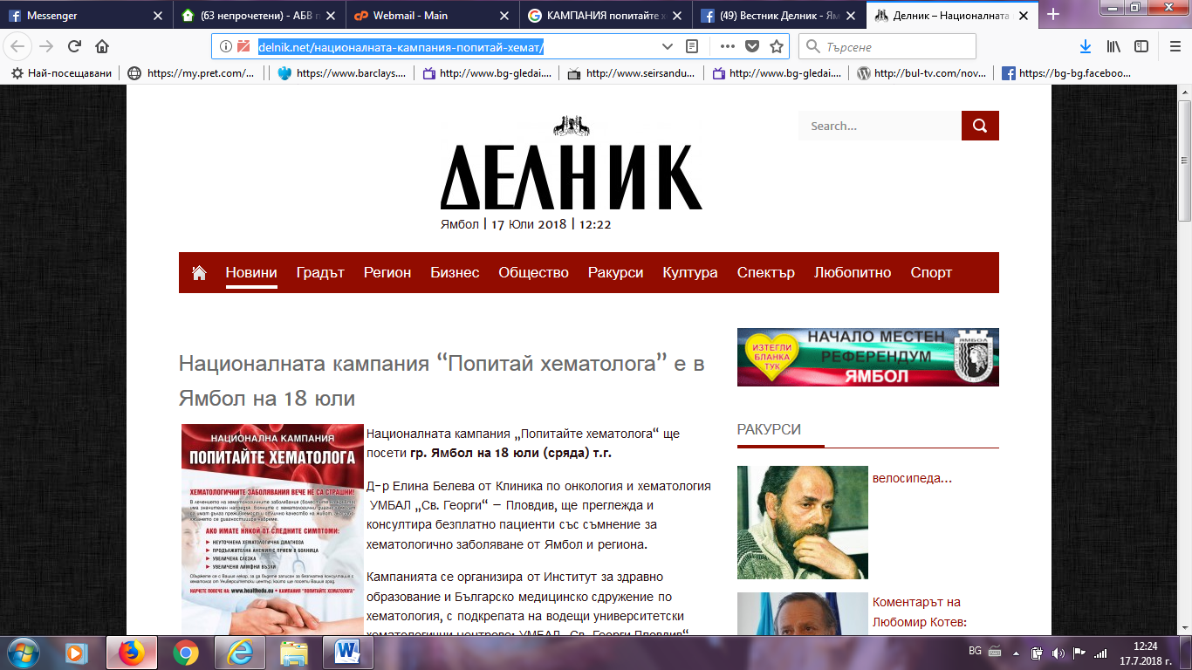

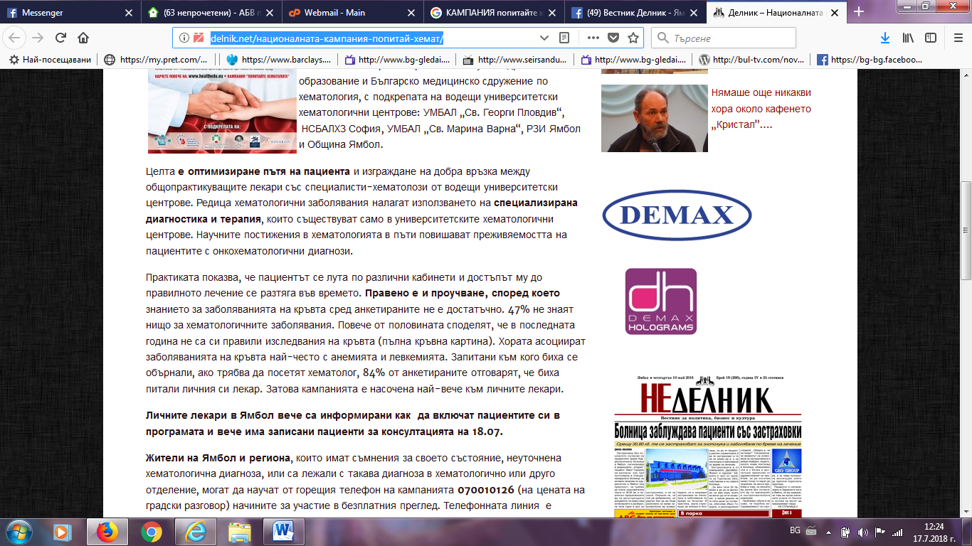
ФЕЙСБУК ВЕСТНИК ДЕЛНИК ЯМБОЛ:
https://www.facebook.com/vestnikdelnik/
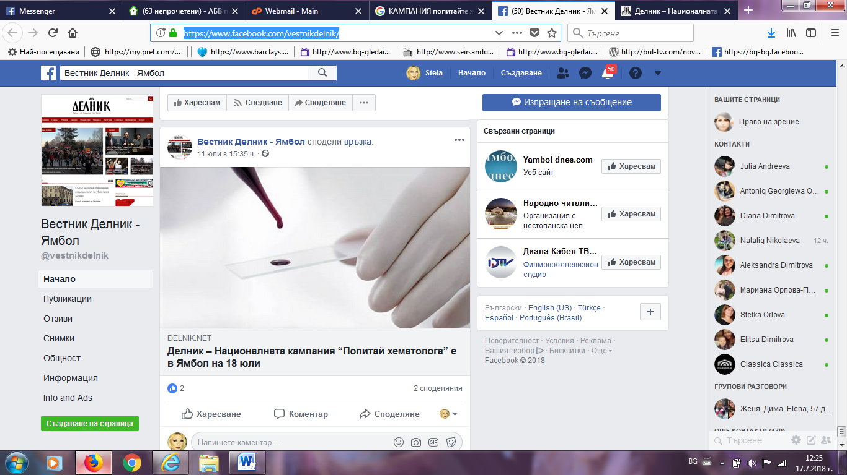

ФЕЙСБУК ДИАНА КАБЕЛ ЯМБОЛ:
https://www.facebook.com/%D0%94%D0%B8%D0%B0%D0%BD%D0%B0-%D0%9A%D0%B0%D0%B1%D0%B5%D0%BB-%D0%A2%D0%92-%D0%9E%D0%9E%D0%94-385362598210889/
