МЕДИА МОНИТОРИНГ ХЕМАТОЛОГИЧНИ ЗАБОЛЯВАНИЯ – СЛИВЕН
СЛИВЕН НЕТ:
http://new.sliven.net/sys/news/index.php?id=275592
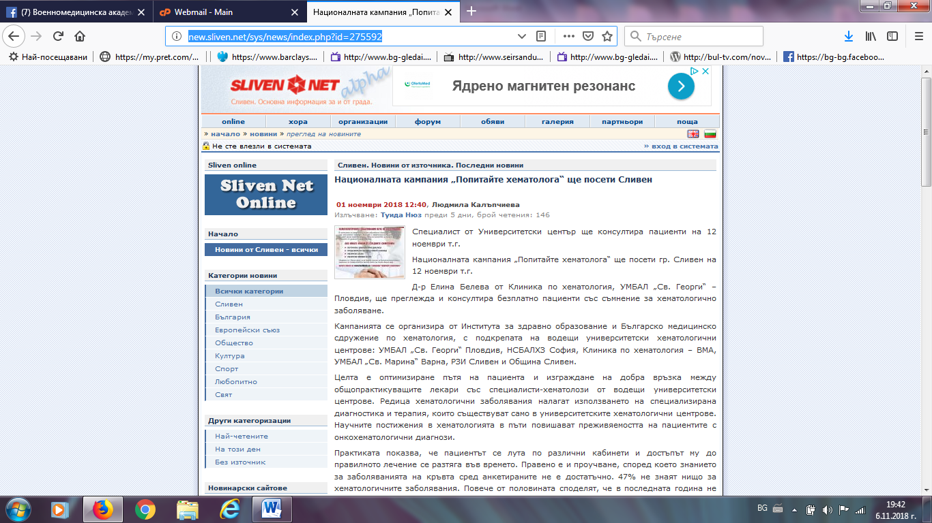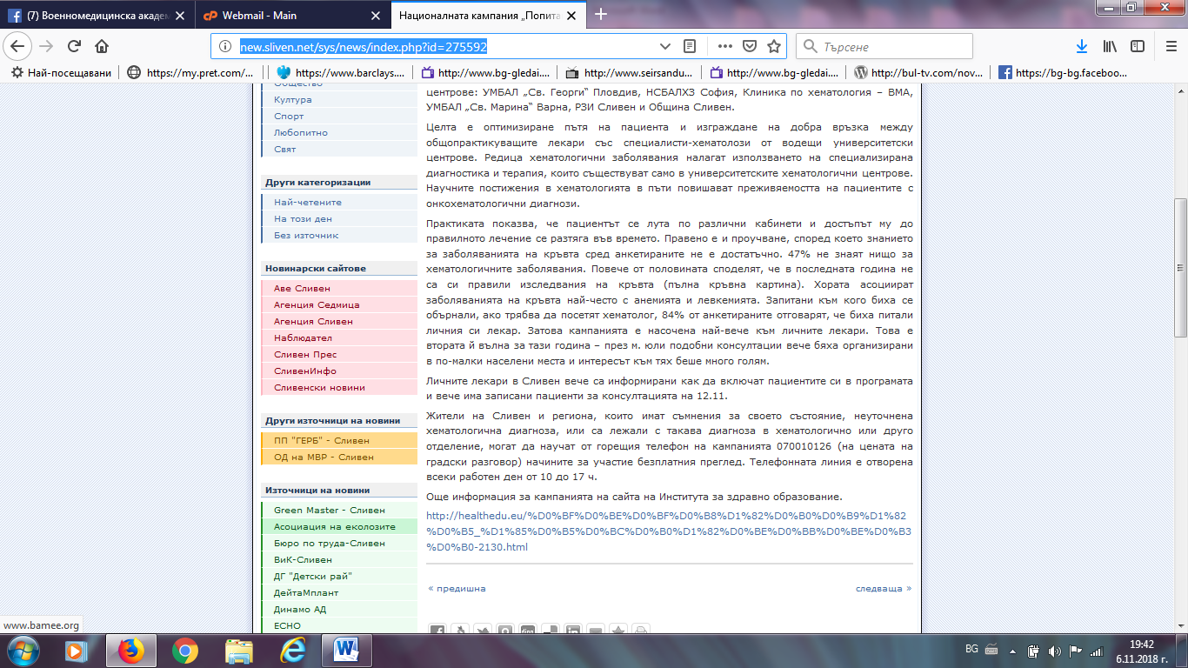

НАБЛЮДАТЕЛ:
http://www.nabludatel.bg//index.php?id=275566
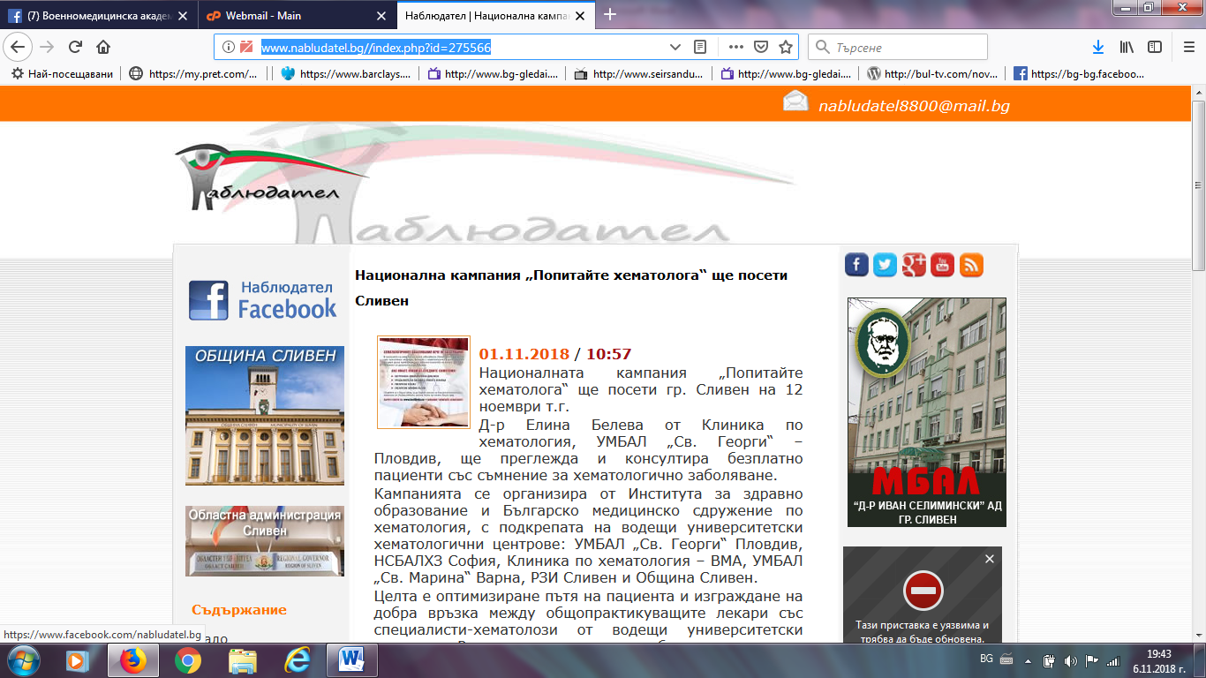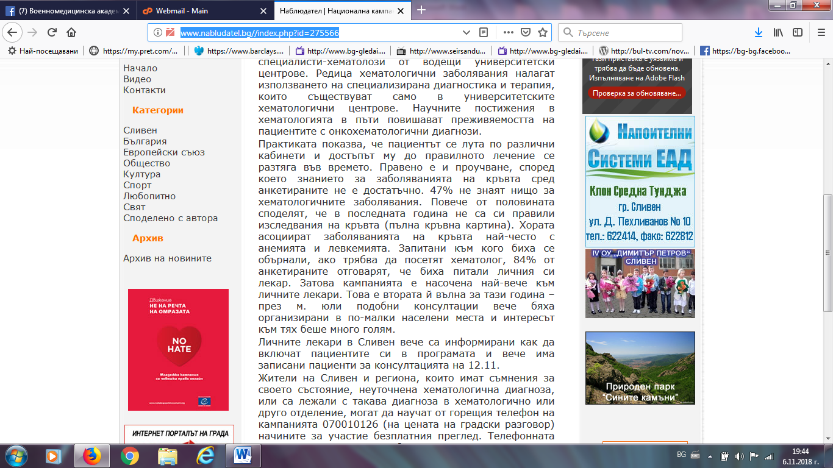

СЛИВЕН ДНЕС И УТРЕ ФЕЙСБУК:
https://www.facebook.com/groups/336876376500858/search/?query=%D0%9F%D0%9E%D0%9F%D0%98%D0%A2%D0%90%D0%99%D0%A2%D0%95%20%D0%A5%D0%95%D0%9C%D0%90%D0%A2%D0%9E%D0%9B%D0%9E%D0%93%D0%90
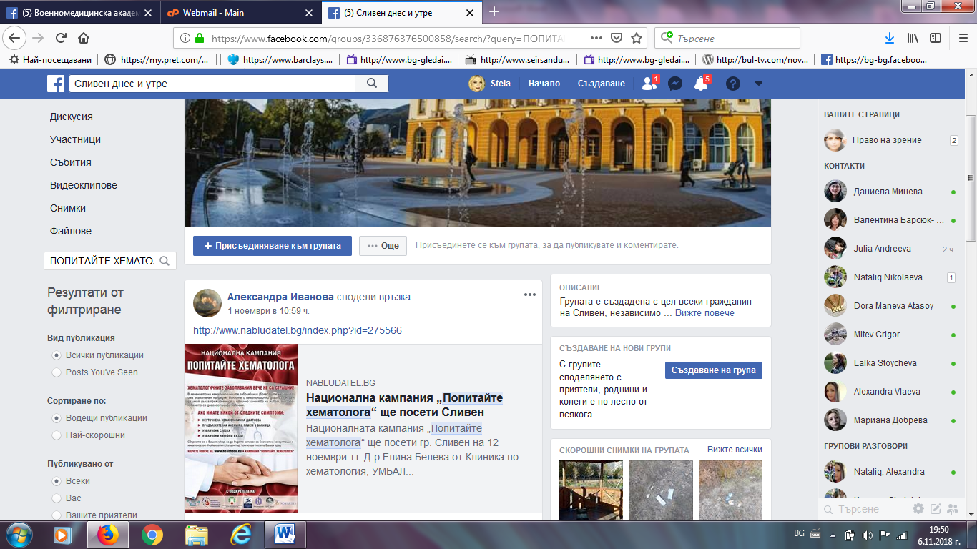
СЛИВЕН ПОСТ: https://slivenpost.bg/%D0%B8-%D0%B2-%D1%81%D0%BB%D0%B8%D0%B2%D0%B5%D0%BD-%D1%89%D0%B5-%D0%BF%D1%80%D0%B5%D0%B3%D0%BB%D0%B5%D0%B6%D0%B4%D0%B0%D1%82-%D0%B1%D0%B5%D0%B7%D0%BF%D0%BB%D0%B0%D1%82%D0%BD%D0%BE-%D0%BF%D0%B0%D1%86/
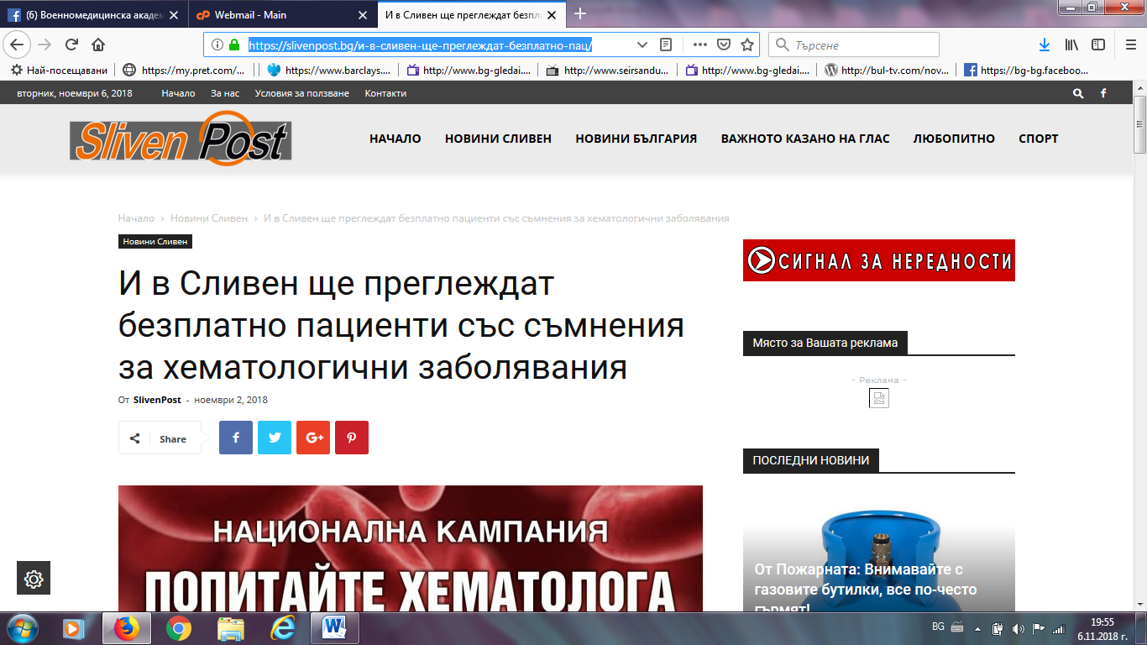
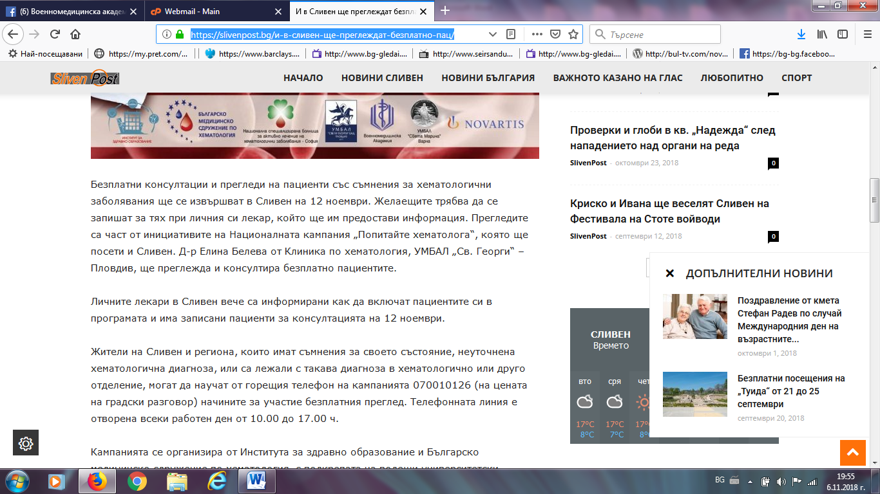
ОБЩИНА СЛИВЕН:
http://mun.sliven.bg/news/275995
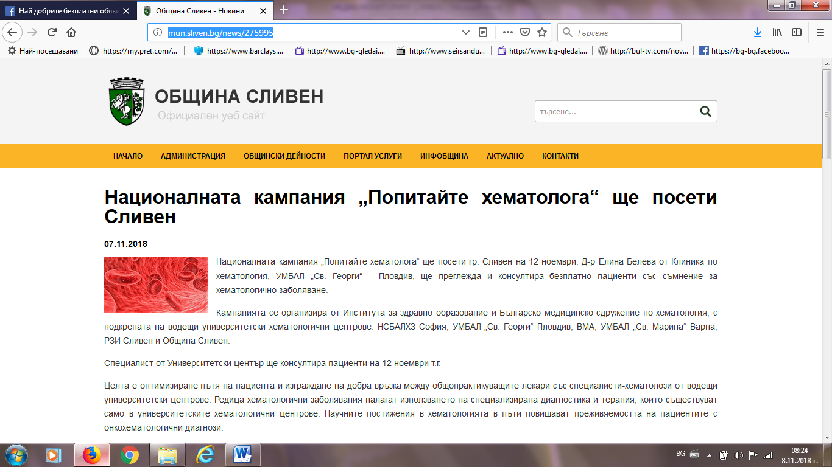

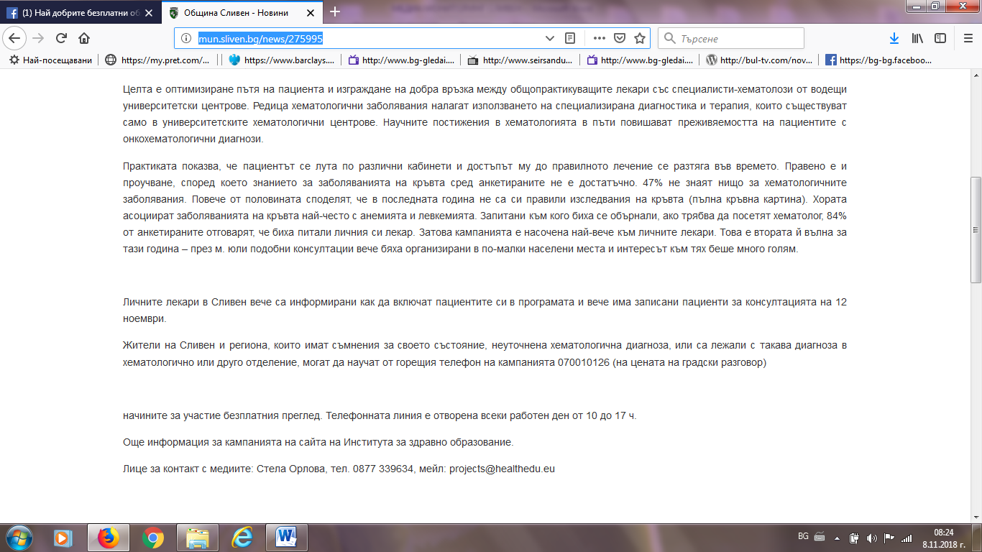
СЛИВЕН ИНФО:
https://sliveninfo.bg/%D0%BD%D0%B0%D1%86%D0%B8%D0%BE%D0%BD%D0%B0%D0%BB%D0%BD%D0%B0%D1%82%D0%B0-%D0%BA%D0%B0%D0%BC%D0%BF%D0%B0%D0%BD%D0%B8%D1%8F-%D0%BF%D0%BE%D0%BF%D0%B8%D1%82%D0%B0%D0%B9%D1%82%D0%B5-%D1%85%D0%B5%D0%BC/
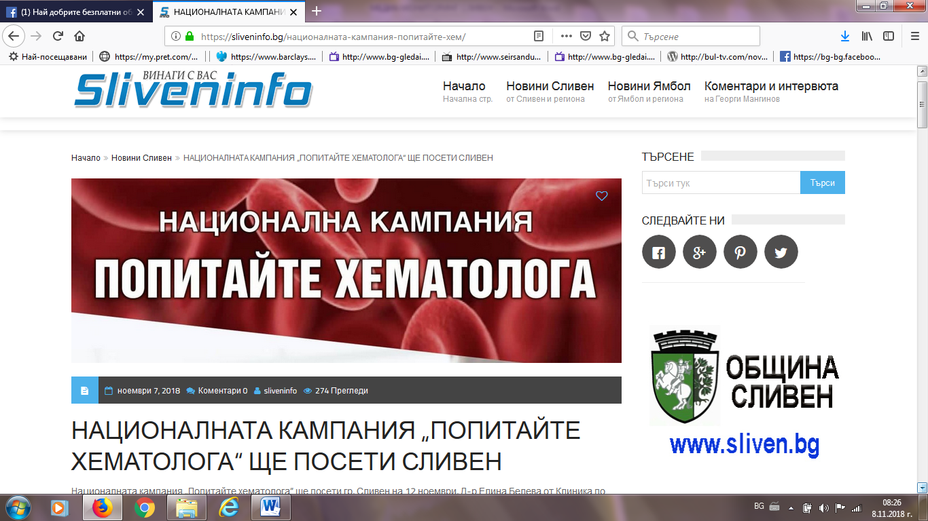

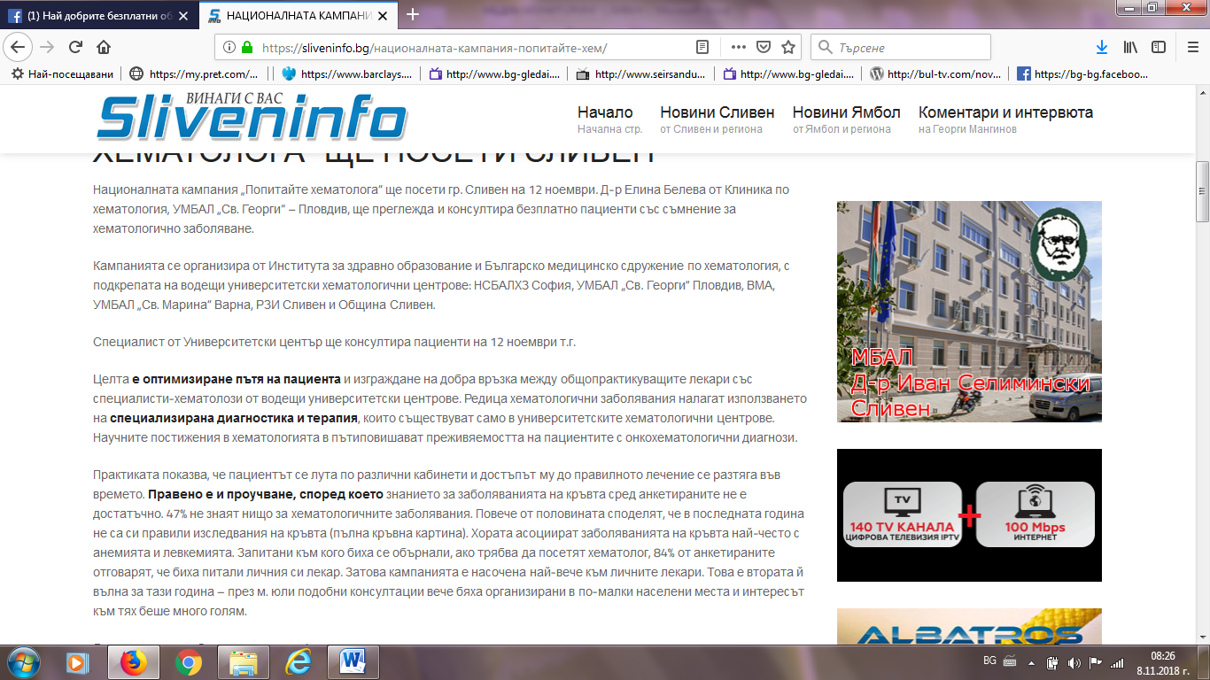
СЛИВЕН ПРЕС:
http://www.slivenpress.bg/novini-sliven/27452-%D0%91%D0%95%D0%97%D0%9F%D0%9B%D0%90%D0%A2%D0%9D%D0%98-%D0%A5%D0%95%D0%9C%D0%90%D0%A2%D0%9E%D0%9B%D0%9E%D0%93%D0%98%D0%A7%D0%9D%D0%98-%D0%9F%D0%A0%D0%95%D0%93%D0%9B%D0%95%D0%94%D0%98-%D0%92-%D0%A1%D0%9B%D0%98%D0%92%D0%95%D0%9D-%D0%9D%D0%90-12-%D0%9D%D0%9E%D0%95%D0%9C%D0%92%D0%A0%D0%98
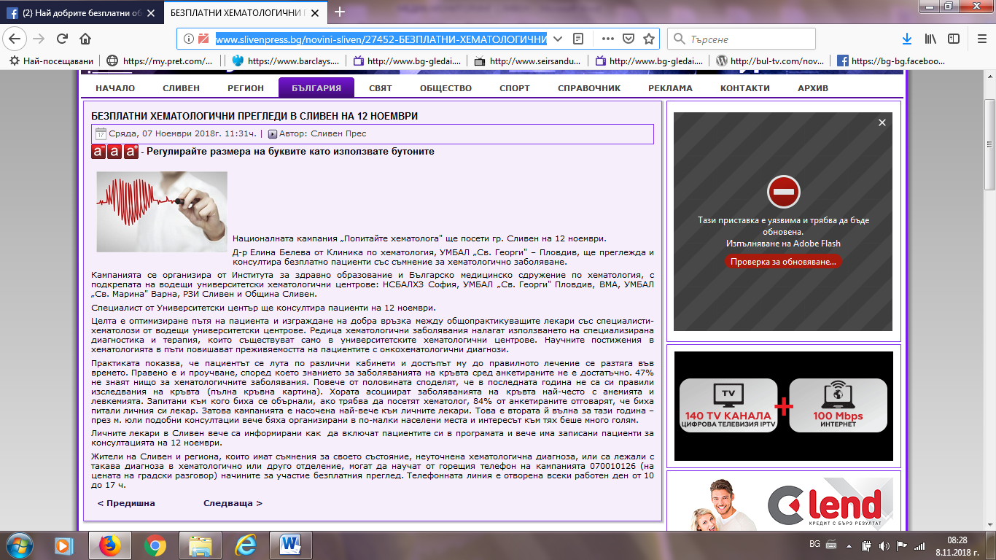

СЛИВЕН НЮЗ: http://sliven-news.com/index.php/sliven/13928-%D0%BD%D0%B0%D1%86%D0%B8%D0%BE%D0%BD%D0%B0%D0%BB%D0%BD%D0%B0%D1%82%D0%B0-%D0%BA%D0%B0%D0%BC%D0%BF%D0%B0%D0%BD%D0%B8%D1%8F-%E2%80%9E%D0%BF%D0%BE%D0%BF%D0%B8%D1%82%D0%B0%D0%B9%D1%82%D0%B5-%D1%85%D0%B5%D0%BC%D0%B0%D1%82%D0%BE%D0%BB%D0%BE%D0%B3%D0%B0%E2%80%9C-%D1%89%D0%B5-%D0%BF%D0%BE%D1%81%D0%B5%D1%82%D0%B8-%D1%81%D0%BB%D0%B8%D0%B2%D0%B5%D0%BD.html
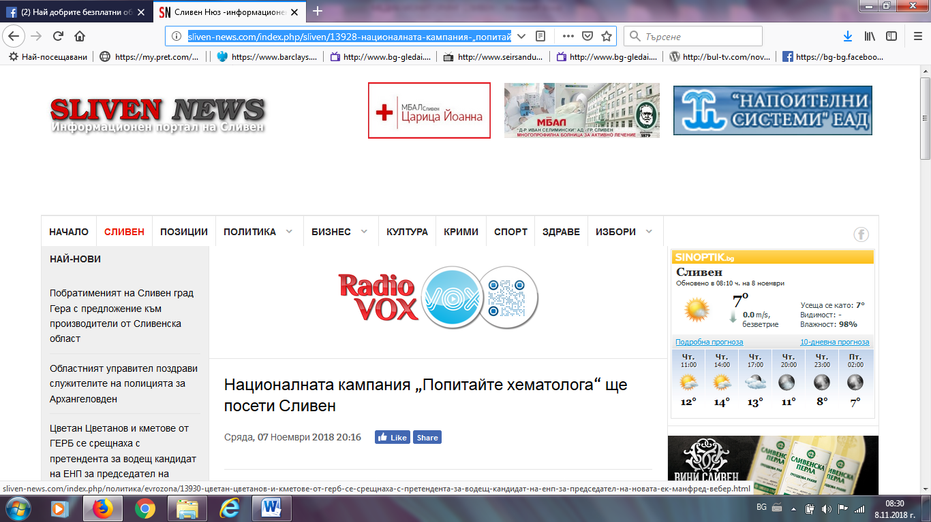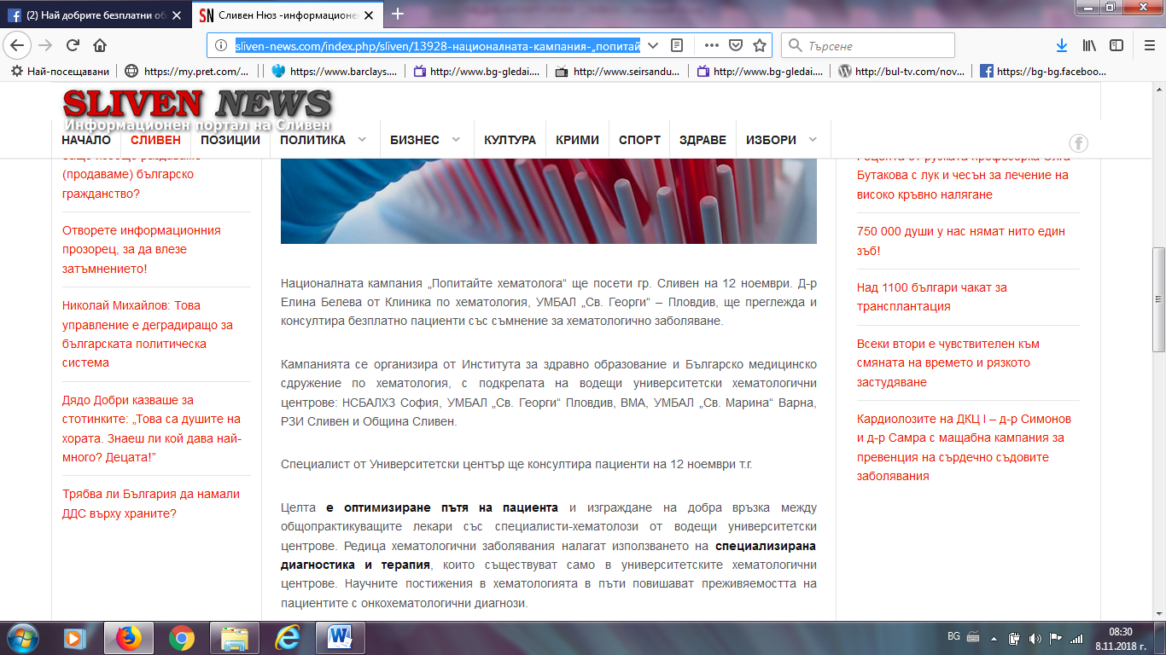

БУЛБОКС:
http://bulbox.net/regioni-sliven/7005554/
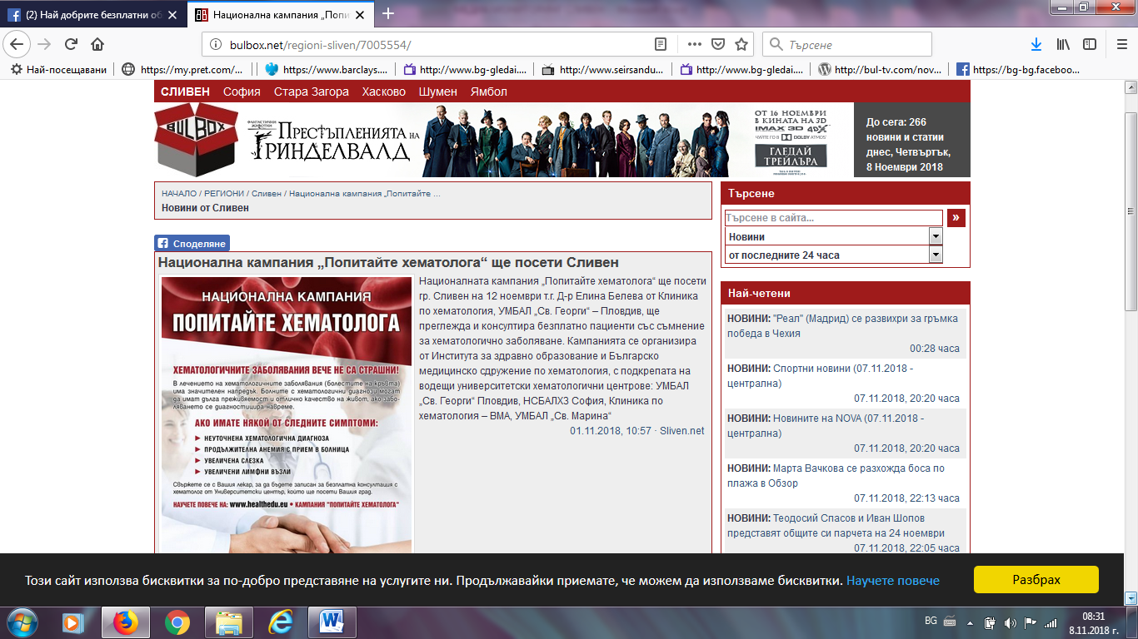

БНР:
http://bnr.bg/burgas/post/101041830/popitaite-hematologa-s-konsultacii-i-v-sliven
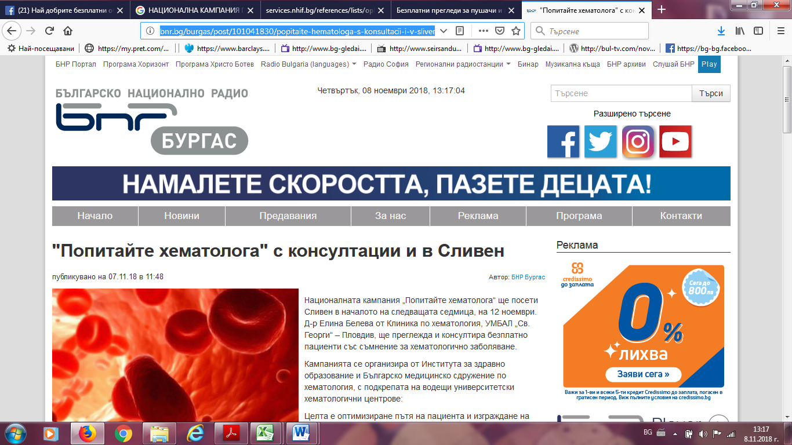

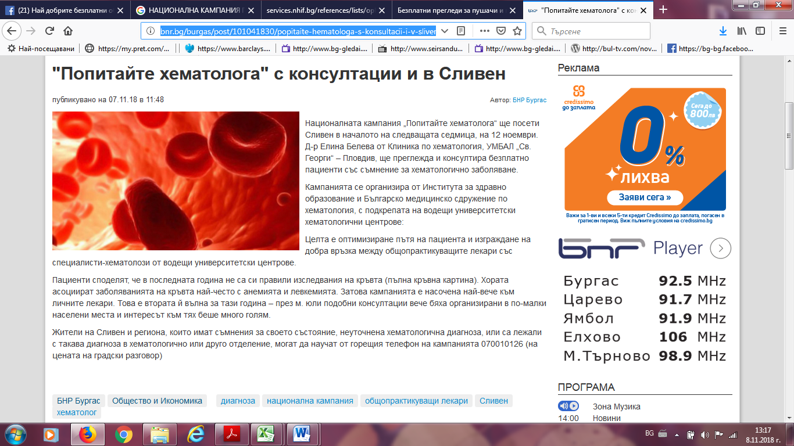
ТРЕТА ВЪЗРАСТ:
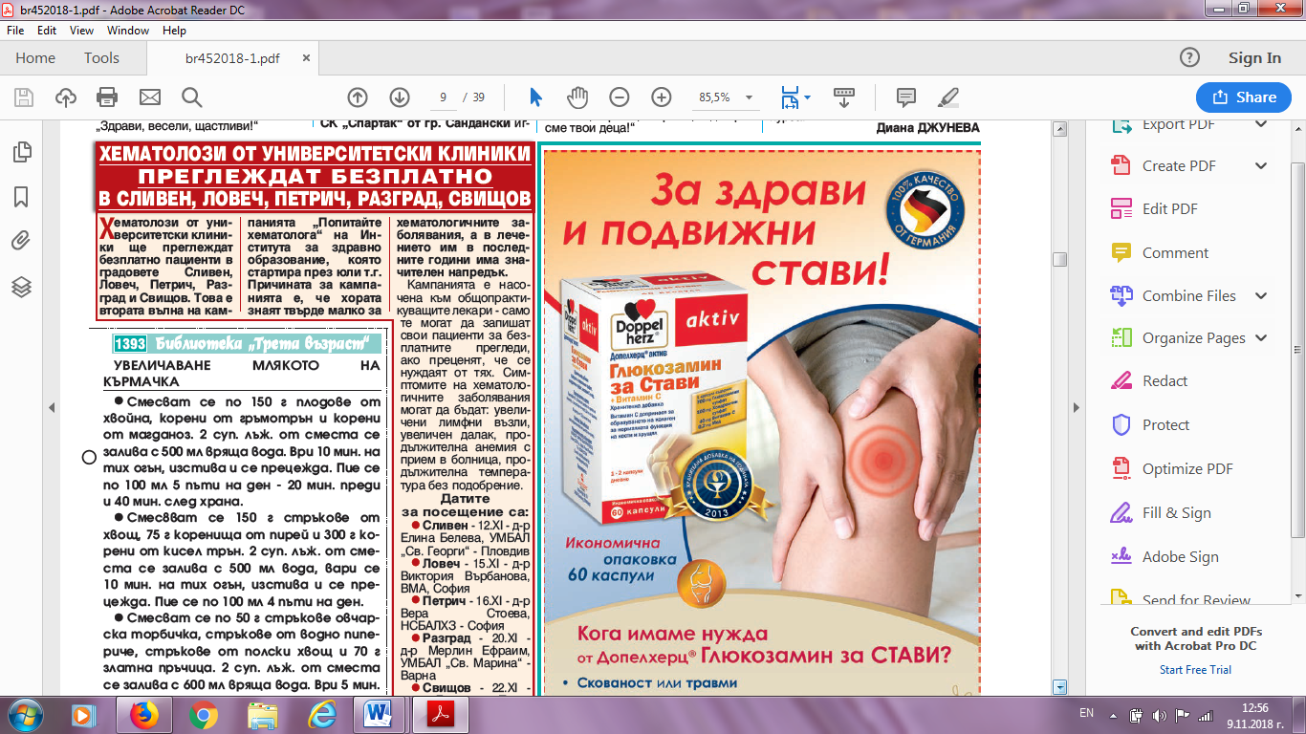

ФРАМАР:
https://media.framar.bg/%D0%B7%D0%B4%D1%80%D0%B0%D0%B2%D0%BD%D0%B8-%D0%BD%D0%BE%D0%B2%D0%B8%D0%BD%D0%B8/%D0%B5%D0%BA%D0%B8%D0%BF%D1%8A%D1%82-%D0%BD%D0%B0-%D0%BD%D0%B0%D1%86%D0%B8%D0%BE%D0%BD%D0%B0%D0%BB%D0%BD%D0%B0%D1%82%D0%B0-%D0%BA%D0%B0%D0%BC%D0%BF%D0%B0%D0%BD%D0%B8%D1%8F-%D0%BF%D0%BE%D0%BF%D0%B8%D1%82%D0%B0%D0%B9%D1%82%D0%B5-%D1%85%D0%B5%D0%BC%D0%B0%D1%82%D0%BE%D0%BB%D0%BE%D0%B3%D0%B0-%D0%BF%D1%80%D0%B5%D0%B3%D0%BB%D0%B5%D0%B6%D0%B4%D0%B0-%D0%B2-%D1%81%D0%BB%D0%B8%D0%B2%D0%B5%D0%BD
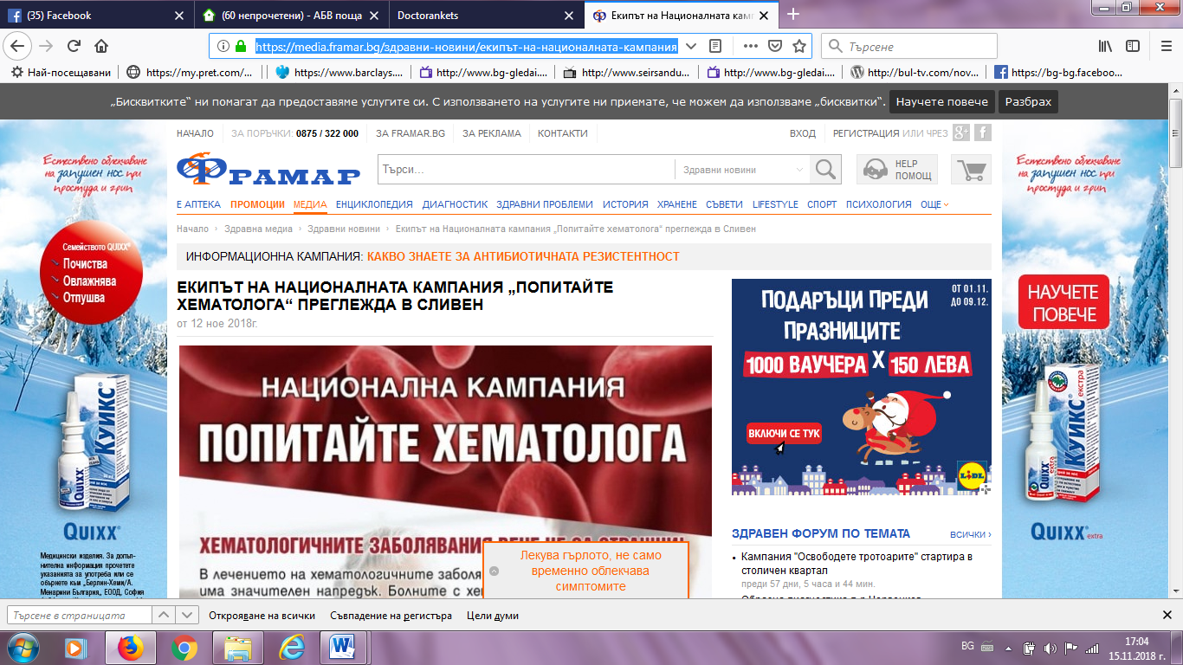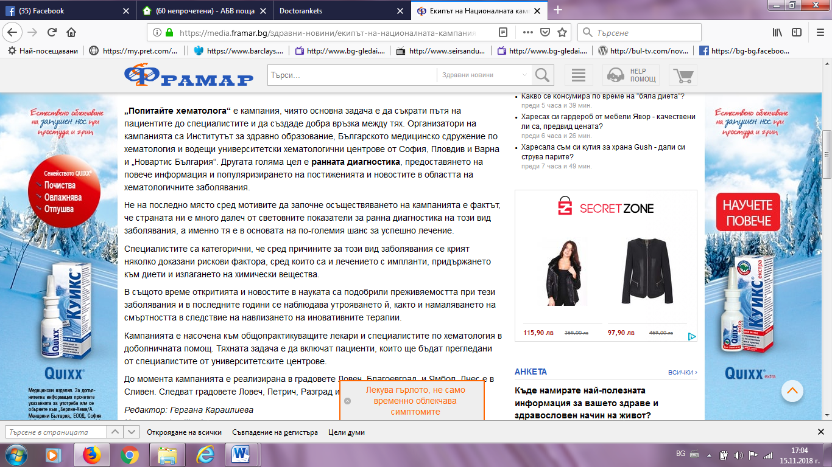
КМЕТА:
http://www.kmeta.bg/popitajte-hematologa-v-sliven
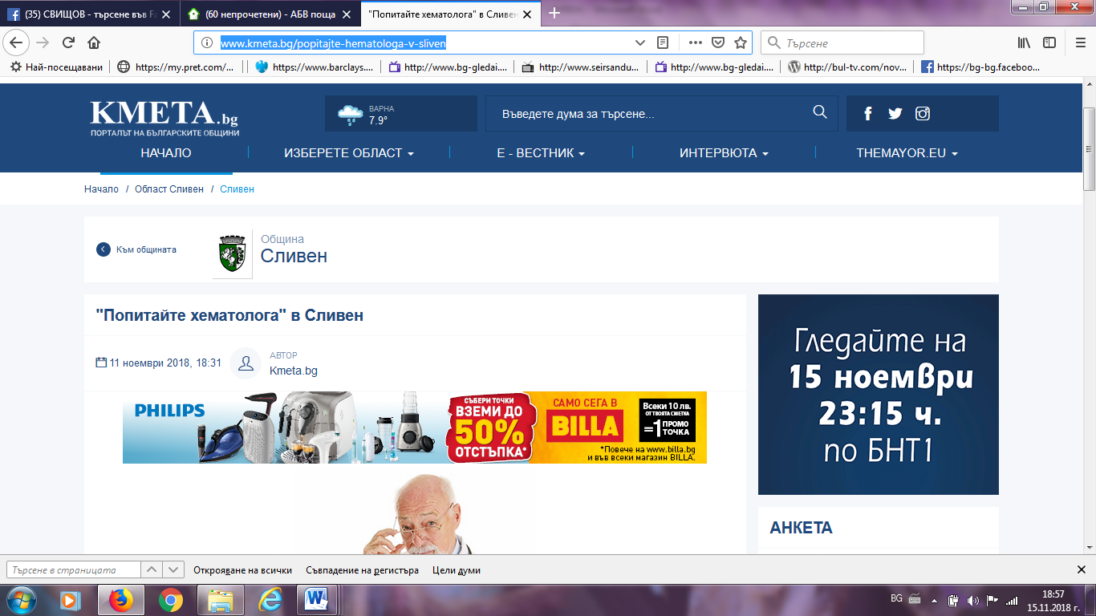
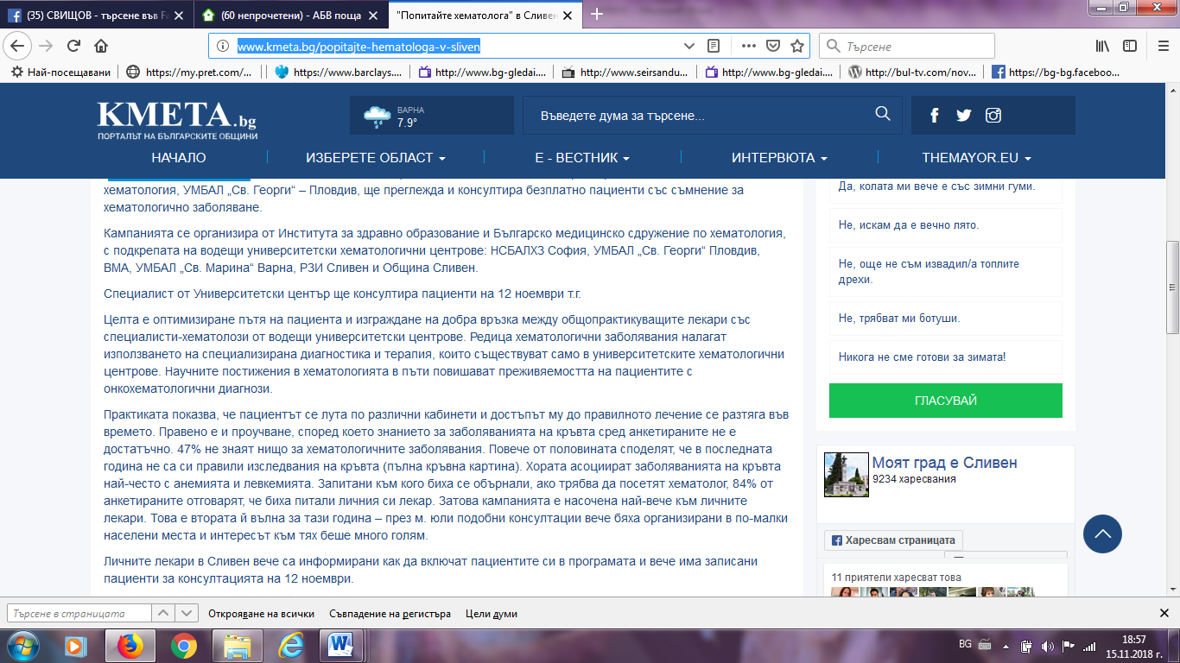

БАРАБАН БГ:
http://www.baraban.bg/index.php/balgariya/1883-natzionalnata-kampaniya-popitaite-hematologa-i-v-sliven
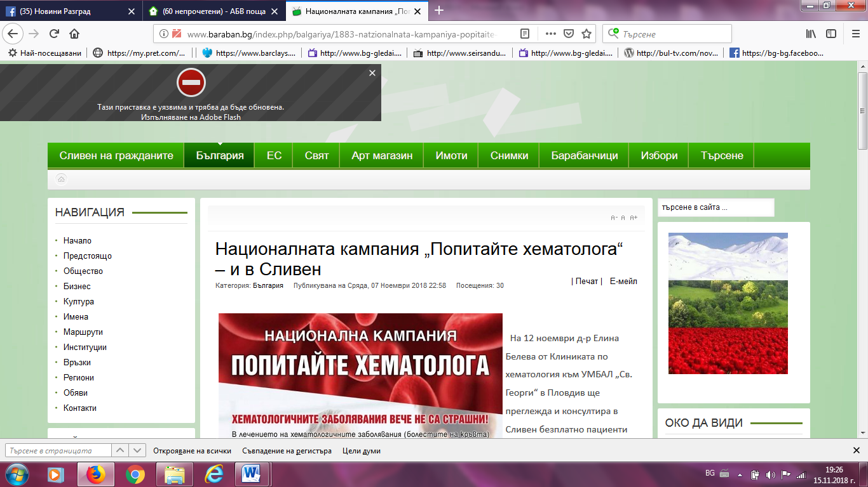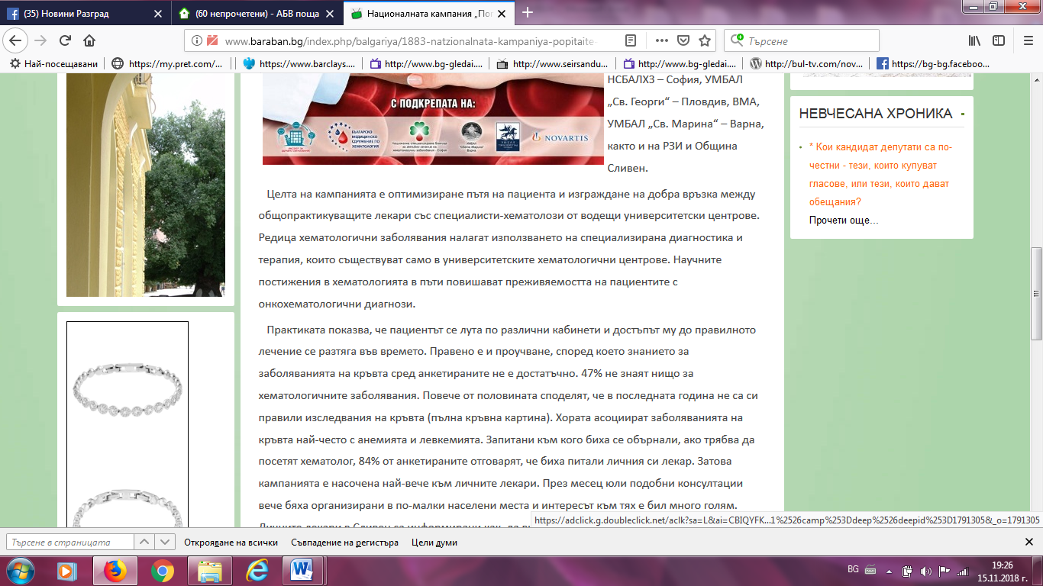

СЛИВЕН ДНЕС:
https://sliventoday.wordpress.com/2018/11/07/%d0%bd%d0%b0%d1%86%d0%b8%d0%be%d0%bd%d0%b0%d0%bb%d0%bd%d0%b0%d1%82%d0%b0-%d0%ba%d0%b0%d0%bc%d0%bf%d0%b0%d0%bd%d0%b8%d1%8f-%d0%bf%d0%be%d0%bf%d0%b8%d1%82%d0%b0%d0%b9%d1%82%d0%b5-%d1%85%d0%b5/
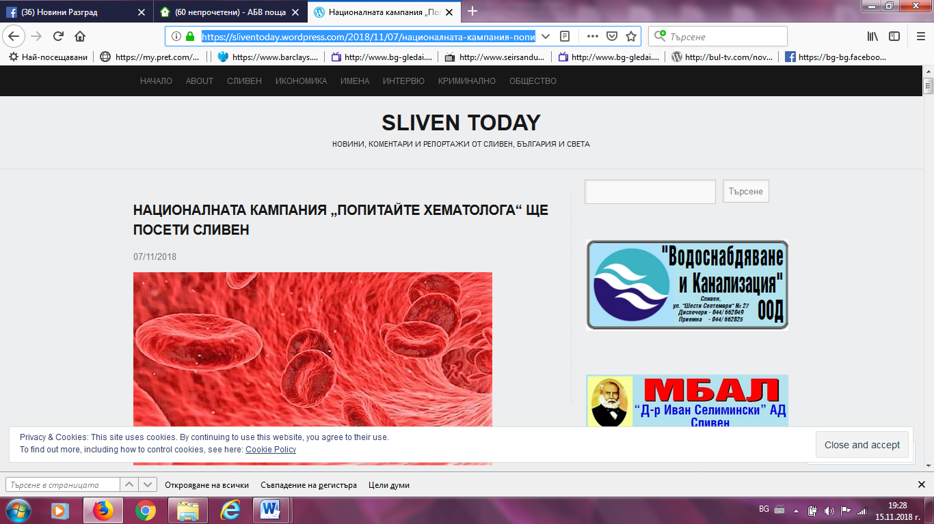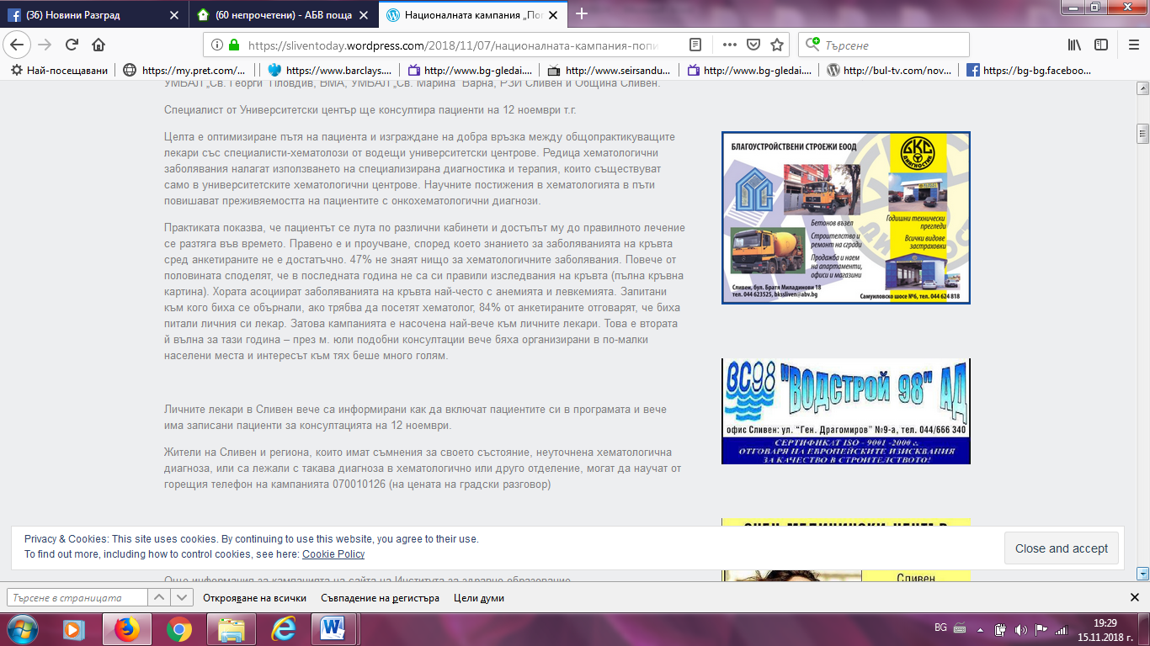

ЯМБОЛ ПРЕС:
http://yambolpress.bg/%d0%bd%d0%b0%d1%86%d0%b8%d0%be%d0%bd%d0%b0%d0%bb%d0%bd%d0%b0%d1%82%d0%b0-%d0%ba%d0%b0%d0%bc%d0%bf%d0%b0%d0%bd%d0%b8%d1%8f-%d0%bf%d0%be%d0%bf%d0%b8%d1%82%d0%b0%d0%b9-%d1%85%d0%b5%d0%bc%d0%b0%d1%82/
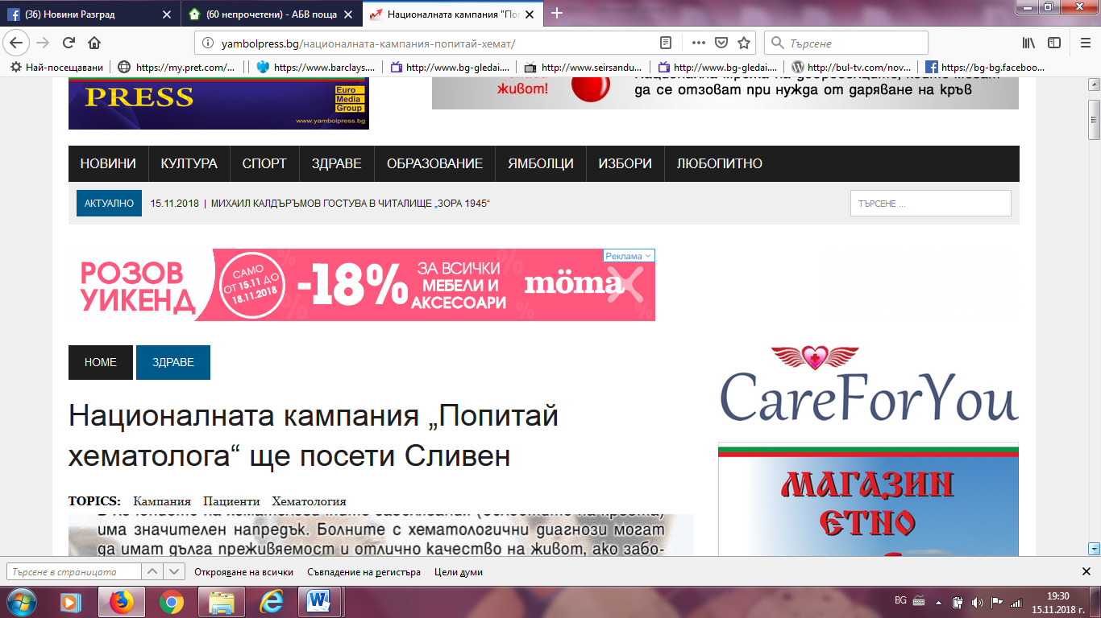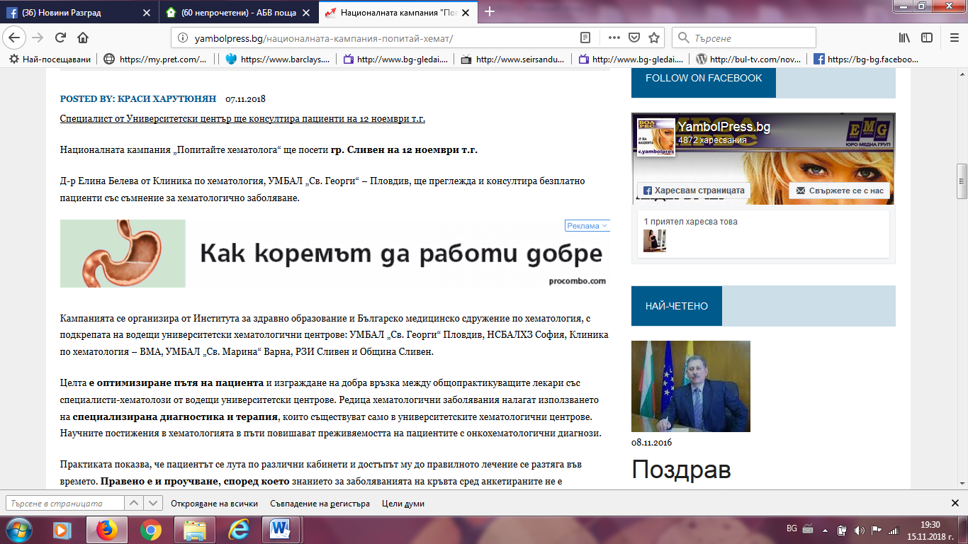

ОБЩИНА СЛИВЕН ФЕЙСБУК:
https://www.facebook.com/pg/%D0%9E%D0%B1%D1%89%D0%B8%D0%BD%D0%B0-%D0%A1%D0%BB%D0%B8%D0%B2%D0%B5%D0%BD-531732533593876/posts/
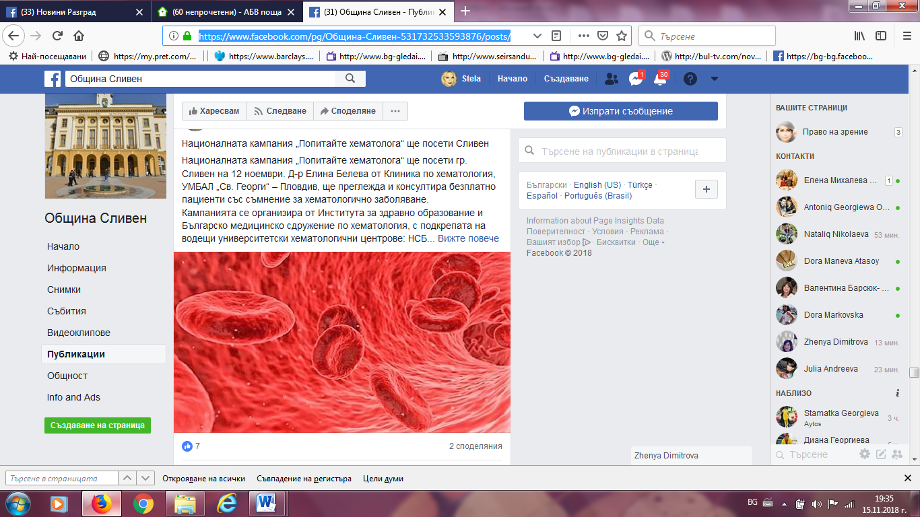
НОВИНАТА БГ:
https://novinata.bg/?p=289054
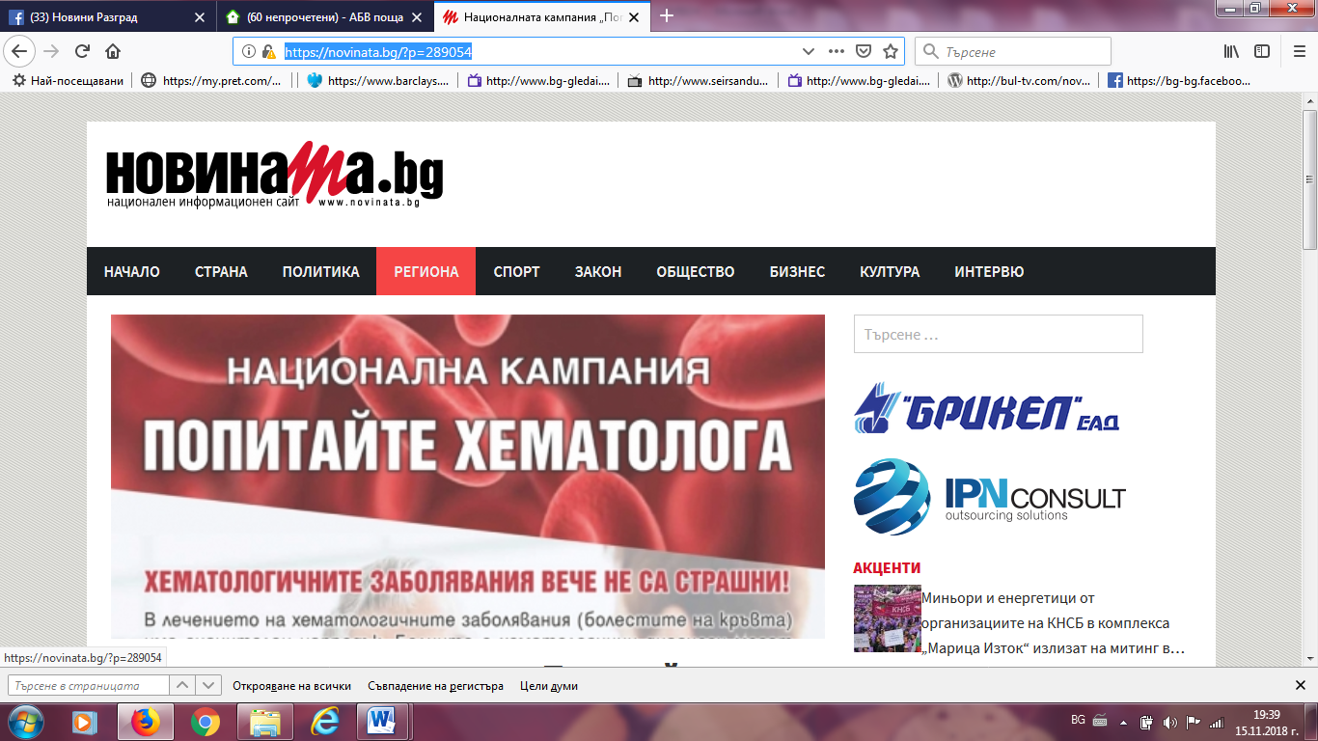

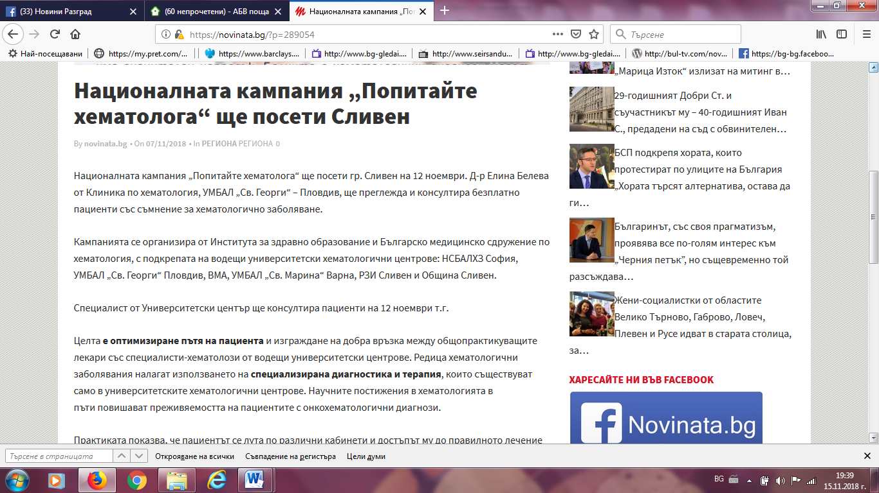

ОБЩИНА СЛИВЕН:
https://mun.sliven.bg/news/277045
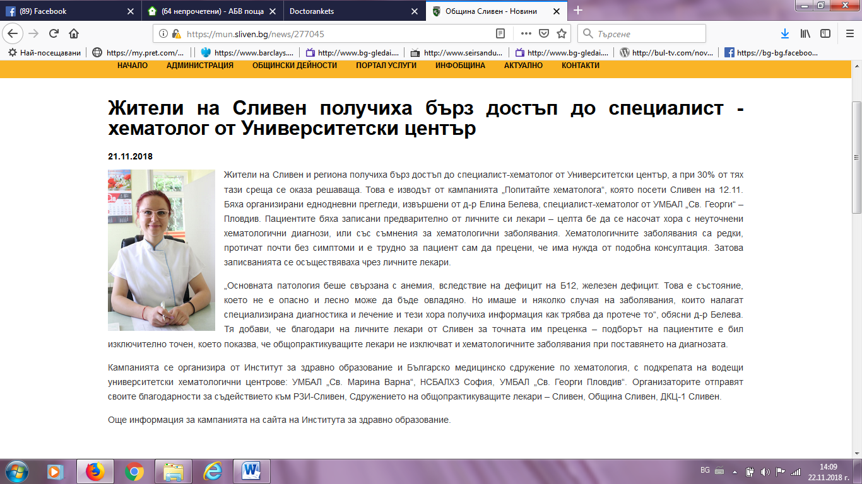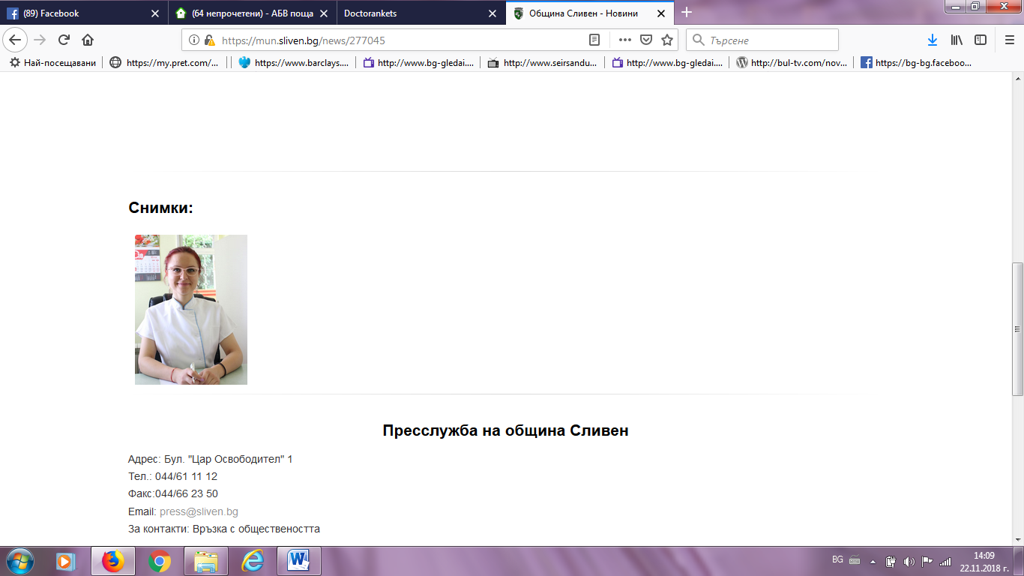

СЛИВЕН НЕТ:
http://new.sliven.net/sys/news/index.php?id=277057
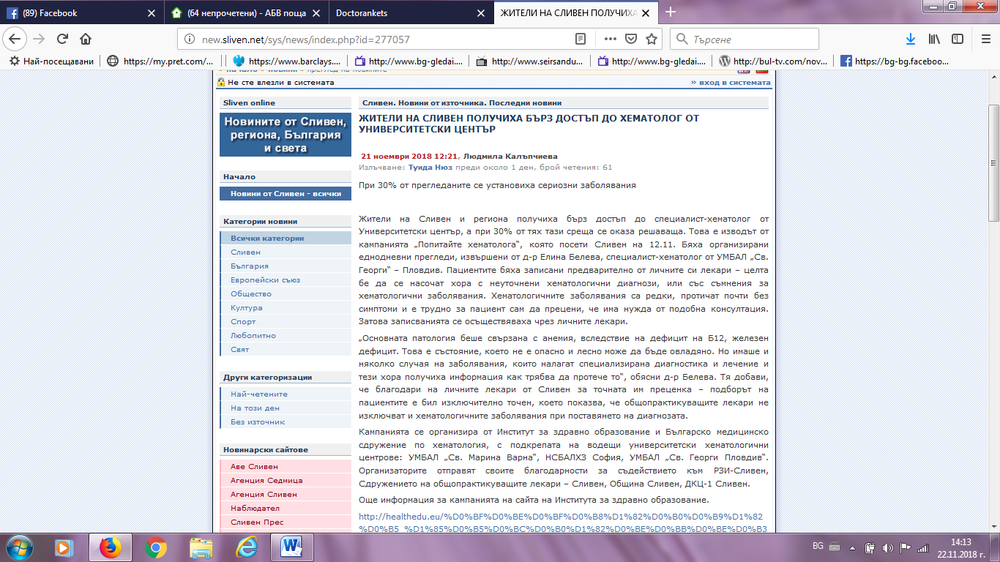
СЛИВЕН ИНФО:
https://sliveninfo.bg/%D0%B6%D0%B8%D1%82%D0%B5%D0%BB%D0%B8-%D0%BD%D0%B0-%D1%81%D0%BB%D0%B8%D0%B2%D0%B5%D0%BD-%D0%BF%D0%BE%D0%BB%D1%83%D1%87%D0%B8%D1%85%D0%B0-%D0%B1%D1%8A%D1%80%D0%B7-%D0%B4%D0%BE%D1%81%D1%82%D1%8A%D0%BF/
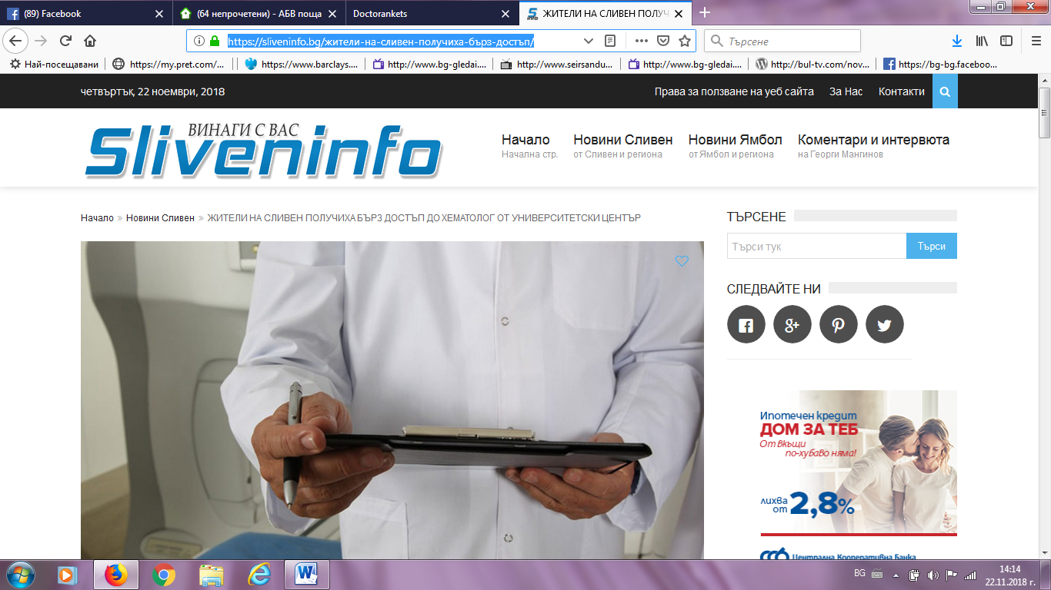

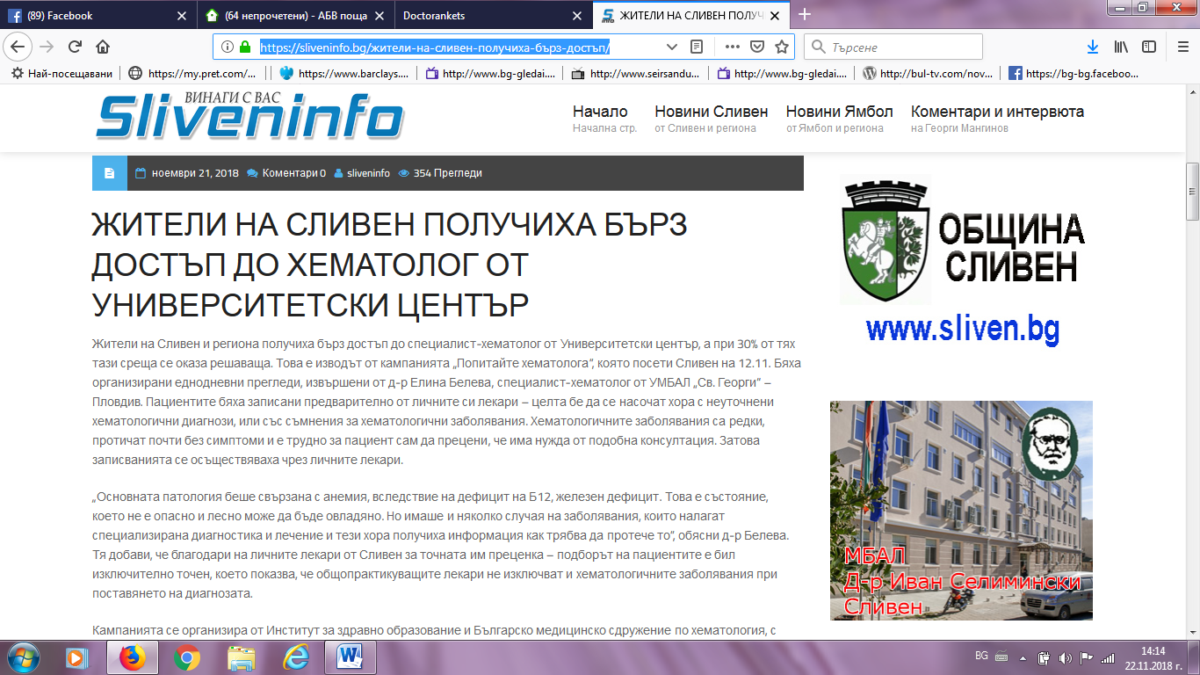
АВЕ СЛИВЕН:
http://www.ave-sliven.com/index.php?id=277065
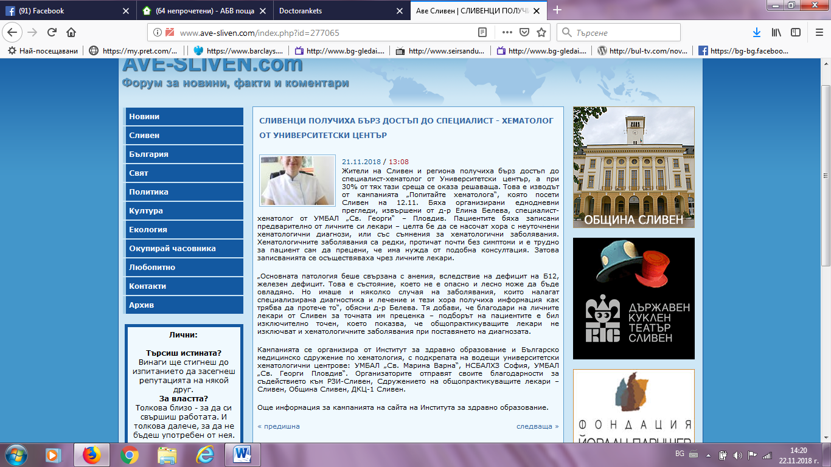

СЛИВЕН СЕГА (ДНЕС И УТРЕ):
https://slivensega.wordpress.com/2018/11/21/%D0%B6%D0%B8%D1%82%D0%B5%D0%BB%D0%B8-%D0%BD%D0%B0-%D1%81%D0%BB%D0%B8%D0%B2%D0%B5%D0%BD-%D0%BF%D0%BE%D0%BB%D1%83%D1%87%D0%B8%D1%85%D0%B0-%D0%B1%D1%8A%D1%80%D0%B7-%D0%B4%D0%BE%D1%81%D1%82%D1%8A%D0%BF/
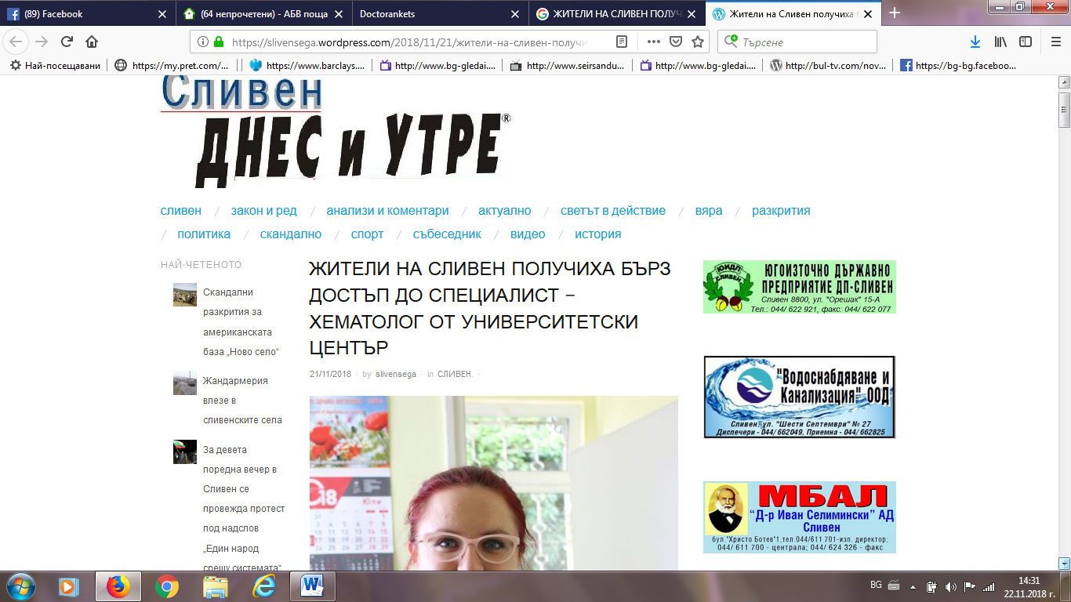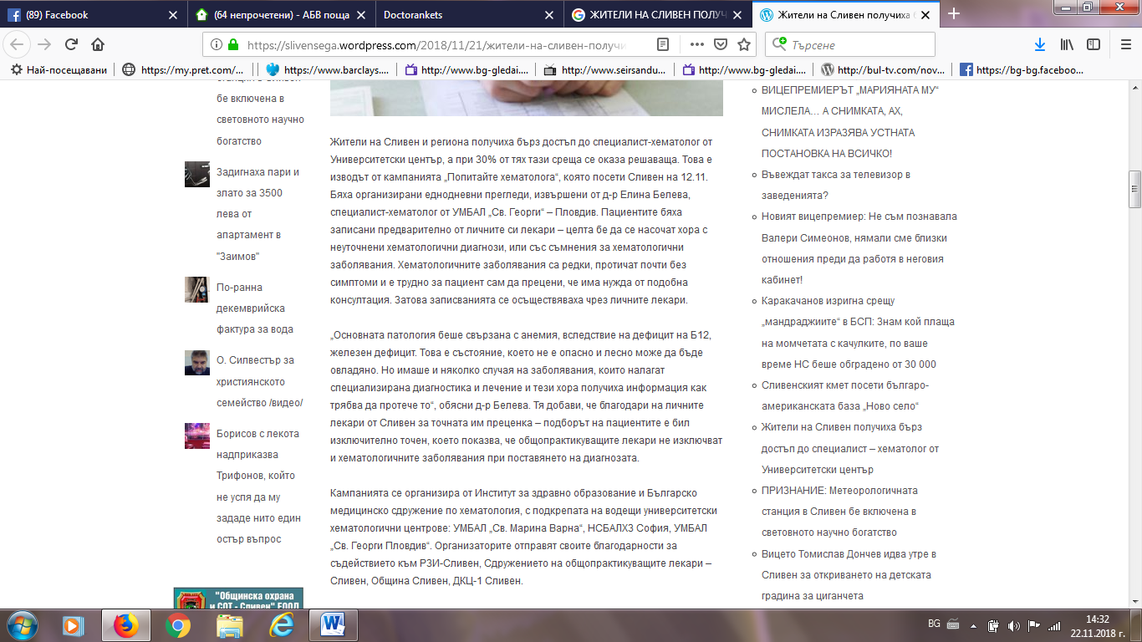

ХОТ ПОЙНТ НЮЗ:
http://hotpoint-news.com/%D0%BD%D0%BE%D0%B2%D0%B8%D0%BD%D0%B8/2018/11/21/%D0%B6%D0%B8%D1%82%D0%B5%D0%BB%D0%B8-%D0%BD%D0%B0-%D1%81%D0%BB%D0%B8%D0%B2%D0%B5%D0%BD-%D0%BF%D0%BE%D0%BB%D1%83%D1%87%D0%B8%D1%85%D0%B0-%D0%B1%D1%8A%D1%80%D0%B7-%D0%B4%D0%BE%D1%81%D1%82%D1%8A%D0%BF-%D0%B4%D0%BE-%D1%81%D0%BF%D0%B5%D1%86%D0%B8%D0%B0%D0%BB%D0%B8%D1%81%D1%82-%D1%85%D0%B5%D0%BC%D0%B0%D1%82%D0%BE%D0%BB%D0%BE%D0%B3-%D0%BE%D1%82-%D1%83%D0%BD%D0%B8%D0%B2%D0%B5%D1%80%D1%81%D0%B8%D1%82%D0%B5%D1%82%D1%81%D0%BA%D0%B8-%D1%86%D0%B5%D0%BD%D1%82%D1%8A%D1%80/
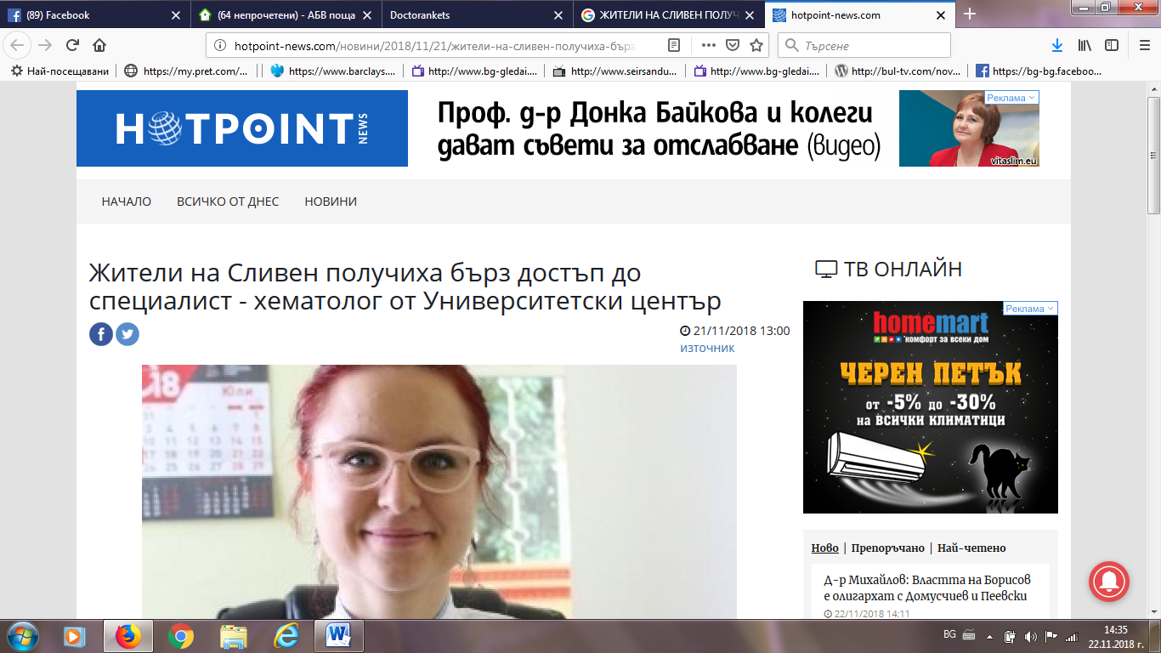

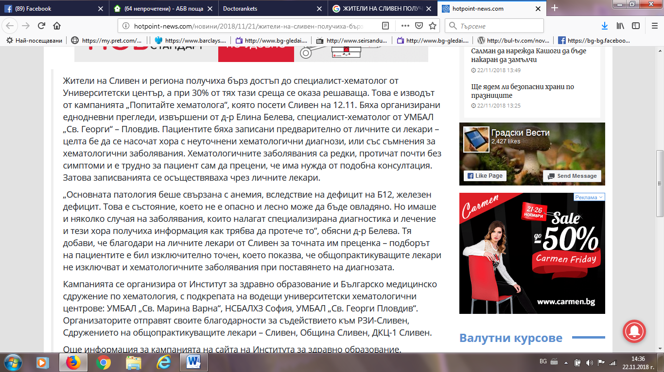
НАБЛЮДАТЕЛ:
http://www.nabludatel.bg/index.php?id=277041
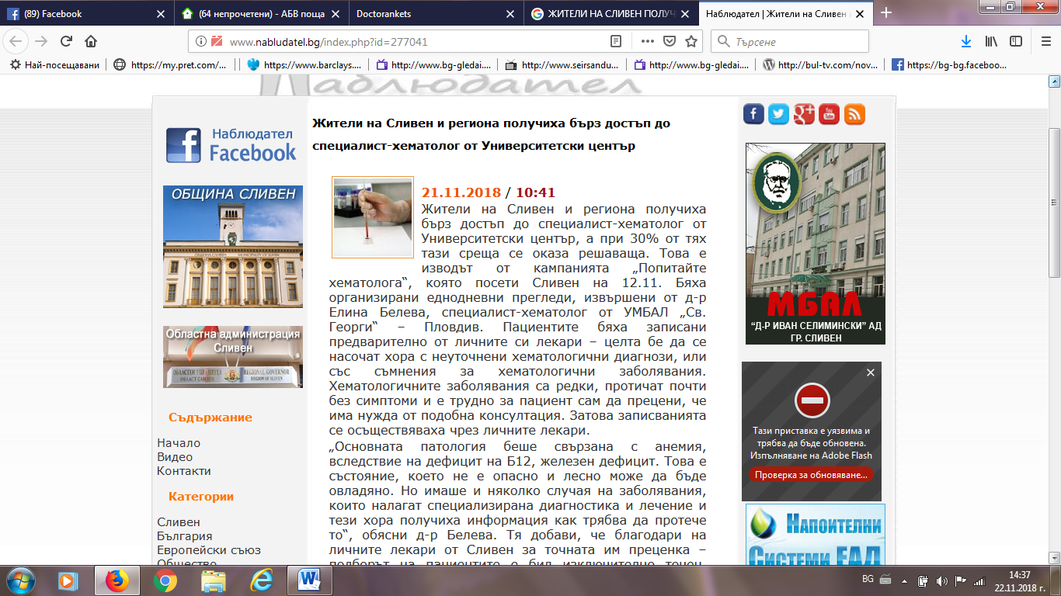

КИБИК БГ:
https://kibik.bg/%D0%B6%D0%B8%D1%82%D0%B5%D0%BB%D0%B8-%D0%BD%D0%B0-%D1%81%D0%BB%D0%B8%D0%B2%D0%B5%D0%BD-%D0%BF%D0%BE%D0%BB%D1%83%D1%87%D0%B8%D1%85%D0%B0-%D0%B1%D1%8A%D1%80%D0%B7-%D0%B4%D0%BE%D1%81%D1%82%D1%8A%D0%BF/
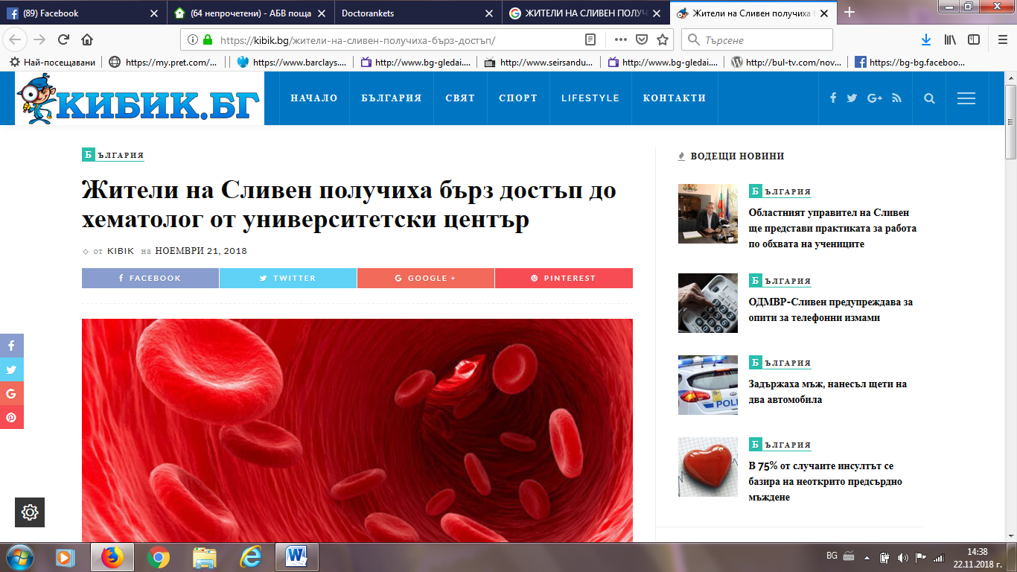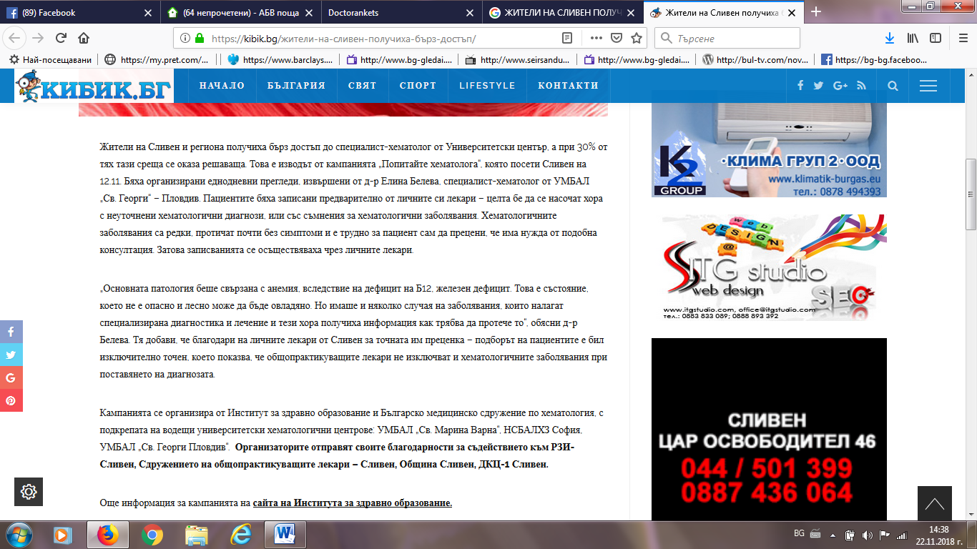

АГЕНЦИЯ СЕДМИЦА:
http://sedmica.sliven.net/index.php?id=277056
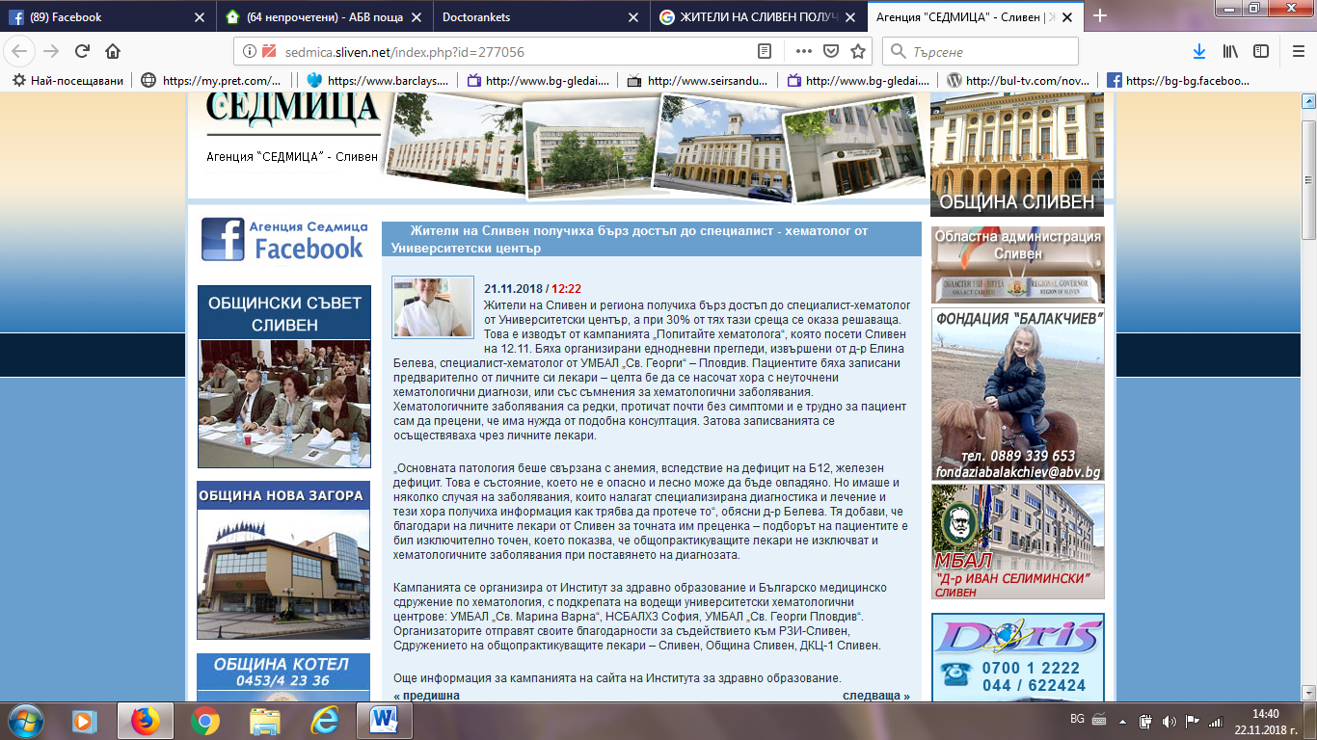
ОБЩИНА СЛИВЕН ФЕЙСБУК:
https://www.facebook.com/531732533593876/photos/a.538607599573036/1580082798758839/?type=3&theater
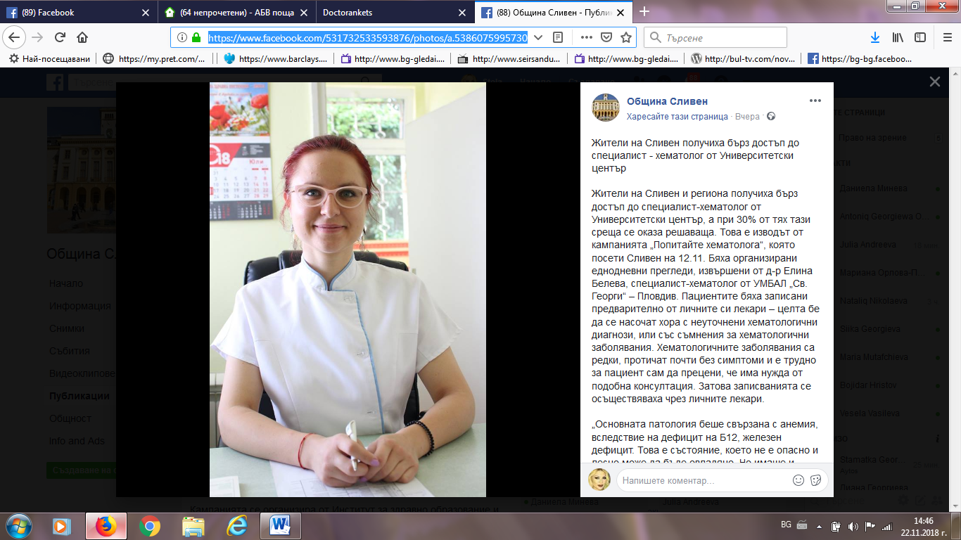

СЛИВЕН ПОСТ:
https://slivenpost.bg/%D0%BE%D0%BF%D0%BB%D0%B0%D0%BA%D0%B2%D0%B0%D0%BD%D0%B8%D1%8F%D1%82%D0%B0-%D0%BF%D1%80%D0%B8-%D1%85%D0%B5%D0%BC%D0%B0%D1%82%D0%BE%D0%BB%D0%BE%D0%B3%D0%B8%D1%87%D0%BD%D0%BE-%D0%B7%D0%B0%D0%B1%D0%BE/
