МЕДИА МОНИТОРИНГ ХЕМАТОЛОГИЧНИ ЗАБОЛЯВАНИЯ – РАЗГРАД
РАЗГРАД НЮЗ:
https://razgradnews.net/2018/11/05/natsionalnata-kampaniya-popitajte-hematologa-shte-poseti-razgrad
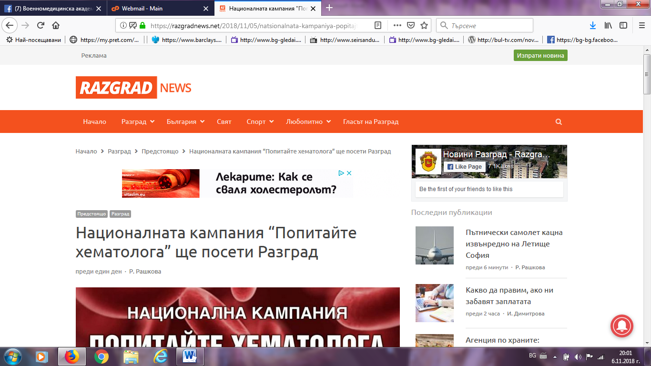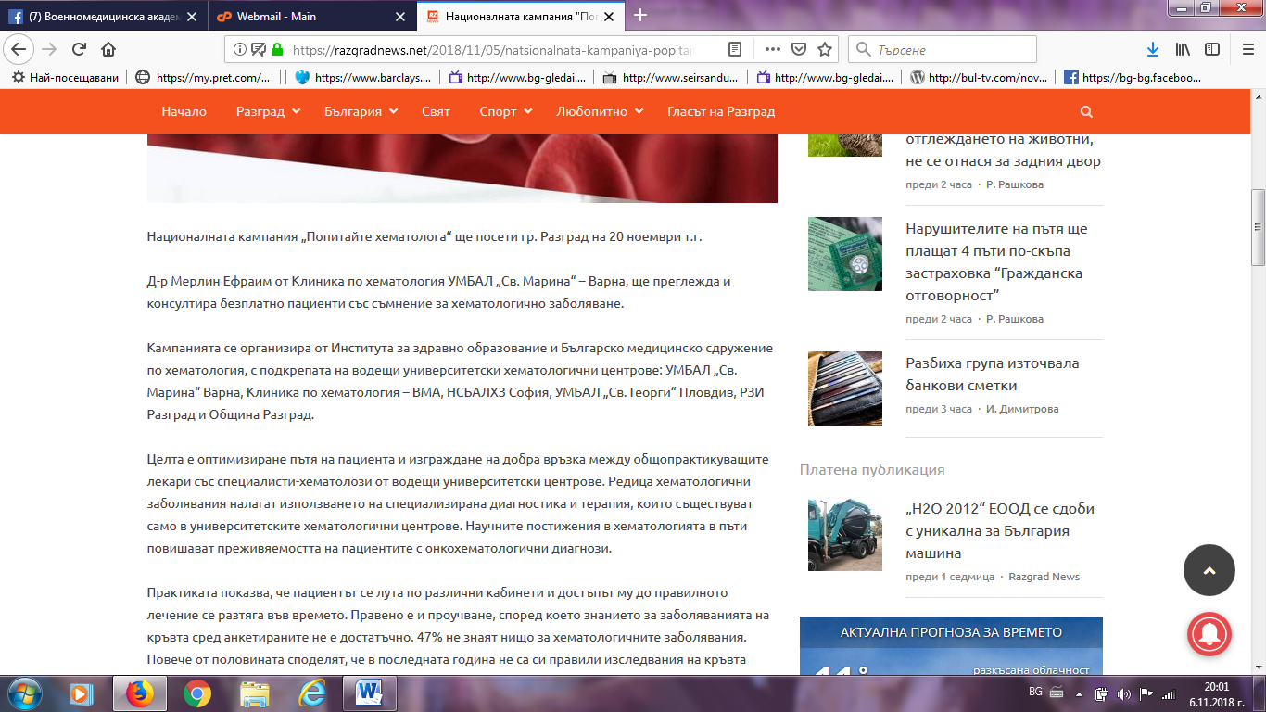

ТЪРГОВИЩЕ:
https://targovishtebg.com/%D0%B1%D1%8A%D0%BB%D0%B3%D0%B0%D1%80%D0%B8%D1%8F/22413-%D0%BD%D0%B0%D1%86%D0%B8%D0%BE%D0%BD%D0%B0%D0%BB%D0%BD%D0%B0%D1%82%D0%B0-%D0%BA%D0%B0%D0%BC%D0%BF%D0%B0%D0%BD%D0%B8%D1%8F-%E2%80%9E%D0%BF%D0%BE%D0%BF%D0%B8%D1%82%D0%B0%D0%B9%D1%82%D0%B5-%D1%85%D0%B5%D0%BC%D0%B0%D1%82%D0%BE%D0%BB%D0%BE%D0%B3%D0%B0%E2%80%9C-%D1%89%D0%B5-%D0%BF%D0%BE%D1%81%D0%B5%D1%82%D0%B8-%D1%80%D0%B0%D0%B7%D0%B3%D1%80%D0%B0%D0%B4
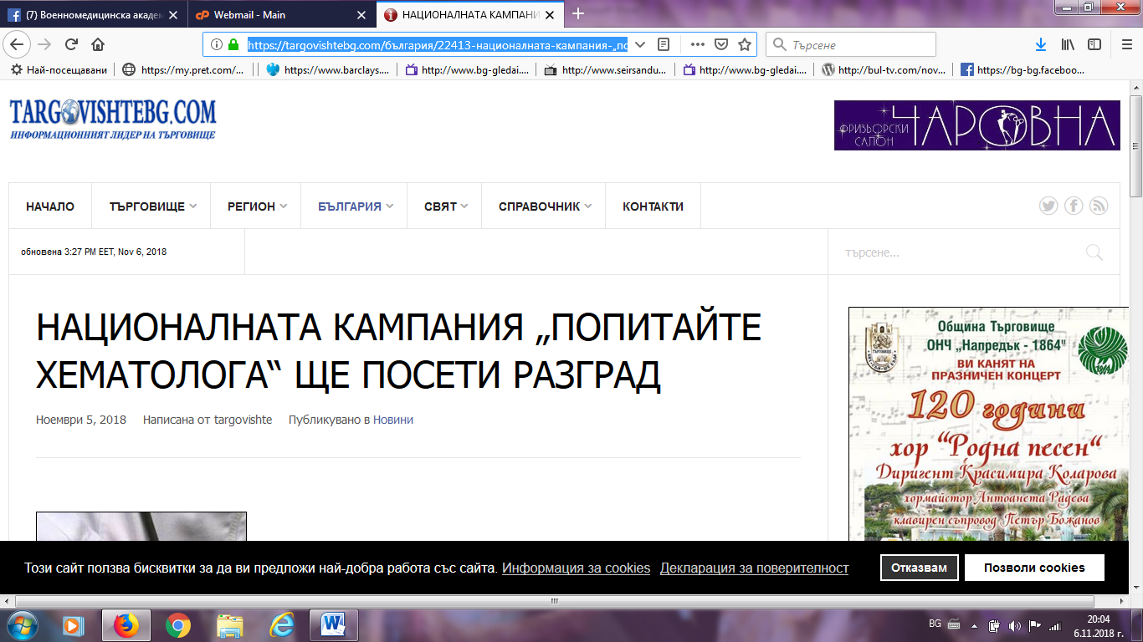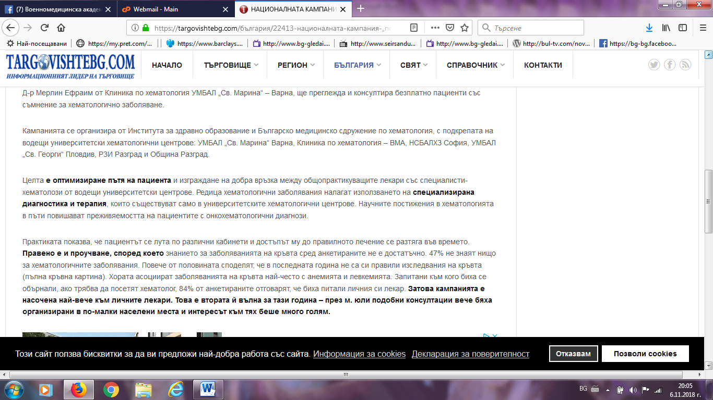

БТА:
http://www.bta.bg/bg/c/BO/id/1901424
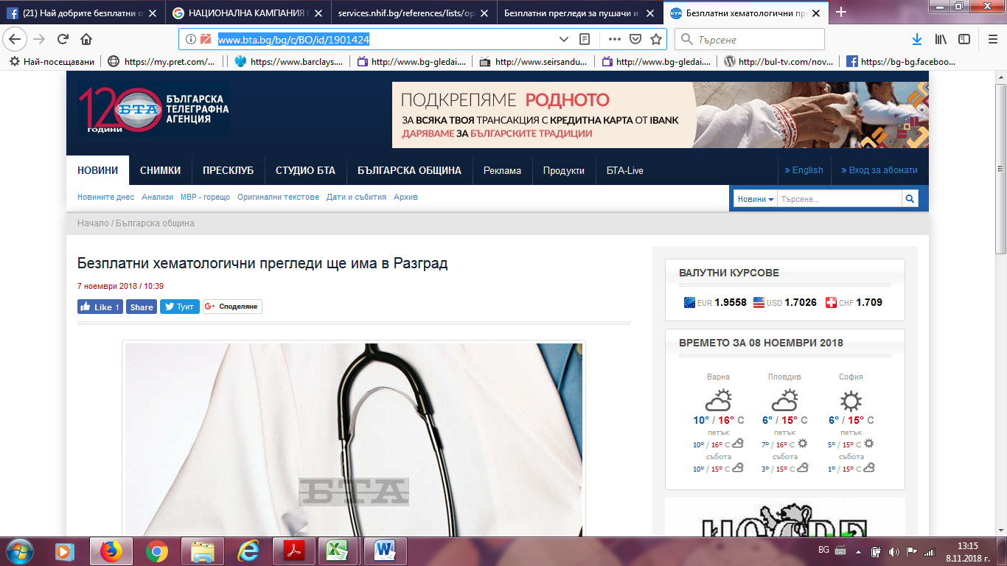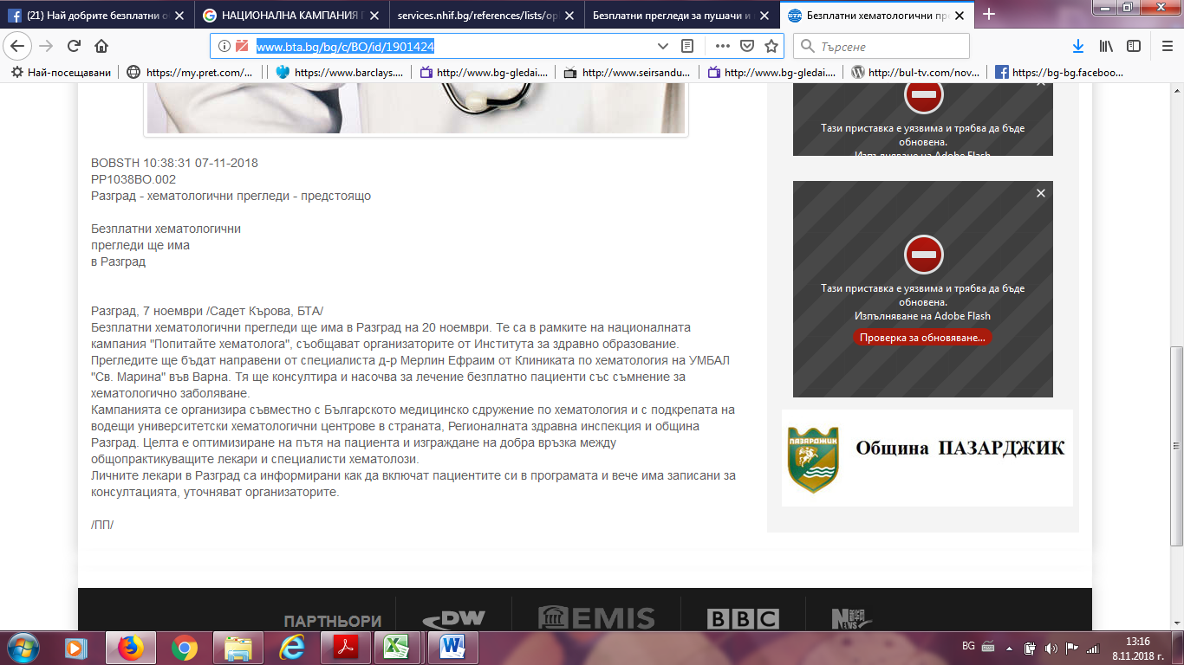

ТРЕТА ВЪЗРАСТ:
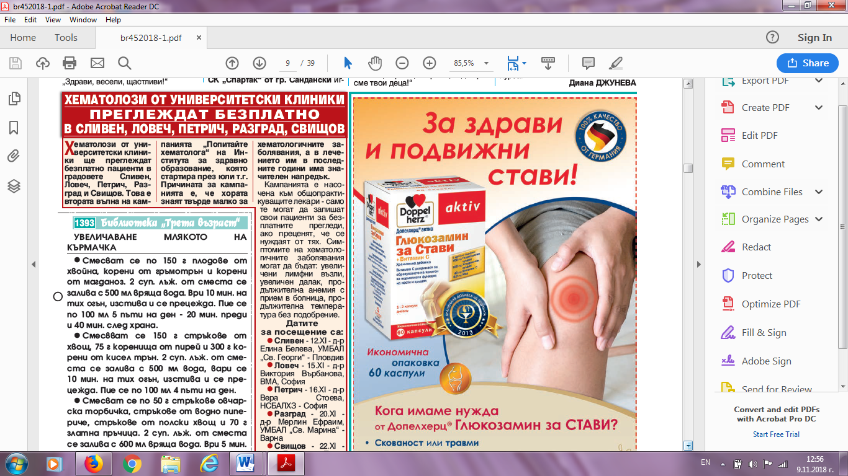
ОБЩИНА РАЗГРАД:
https://www.razgrad.bg/index.php?option=com_content&view=article&id=10262%3A2018-11-09-09-04-45&catid=15%3Anews&Itemid=21&lang=bg
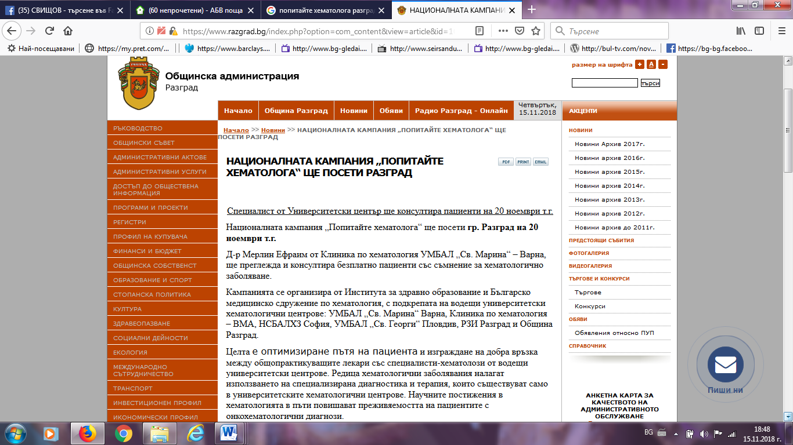

ЛУДОГОРЕЦ НЮЗ:
http://ludogorienews.bg/2018/11/07/%D0%B1%D0%B5%D0%B7%D0%BF%D0%BB%D0%B0%D1%82%D0%BD%D0%B8-%D0%BF%D1%80%D0%B5%D0%B3%D0%BB%D0%B5%D0%B4%D0%B8-%D0%BE%D1%82-%D1%81%D0%BF%D0%B5%D1%86%D0%B8%D0%B0%D0%BB%D0%B8%D1%81%D1%82-%D1%85%D0%B5%D0%BC/
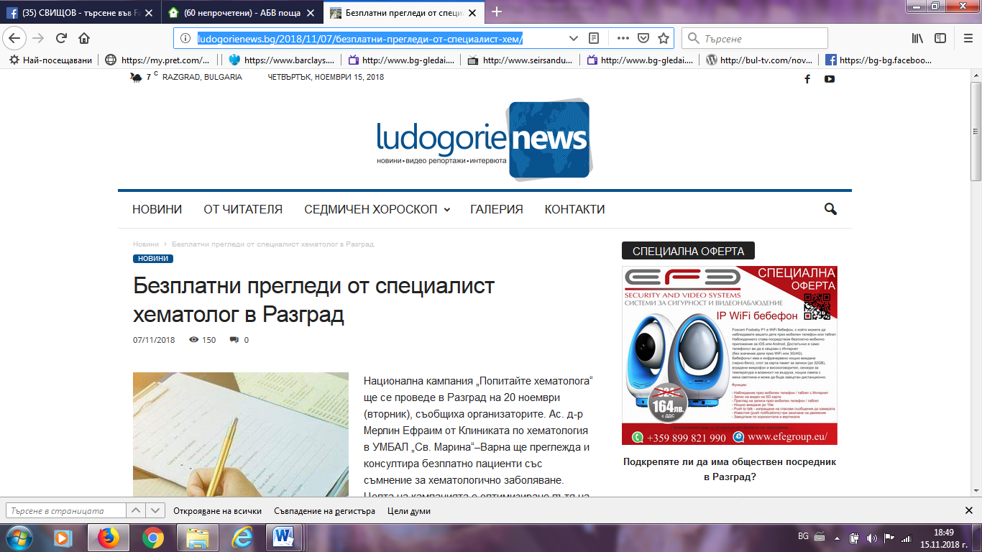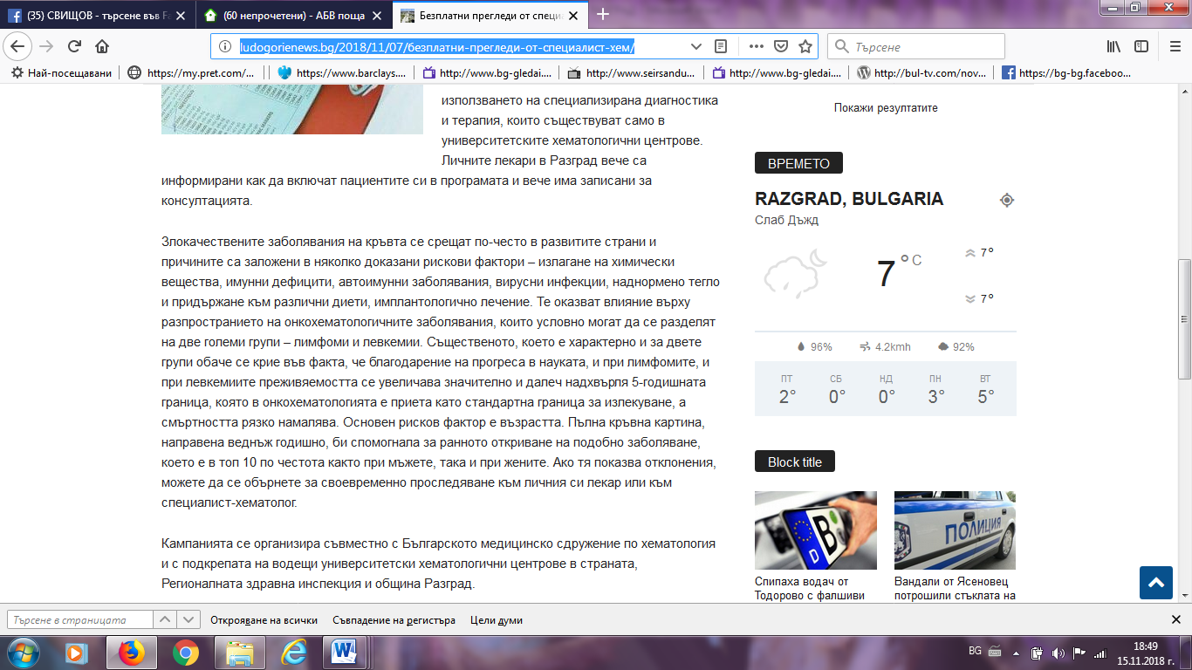

ТОП НОВИНИ:
https://topnovini.bg/novini/811301-bezplatni-hematologichni-pregledi-shte-ima-v-razgrad
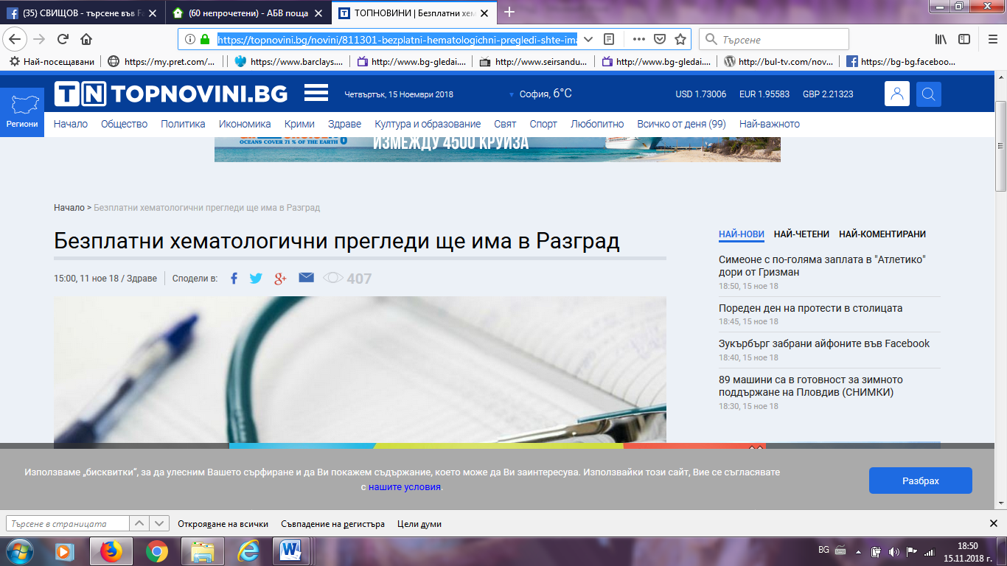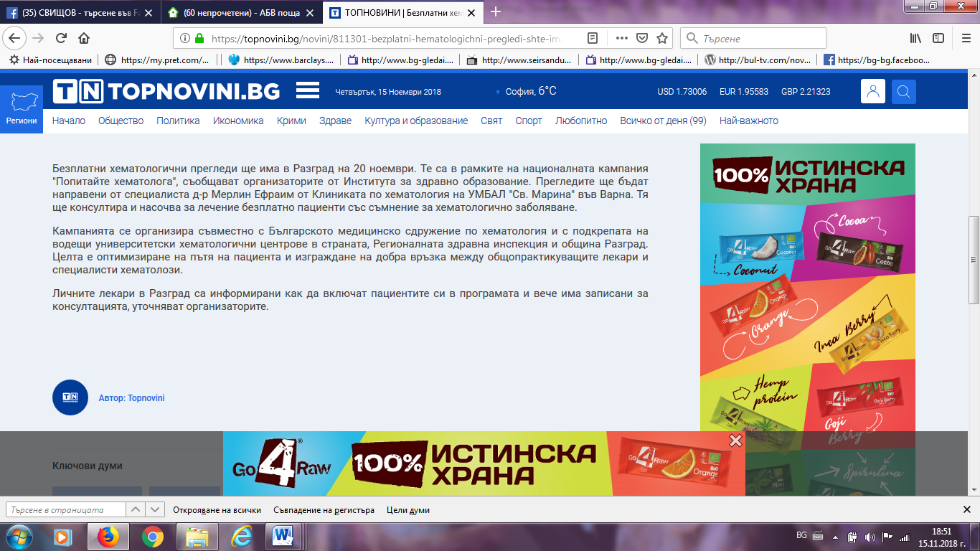

ЕКИП 7:
http://www.ekip7.bg/index.php?option=com_content&task=view&id=26113&Itemid=41
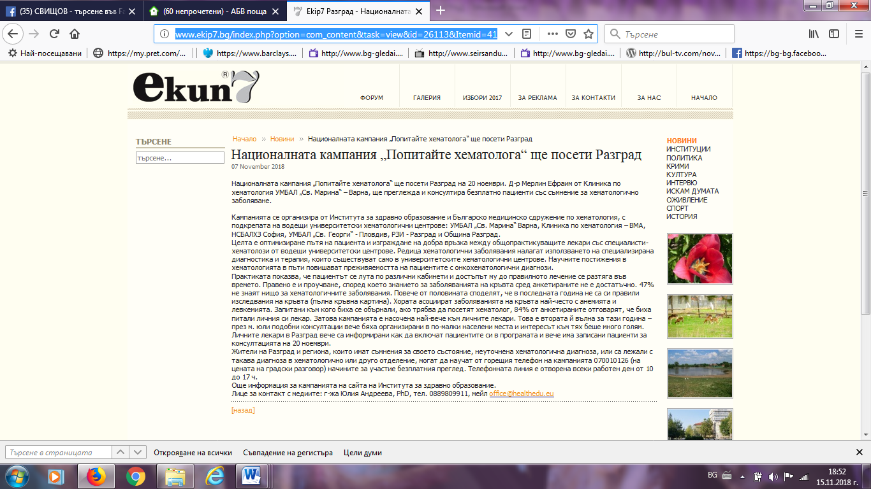
НОВИНИ РАЗГРАД ФЕЙСБУК:
https://www.facebook.com/groups/razgradnews.net/search/?query=%D0%9F%D0%9E%D0%9F%D0%98%D0%A2%D0%90%D0%99%D0%A2%D0%95%20%D0%A5%D0%95%D0%9C%D0%90%D0%A2%D0%9E%D0%9B%D0%9E%D0%93%D0%90
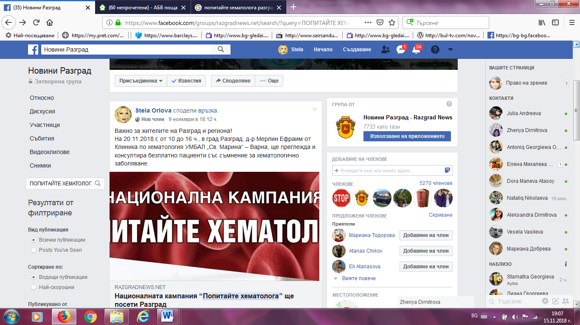

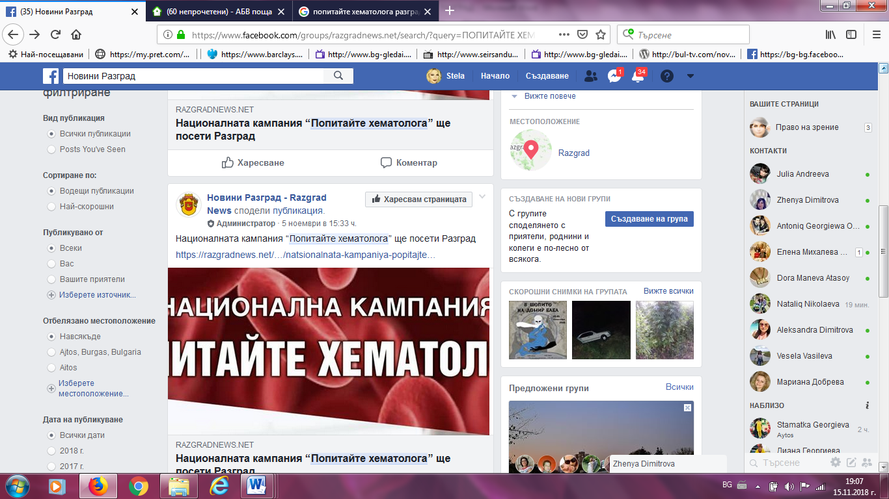
РАЗГРАД НЮЗ:https://razgradnews.net/2018/11/26/zhiteli-na-razgrad-poluchiha-barz-dostap-do-hematolog-ot-universitetski-tsentar
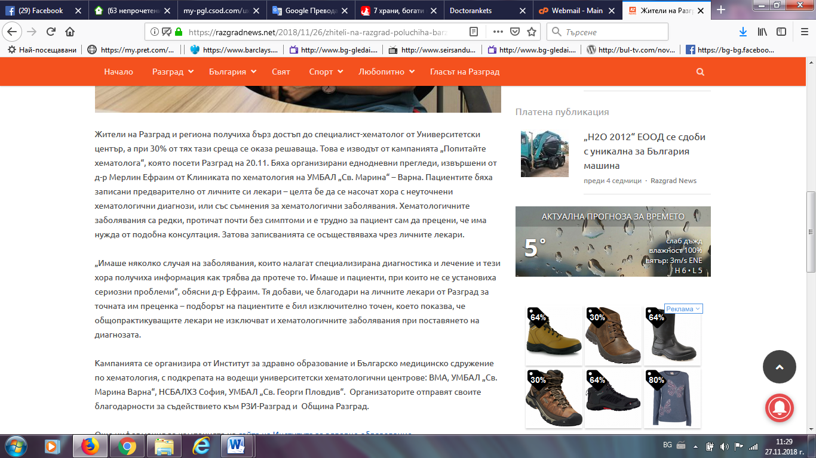

ЕКИП 7:
http://www.ekip7.bg/index.php?option=com_content&task=view&id=26301&Itemid=1
