МЕДИА МОНИТОРИНГ ЗОНА ЗДРАВЕ БУРГАС 2019
ВЕСТНИК ЗДРАВЕ:
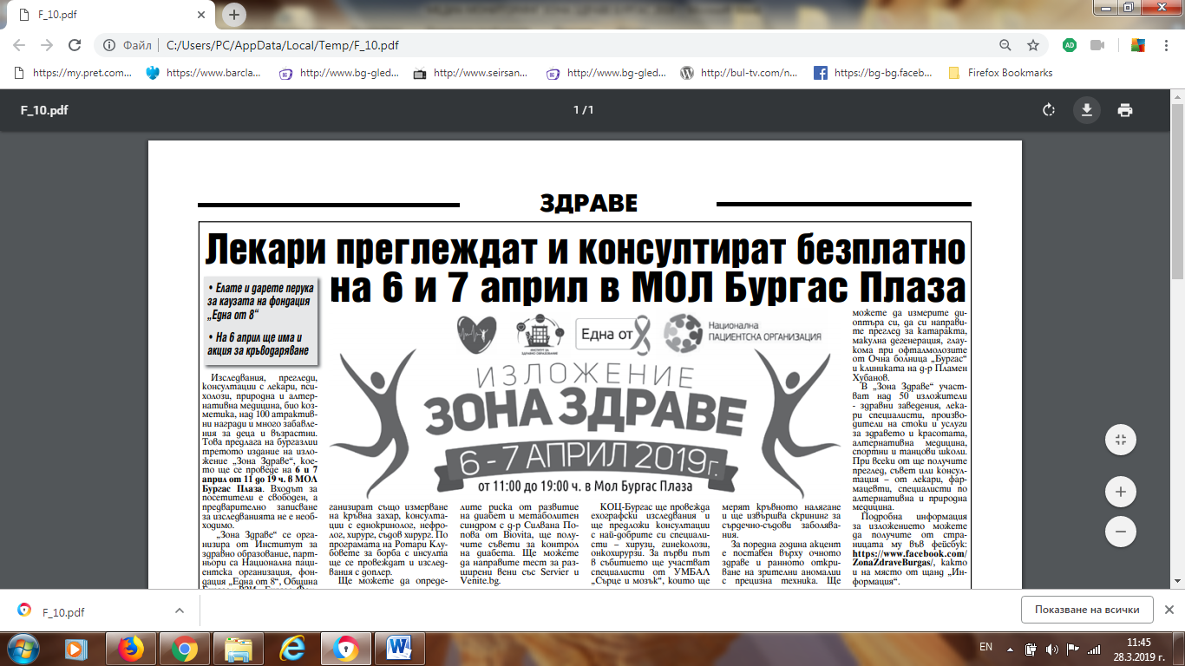
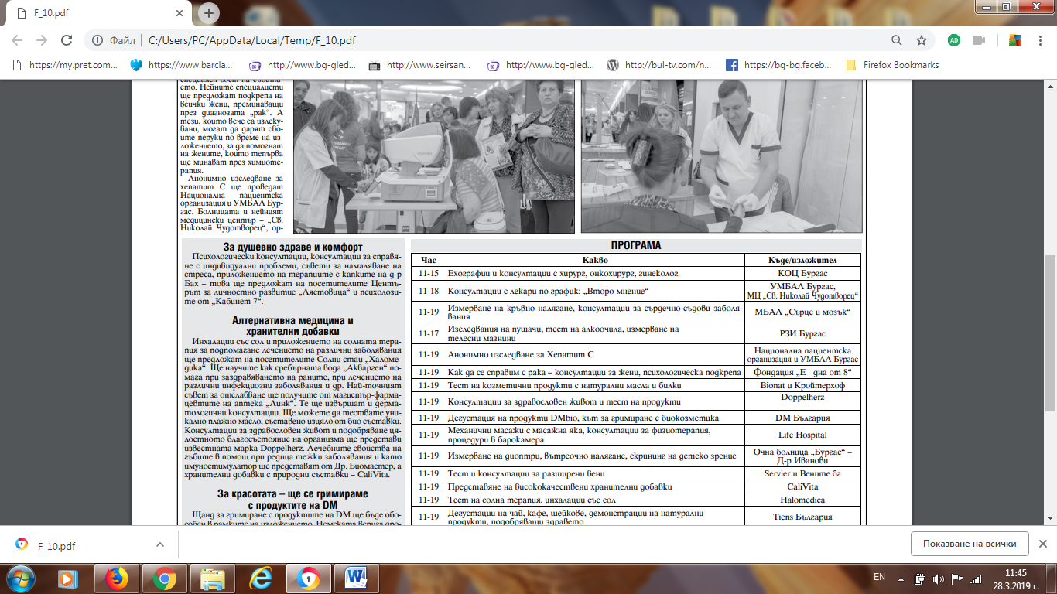

ФЛАГМАН:
https://www.flagman.bg/article/181419
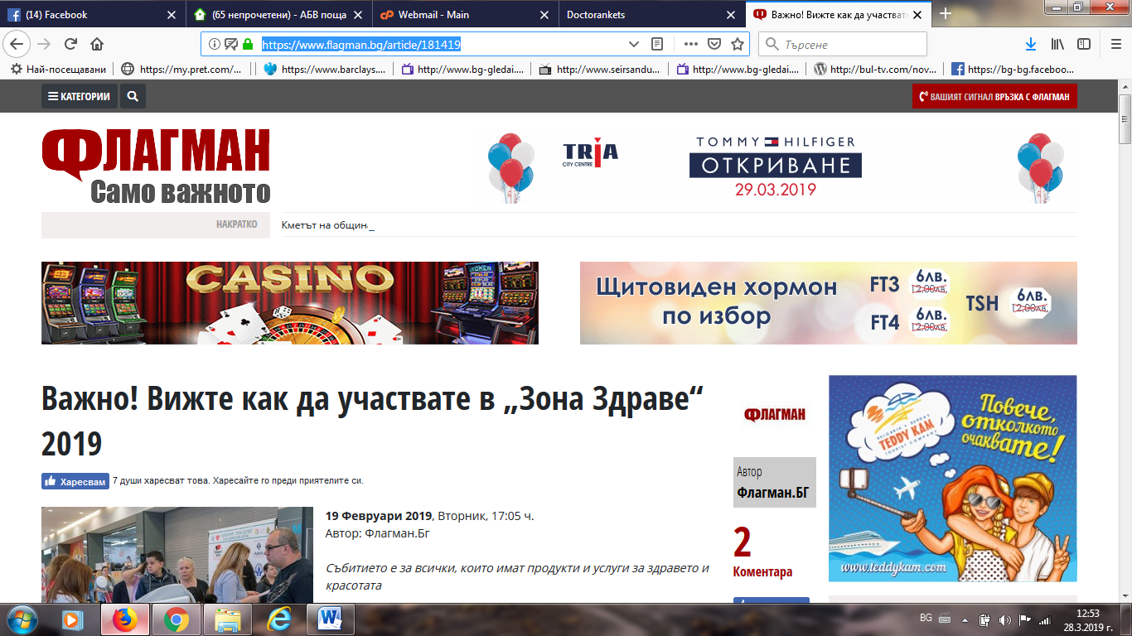
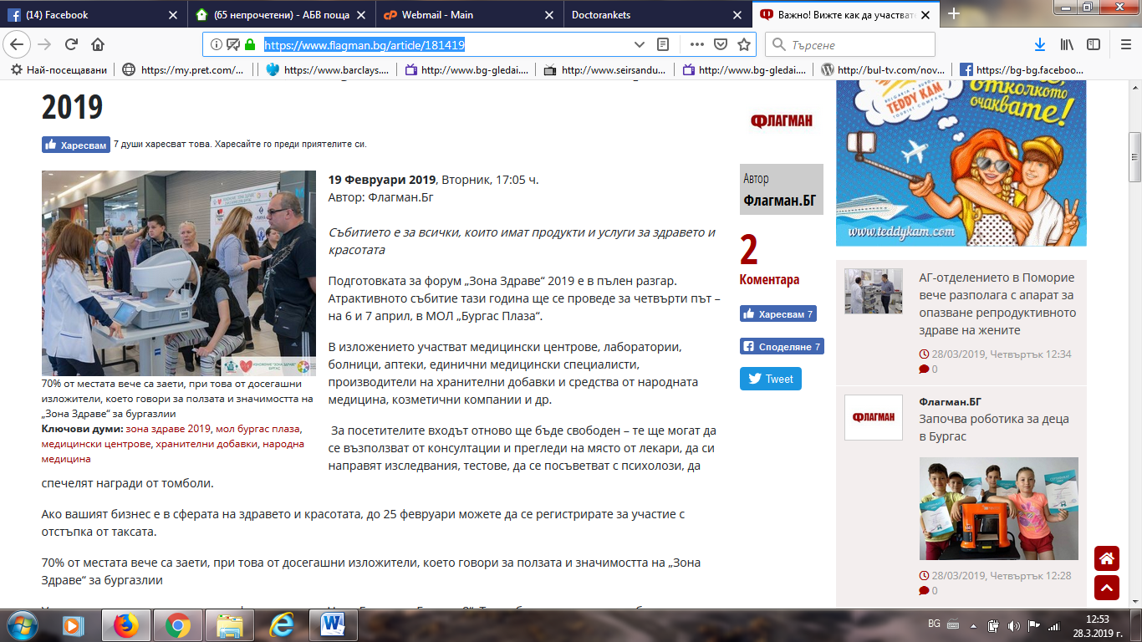

КОЦ БУРГАС:
http://onkobs.bg/?p=15190
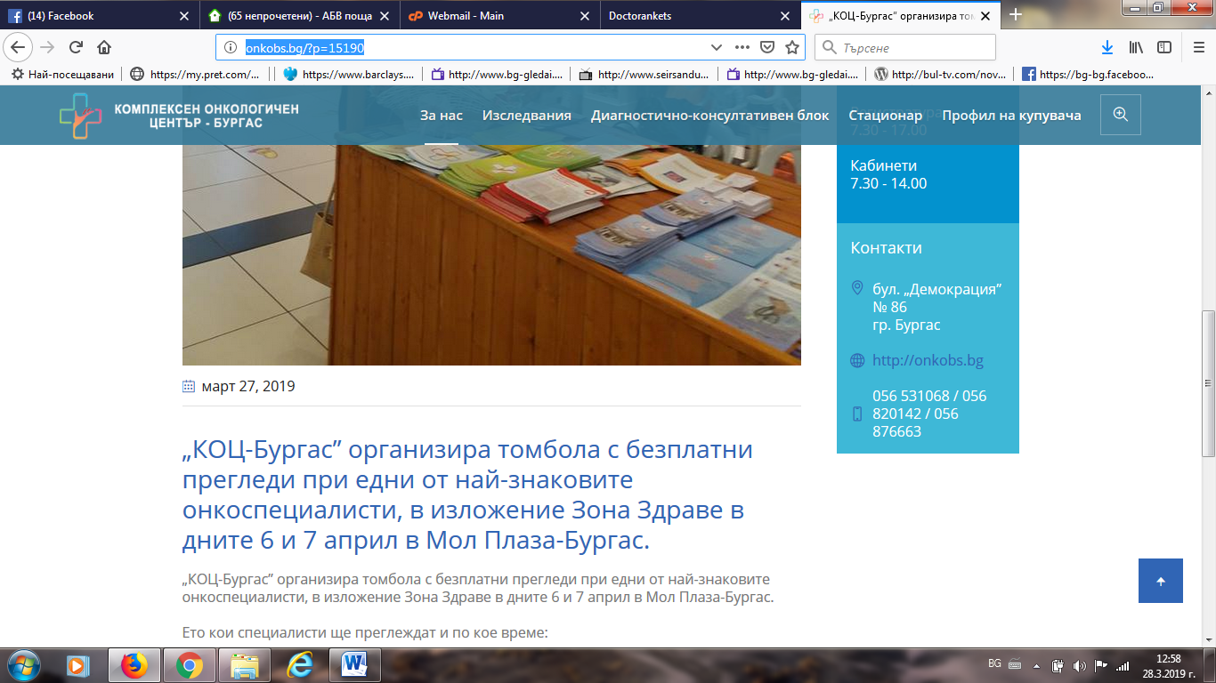
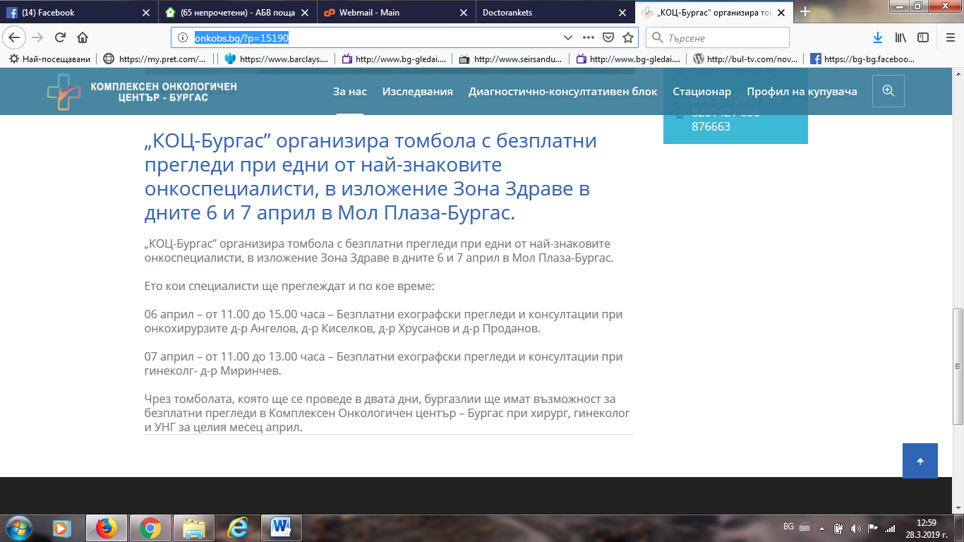

БНР БУРГАС:
http://bnr.bg/burgas/post/101101819/onkoprofilaktikata-shte-e-akcentat-na-izlojenieto-zona-zdrave
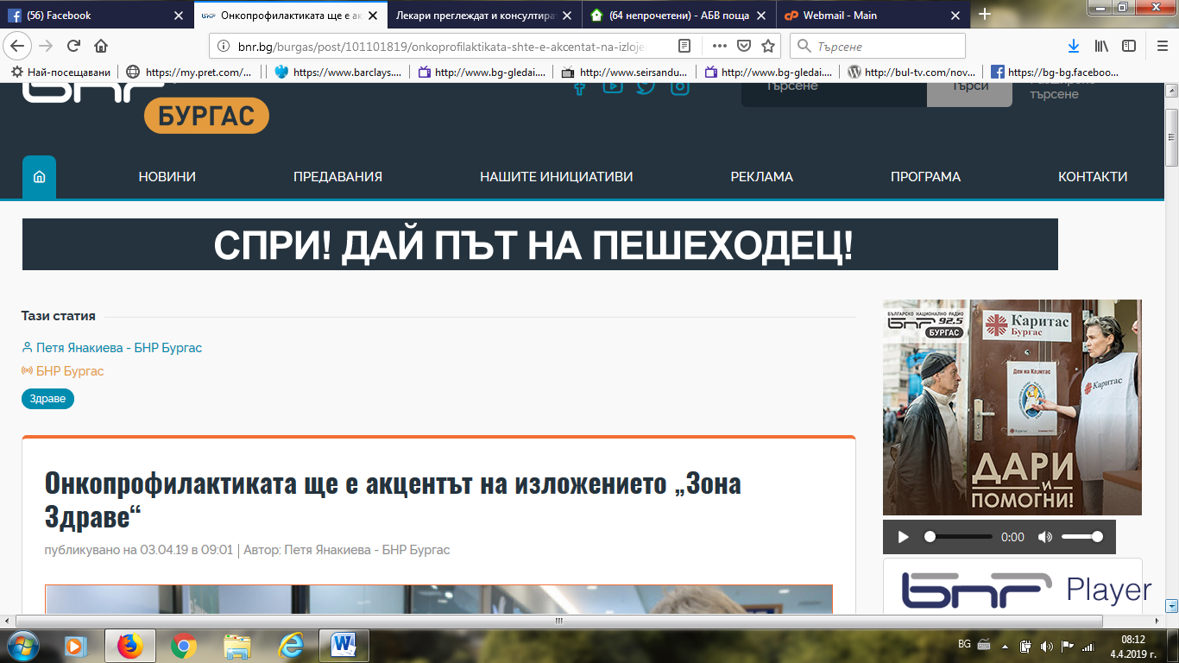
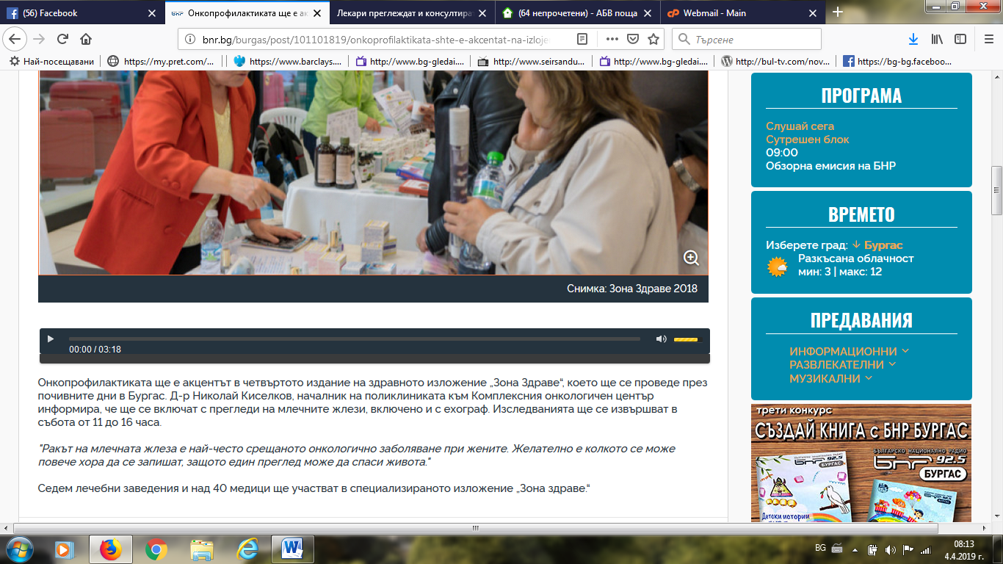

БУРГАС СИТИ:
http://burgascity.com/%D0%BB%D0%B5%D0%BA%D0%B0%D1%80%D0%B8-%D0%BF%D1%80%D0%B5%D0%B3%D0%BB%D0%B5%D0%B6%D0%B4%D0%B0%D1%82-%D0%B8-%D0%BA%D0%BE%D0%BD%D1%81%D1%83%D0%BB%D1%82%D0%B8%D1%80%D0%B0%D1%82-%D0%B1%D0%B5%D0%B7%D0%BF-2/
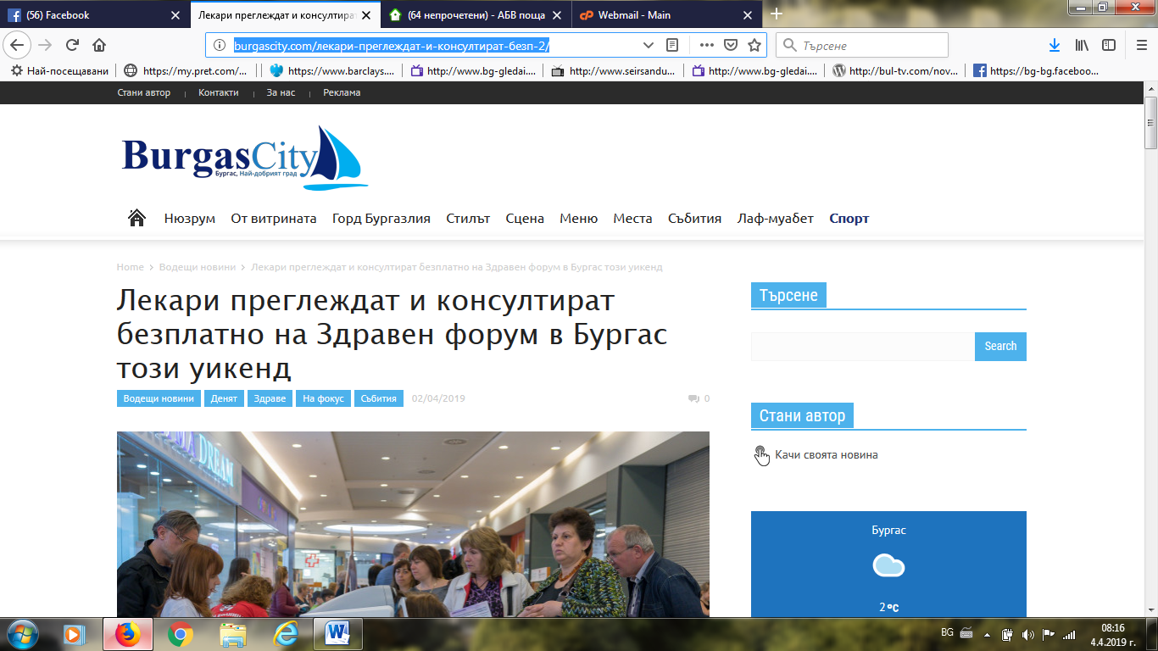
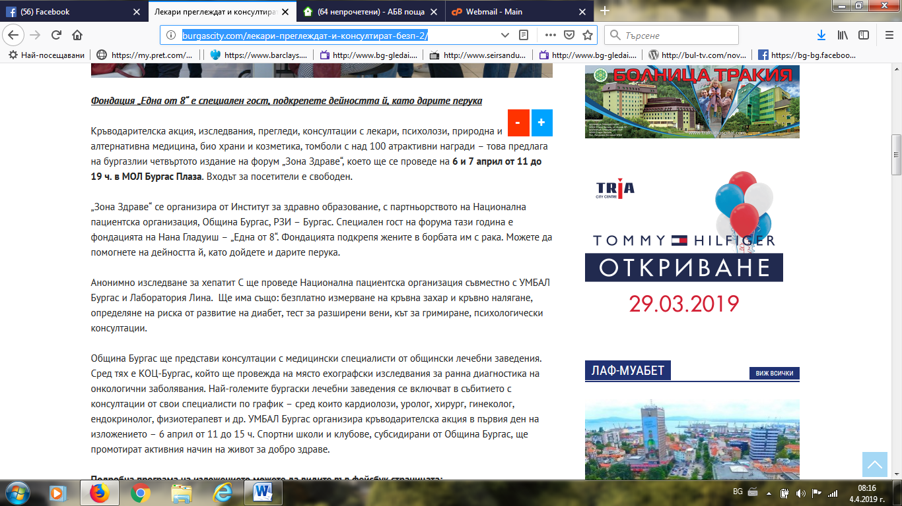

ЧЕРНОМОРСКИ ФАР:
http://m.faragency.bg/bg/-bezplatni-pregledi-i-konsultatsii-na-zdraven-forum-tozi-uikend/
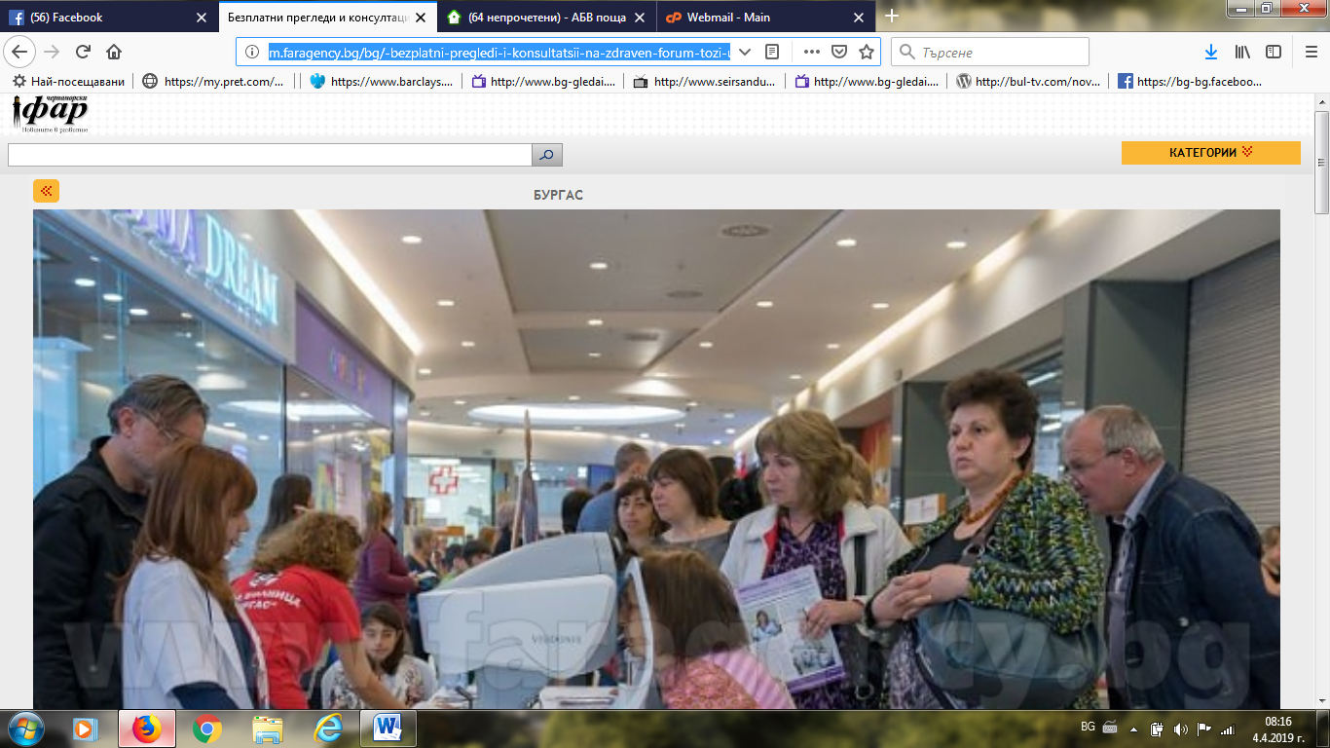
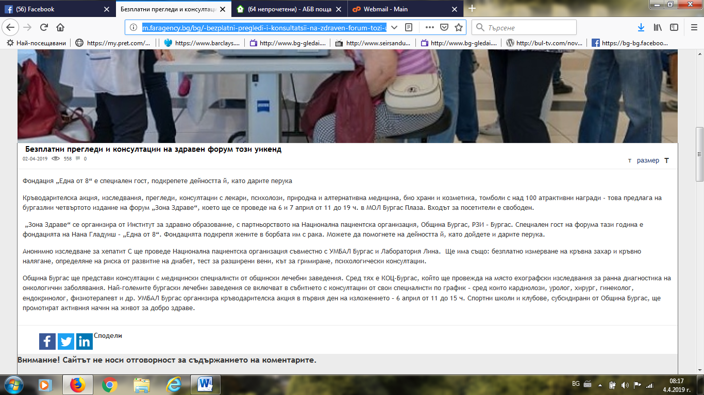

ФЛАГМАН:
https://www.flagman.bg/article/184487
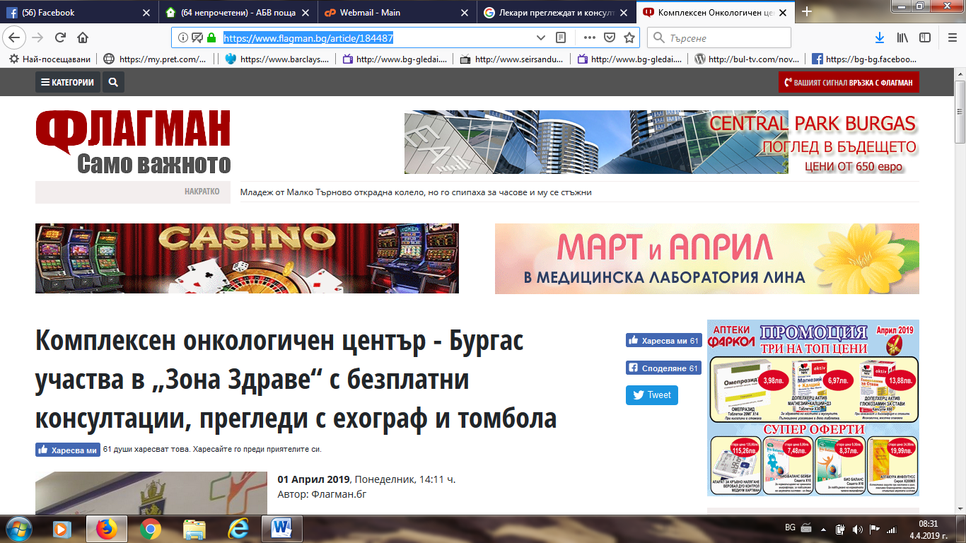
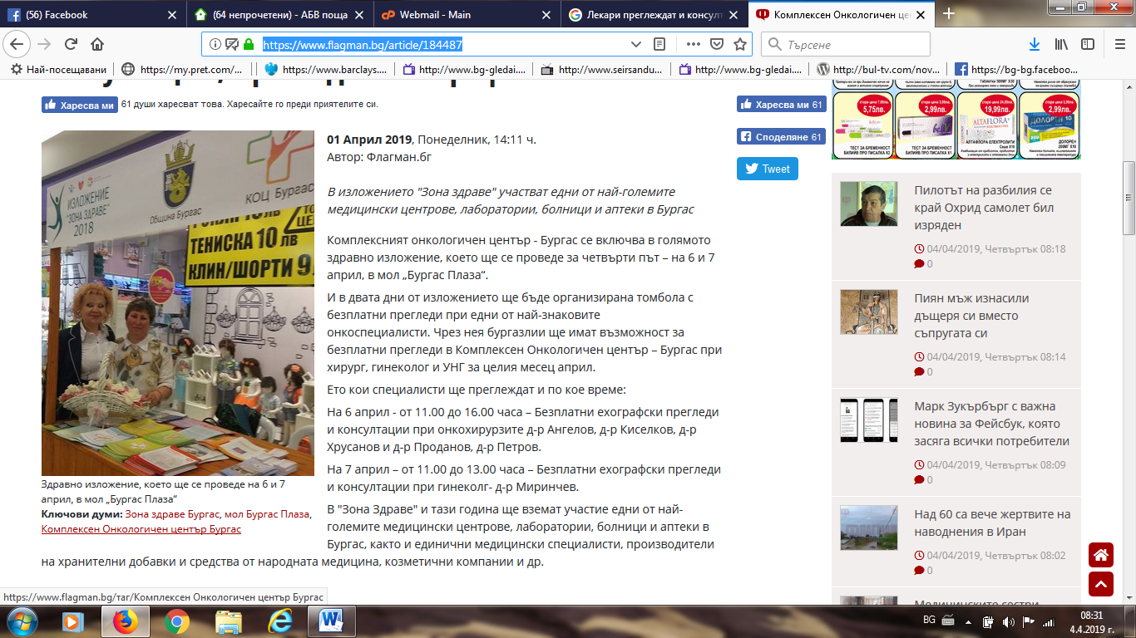

РАДИО МИЛЕНА:
http://radiomilena.com/2013/57374/%D0%B8%D0%B7%D0%BB%D0%BE%D0%B6%D0%B5%D0%BD%D0%B8%D0%B5%D0%B7%D0%BE%D0%BD%D0%B0-%D0%B7%D0%B4%D1%80%D0%B0%D0%B2%D0%B5-%D0%BD%D0%B0-6-%D0%B8-7-%D0%B0%D0%BF%D1%80%D0%B8%D0%BB-%D0%B2/
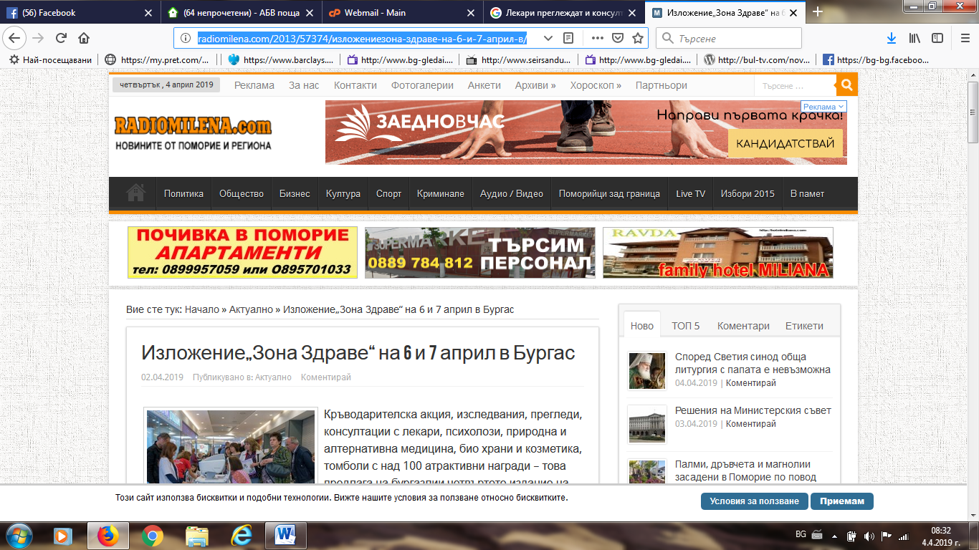
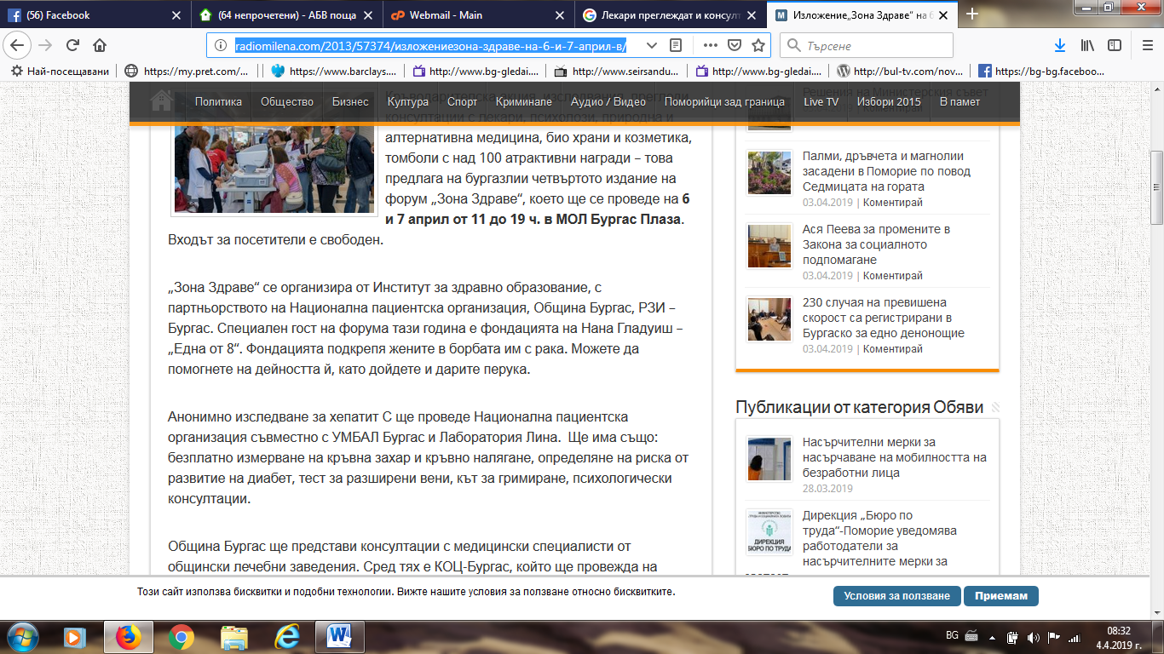

ГОТО БУРГАС:
https://www.gotoburgas.com/en/news/view/3/2895
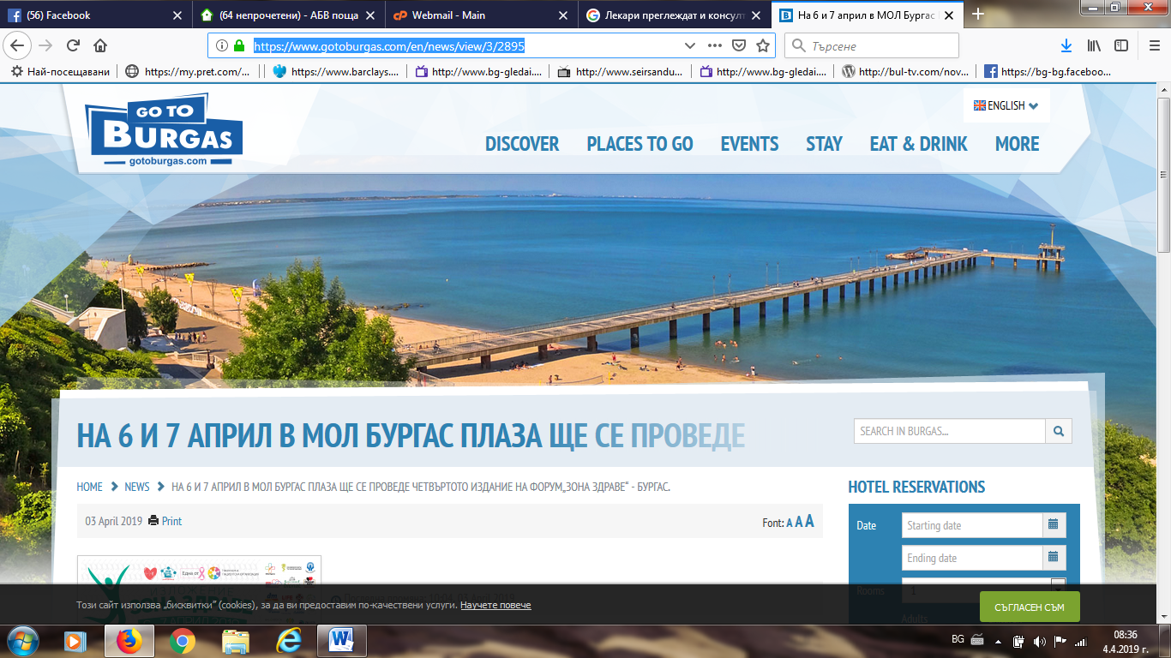
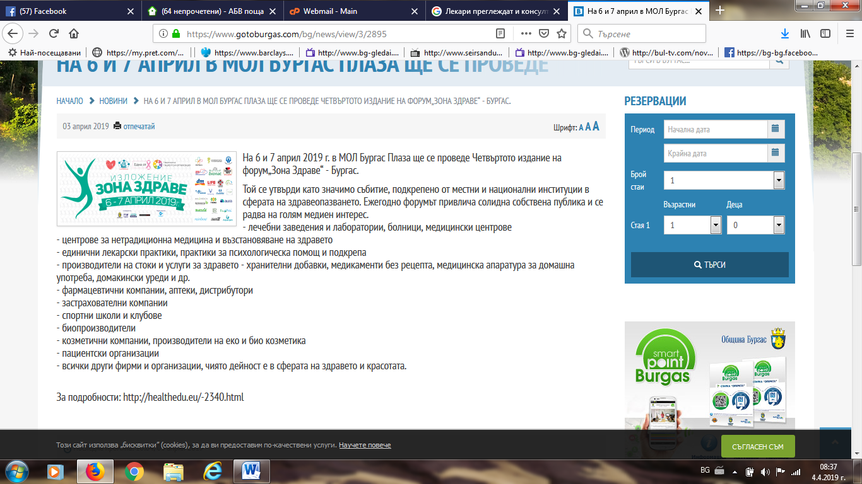

Д-Р БИОМАСТЕР:
http://www.drbiomaster.com/%D0%B7%D0%BE%D0%BD%D0%B0-%D0%B7%D0%B4%D1%80%D0%B0%D0%B2%D0%B5-%D0%B1%D1%83%D1%80%D0%B3%D0%B0%D1%81-2019/
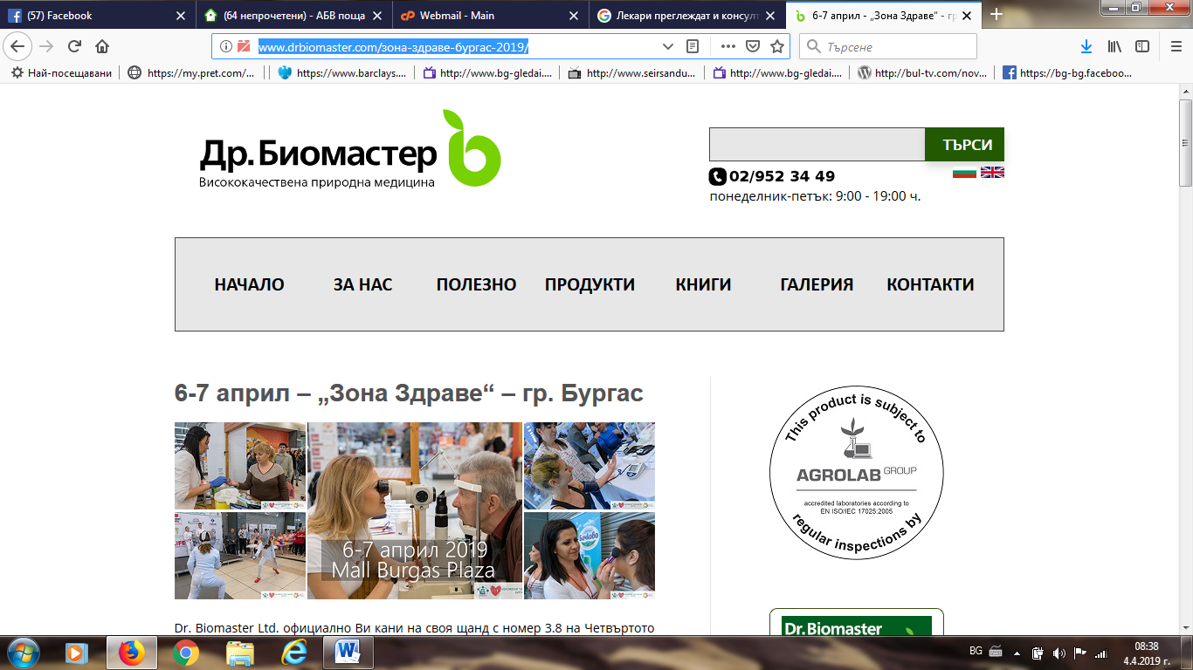
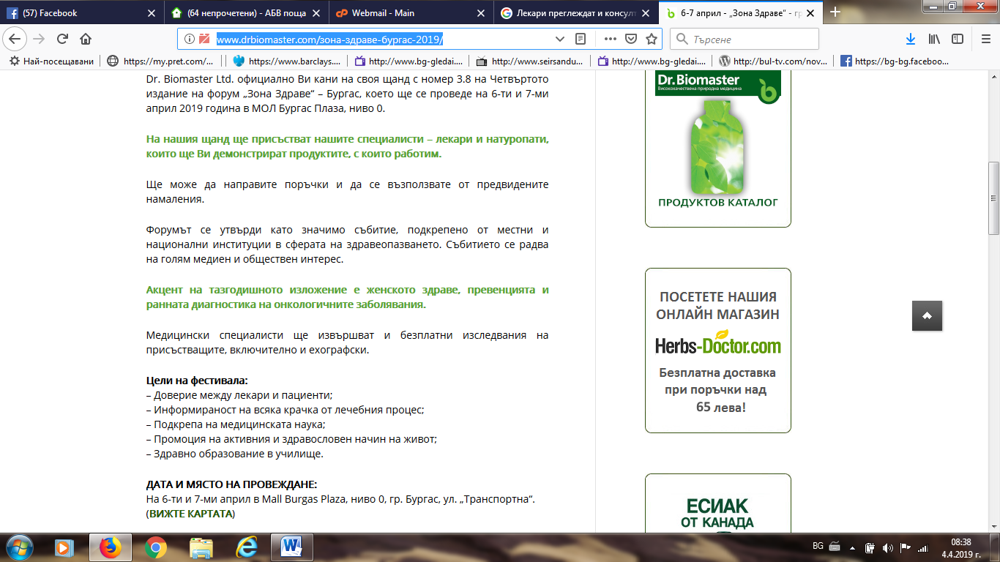

ПОЛИГРАФ: http://poligraff.net/%D1%81%D1%82%D0%B0%D1%82%D0%B8%D1%8F/%D0%91%D0%B5%D0%B7%D0%BF%D0%BB%D0%B0%D1%82%D0%BD%D0%B8-%D0%BF%D1%80%D0%B5%D0%B3%D0%BB%D0%B5%D0%B4%D0%B8-%D0%B8-%D0%BA%D0%BE%D0%BD%D1%81%D1%83%D0%BB%D1%82%D0%B0%D1%86%D0%B8%D0%B8-%D0%B2-%D1%87%D0%B5%D1%82%D0%B2%D1%8A%D1%80%D1%82%D0%BE%D1%82%D0%BE-%D0%B8%D0%B7%D0%B4%D0%B0%D0%BD%D0%B8%D0%B5-%D0%BD%D0%B0-%D0%97%D0%BE%D0%BD%D0%B0-%D0%97%D0%B4%D1%80%D0%B0%D0%B2%D0%B5/50568 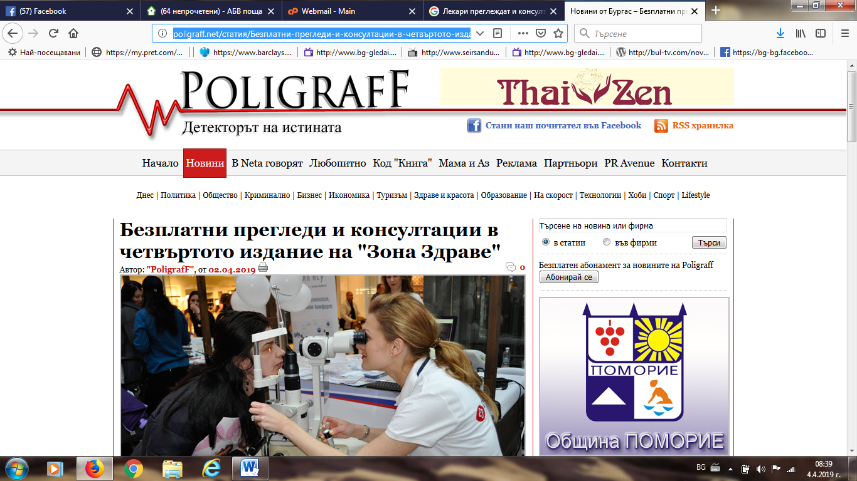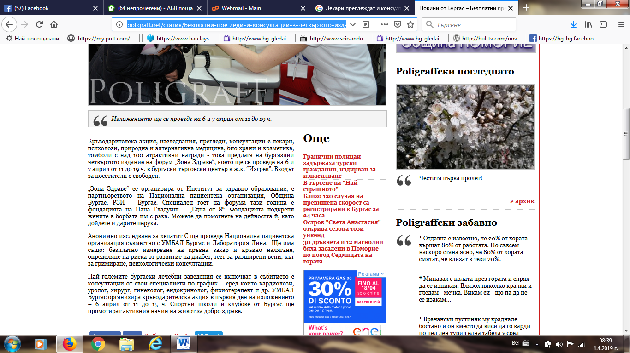

ФЛАГМАН:
https://www.flagman.bg/article/184583
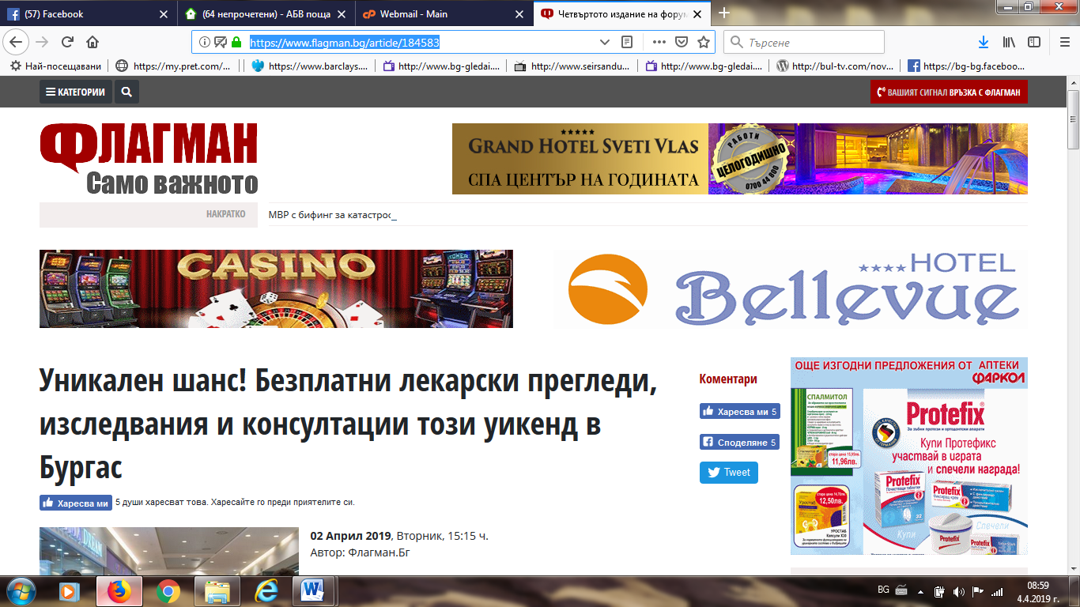
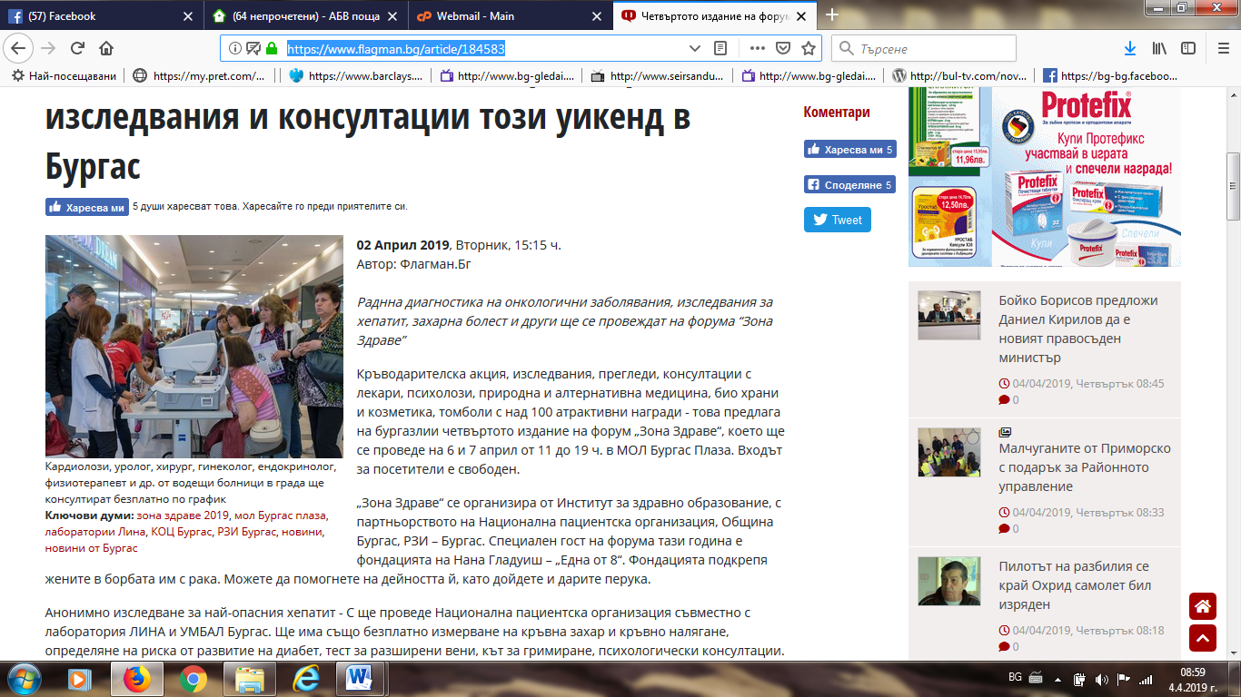

БНР РАДИО БУРГАС:
http://bnr.bg/burgas/post/101101819?fbclid=IwAR3AqrKdbCur0-Py6P6IZMp5yk6KrXRIhFCIYZuhkSM5WhjHqBVW3kiLaI0
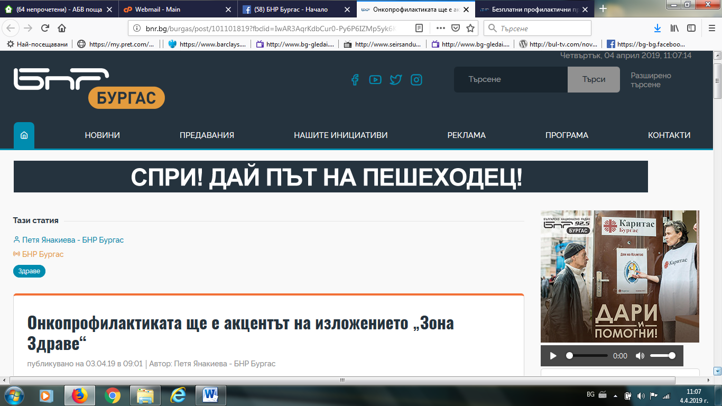
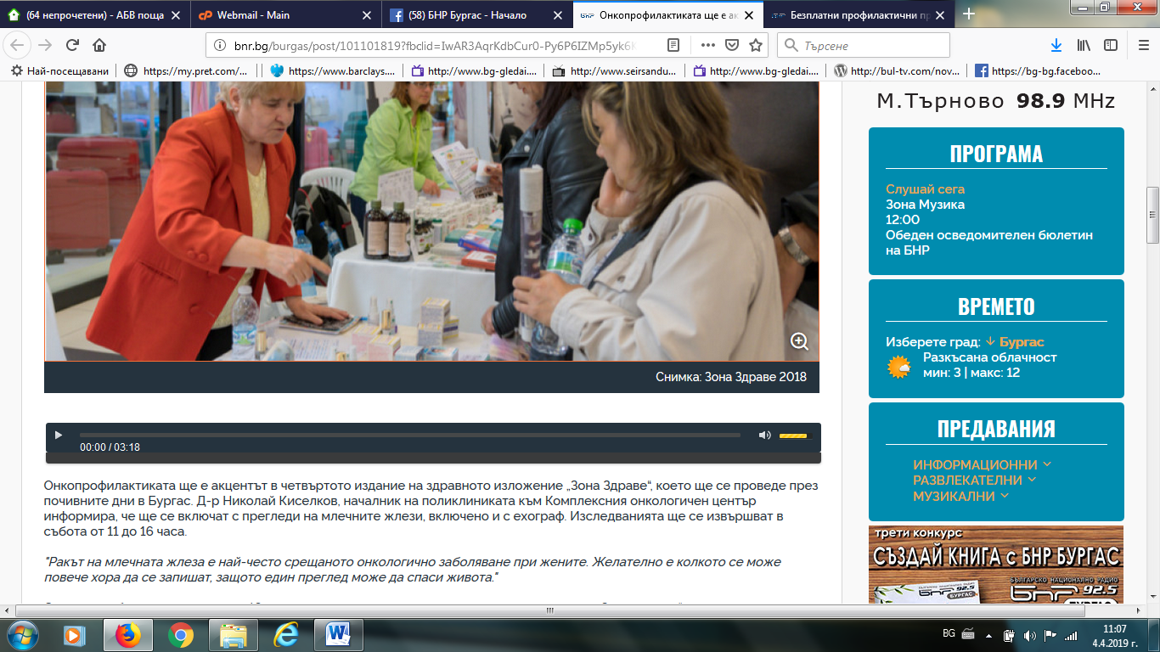

БНР БУРГАС ФЕЙБУК:
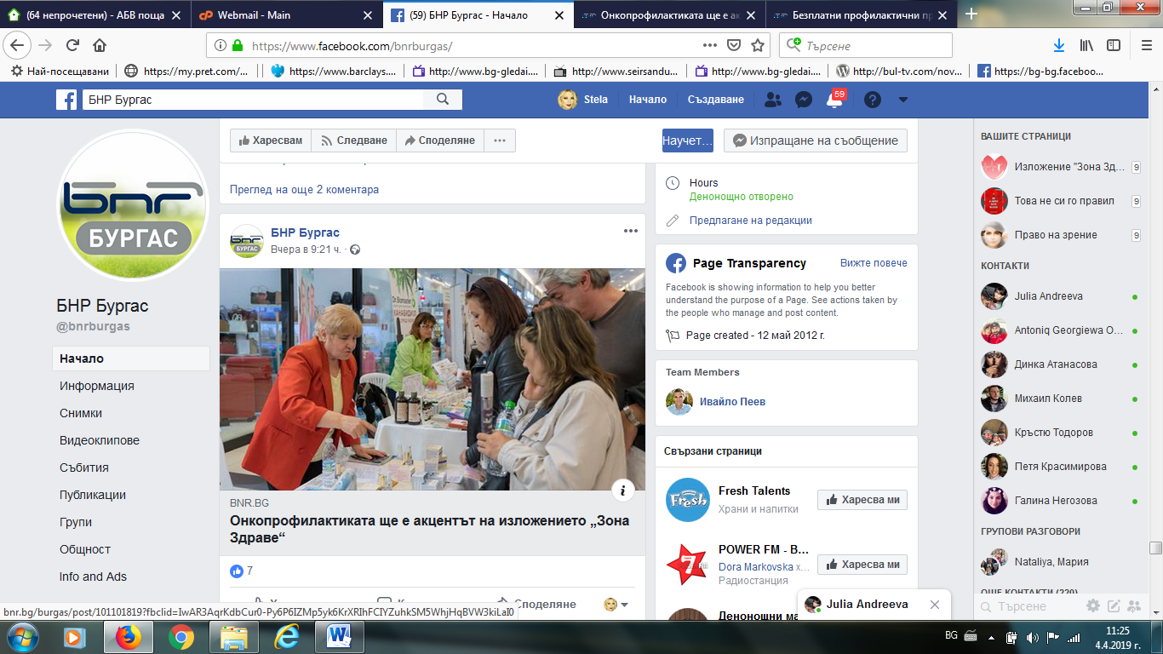

ЕДНА ОТ 8 ФЕЙСБУК:
https://www.facebook.com/ednaot8/photos/a.187664474771225/1035189476685383/?type=3&theater
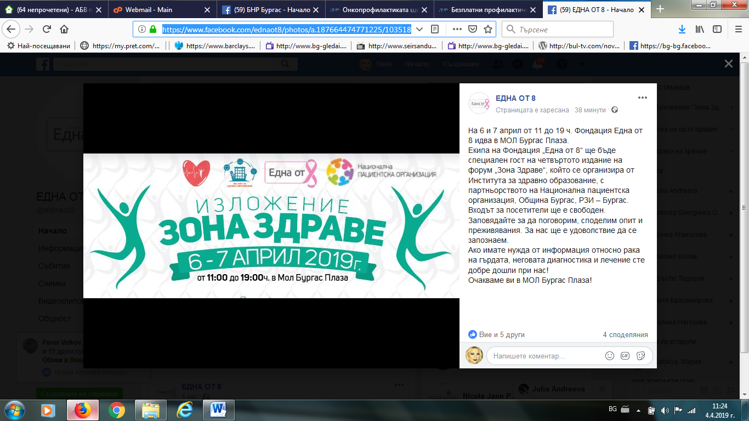

ОБЩИНА БУРГАС:
https://www.burgas.bg/bg/news/details/1/37986?fbclid=IwAR1g-w44108Oomz3eumHVysfZAAQz8t2aW-uCuer7Lv9rslFBA4UcNIlk1I
